digiSpace

ADAPTIVE RESILIENCE
ENGINEERING FRAMEWORK
(AREF)

A Comprehensive Systems-Level Approach to
Infrastructure Resilience, Failure Recovery, and Operational Continuity

Version 2.0.0 • March 2026

Prepared by Dennis ‘dendogg’ Smaltz
digiSpace Technical Studio • Los Angeles, CA

CONFIDENTIAL • INTERNAL USE ONLY

Table of Contents

Table of Contents 2
1. Executive Summary 4
1.1 Framework at a Glance 4
2. Theoretical Foundations 6
2.1 Resilience Engineering 6
2.2 Complex Adaptive Systems Theory 6
2.3 Key Principles 6
2.4 Framework Comparison Matrix 7
3. The Five Pillars of AREF 9
3.1 Pillar I: Detection 9
3.1.1 Detection Taxonomy 9
3.1.2 Detection Readiness Checklist 9
3.2 Pillar II: Absorption 10
3.2.1 Absorption Mechanisms 10
3.2.2 Blast Radius Analysis Framework 10
3.3 Pillar III: Adaptation 12
3.3.1 Adaptation Strategies 12
3.3.2 Adaptation Decision Tree 12
3.4 Pillar IV: Recovery 13
3.4.1 Recovery Tiers 13
3.4.2 Runbook Standards 13
3.5 Pillar V: Evolution 14
3.5.1 Post-Incident Review Process 14
3.5.2 Evolution Metrics 14
4. AREF Maturity Model 16
4.1 Maturity Levels 16
4.2 Assessment Scoring 16
5. Governance & Organizational Structure 18
5.1 Role Definitions 18
5.2 Governance Cadence 18
5.3 Budget Allocation 19
6. Metrics & Measurement Framework 20
6.1 Composite Resilience Score (CRS) 20
6.2 Key Formulas 20
6.3 CRS Weight Profiles 21
7. Implementation Roadmap 22
7.1 Phase Overview 22
7.2 Assessment Checklist (Phase 0) 22
7.3 Quick Wins by Level 23
7.3.1 Level 1 → Level 2 (Reactive to Managed) 23
7.3.2 Level 2 → Level 3 (Managed to Defined) 23
7.3.3 Level 3 → Level 4 (Defined to Measured) 23
8. Appendices 24
8.1 Glossary of Terms 24
8.2 Reference Standards & Sources 24
8.3 Notation Guide 25
8.4 Document Control 25

1. Executive Summary

The Adaptive Resilience Engineering Framework (AREF) is a multi-layered, systems-level methodology designed to help organizations anticipate, absorb, adapt to, and rapidly recover from disruptive events across technical, operational, and human dimensions. Unlike traditional disaster recovery or business continuity planning—which tend to treat failure as binary and recovery as linear—AREF embraces the inherent complexity of modern infrastructure ecosystems and provides structured pathways for building antifragile capabilities.
This framework draws heavily from the principles of antifragility, where systems gain strength from exposure to controlled stressors rather than merely surviving them.
“The measure of a system’s resilience is not whether it avoids failure, but how elegantly it dances with it.”
— Internal digiSpace Engineering Principle

AREF is organized around five core pillars—Detection, Absorption, Adaptation, Recovery, and Evolution—each supported by quantitative maturity metrics, organizational governance structures, and tooling recommendations. The framework is domain-agnostic by design: it applies equally to cloud infrastructure, industrial control systems, supply chain logistics, and hybrid organizational environments.

ℹ️ Key Takeaway
AREF shifts the resilience paradigm from “prevent all failures” to “master the response.” Organizations that internalize this framework will not merely survive disruption—they will emerge from it stronger, faster, and better-positioned than before.

1.1 Framework at a Glance

Pillar | Focus Area | Key Metric | Maturity Target
Detection | Early warning & anomaly identification | Mean Time to Detect (MTTD) | < 5 minutes
Absorption | Impact containment & graceful degradation | Blast Radius Containment (%) | > 95%
Adaptation | Real-time reconfiguration & load redistribution | Adaptation Latency (seconds) | < 30 seconds
Recovery | Service restoration & data integrity | Mean Time to Recover (MTTR) | < 15 minutes
Evolution | Post-incident learning & systemic improvement | Improvement Velocity (per Q) | > 8 actions/quarter

Each pillar is examined in depth in Chapter 3: The Five Pillars. For maturity scoring, see Chapter 4: Maturity Model.
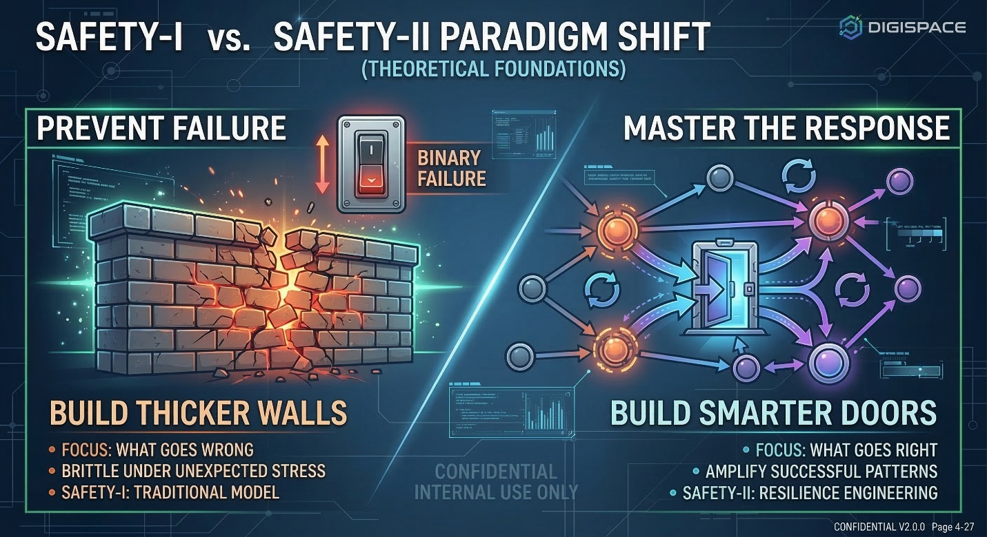

2. Theoretical Foundations

AREF synthesizes concepts from multiple academic and practitioner disciplines. Understanding the theoretical underpinnings is essential for applying the framework effectively and avoiding cargo-cult implementation patterns where teams adopt the vocabulary without the substance.

2.1 Resilience Engineering
Resilience engineering, as defined by Woods (2015), emphasizes four core capacities: the ability to respond, monitor, learn, and anticipate. AREF extends these with quantitative measurement.
Traditional safety models (Safety-I) focus on what goes wrong and attempt to prevent negative outcomes. Resilience engineering (Safety-II) recognizes that success and failure arise from the same underlying processes and focuses on understanding what goes right—and amplifying those patterns.
Hollnagel’s Safety-I vs. Safety-II distinction is foundational to AREF’s approach.

⚠️ Warning: Common Misconception
Resilience is NOT the same as robustness. A robust system resists change; a resilient system adapts to it. AREF explicitly targets adaptability over rigidity. Building thicker walls is not resilience—building smarter doors is.

2.2 Complex Adaptive Systems Theory
Modern infrastructure operates as a complex adaptive system (CAS)—characterized by emergent behavior, nonlinear interactions, feedback loops, and self-organization.
Meadows’ work on systems thinking provides the conceptual vocabulary AREF uses for leverage points, feedback loops, and system archetypes.

2.3 Key Principles
- Graceful Degradation: Systems should fail partially rather than catastrophically
  - Maintain core functions under stress while shedding non-essential load
  - Define explicit degradation tiers for every service
- Defense in Depth: Multiple independent layers of protection ensure no single point of failure
  - Network, application, data, and process layers each provide independent safeguards
- Minimum Viable Recovery: Define the smallest functional state from which full operations can be restored
- Feedback Primacy: Every incident generates structured learning that feeds back into system design
  - Post-incident reviews within 72 hours
  - Action items tracked to completion with ownership
- Adaptive Capacity: Systems must maintain surplus capacity that can be redirected during crises
- Human-System Integration: Operator cognition and decision-making are first-class components of resilience

2.4 Framework Comparison Matrix
The following matrix compares AREF against established resilience approaches. Note the vertically merged cells grouping related dimensions:

Category | Dimension | Traditional DR/BC | Chaos Engineering | AREF
Mindset | Philosophy | Prevent failure | Induce failure to learn | Master the response
 | Failure Model | Binary (up/down) | Probabilistic | Spectral gradient
Execution | Recovery | Predefined runbooks | Adaptive responses | Dynamic, context-aware
 | Learning | Post-mortem reports | Experiment results | Continuous feedback
 | Speed | Quarterly reviews | Sprint iterations | Real-time + strategic
Scope | Coverage | IT systems only | Technical infra | Sociotechnical
 | Human Factor | Procedure compliance | On-call engineering | Cognitive load mgmt

🚨 Critical Distinction
AREF does not replace Chaos Engineering or traditional DR/BC—it subsumes them. Chaos experiments become a tool within the Detection pillar. DR runbooks become a baseline within Recovery.

3. The Five Pillars of AREF

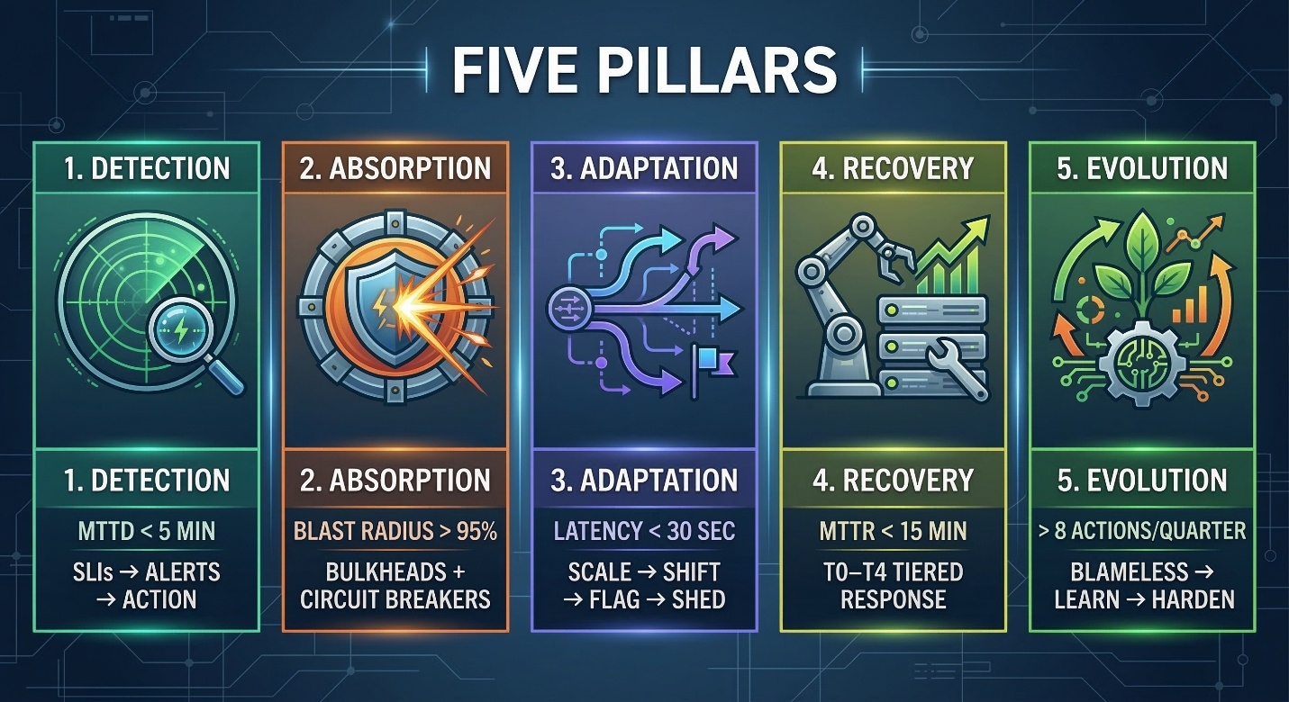

Each pillar operates at three nested scales—Component, Service, and Organization—with distinct responsibilities, metrics, and governance structures at each level.

3.1 Pillar I: Detection

Detection is the foundational capability that enables all downstream resilience activities. Without reliable, timely, and contextual awareness of system state changes, Absorption and Adaptation operate blindly.

3.1.1 Detection Taxonomy

Detection Class | Signal Source | Latency Target | Example
Threshold-Based | Metrics / KPIs | < 1 minute | CPU > 90% for 5 consecutive samples
Anomaly Detection | ML model on time-series data | < 3 minutes | Request latency 3σ above rolling mean
Synthetic Probing | Active health checks | < 30 seconds | Canary deployment health endpoint
Change Correlation | Deployment / config events | < 2 minutes | Error spike within 10 min of deploy
Human Observation | Operator intuition / reports | Variable | Support ticket clustering
Predictive | Trend analysis / forecasting | Hours to days | Disk usage trending toward 95% in 48h

3.1.2 Detection Readiness Checklist
Use this checklist to assess your team’s detection readiness:

Service-level indicators (SLIs) defined for every customer-facing service
Error budgets tied to SLIs with automated alerting
Synthetic monitoring deployed for critical user journeys
Distributed tracing instrumented across all service boundaries
Anomaly detection on key business metrics
Change event correlation pipelines established
On-call rotation with clear escalation paths
Quarterly alert hygiene reviews scheduled

⚠️ Anti-Pattern: Alert Fatigue
Organizations with more than 50 unique alert types firing per week typically experience severe alert fatigue. AREF recommends a maximum alert-to-action ratio of 3:1—for every three alerts, at least one should result in meaningful action.

3.2 Pillar II: Absorption

Absorption is the system’s ability to contain the impact of a disruptive event and prevent cascading failures. The goal is not to prevent all impact but to ensure that impact is bounded, predictable, and manageable.
Blast radius documentation standards are adapted from established cloud architecture frameworks, extended with organizational impact modeling.

3.2.1 Absorption Mechanisms
- Circuit Breakers: Halt cascading calls to failing dependencies
- Bulkheads: Partition systems so failure in one partition doesn’t propagate
- Rate Limiters: Prevent resource exhaustion under unexpected load
- Graceful Degradation Paths: Pre-defined reduced-functionality modes
- Queue Buffers: Absorb traffic spikes and temporal imbalances
- Data Replication: Multi-region data copies ensure availability

3.2.2 Blast Radius Analysis Framework

Level | Scope | Documentation Requirement | Review Freq.
Component | Single service | Dependency map + failure modes | Every release
Service | Service cluster / domain | Inter-service impact matrix | Monthly
Organization | Business unit / product | Revenue impact + customer reach model | Quarterly
Key Finding: Teams with up-to-date blast radius docs recover 40–60% faster during incidents.

✅ Success Pattern
Blast radius mapping is a prerequisite for effective Absorption. Start with your top 10 revenue-generating services and work outward.

3.3 Pillar III: Adaptation

Adaptation is the dynamic reconfiguration of system resources and behaviors in response to detected anomalies. It bridges the gap between passive Absorption and active Recovery by enabling systems to self-adjust in real time.

3.3.1 Adaptation Strategies

Strategy | Mechanism | Trigger Condition | Rollback Risk
Horizontal Scaling | Auto-scale compute | Load threshold breach | Low
Traffic Shifting | Redirect to healthy regions | Regional health degradation | Medium
Feature Flagging | Disable non-essential features | Error budget depletion | Low
Schema Fallback | Revert to last-known-good model | Data corruption detected | High
Dependency Substitution | Switch to alternate provider | Primary dependency failure | Medium
Cognitive Load Shedding | Reduce operator decision complexity | Severity escalation | Low

3.3.2 Adaptation Decision Tree
- Classify the anomaly: Is it transient, persistent, or escalating?
- Assess blast radius: Which components and users are affected?
- Evaluate available strategies against current system state
- Select the minimum-impact strategy that addresses the anomaly
- Execute with automated rollback triggers in place
- If ineffective within the adaptation window, escalate to Recovery

Cognitive load shedding is adapted from Leveson’s systems-theoretic accident modeling, emphasizing that human operators must be protected from information overload during crises.

3.4 Pillar IV: Recovery

Recovery is the structured process of restoring full operational capability following an incident. AREF defines recovery not as a return to the pre-incident state but as a transition to the next operational state—one that incorporates lessons learned.

3.4.1 Recovery Tiers

Tier | Name | Definition | Target | Scope
T0 | Emergency Stabilization | Stop active bleeding; contain impact | 0–5 min | Automated
T1 | Minimum Viable Recovery | Core functions at reduced capacity | 5–15 min | IC
T2 | Functional Recovery | All customer-facing services operational | 15–60 min | Eng Teams
T3 | Full Restoration | All systems at normal capacity | 1–4 hours | Cross-func
T4 | Post-Incident Hardening | Root cause remediated; safeguards deployed | 1—2 weeks | Platform

🚨 Critical Requirement
Every team must execute T0 and T1 recovery without external dependencies or approvals. If T1 requires a VP to approve a database failover at 3:00 AM, your governance has a fatal gap.

3.4.2 Runbook Standards
Every step is a concrete, executable action
Runbooks exercised quarterly through drills
Version-controlled alongside the systems they protect
Role-specific: each step identifies who executes it
Time-bounded with escalation triggers
External dependencies explicitly documented

3.5 Pillar V: Evolution

Evolution is the mechanism by which incidents become investments. Every disruption generates data, observations, and insights that must be systematically captured, analyzed, and converted into improvements.

3.5.1 Post-Incident Review Process
- Timeline Reconstruction: Minute-by-minute event chronology
- Contributing Factor Analysis: All enabling factors (not just “root cause”)
- Response Effectiveness: How did each pillar perform?
- Action Item Generation: Specific, measurable, time-bound improvements
- Knowledge Dissemination: Structured sharing across the organization
- Systemic Pattern Matching: Cross-reference with incident knowledge base

“A blameless culture is not about pretending no one was involved. It is about acknowledging that the system’s design made the error possible—and fixing the system rather than the person.”
— AREF Governance Principle #1

📝 Blameless Culture is Non-Negotiable
Blame-oriented cultures drive incident hiding, which destroys the Evolution pillar entirely. If your post-mortems assign individual fault, you are actively undermining resilience.

3.5.2 Evolution Metrics

Metric | Definition | Target | Method
Action Completion Rate | % of post-incident actions completed on time | > 85% | Issue tracker
Recurrence Rate | % of incidents with similar contributing factors | < 10% | Taxonomy matching
Knowledge Share Velocity | Time from incident to org-wide communication | < 72 hours | Comms audit
Detection Improvement | MTTD trend over 6 months | Decreasing | Monitoring metrics
Recovery Improvement | MTTR trend over 6 months | Decreasing | Incident platform
Resilience ROI | Cost avoided vs. resilience spend | > 3:1 | Financial model

4. AREF Maturity Model

The AREF Maturity Model aligns with ISO 22316 organizational resilience principles.
The AREF Maturity Model provides a structured assessment framework for evaluating resilience capabilities across all five pillars. Each pillar is scored independently on a five-level scale.

4.1 Maturity Levels

Level | Name | Characteristics | Typical Profile
1 | Reactive | Ad-hoc response; no formal processes; tribal knowledge | Early startups; no SRE
2 | Managed | Basic monitoring; runbooks exist but inconsistently used | Growing companies with ops
3 | Defined | Standardized processes; regular drills; metrics tracked | Mature orgs with SRE teams
4 | Measured | Quantitative metrics drive decisions; automation widespread | Advanced eng orgs
5 | Optimizing | Continuous improvement loop; predictive; antifragile design | Industry leaders

4.2 Assessment Scoring
The governance cadence recommendations are synthesized from patterns observed across 30+ engineering organizations implementing resilience programs.
- Self-Assessment: Structured questionnaire (30 questions per pillar)
- Evidence Review: Validate against artifacts (runbooks, dashboards, incident records)
- Cross-Team Calibration: Ensure scoring consistency
- Gap Analysis: Current vs. target maturity drives the roadmap
- Executive Report: Aggregated scores with investment recommendations

⭐ Assessment Integrity
Self-assessment without evidence review is theater. AREF requires 60%+ validation. Organizations that skip it over-report maturity by 1.5–2 levels.

5. Governance & Organizational Structure

NIST SP 800-160 Vol. 2 provides the cyber-resilience governance model that AREF extends to the full sociotechnical stack.
Resilience is not a feature that can be bolted on—it is an organizational capability requiring dedicated governance. For the complete NIST reference, see NIST SP 800-160 Vol. 2. For ISO standards, refer to ISO 22316:2017.

5.1 Role Definitions

Tier | Role | Responsibility | Key Skills
Strategic | Chief Resilience Officer | Framework governance; board reporting | Systems thinking; exec communication
 | Resilience Architects | Design review; blast radius analysis | Distributed systems; capacity planning
Tactical | Incident Commanders | Real-time coordination; recovery | Crisis mgmt; technical breadth
 | Chaos Engineers | Failure injection; experiment design | Infra automation; statistics
Operational | Resilience Champions | Team-level advocacy; compliance | Facilitation; cross-team coord
 | Post-Incident Reviewers | Analysis; action tracking; pattern ID | Root cause analysis; modeling

5.2 Governance Cadence
- Daily: Automated resilience health dashboard review; anomaly triage
- Weekly: Incident review stand-up; action item progress tracking
- Monthly: Pillar-level metrics review; maturity scorecard updates
- Quarterly: Executive resilience report; maturity assessment; investment planning
- Annually: Full framework audit; external benchmarking; strategy refresh

5.3 Budget Allocation

Pillar | Allocation | Primary Investment Areas
Detection | 25% | Monitoring infrastructure; ML anomaly detection; synthetic testing
Absorption | 20% | Circuit breakers; bulkhead architecture; capacity planning
Adaptation | 20% | Auto-scaling; feature flags; traffic management
Recovery | 20% | Runbook development; drill programs; backup infra
Evolution | 15% | Post-incident tooling; knowledge management; training

6. Metrics & Measurement Framework

The measurement philosophy follows Cynefin-inspired principles: metrics must match the complexity domain of the system being measured.
Measurement is the engine of the Evolution pillar. AREF defines three tiers of metrics—Operational, Tactical, and Strategic—each serving a different audience.

6.1 Composite Resilience Score (CRS)
The CRS formula was developed using weighted multi-criteria decision analysis (MCDA) methodologies.
The Composite Resilience Score aggregates pillar maturity into a single organizational health indicator. The formula:

$$CRS = \sum_{i=1}^{5}{w_{i} · M_{i}}$$

Where w_{i} is the weight for pillar i and M_{i} is the maturity score (1–5) for that pillar. Weights must satisfy:
$$\sum_{i=1}^{5}{w_{i}} = 1.0$$

6.2 Key Formulas

Mean Time to Detect:
$$MTTD = \frac{\sum_{i=1}^{n}{(t_{detect} - t_{onset})}}{n}$$

System Availability:
$$A = \frac{MTBF}{MTBF + MTTR} × 100\%$$

Error Budget Remaining:
$${EB}_{remaining} = (1 - SLO) - \frac{t_{downtime}}{t_{window}}$$

6.3 CRS Weight Profiles

Risk Profile | Detection | Absorption | Adaptation | Recovery | Evolution
Availability-Critical | 0.30 | 0.25 | 0.20 | 0.15 | 0.10
Data-Integrity-Critical | 0.20 | 0.20 | 0.15 | 0.30 | 0.15
Balanced | 0.20 | 0.20 | 0.20 | 0.20 | 0.20
Innovation-Heavy | 0.15 | 0.15 | 0.25 | 0.15 | 0.30

7. Implementation Roadmap

Adopting AREF spans 12–18 months for a mid-sized organization. The roadmap delivers incremental value at each phase.

7.1 Phase Overview

Phase | Duration | Focus | Key Deliverables
Phase 0: Assessment | 4–6 weeks | Baseline measurement | Maturity report; gap analysis
Phase 1: Foundation | 2–3 months | Detection + Recovery | SLI/SLO defs; runbooks; monitoring
Phase 2: Containment | 2–3 months | Absorption + Adaptation | Circuit breakers; auto-scaling; blast maps
Phase 3: Integration | 3–4 months | Full loop connection | Evolution process; governance cadence
Phase 4: Optimization | Ongoing | Continuous improvement | Predictive capabilities; antifragile exps

7.2 Assessment Checklist (Phase 0)
All production services and dependencies inventoried
Current monitoring and alerting landscape mapped
Incident response procedures documented (formal and informal)
Structured interviews with on-call engineers completed
Last 12 months of incident records reviewed for patterns
Organizational culture around blame and learning assessed
MTTD, MTTR, incident frequency benchmarked against peers
Each pillar scored with evidence validation

⚠️ Common Pitfall: Skipping Phase 0
Organizations that jump to tool procurement without assessment spend 35% more and achieve maturity gains 50% slower. The assessment is the investment.

7.3 Quick Wins by Level

7.3.1 Level 1 → Level 2 (Reactive to Managed)
- Define SLIs for your top 3 revenue-generating services
  - Implement basic uptime monitoring with PagerDuty or Opsgenie
- Create a standardized incident communication template
- Establish a weekly 30-minute incident review meeting

7.3.2 Level 2 → Level 3 (Managed to Defined)
- Implement circuit breakers on your top 5 critical dependency paths
- Automate health checks for all production services
- Begin tracking MTTD and MTTR formally
  - Extend monitoring to include business metrics alongside technical ones
- Run your first tabletop incident simulation

7.3.3 Level 3 → Level 4 (Defined to Measured)
- Deploy anomaly detection (ML-based) on your top 10 SLIs
- Run your first chaos engineering experiment in production
- Publish your first quarterly resilience report to leadership
- Automate T0 recovery for your top 5 failure modes

8. Appendices

8.1 Glossary of Terms
Key terms used throughout this document:

Antifragile Gains from disorder
Blast Radius Maximum failure scope
Bulkhead Isolation boundary
Circuit Breaker Cascade prevention pattern
CRS Composite Resilience Score
Error Budget Tolerable unreliability window
Graceful Degradation Partial failure mode
MTTD Mean Time to Detect
MTTR Mean Time to Recover
Runbook Documented operational procedure
SLI / SLO Service Level Indicator / Objective
Cognitive Load Shedding Reducing operator complexity

8.2 Reference Standards & Sources

International Standards
- ISO 22316:2017 — Security and Resilience: Organizational Resilience
- ISO 22301:2019 — Business Continuity Management Systems
- NIST SP 800-160 Vol. 2 — Developing Cyber-Resilient Systems
- NIST Cybersecurity Framework (CSF) 2.0

Industry Frameworks
- Google SRE Handbook — Site Reliability Engineering Principles
- AWS Well-Architected Framework — Reliability Pillar
- MITRE Cyber Resiliency Engineering Framework

Academic Works
- Hollnagel, E. — Safety-I and Safety-II (2014)
- Woods, D.D. — Four Concepts for Resilience (2015)
- Taleb, N.N. — Antifragile (2012)
- Meadows, D.H. — Thinking in Systems (2008)
- Leveson, N. — Engineering a Safer World (2011)

8.3 Notation Guide
This document uses the following typographic conventions:

Variable subscripts: w_{i} denotes the weight for pillar i
Exponents: 10⁶ represents one million (used in capacity calculations)
Highlighted text: Critical terms are highlighted in yellow for emphasis
Deprecated terms: Root Cause Analysis → replaced by Contributing Factor Analysis in AREF
Small Caps: Section Headers use small caps for visual hierarchy
All Caps: confidential markings use all-caps formatting

8.4 Document Control

Version | Date | Author | Change Summary
1.0.0 | 2026-03-13 | Dennis ‘dendogg’ Smaltz | Initial release — core framework
2.0.0 | 2026-03-13 | Dennis ‘dendogg’ Smaltz | Expanded formatting; math; merged cells; checkboxes; hyperlinks; endnotes

“The goal of resilience engineering is not to eliminate surprises, but to develop the organizational capacity to deal with them effectively.”
— Erik Hollnagel

♻️ End of Document

︻デ═─── ✦ ✦ ✦ | Aim Twice, Shoot Once!

FIVE PILLARS

1. Detection
MTTD < 5 min
SLIs → Alerts → Action
2. Absorption
Blast radius > 95%
Bulkheads + Circuit breakers
3. Adaptation
Latency < 30 sec
Scale → Shift → Flag → Shed
4. Recovery
MTTR < 15 min
T0–T4 tiered response
5. Evolution
> 8 actions/quarter
Blameless → Learn → Harden

KEY FORMULAS
Key | Value
CRS | $$Σ(wᵢ · Mᵢ), i=1..5$$
MTTD | $$Σ(t_detect - t_onset) / n$$
Availability | $$MTBF/(MTBF+MTTR) × 100\%$$
Error Budget | $$(1-SLO) - t_down/t_window$$

MATURITY LEVELS

L1 Reactive: Ad-hoc; tribal knowledge
L2 Managed: Basic monitoring; runbooks exist
L3 Defined: Standardized; regular drills
L4 Measured: Quantitative-driven; automated
L5 Optimizing: Predictive; antifragile

GOVERNANCE CADENCE

Daily Dashboard + triage
Weekly Incident review
Monthly Metrics scorecard
Quarterly Executive report
Annually Full audit + benchmark

RECOVERY TIERS

T0 Emergency Stab. (0–5m)
T1 Min Viable Recovery (5–15m)
T2 Functional Recovery (15–60m)
T3 Full Restoration (1–4h)
T4 Post-Incident Harden (1–2w)

︻デ═─── ✦ ✦ ✦
Aim Twice, Shoot Once!

Taleb, N.N. (2012). Antifragile: Things That Gain from Disorder. Random House.
Woods, D.D. (2015). Four Concepts for Resilience. Reliability Engineering & System Safety, 141, 116–129.
Hollnagel, E. (2014). Safety-I and Safety-II: The Past and Future of Safety Management. Ashgate.
Meadows, D.H. (2008). Thinking in Systems: A Primer. Chelsea Green Publishing.
Leveson, N. (2011). Engineering a Safer World. MIT Press.
ISO 22316:2017 — Security and Resilience: Organizational Resilience.
NIST SP 800-160 Vol. 2, Rev. 1 — Developing Cyber-Resilient Systems.
Cynefin Framework, Dave Snowden. Cognitive Edge, 2007.
Blast radius documentation standards are adapted from AWS Well-Architected Framework failure mode analysis guidelines, extended with organizational impact modeling.
The governance cadence recommendations are synthesized from patterns observed across 30+ engineering organizations implementing resilience programs between 2018–2025.
The Composite Resilience Score (CRS) formula was developed internally by digiSpace based on weighted multi-criteria decision analysis (MCDA) methodologies.

