On the graphics below I have added the point **T**. The points **P** and **T** both have the same **y**-coordinate.

I also added the points **Xp** and **Xc** – these are the **x-**coordinates of **P** and **T** on the **x** axis:

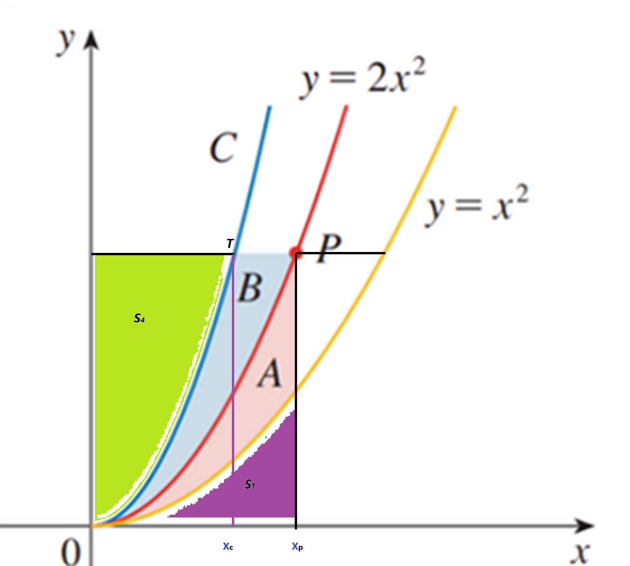

Also, the **purple** area has total space of S1 . The **green** area has total space of S4 .

Now, I assume that C = k*x2  and we just want to find the value for k.

To do so, I will:

1. Calculate the values of S1 and A (and thus of B) and show they are all equal to: (Xp)3 / 3
2. Calculate the value of S4 in two different ways and use these to find k.

S1 = = 1/3 (Xp)3

A = = 1/3 (Xp)3

B = A by the definition of the problem thus B = 1/3 (Xp)3

Thus:  
  
**(1) A = B = S1 = 1/3 (Xp)3**

Now, in the rectangle R1 with vertices: {0, Xc, T, y} we notice that:

S4 + = Xc * k*(Xc)2 = k*(Xc)3

S4 + k * (Xc)3 / 3= k*(Xc)3

Thus:  
**(2) S4 = 2/3 * k*(Xc)3**

Now we view S4 as part of the rectangle R2 with vertices: {0, Xp, P, y}

S4 = Xp * 2* (Xp)2 - A - B - S1

From (1) above: A + B + S1 = (Xp)3 . Replacing in the line above we get:

**(3) S4 = (Xp)3**

So, the right-hand sides of (2) and (3) above are equal:

**(Xp)3 = 2/3 * k*(Xc)3**

**(4) k = 3/2 * (Xp / Xc)3**

Now, the points P and T both have the same value for their Y coordinate, which we get by computing the corresponding function value:  
  
**2*(Xp)2 = k*(Xc)2**

Thus from the above. We get:  
  
**(5) k = 2* (Xp / Xc)2**

The right-hand sides of (4) and (5) above are both equal, thus we get:  
  
**(6) 2* (Xp / Xc)2  = 3/2 * (Xp / Xc)3**

Let **z =** **(Xp / Xc)** replacing in (6) we get:  
  
**2*z2 = 3/2 * z3**

**3 * z3 - 4 * z2 = 0**

**z = 4/3** (z cannot be 0, because Xp is positive). But **z =** **(Xp / Xc)** and from (5) **k = 2* z2**

**k = 2 * 16/9 = 32/9**

Thus finally:

**C = k* x2 = 32/9 * x2**