We will use the general equation for a circle with center ***(a, b)*** and radius ***r***:  
  
(GenCircle) ***(x – a) 2 + (y - b) 2  = r 2***

We will express a circle with center ***O(a, b)*** and radius ***r*** as: ***(a, b, r)***

The given equation:  
***x 2  + y 2 =* |*x*| *+* |*y*|**

Decomposes into 4 different cases:

**Case 1**: ***x >= 0, y >= 0***

The equation now is:

1. ***x 2  + y 2 = x + y***

This can easily be re-written to the equivalent:

* 1. ***(y – 0.5) 2 + (x – 0.5) 2 = 0.5***

Using the general equation for circles (GenCircle), this is the graphic for a circle **C1** ***(0.5, 0.5, sqrt(0.5) )***.

**Case 2**: ***x < 0, y >= 0***

The equation now is:

1. ***(y – 0.5) 2 + (x – (-0.5)) 2 = 0.5***

Using the general equation for circles (GenCircle), this is the graphic for a circle **C2** ***(-0.5, 0.5, sqrt(0.5) )***.

**Case 3**: ***x >= 0, y < 0***

The equation now is:

1. ***(y – (-0.5)) 2 + (x – 0.5) 2 = 0.5***

Using the general equation for circles (GenCircle), this is the graphic for a circle **C3** ***(0.5, -0.5, sqrt(0.5) )***.

**Case 4**: ***x < 0, y < 0***

The equation now is:

1. ***(y – (-0.5)) 2 + (x – (-0.5)) 2 = 0.5***

Using the general equation for circles (GenCircle), this is the graphic for a circle **C4** ***(-0.5, -0.5, sqrt(0.5) )***.

Thus, the graphics of the 4 circles, put together, look nicely like this:

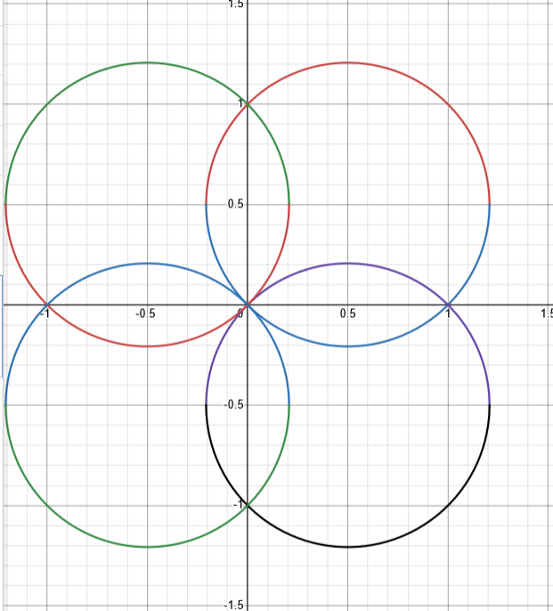

We have 4 circles with the same radius: sqrt(0.5), overlapping in 8 areas, thus the total area is:  
  
(5) ***Stotal  = 4 * 𝝅 * 0.5 - 8 * Ssingle_overlap***

We can easily find Ssingle_overlap , based on the following observation:  
  
(6) ***Scircle = 1 + 4 * Ssingle_overlap***

Indeed, each circle is filled completely by a square with side 1, surrounded by 4 of the “single_overlap” pieces.

(7) ***Scircle  = 𝝅 * sqrt(0.5) = 0.5 * 𝝅***

Thus

(8) ***Ssingle_overlap = 0.25 * (Scircle - 1)***

Finally, substituting (8) into (5) we get:

***Stotal  = 4 * 𝝅 * 0.5 - 8 * 0.25 * (0.5 𝝅 - 1) = 2 * 𝝅 - 2* 0.5 * 𝝅 + 2 = 𝝅 + 2***

Or, as calculated by Desmos:

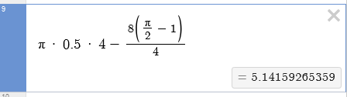  
  
The wanted answer is: ***𝝅 + 2***