Bioinformatics, BSC 4434C/6932, Midterm 2 Name: ____Devin Quigley________
Take-home practical

Write your name at the top right of this page.

This midterm is out of 100 points. 80 of those points were from the in-class exam sheet that you already completed. The remaining 20 are from this take-home, open-book practical exam distributed on Canvas that is due on Thursday, 9 April, at 5:00 pm.

This practical is largely based on coding in R and/or bash, so will be similar to the labs that you have completed. As Bioinformaticians, we often re-use code, and you are welcome to do so here. I recognize that much of the code will be identical to both that of your classmates and to the code you’ve already written. That is fine. For every few lines of code that work together to complete a similar task, you must write a comment line describing what your code is doing. This must be your own work. See the answer key to Lab 3 as an example. The “#” at the start of a line of code makes it a comment line in both R and bash.

A note on the use of AI for this assignment: I have intentionally had you not use AI until Lab 10. That was done so that you can work on building your coding skills and the basics of how to interpret code that I wrote. You cannot judge the accuracy of code written by an AI generator unless you also know the syntax of the language. However, I recognize that AI code writing is the future, and you should all be comfortable coding in both R and bash at this point. Therefore, you have two options to complete the coding-based portions of this practical. You may either A) complete all the coding below on your own, or B) complete the coding sections only using the AI code generator of your choice. If you choose option B, you must tell the code generator to not include any text comments in the code (lines including a # symbol). You will then need to add those comment lines on your own that tell me what each line of code does and why the output does or does not make sense. Submit in Canvas both the AI-generated code file and your version with comment lines added. For option B, all writing the answers to the questions in this handout will still need to be answered without the use of AI.

Type A or B here to select the option that you will use for this assignment: _B__

You are welcome to work together on this practical. However, the work that you submit must be your own. Submitting identical work will be considered plagiarism and you will receive zero points for this part of the exam.

Push all your scripts and results plots to your Bioinformatics GitHub page. At the end of this document there is space for you to add a link to your GitHub page for this assignment. Make sure that the GitHub repository is public (otherwise I can’t access it).

To make a GitHub repository public, go to your repository on the website, click ‘settings’, scroll to the bottom under ‘Danger Zone’ and click ‘Change visibility’, then ‘change to public’. There will be a few more steps to verify that you want to make this change.

On Canvas: submit only this document

The questions in this practical are on the following page. Answer the questions in this document, not in your code.
Take Home practical questions:

Per the previous page, the code to complete these tasks must be written in a script. You may write an R script, a bash script, or both. The answers to the questions must be written below each question, in this document. Submit this document to Canvas.

Your research lab is conducting a project on the phylogenetics and protein function in metazoans. There is a file on Canvas containing a DNA alignment from your sequencing efforts called metazoa_alignment.5k.fasta that you will use to answer questions 1-5, and another called metazoa_alignment.gene.fasta that you will use for questions 6-10.
Download both files to your working directory. Work through the questions below. Please use a different text color than black so that it is easier for me to read and grade.

Ten points come from questions 1-5, and the other ten from questions 6-10.

- The data in your alignment are from an mRNA sequencing project. The mRNAs were converted to cDNA for sequencing using next-generation Illumina technology. After assembly, the cDNAs contigs were concatenated and aligned. Estimate the phylogenetic tree from this alignment. Use the phylogenetic tree tool that is most appropriate given the dataset that you have been provided. Add a comment describing why you chose this phylogenetic software. Note: you must provide the script commands used to estimate the phylogenetic tree (e.g., a bash command for RAxML or the .xml file if using BEAST). Provide the .log files as well.
Next generation sequencing produces a lot of data, making it computationally expensive. Maximum likelihood trees are generally preferred for very large, concatenated datasets due to its computational speed and accuracy.

- Root the tree on the branch leading to Plakina jani and Grantia compressa.

- Find a way to measure how “good” your tree is. Is this a good tree or a bad one? How can you tell? Are there some parts of the tree that are better than others?
The quality of the tree appears “good” in many regions as indicated by a majority of high bootstrap values >70-90%. However, some branches have low values <50-70% which indicate that these relationships are unreliable and should not be considered in interpretations. Overall, the tree quality is generally good, with weaker regions where more analysis may be needed.

- There are six groups of taxa in your tree (Lophotrochozoa, Ecdysozoa, Xenambulacraria, Chordata, Cnidaria, and Porifera). Does your tree support the monophyly of these clades? What evidence supports or does not support your conclusion?
The tree supports the monophyly of Porifera, Cnidaria, and Chordata. However, Xenambulacraria, Ecdysozoa, and Lophotrochozoa do not support that conclusion. In Xenambulacraria, Xenoturbella bocki is separated from the other taxa, so the group is not considered a single clade. In Ecdysozoa, most species are clustered together, but Priapulus sp. and Parhyale sp. branch off separately, not supporting the group as monophyletic. Due to the low bootstrap values, placements of Priapulus sp. and Parhyale sp. are uncertain and re-running the tree may change its placement. In Lophotrochozoa, Macrostomum lignano is separate from its taxa group which also does not support the monophyly conclusion.

Porifera (Grantia compressa and Plakina jani)
Cnidaria (Plumapathes pennacea and Antipathes caribbeana)
Chordata (Lepisosteus oculatus, Homo sapiens, Xenopus tropicalis, Latimeria chalumnae, and Petromyzon marinus)
Xenambulacraria (Xenoturbella bocki, Strongylocentrotus purpuratus, Rhabdopleura sp., and Ptychodera flava)
Ecdysozoa (Tribolium castaneum, Strigamia maritima, Parhyale sp., Priapulus sp.)
Lophotrochozoa (Golfingia vulgaris, Cerebratulus sp., Leptochiton rugatus, Novocrania anomala, and Macrostomum lignano)

- Plot your rooted tree in the tree visualizer of your choice (I recommend FigTree or one of these R packages: ape, ggtree, treeio, tidytree), and export a pdf or similar file (e.g., png, jpeg). Include this file in your submission.
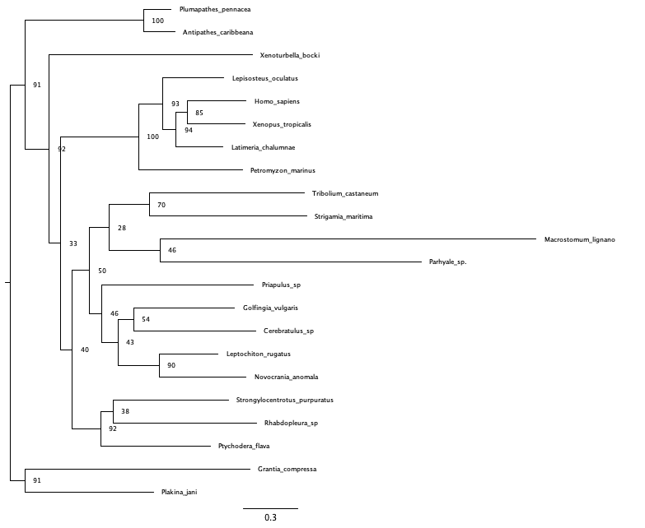

- Next, you will investigate protein function. You have been provided the data from one of the mRNAs. Your goal is to investigate the function of the protein. Use the metazoa_alignment.gene.fasta file for questions 6-10.

- Look at the samples in your alignment. What biological/genetic process might have resulted in some samples having so many dashes in the alignment? What evidence led you to that conclusion?
Dashes in a FASTA file indicate gaps inserted to increase the homology between sequences during the alignment process. Dashes can indicate insertions/deletions that occur over time and gene duplication or loss. Evidence for this includes regions where some sequences have nucleotides while others have gaps.
- Load your file into R. Find the gene from Homo sapiens in your alignment. Translate that sequence to protein. Write it to a .fasta file.

- Use a database to figure out what your protein is. Click on the record for the best match. What is the name of the gene?
DNA polymerase subunit gamma-1 [Homo sapiens]
e-value: 0.0 percent identity: 99.68%

- Locate the closest match to your sample in the UniProt database. Find the UniProt accession number. Using an R script, find the GO sub-ontologies for this gene. List at least one term from each of the three sub-ontologies. Plot the GO info and provide the plot in your submission.
P54098

#GO Term results:
uniprotswissprot go_id namespace_1003
1 P54098 GO:0003677 molecular_function
2 P54098 GO:0003887 molecular_function
3 P54098 GO:0006260 biological_process
4 P54098 GO:0005760 cellular_component
5 P54098 GO:0006264 biological_process
6 P54098 GO:0016787 molecular_function
name_1006
1 DNA binding
2 DNA-directed DNA polymerase activity
3 DNA replication
4 gamma DNA polymerase complex
5 mitochondrial DNA replication
6 hydrolase activity

#Select one term from each sub-ontology:
uniprotswissprot go_id namespace_1003
1 P54098 GO:0003677 molecular_function
3 P54098 GO:0006260 biological_process
4 P54098 GO:0005760 cellular_component
name_1006
1 DNA binding
3 DNA replication
4 gamma DNA polymerase complex
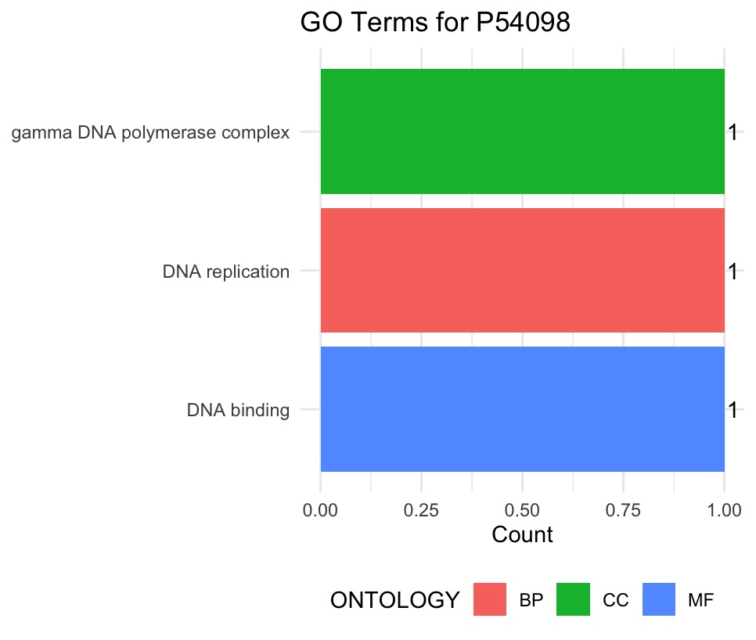

- Upload to GitHub all your scripts (R and/or bash), and two figures (tree and GO info). There is no need to upload the alignment files if you don’t want to.

In the space below, add a link to your GitHub repository containing your code and figures:
https://github.com/dnquigley/Bioinformatics-/tree/main/Midterm2

