Lab 11, Phylogenetics

Goals: To estimate fast ML and Bayesian phylogenies from large datasets using concatenated alignments. Alternatively, to estimate a Bayesian phylogeny from a smaller dataset using a partitioned mitochondrial alignment.

What you will learn:
- Working with the phylogenetic programs RAxML, MrBayes, and BEAST2
- Working with alignment datasets
- Determining the accuracy of a phylogenetic tree
- Visualizing phylogenetic trees

Links to relevant tutorials / data

- The RAxML-NG ReadMe:
https://github.com/amkozlov/raxml-ng/blob/master/README.md

- BEAST2 tutorial: https://taming-the-beast.org/tutorials/Introduction-to-BEAST2/

- The MrBayes website: https://nbisweden.github.io/MrBayes/download.html and GitHub page: https://github.com/NBISweden/MrBayes

Operating system

Mac, Linux, or PC (although you will need to install RAxML-NG on the WSL if you have a PC, and it may not work well). Alternatively, you can run RAxML-NG scripts on the CIPRES science gateway servers (https://www.phylo.org/). BEAST is a standalone program that should work well on any system but is more complex to set up an analysis. MrBayes should work on any system, if installed with Homebrew.

Background

This lab involves installing and running RAxML-NG, MrBayes, or BEAST2.

RAxML-NG is a phylogeny inference program that uses maximum-likelihood (ML) as an optimality criterion. It is one of the fastest ML/Bayesian (versus distance or parsimony) methods out there, making it the preferred choice for very large datasets. It can be used for tree estimation, bootstrapping to assess support for a tree topology, evaluating the likelihood of alternative models of substitution, etc.

MrBayes is a program for Bayesian inference, so uses posterior distributions of model parameters as its optimality criteria. MrBayes provides a flexible framework that can conduct all sorts of analyses, but we will only use it for tree estimation.

BEAST2 is also a program for Bayesian tree inference, especially for partitioned alignments. It provides lots of flexibility in assignment of priors, especially for divergence time estimation (e.g. using molecular clock assumptions), but as such it is useful only for smaller datasets of just a handful of loci.

I am providing three msa datasets to choose from. The primate.phy is 13,472 base pairs from 12 species of primates and should run quickly on MrBayes or RAxML. The primate-mtDNA.nex file is 898 base pairs of three mitochondrial genes.

Steps

- Preparing the input files

- Download the data from Canvas (under Phylogenetics lab assignment). These are alignments in Nexus format (.nex) or Phylip format (.phy), which are similar to the .fasta format that we’ve been working with, but work well with alignment datasets.

- Choose phylip format for RAxML-NG, Nexus format for MrBayes, and the mtDNA alignment for BEAST2. I suggest using a different folder for each phylogenetics software that you’re running.

- [Optional: upload your alignment to the Cipres Science Gateway (https://www.phylo.org/) and run it on the jModelTest to estimate the best model of sequence evolution to use for your alignment. You will need to make an account, but it’s free. Then upload your msa to a new data folder, and run an analysis, selecting jModelTest as the tool to use.]

- RAxML-NG

- If you haven’t already, download RAxML-NG from https://github.com/amkozlov/raxml-ng. Unzip and move the unzipped folder containing the binary to an appropriate location. You can then call the binary in terminal using ./raxml-ng from within the containing folder, by specifying the full path from wherever you are (e.g., “/Applications/raxml-ng_v1.1.0_macos_x86_64/raxml-ng”), or by adding the location to your PATH.

- Perform a “single tree inference on DNA alignment” (estimate a tree) using RAxML-NG, following the instructions in the Readme.

Note: If using the Epinecrophylla alignment, this will take at least several hours to run and uses quite a bit of RAM. I recommend testing it quickly in class and then starting it sometime when you aren’t going to need your computer (e.g., at night before you go to bed) so you can leave it running. If the default single tree inference analysis is impractical on your machine, either find a different computer/cluster to run it on, or reduce the number of tree searches performed. By default, RAxML-NG conducts searches on 20 starting trees (10 random, 10 parsimony). You can reduce this using the –tree flag as follows:

--tree pars{N},rand{M}

Where N and M are the number of searches to run on parsimony and random trees, respectively. Reduce these from the default 10 as needed (although keep in mind you may end up with a poor tree if you do too few searches).

- View your tree! It can be viewed in the free GUI program FigTree (http://tree.bio.ed.ac.uk/software/figtree/), as well as in R using various R packages. Note that FigTree requires a jdk (java development kit): https://www.oracle.com/java/technologies/downloads/. Note: Your tree will look nicer once you re-root it on the outgroup. Find the lemur sample (or the branch leading to the lemur and tarsier) and click “Reroot” in FigTree.

- [Optional: If you completed step 5 and have time, you may want to complete a bootstrap analysis to evaluate support for your best tree (particularly if you are using your own dataset). To do this, try using the instructions in the Readme (steps 2-4). Alternatively, rather than re-estimate the tree, you can use the existing tree from step 6 using the –support flag.]

- MrBayes

- If you haven’t already, install MrBayes. A pre-compiled version is available for Windows on the Installation page of the MrBayes website. If you are on a Mac, the instructions at https://github.com/NBISweden/MrBayes worked for me. Here is the MrBayes manual: https://github.com/NBISweden/MrBayes/blob/develop/doc/manual/Manual_MrBayes_v3.2.pdf

- Navigate to your working folder (the one containing the Nexus alignment output in step 4). Start MrBayes. The default install location of MrBayes is generally “/usr/local/bin/”, so try typing:

/usr/local/bin/mb

- Load the data:

execute primate.nexus

- Set the evolutionary model to GTR with gamma-distributed rate variation and a proportion of invariable sites:

lset nst=6 rates=invgamma

- Start the MCMC:

mcmc ngen=20000 samplefreq=100 printfreq=100 diagnfreq=1000

- After the 20,000 generations specified above, you will be prompted to decide if you want to continue the analysis. Typically, you would want to continue it if the value of “standard deviation of split frequencies” printed to the screen is above 0.01. We will probably be able to reach that benchmark in a reasonable amount of time with this dataset, but if not, it is okay to stop the analysis after 20,000 generations for the purposes of this assignment.

- Once the analysis is stopped, summarize the posterior distribution of parameter values including substitution model parameters and ESS (effective sample size) values. You typically want average ESS values >100 for a publishable analysis.

sump

- [Optional: View traces of the posterior parameter distributions (these should end in “.p”) using the program Tracer (http://tree.bio.ed.ac.uk/software/tracer/). We will use this program more in the next week or two with the BEAST analysis, but could be fun to get a sneak preview with this first Bayesian analysis.]

- Summarize the posterior distribution of trees (this is printed to a file ending in :

sumt

- The file produced by the above step includes posterior probability for each node in the tree. As with the RAxML tree, it can be viewed in FigTree or R (see above). It may still be quite unresolved after a short MCMC!

- BEAST2

- If you haven’t already, install BEAST2: https://www.beast2.org/ This should be as easy as clicking on the appropriate file for your operating system and adding it to your Applications folder.

- Follow the instructions in the Introduction to BEAST2 tutorial using the primate-mtDNA.nex alignment file: https://taming-the-beast.org/tutorials/Introduction-to-BEAST2/.

Products

  - One ML or one Bayesian tree from concatenated alignments, or one Bayesian tree from partitioned alignments, each with 12 tips representing some primate species, including an outgroup. The Bayesian trees might be unresolved (too short an analysis), but the ML tree should be decent.

  - Export a .pdf / .png / .jpg file of your tree to your Bioinformatics folder and push your data to GitHub.

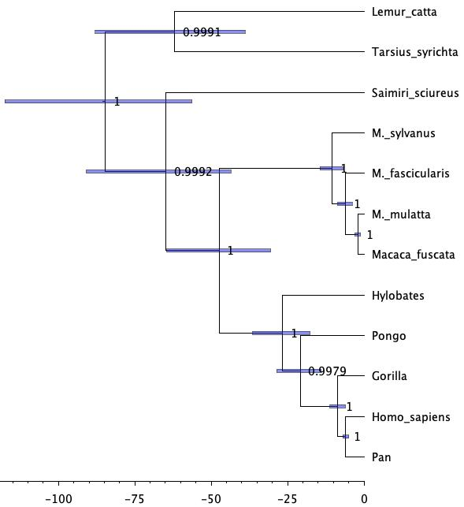

  - Write a short Methods and Results text based on the program that you used (RAxML-NG, MrBayes, or BEAST2). Outline 1) what you did, 2) what you found, and 3) why you think it is interesting/relevant. This should be three paragraphs (one for each of the three topics):

What I did:
Using the program BEAST2, I created a Bayesian phylogenetic tree using a partitioned mitochondrial alignment of primates. This dataset was imported into BEAUti, where I made sure that all four partitions (noncoding, 1st position, 2nd position, and 3rd positon) shared the same evolutionary history. I did so by linking the trees as well as the clock models. The HKY model was selected because it accounts for different base frequencies and distinct rates for transitions vs transversions. This model is often considered more flexible and complex than JC and K2P models. I used a random local clock instead of the recommended strict clock in the instructions in order to accommodate rate variations across branches. Priors were determined to allow prior distributions to be specified for each of the model parameters. The Calibrated Yule Model was specified as the tree prior as it is a simple model of speciation generally used for sequences from different species. Homo_sapiens and Pan were added as additional priors to allow BEAST2 to calibrate the tree in time. MCMC analysis was performed to estimate posterior distributions of tree topologies and parameters. The .xml file created from BEAUti was input into BEAST2 to run the analysis. The results from BEAST2 are then uploaded into Tracer which provides summary statistics including traces for the posterior, prior, likelihood, tree likelihoods, and other parameters. This program allows us to specify the Burn-In value used to give the Markov Chain time to reach equilibrium distribution if the starting point is bad. After running the files, I realized that many of the ESS values were too low (<100), so I went back to the BEAUti file to readjust the MCMC chain length parameter to 10,000,000 which provides more data points to calculate posterior distribution and increases ESS values. Finally, the MCC phylogenetic tree was generated with TreeAnnotator and visualized with FigTree.

What I found:
A Bayesian phylogenetic tree was formed representing the relationships among 12 primate species. Lemur_catta and Tarsius_syrinchta at the top of the tree (shown above) represent the outgroup which diverged earlier than the other primates listed on the tree. Saimiri_sciureus branches off next below the outgroup and separate from the clade below. At the bottom of the tree is the clade of apes. This shows Hylobates splitting first, then the Pongo, Gorilla, and finally Homo_sapiens and Pan. Homo_sapiens and Pan are most closely related to each other as they are sister taxa. The horizontal values indicate posterior probability which gives the Bayesian probability that tree topology or branches are correct given the data, model, and priors. In BEAST2, the MCMC method is employed which samples trees, and higher probability trees are visited most frequently. The confidence values range from 0 to 1, 1 indicating strong confidence, and values less than 0.5 indicating weak confidence. All posterior probability values are strong on the tree shown above.

Why it’s relevant:
This analysis is important because it shows how Bayesian phylogenetics can determine and visualize evolutionary relationships and divergence using genetic data. Phylogenetic trees can show estimates of time or amount of genetic change, it shows how closely related species are to each other, they can classify new species, and trace evolution over time. Mitochondrial DNA is useful for indicating relationships because it evolves quickly and is inherited without recombination. This allows us to more accurately track genetic changes over time.

