Estimations of Loads and Sources of Phosphorus and Sediment at Ungaged Sites in the Wisconsin River Basin:
Preliminary Notes on SWAT Model Configuration
Wisconsin Department of Natural Resources

Abbreviations
ArcSWAT |  |  | ArcGIS plug-in software for SWAT configuration
CDL |  |  | Cropland Data Layer
DEM |  |  | Digital Elevation Model
EPA |  |  | Environmental Protection Agency
EVAAL |  |  | Erosion Vulnerability Assessment for Agricultural Lands
HRU |  |  | Hydrologic Response Unit
HSG |  |  | Hydrologic Soil Group
MS4 |  |  | Municipal Separate Storm Sewer System
NASS |  |  | National Agricultural Statistics Service
NCDC |  |  | National Climate Data Center
NED |  |  | National Elevation Dataset
NHDPlus |  |  | National Hydrography Dataset Plus
NLCD |  |  | National Land Cover Dataset
NRCS |  |  | Natural Resources Conservation Service
NWIS |  |  | National Water Information System
OSD |  |  | Official Series Description
(g)SSURGO |  |  | (gridded) Soil Survey Geographic
SWAT |  |  | Soil Water Assessment Tool
TMDL |  |  | Total Maximum Daily Load
TSS |  |  | Total Suspended Solids
TP |  |  | Total Phosphorus
USDA |  |  | United States Department of Agriculture
USGS |  |  | United States Geological Survey
USLE |  |  | Universal Soil Loss Equation
WBD |  |  | Watershed Boundary Dataset
WDNR |  |  | Wisconsin Department of Natural Resources
WHDPlus |  |  | Wisconsin Hydrography Dataset Plus
WRB |  |  | Wisconsin River Basin
WVIC |  |  | Wisconsin Valley Improvement Company
WWI |  |  | Wisconsin Wetland Inventory

Introduction
This document is intended to describe the configuration of the Soil and Watershed Assessment Model (SWAT) for the estimation of streamflow and sources of sediment and phosphorus in the Wisconsin River basin. It is a technical document that presumes the reader has a high level of familiarity with SWAT and the Wisconsin River Basin (WRB) Total Maximum Daily Load (TMDL). In fact, it is written specifically to water quality modelers to invite a critical review and ensure the quality of the resulting estimations. The document was written after the model was configured, but before it has been calibrated. Therefore, the methods described here may change prior to the release of the final model given new developments during the calibration phase of the project. The model itself is available for download at the following URL:
ftp://dnrftp01.wi.gov/geodata/wrb_swat/
Due to the large amount of data required to configure The Wisconsin River SWAT model, the products and data described in this document were created using a series of data processing scripts that can be executed using either the Python or R programming languages. These scripts are described in Section [sec:model_{d}ata]. To the extent possible, these scripts have been written in a way that makes the data processing transparent and reproducible. However, because the model is not complete in configuration or documentation, in some cases the scripts are not annotated to assist in interpretation. Therefore, the reader needs to have a strong understanding of computer programming, Python and R syntax, statistics, and processing of spatial data in order to completely understand these scripts. These scripts are publicly available on the website GitHub owned by the username dnrwaterqualitymodeling. These scripts can be viewed and downloaded across the history of their development. However, it must be noted that the original datasets used in the processing are not available with the scripts due to limitations in data storage and transfer.
The basic model configuration is described in Section [sec:basic_{m}odel_{c}onfig]. This section describes the methods and procedures used in setting up the necessary data for a SWAT project. The ArcSWAT program was used to create the Wisconsin River SWAT project; this program facilitated many of the tasks necessary for the creation of a working SWAT model. These steps included the overlay of the land use, soils and slope layers to create the hydrologic response units (HRUs), and the creation of the input files needed to run SWAT. The items described in Section [sec:basic_{m}odel_{c}onfig] describe decisions made within ArcSWAT regarding configuration as well as additional data processing and configuration steps that were taken before inputting the data into ArcSWAT. These steps include
- climate data processing (Section [sec:climate_{d}ata])
- SWAT subbasin delineation (Section [sec:sub_{d}elineation])
- HRU definition (Section [sec:hru_{d}efinition]), and the components of the HRU definition:
  - land cover data specification (Section [sec:land_{c}over])
  - soil data aggregation (Section [sec:soils])
  - slope classification (Section [sec:slope])
The Wisconsin Department of Natural Resources SWAT project team has developed and configured datasets additional to those necessary to create and run a SWAT model. These additional datasets were created for several different and overlapping reasons, as listed below.
- The WRB drains an area of 23,713 km$^2$ and has significant variation in soils, geologic history, vegetation, and land use. To create the most accurate model possible, we tried to tailor parameters to local conditions (a process known as regionalization). Thus additional datasets were created to describe regionally specific physical and chemical processes (Sections [sec:ag_{l}and_{m}gt], [sec:soil_{p}hosphorus], [sec:gwp], and [sec:baseflow]).
- The WRB TMDL is a large modeling effort and contains several other modeling components and we adjusted and accommodated the SWAT project to other aspects of the WRB TMDL modeling process (Section [sec:urban]).
- The calibration phase is a the process of the project whereby parameters are adjusted so that simulated variables match observed variables as best as possible. This phase is not completely distinct from the calibration phase; input data will likely be revised once more is known from the calibration process and during the configuration process we started the calibration phase by processing observed data (Sections [sec:reservoirs] and [sec:streamflow_{c}alibration_{s}ites]).
- Some model parameters were set during the configuration phase of the model development; this was done for reasons already mentioned and to save time during the calibration phase. These set parameters may be adjusted during the calibration process, but the estimates set during the configuration phase likely represent better starting points than the default values of the parameters (Sections [sec:reservoirs], [sec:streamflow_{c}alibration_{s}ites],[sec:et_{m}ethods], [sec:baseflow], and [sec:gwp]).
It must be noted that the SWAT modeling component of the WRB TMDL remains a work in progress and the methods and data described and distributed at this stage may change at a future data because of issues and concerns that may develop during the calibration phase.

Model Data Files
[sec:model_{d}ata] The Wisconsin River Basin (WRB) SWAT model distributed for review contains all the files necessary to run the model. The ArcSWAT program was used to set up the SWAT project and so the file structure was determined by ArcSWAT.
Much of the model configuration was done with the R statistical package (files with a .r extension) and the Python scripting language (files ending with .py). These scripts can be found on the GitHub website and the WDNR water quality modeling team’s page. Below is a brief description of the contents of each code folder and how the scripts inside were used. Included are references and links to sections for further description of methods. The titles of each folder are listed here as they appear on the GitHub site.
- climate: contains scripts pertaining to data processing for air temperature, precipitation, relative humidity, solar radiation, and a nearest neighbor algorithm for filling in missing data (see Section [sec:climate])
- DEM: scripts for processing the WRB elevation data from the National Elevation Dataset (NED)
- LandManagement: the script correlateCdlAndDatcpDairy.R is for validating the predictions of the generalized rotation algorithm and GeneralizeMergeLandManagementLandCover.R is for creating a map of the land management types of the WRB (see Section [sec:ag_{l}and_{m}gt])
- et: the scripts contained in the folder pertain to investigating the proper equation for modeling evapotranspiration in the WRB (see Section [sec:et_{m}ethods])
- groundWater: the script baseflow_phosphorus.R contains the processing for estimating the amount of phosphorus from groundwater and the scripts in the baseFlow folder contain the files for carrying out the processing and modeling for estimating baseflow contribution to streams (see Section [sec:gwp] and [sec:baseflow])
- hydrology: calculateRunoffUsingBaseflowSeparation.R is a script for developing basin-wide water balance estimates and formatting the outflows from the basin reservoirs
- landCover: the script mergeWwiWithNass2011.py was used to reclassify and rasterize the Wisconsin Wetlands Inventory (WWI) into two classes: woody wetlands and herbaceous wetlands. The script mergeCdlWithWetlandsCrpCranberries.py merged the 2011 Cropland Data Layer (CDL) with the rasterized wetlands, a layer of CRP attributed field boundaries within the 2007 Common Land Unit dataset, and a layer of cranberry bogs developed by the Wisconsin DNR (see Section [sec:land_{c}over])
- ponds: these scripts were used in the processing and modeling to derive pond parameters for SWAT (see Section [sec:ponds])
- soils: these scripts determine which hydrologic soil group (HSG) to assign to dual HSG map units, aggregate SSURGO data, and process the soil phosphorus data (see Section [sec:soils])
- updateParameters: the script in this folder is used to update the ArcSWAT database with specific data derived in many of the scripts in these folders; they include:
  - Management operations
    - Crop rotations
    - Plant harvest schedule
    - Fertilizer type/amount/schedule
    - Tillage type and schedule
  - Groundwater
    - Baseflow contributions
    - Baseflow phosphorus concentrations
  - Reservoirs, physical properties and daily outflow
  - Internally draining areas (i.e., SWAT wetlands and Ponds)
  - Soil phosphorus concentrations
- watershedAggregation: scripts for aggregating the Wisconsin Hydrography Dataset (WHDPlus) watersheds up to the SWAT subbasins (see Section [sec:sub_{d}elineation])
- wetlands: script for calculating wetland parameters (see Section [sec:wetlands])

Model Configuration
[sec:basic_{m}odel_{c}onfig] The section details the configuration and data processing steps necessary for a working SWAT project.

Climate and Weather Data
[sec:climate_{d}ata]
Daily weather and climate data used in the SWAT model were downloaded from the National Climate Data Center (NCDC) - Global Historic Climate Data Network website. Weather data include precipitation and temperature. Data sets from 120 different stations were downloaded, from which precipitation data was taken from 74 stations, and temperature from 46. Climate data included solar radiation, wind speed, and relative humidity.
Not all stations had complete data records covering the entire timeframe being modeled. For time periods missing precipitation or temperature data, the record was supplemented with data from the nearest weather station that did have data for that time period, see Figure [fig:climate_{m}issing] for locations of precipitation and temperature stations and the number of missing days for each station. For time periods missing data at all stations, weather data was generated automatically by SWAT’s internal weather generator. SWAT’s weather generator was was used for all missing solar radiation, wind speed, and relative humidity records.

Subbasin Delineation
[sec:sub_{d}elineation] To estimate sources of pollutants in a river in SWAT, it was first necessary is to delineate subbasins. The size of each subbasin is critical to water quality improvement following model development—they should be small enough that water quality improvement plans can address specific pollutant sources, while large enough that model results appropriately match the scale of model inputs and calibration data. Ultimately, the size of each subbasin depends on what the project is intending to achieve by simulating water quality, and therefore requires communication with water quality policy staff and watershed planners.
The Wisconsin River is a relatively large area for a TMDL project. Consequently, much of the point and non-point load-reduction efforts will occur as nested projects within the overall TMDL framework. Each subbasin was scaled to a size that watershed managers and stakeholder groups can realistically account for and assess downstream improvements in water quality related to implementation of upstream best management practices.
In addition to the above guidelines, hydrologic and regulatory transitions were used to guide placement of subbasin transitions. TMDL subbasins were delineated:
- to address specific water quality impairments where local water quality does not meet codified standards; this is an EPA mandate for de-listing of water quality impairments. Consideration was given to streams that were estimated to be impaired, but where monitoring data do not exist to prove it.
- near point source outfalls; delineations were not required to be at precisely the location of the outfall, but rather close enough that flow could be accurately estimated by proportionally scaling modeled flow by upstream contributing area.
- at locations where water quantity and quality were measured during the model period for use in model calibration.
- at major transitions of water quality standards, for instance at river impoundments that receive lake criteria.
- at major hydrologic transitions such as the confluence of two large streams or where there are significant changes in landuse/landcover.
After the locations of subbasin outfalls were identified, we delineated the contributing area upstream of each. ArcSWAT will automatically delineate model subbasins, but because of our specific reasons for creating subbasins outlined above, we manually created the SWAT subbasins by aggregating the WHDPlus dataset. We delineated 338 subbasins with an average size of 68 km$^2$ (σ = 80 km$^2$) where larger subbasins were located in areas with fewer water quality impairments and points sources.

Land Cover
[sec:land_{c}over] The composite land cover developed for the SWAT model input began with the United States Department of Agriculture (USDA) National Agricultural Statistics Service (NASS) 2011 Cropland Data Layer (CDL) for Wisconsin . The layer, originally created to provide agricultural information for the major crops to the USDA Agricultural Statistics Boards, provides a raster-based, geo-referenced data layer that defines growing-season land cover at a cell resolution of 30 x 30m for Wisconsin using satellite imagery from a variety of satellites . For non-agricultural land cover, the CDL relies on the United States Geological Survey (USGS) National Land Cover Database (NLCD) 2006. The 2011 USDA NASS CDL was selected because that year had improved accuracy statistics when compared to other years, and there were no flooding or drought events within the growing season. To improve the landcover definition, Wisconsin Wetlands Inventory (WWI) information was integrated into the 2011 CDL. The WWI coverage provides the geographic extent of wetlands that have been digitized from aerial photography, verified through photo interpretation, and compared against soil surveys, topographic maps, and previous wetland inventories .

Soil Data Aggregation
[sec:soils]
Soils are a critical part of the SWAT modeling framework; they determine many surface hydraulic properties such as texture, hydraulic conductivity, and available water capacity. We used the county-scale Soil Survey Geographical Database (SSURGO) . For more information about SSURGO
data see the SSURGO metadata. The SSURGO database is structured in three levels of information: map units, components, and horizons (Figure [fig:ssurgo_{s}chematic]). Horizons are the fundamental unit of soil in SSURGO, and are therefore where the majority of soil information is stored in the database. Components are aggregations of horizons that represent a full soil profile, typically conforming to the Official Series Description (OSD). Map units are discrete polygons drawn on a map (originally mapped at scales from 1:12,000 to 1:63,360) that contain one or more components that are stored non-spatially in the database—that is, only a list of components and their percent composition of the map unit is given.
We chose to use the gSSURGO distribution of SSURGO. gSSURGO is a form of the SSURGO database that is packaged in a more convenient form for coarse scale projects such as the WRB TMDL. The tabular data representing the components and horizons were joined together so that each component had the data required for the SWAT model (Table [table:soil_{a}ttr_{i}n_{s}wat]). For all these properties, the representative value given by SSURGO was used. For more information about these parameters see the SSURGO metadata.
HRU definition in a SWAT model is a balance of incorporating the most important pieces of information without overloading it with redundant or insignificant information—a modeler should represent every process that controls the system, however an overloaded model requires more computational resources, which may not be feasible to acquire. To reduce the number of HRUs in the model and generally create a simpler model, we aggregated soils together based on similarity of several key properties that impact the hydrologic cycle. This was a two step process: first, components within map units were aggregated together, and second, map units were aggregated together based on similarity (Figure [fig:agg_{f}low_{d}iagram]).
Several changes were made to the dataset before aggregation, in order to facilitate processing. Soil organic carbon content is required by SWAT, but is given by SSURGO as soil organic matter. The percent organic matter value given in SSURGO was converted to percent organic carbon by multiplying by 50% which is the generally accepted average carbon content of soil organic matter . The HSG is denoted as a letter in SSURGO, either A through D, or if the soil has different characteristics when drained, as two letters, A/D, B/D or C/D, the latter of which is the natural state of the soil if not artificially drained (i.e., through tiling or ditching) while the former is if the soil is drained. In order to average the different components it was necessary to convert these letters into numbers; groups A through D were converted to 1 through 4 to correspond with increasingly wetter drainage conditions. Once a number was obtained for the HSG, it was treated as any other soil property in the aggregation process, then rounded to the nearest integer, and converted in the same manner to a letter once the aggregation was finished. For those components with dual HSGs, we assumed that if half of the area in the map unit was agriculture it was drained and the first HSG taken. Conversely, if the land use was not majority agriculture then it was assumed to not be drained and the “D” designation was chosen.
The first aggregation step was to aggregate components by map unit to conform to the SWAT soils data structure. The data structure for soils in SWAT does not directly conform to SSURGO data structure, mainly that there is no analogue to the SSURGO component level in SWAT—in other words, soils in SWAT cannot be subdivided (Figure [fig:component_{s}chematic]). We aggregated components by computing component-weighted averages of each soil property for any given depth of soil from the soil surface to the average depth . These averages were computed using the slab function in the aqp package in R . We used this algorithm to apply a depth weighted average to each horizon, while also weighting the percent composition of each component. The depth and number of horizons of the aggregated soil profile produced by this algorithm must be specified before processing. The depth was calculated as a weighted mean of the full depths of soil profile in each of the components, with the weights equal to the percent composition of each component. As the number of horizons was not seen to matter as much as the maximum depth, an arbitrary number of five horizons was chosen for the aggregation algorithm.
Using the above aggregation method 48,585 individual soil components were aggregated to 1,603 map units. Because the HRU used in SWAT is derived using unique combinations of land use, slope and soil types, this number of soil map units is still too many for efficient computation and so the second step of the soils data configuration was necessary to further reduce the number of soil types.
Other researchers have aggregated soil types by their taxonomic class but Soil Taxonomy, the soil classification system of the US, primarily classifies based on soil morphology and not necessarily on properties relevant to SWAT. We decided that the most relevant soils information to SWAT is hydrology data, specifically the HSG, which has a large impact on the soil curve number. With this consideration, aggregation was based around (and so preserved) the HSG of the map unit. Groups of the same HSG were divided into smaller groups (hereafter known as clusters) of homogeneous soil properties. The map units within each of these clusters were then averaged together to create an average profile for that homogeneous set of soils. These averages were then used as the soil types for the HRU definitions and the SWAT modeling.
To begin, each map unit (each of which is an aggregation of components, as described above) was placed into one of four groups according to its hydrologic soil group, A, B, C or D. To subdivide these groups further, a clustering algorithm was used to objectively create clusters of map units with homogeneous soil properties. For this purpose, we used Gaussian mixture models to assign map units to clusters. The mixture model approach we used was implemented within the Mclust function in the mclust package in R . A mixture model is a probabilistic model for representing the presence of subpopulations within an overall population. In our case, the overall population would be the group of map units of similar hydrologic soil groups (i.e., all map units with an HSG of A), while the (unknown) subpopulations are the clusters of map units with similar distributions of soil properties (such as a clusters of sandier soils, shallow soils, or slow saturated conductivity). Using the default settings of the function, we clustered all of the A HSG map units into 6 clusters, B HSG map units had 8 clusters, and C and D both had 9 clusters.
In order to use the clustering function we had to put our data in a format in which it could be used by the Mclust function. We calculated horizon depth-weighted averages of each soil property for each map unit, essentially collapsing the soil profile down to one aggregate horizon with average properties. Profile depth was still considered in the clustering algorithm using the total depth of the profile.
After each map unit had been assigned to a cluster, the map units within each cluster were aggregated together to form a composite or average soil profile. The same soil profile aggregation algorithm used to aggregate several components together in the first step was used to combine the soil profiles of a cluster into one composite soil profile. In this implementation, each map unit was given equal weight in the aggregation algorithm.
Not every map unit was included in the clustering procedure. Several of the soil property fields of the SSURGO dataset were not populated or commonly had “no data” values, these properties were not used in the clustering process so the spurious zeros would not influence the algorithm (Table [table:soil_{a}ttr_{i}n_{s}wat]). These properties were coarse fragments, calcium carbonate, and electrical conductivity. Albedo and pH were also excluded from the clustering algorithm. Mapunits that had no HSG designation were not included, nor were map units that did not have information on the soil properties of the horizons. Examining these excluded map units revealed that they were generally disturbed landscapes or those without a significant soil layer such as pits, landfills, urban or made land, rock outcrops, and water. These miscellaneous map units were all grouped together as one cluster with the exception of water. All water map units were collapsed into one using properties described in the default ArcSWAT SSURGO database.
A total of 35 soil classes were distilled from this process. An example of the properties of each cluster are shown in Table [table:soil_{p}rop] and the number of map units in each cluster can be found in Table [table:soil_{c}lust]. The hydrologic soil groups and the clusters within these groups are displayed in Figure [fig:soil_{b}oxplots], which shows the relative variability of soil properties of map units that were aggregated to clusters.

Slope Classification
[sec:slope]
Topographic features are characterized at the subbasin level in SWAT. Using ArcSWAT software, we created a slope grid within the same grid domain as our basin-wide DEM (900 m$^2$ resolution). The slopes for each subbasin were grouped into five quantile classes. Each class contained approximately equal numbers of gridcells whose value fell wihin the range of values of each bin. These bins in degrees were 0.0–0.5, 0.5–1.5, 1.5–3.0, 3.0–5.8, and > 5.8.

HRU Definition
[sec:hru_{d}efinition]
The hydrologic response units in SWAT are defined by unique combinations of land use, soils and slope class and are unique for every subbasin. If there were unique combinations of each of these, there would many tens of thousands of HRUs and the model would take an impractical amount of time to run while have much functional redundancies within it, as many of the HRUs are negligibly small in area. To reduce the number of HRUs, ArcSWAT allows for the removals of small HRUs; by setting a threshold, a user can tell ArcSWAT to ignore HRUs if they are below a certain threshold and divide the area equally amongst the other HRUs. The first threshold is of land use, the second is soil type within any given land use, and the third threshold is the slope class within any given land use/soil combination. We found that thresholds of 1%, 25% and 50% resulted in 4,400 HRUs; a manageable number for performing calibrations and yet detailed enough where there is little data resolution lost.

Additonal Model Configuration
This section details some of the additional data configuration that was done in the WRB SWAT model. This configuration is not necessary for the model to run but were done to better represent actual conditions in the Wisconsin River basin.

Agricultural Land Management
[sec:ag_{l}and_{m}gt] The representation of agriculture is particularly important in the WRB where agriculture covers nearly 25% of the watershed, and when combined with other variables such as precipitation, soils, and slope, agriculture can be a significant contributor of sediment and phosphorus delivery to receiving waters. The SWAT model provides the opportunity to distinguish between land cover and land management. One of SWAT’s strengths, and one of the primary reasons it was selected for the WRB TMDL modeling effort, is its ability to model variability in land management on a daily time step.
The objective of this effort was to develop and implement a methodology to define agricultural management by integrating geospatial data and analysis, local knowledge from county land and water conservation staff and agronomists, and field data. The methodology was applied to agricultural landcover within the WRB. The result is a spatial layer that defines spatiotemporal variability of agricultural land management, such as rotation, tillage, and nutrient application for any given 900 mi$^2$ pixel in the basin-wide grid. All methods described in Section [sec:ag_{l}and_{m}gt] are fully described in the WDNR Land Cover and Agricultural Management Definition Report .

Tillage
No unified dataset existed with data related to changes in tillage practices, fertilizer application, timing of the fertilizer application, etc. Local knowledge became essential as county and regional experts were brought together to supply this missing information and develop a regionally-specific dataset at the quarter section level. A balance was struck between relying on satellite imagery and relying on local knowledge. The satellite imagery is trusted (with confidence percentages around 95%) to spatially identify rotation types better than a local expert, but the local experts were trusted to inform the satellite-identified rotation with the land management information.
Transect data collected in the field provided us with tillage information by crop type. The tillage information from the transects was compared with the information that the county/regional staff provided. The tillage information was very dense and there was not consistent naming of the tillage types by county.
The general tillage types and timing were interpreted by looking at the predominant tillage by crop type. This data corroborated what we heard from county staff, which was that fall tillage is predominant in the north central WRB and that spring tillage is predominant in the southern WRB. Note that the tillage reported is for all crop types under all rotations for each county.

Inorganic Fertilizer
The starter fertilizer applications in SWAT were changed from 0.22 to 0.17 tons ⋅ ha ⁻ ¹ ⋅ yr ⁻ ¹. This was done in accordance to the suggestion from a panel of WDNR staff, faculty from the University of Wisconsin, private agronomists, manure haulers, and crop consultants.

Manure
Similar to past SWAT applications, cattle inventories were used to validate the amount of manure application reported by the counties, as well as the extent of dairy rotation identification .
SWAT uses dry weight values for manure application, so reported values of liquid and solid manure were converted to dry weight values in kg/ha. The conversion process required dry weight percentages of dry manure and liquid manure. Based on previous research 6% dry weight for liquid manure and 24% dry weight for solid manure were used (Jokela and Peters 2009, Laboski and Peters 2012, NRCS 2006). Based on the DATCP dairy manure estimation calculator, it was assumed that there are 8.34 pounds of dry weight per gallon of liquid manure.

Crop Rotations
Generalized rotations were created by using rules to classify five years of cropland information, as described in . The generalized rotations were entered into a database where each activity was stored for the 6 year period. In total, 15 rotations (11 dairy, 3 cash grain, and 1 potato/vegetable) were created for the WRB, based on the data from the CDL, information from county and regional staff, NASS census data, and information from our meeting with agronomists. Each of the 15 rotations had three variations, resulting in 45 rotations that were incorporated into the SWAT model .
We found it necessary to randomize several of the rotation types and for several different reasons. Firstly, locations where corn was grown continuously for the five year period were randomly classified as either a cash grain rotation or a dairy rotation. This was done because county experts had explained that when corn was being grown year after year it was equally likely to be a cash grain operation or a dairy rotation. Additionally, several of the counties provided non-spatial information about how manure was handled: it was estimated that about 50% of producers used liquid storage while the other 50% were daily haulers. The manure management types were randomly assigned to the dairy rotations for those counties.
The dairy and cash grain rotation types covered such a large area that we considered that it would be a potential problem for the SWAT model if every year a significant portion of the landscape was growing all the same crop. This was considered an issue especially for the corn silage years of the dairy rotations. If all of the dairy rotations were growing corn silage in the same year, there could be unreasonably large spikes in runoff and erosion during that year. To remedy this issue, rotations of identical management operation schedules were staggered as to what their starting crop would be, that is each would be offset from the other by two years. In this way variations in crop effects would be smoothed out.

Soil Phosphorus
[sec:soil_{p}hosphorus] Soil Phosphorus concentrations were obtained through the University of Wisconsin Soil Testing Laboratory . Soil phosphorus concentrations were aggregated by county by the soil laboratory for each year from 1974 to the present. We chose the annual average soil concentration nearest the beginning of the model spin-up period, 1995, to establish prior concentrations. Subbasin-level soil phosphorus concentrations were estimated by calculating an area-weighted average of intersecting counties within a subbasin. The soil testing laboratory receives almost exclusively agricultural soils so to reflect this bias in the soil phosphorus data, only agricultural HRUs were given the subbasin average concentration, while the non-agricultural HRUs were given SWAT’s default concentration (5 mg P/Kg). This default concentration is assumed to equilibrate over the 6-year model spin-up period. Soluble phosphorus concentrations were estimated as half of the reported phosphorus using the Bray-1 method measured with a spectrophotometer . Organic phosphorus concentrations were estimated by assuming that phosphorus constitutes 0.85% of organic material measured by loss of weight upon ignition . Soil phosphorus estimates are not included in the SWAT model provided—they will be included during the phosphorus calibration phase.

Urban Delineation
[sec:urban] The simulation of urban areas within the WRB will be completed using the Source Loading and Management Model for Windows (WinSLAMM v10.0). Urban runoff volumes, total suspended solid (TSS) loads and total phosphorus (TP) loads exported from WinSLAMM will be incorporated into the watershed response model (SWAT) as point source discharges. Areas within the WRB modeled in WinSLAMM comprise the urban model area. The urban model area was not modeled used SWAT, that is these areas were removed from the data layers input into SWAT. See Table [tab:urban_{m}odel_{b}oundary_{d}ata] and Table [tab:specific_{u}rban_{a}reas_{l}imits] for the specific data files from which boundaries were derived. The extent of the urban model area is defined as
- Cities and villages, excluding the following areas:
  - Large, contiguous non-urbanized, undeveloped areas located within the municipal limits of a city or village
  - Areas mapped as open water within the municipal limits of a city or village
  - Undeveloped floodplain islands within the municipal limits of a city or village
- Urbanized areas within townships that have a permitted Municipal Separate Storm Sewer System (MS4)
- Department of Transportation right-of-ways
Data sets used to define the urban model area layer include the published statewide data listed in Table [tab:urban_{m}odel_{b}oundary_{d}ata] and data provided by individual permitted MS4s.
The SWAT model simulates rainfall storage using the ponds, wetlands, and potholes functions, where ponds and wetlands are defined at the subbasin level and potholes are defined at the HRU level. Due to the large scope of the WRB SWAT, we chose to model rainfall storage using both ponds and wetlands, conceding that HRU-level storage was too detailed and did not match the scale of analysis. The ponds routine is used to simulate storage of internally drained ponds or lakes, and the wetlands routine is used to simulate smaller depressions that either manifest in true wetlands, or at least function as seasonal capture zones.

Ponds
[sec:ponds]
The ponds function in SWAT requires geometric properties and hydraulic conductivity at the very least, with a number of additional paramaters to control sediment and chemical processes. We calculated geometric properties using a combination of WHDPlus , the Wisconsin 1:24k Hydrography Geodatabase , the Wisconsin Lake Book , and terrain analysis. We set hydraulic conductivity to zero, reserving it as a calibration parameter.
The geometric properties for the lakes themselves, as required by SWAT, are the fraction of the subbasin that drains to a pond (in percent), principal and emergency storage volume, and principal and emergency surface area. The principal/emergency jargon are adopted from reservoir management, but here are taken to mean normal conditions and conditions that would cause the internally drained lake to overtop, respectively. Normal surface areas were extracted from the Wisconsin Hydrography Geodatabase. The Wisconsin Hydrography Geodatabase was digitized from USGS topographic maps, so we assume that the interpretation of the aerial photography associated with the USGS topography maps was representative of normal conditions. We also assume that normal surface area matches normal volumes that were taken directly from Wisconsin Lakes .
If normal volumes were not listed in Wisconsin Lakes , at least the maximum depth of the lake typically was. For those lakes where volume was not listed, we predicted their volume based on a fitted regression using maximum depth (p < 0. 001) and surface area (p < 0. 001) as predictors (Figure [fig:volume_{r}egressions]).
$\bm{V} = e^{-0.1 + 1.1 \cdot \ln(\bm{A}) + 0.6 \cdot \ln(\bm{D})}$
If maximum depth was not available, we fitted a separate regression using only surface area. (Figure [fig:volume_{r}egressions]).
$\bm{V} = e^{0.7 + 1.3 \cdot \ln(\bm{A})}$
In the above equations, $\bm{V}$ is the volume of any given lake in acre ⋅ feet, $\bm{A}$ is surface area in acres, and $\bm{D}$ is maximum depth in feet.
The contributing area of each pond was estimated using WHDPlus. WHDPlus includes a polygon feature class of watersheds of each hydrographic unit in the Wisconsin Hydrography Geodatabase. Stream-type hydrographic units are confluence-bounded reaches that are further subdivided by changes in hydrology “type” (e.g., transition from stream to wetland gap). Lake-type hydrographic units are any lake greater than five acres. The watersheds of all lake-type hydrographic units defined as “landlocked” were selected, and the sums of the areas of these watersheds were used to define the percent of each subbasin that flows to a pond.
Emergency volume and surface area were estimated using terrain analysis. We simulated overtopping of ponds by "filling" the DEM—filling the DEM raises the elevation of grid cells within internally draining areas until the landscape simulates overtopping of internally draining areas. Once the DEM was filled, we calculated the elevation difference of each filled grid cell that intersected the internally draining area associated with the landlocked lake (Figure [fig:maximum_{p}ond_{v}olume]). To calculate emergency volume, we summed the elevation differences and multiplied by the grid cell area. This was done for each landlocked hydrographic unit in WHDPlus, and summarized for each of the 338 subbasins in the WRB.
$V_{max,s} = \sum\limits_{l=1}^m \sum\limits_{c=1}^n (\Delta e_c \cdot 900)_l$
Emergency volumes of all ponds within a given subbasin V_{max, s} were calculated using the above equation where l represents a landlocked lake within a subbasin, c is a grid cell associated with the internally drained area of a landlocked lake, Δ e_{c} is the elevation difference between the original DEM and the filled DEM for any grid cell c, and 900 is equal to the area in meters of all grid cells in the DEM.

Wetlands
[sec:wetlands]
SWAT considers wetlands in a manner very similar to how it considers ponds, the difference only being in the outflow calculation. There were several parameters that needed to be calculated for the basin’s wetlands and these were the same as for ponds: the fraction of each subbasin composed of wetlands, the normal and maximum surface areas, and the normal and maximum volumes.
These parameters were calculated using a topography-based approach and were calculated by individual subbasin. A digital elevation model (DEM) was filled using a the Fill function in ArcGIS, filling all of the sink areas and causing all simulated water to run off of the landscape. The original DEM was subtracted from the filled DEM to derive a surface of the depth of internally drained areas or sinks. This sinks layer shows the internally drained areas for the basin. The sink layer provided the starting point for the wetlands layer.
The areas identified by the USDA-NASS’s Cropland Data Layer (CDL) as herbaceous and woody wetlands and cranberry were considered to be areas where wetland vegetation is likely to be found. If wetland vegetation exists it can be assumed that that landscape has a consistent wetland hydrology, consistent enough that it is expressed in the vegetation. The intersection or overlap of the sinks layer and the wetland vegetation, as identified by the CDL, was considered to be the normal wetland area. From this the normal surface area was calculated. The depth of the sinks were used as the depth of water in the wetland areas and this was multiplied by the normal surface area to calculate the normal volume. For maximum surface area, all sinks were considered to be wetland areas, regardless of their relationship with the wetland vegetation map. The area of the sinks was considered the maximum surface area. The maximum surface area was multiplied by the sink depth to derive the maximum volume. The maximum wetland surface area was divided by the subbasin area to derive the fraction of the subbasin that is wetland. The SWAT wetland areas can be seen in Figure [fig:wetlands_{a}nd_{p}onds]
There are precedents to using a topography-based approach to defining wetland areas in SWAT; several studies conducted in the midwest are discussed here. considered internally drained areas as wetlands (as identified by remote sensing) if they were not connected to the main channel and lakes were considered ponds in their SWAT model. Wetlands, identified through remote sensing, were considered SWAT wetlands only if they occur on the main channel. Similarly, considered internally drained areas as wetlands in SWAT if they overlapped with remotely-sensed-defined wetlands; if they did not, they were considered ponds. modeled closed internal depressions as wetlands and open (those draining to the main channel) as ponds.

Evapotranspiration Equation
[sec:et_{m}ethods]
The method selected to model potential evapotranspiration is used across all subbasins within the model. The three methods to choose from include the Hargreaves, the Penman-Monteith, and the Priestley-Taylor equations. We determined which method would work best by evaluating the percent bias and the Nash-Sutcliffe model efficiency coefficient when comparing modeled water yield to observed water yield at 20 sites across the basin. The three methods compared were Hargreaves, Penman-Monteith, and Priestley-Taylor. Without calibrating the initial model, Penman-Monteith outperformed the other two methods in both Nash-Sutcliffe coefficient and percent bias, Table [table:et_{m}ethod]. See Figure [fig:et_{m}ethods] for maps of the quality metrics for each of the different evapotranspiration equations.
The Penman-Monteith equation is an energy balance and aerodynamic formula that computes water evaporation from vegetated surfaces. The equation estimates evapotranspiration rates based on solar radiation, temperature, wind speed, and relative humidity.

Groundwater

Groundwater Inflow (Baseflow)
[sec:baseflow] In SWAT, the relative contribution of streamflow as baseflow is determined by the ALPHA_BF parameter and can be adjusted for each subbasin. An effort was made to regionalize this variable to account for the wide variations in baseflow conditions across the WRB. A model was constructed relating baseflow to local watershed characteristics and then this model was used to create a local value of ALPHA_BF based upon local conditions.
In order to construct a model relating baseflow contribution to watershed characteristics it was necessary to obtain observed values of baseflow. Bflow, a baseflow separation program, was used to estimate baseflow from daily streamflow data. The observed streamflow data were retrieved on 27 August, 2014 from the USGS National Water Information System (NWIS) . All monitoring stations in Wisconsin that met the requirements of the Bflow separation program were used, excluding sites with upstream watersheds less than 50 km$^2$ or greater than 1,000 km$^2$ .
This algorithm requires continuous daily observations of streamflow for at least one year, from which it determines the baseflow contribution from the hydrograph. After the observed data were downloaded, they were processed to ensure that only contiguous periods of streamflow of at least one year were used in the routine. For this analysis gaps of up to nine days were allowed in the record and still considered contiguous. If a monitoring site had a gap, or gaps, of longer than nine days, it was split at the gaps into separate records and each part assessed as to whether it contained at least a year of data. Therefore, it was possible for a monitoring site to have several periods of contiguous streamflow records. If a record spanned less than one year of data it was not used in the analysis.
Each record of streamflow was analyzed using the SWAT Bflow filter . This smoothing algorithm produces several estimates of ALPHA_BF, one for each successive pass of a smoothing filter; in this analysis for every record, the final pass (third and smoothest) was used. For sites with multiple records, the ALPHA_BF values were averaged, weighting the values by the length of the record. The end result was an ALPHA_BF value for each monitoring station that satisfied the requirements for the Bflow filtering algorithm.
To estimate ALPHA_BF for all SWAT subbasins in the WRB, we fit a multiple linear regression model to predict ALPHA_BF using upstream watershed characteristics. Data regarding the landscape characteristics of the watershed for each monitoring station were retrieved from the Wisconsin DNR’s Wisconsin Hydrography Dataset Plus (WHDPlus) . Additionally, the EPA’s Ecoregion boundaries level III were also used as a categorical predictor. We tested a suite of geologic, soil, and topographic watershed characteristics that could potentially affect baseflow by calculating Pearson correlation coefficients and visually analyzing scatterplots. We made an effort to avoid overfitting and multicollinearity by excluding collinear parameters based on correlation coefficients. The final model was selected based on R² (Figure [fig:alpha_{b}f_{s}catterplot]). We used residual plots to examine evidence of model bias. The best model (eq. [eq:bflow]) used average slope of watershed, average permeability, and the EPA ecoregion boundaries. The ecoregion boundaries were used as a factor on the watershed slope term. The ecoregion term with slope was meant to allow for the expression of the effect of slope on the baseflow contribution in different regions in the WRB, e.g., different slope terms for the Driftless Area and the Central Sands.
$\bm{A} = \beta_0 + \beta_1 \bm{E_1} \bm{S} + \beta_2 \bm{E_2} \bm{S} + \beta_3 \bm{E_3} \bm{S} + \beta_4 \bm{E_4} \bm{S} + \beta_4 \bm{P} \label{eq:bflow}$
Where $\bm{A}$ represents the SWAT ALPHA_BF parameter controlling baseflow, $\bm{P}$ is average surface permeability of the watershed, $\bm{S}$ is the average slope of the watershed, while $\bm{E_x}$ are dummy variables denoting one of four ecoregion within the WRB (i.e., the slope term of $\bm{S}$ varies by ecoregion).
This model was used to predict the ALPHA_BF for every small watershed in the WHDPlus dataset. An area weighted average of these small watersheds was taken for each SWAT subbasin to aggregate the ALPHA_BF predictions. These values were used to update ALPHA_BF in the groundwater files for each subbasin. The resulting distribution of the ALPHA_BF parameter in the WRB can be found in Figure [fig:alpha_{b}f].
The regionalized parameters of ALPHA_BF do not necessarily represent the final values of ALPHA_BF as this parameter will be included in the calibration phase of the model. This modeling effort was meant as a first step in creating accurate and useful values of ALPHA_BF.

Baseflow Phosphorus
[sec:gwp] The baseflow component of background phosphorus is not simulated by default in SWAT and so the parameter controlling soluble phosphorus in groundwater (GW_SOLP) needs to be populated manually. Rather than estimate a value of baseflow phosphorus for the whole WRB, we attempted to regionalize this variable. In the Wisconsin River Basin SWAT model, we used values of reference baseflow phosphorus from a USGS study of nutrient concentrations in wadeable streams in Wisconsin . In their study, used a multiple linear regression equation to predict reference phosphorus in nutrient boundaries known as “environmental phosphorus zones”, which they use as a way of dividing the state into smaller, homogeneous regions. These zones were derived in an earlier study by .
For each of the phosphorus zones, the percent land area in agricultural use and percent land in urban use was calculated along with the number of point sources. Using these variables, a multiple linear regression model predicting the log concentration of phosphorus was constructed. To represent the scenario where human impact is negligible, the values of the predictors of this model (all of which represent human impact) are set to zero. With the predictors set to zero (i.e., model intercept), the predicted value of the model is the median phosphorus concentration when human impact is zero, see Equation [eq:gw_{p}]. The SWAT subbasins were overlaid with the phosphorus zones, and the predicted reference phosphorus was calculated for each subbasin using an area-weighted average. These reference phosphorus levels were input into SWAT using the groundwater soluble P parameter.
$\bm{P} = e^{\beta_0 + \beta_1 \bm{A} + \beta_2 \bm{U} + \beta_3 log_{10}(\bm{O})} \label{eq:gw_p}$
Here, $\bm{A}$, $\bm{U}$, and $\bm{O}$ are the percent of the watershed in agricultural and urban landuse and the number of point source outfalls, respectively. When these are set to zero, the equation reduces to simply:
$\bm{P} = e^{\beta_0}$
The resulting distribution of the groundwater phosphorus in the WRB can be found in Figure [fig:groundwater_{p}].
intend their background phosphorus values to estimate median phosphorus concentration in streams when there is no human impact in the watershed. They do not specifically estimate the groundwater or baseflow contribution to reference phosphorus concentration. We assume that the median reference phosphorus estimate is an accurate estimate of baseflow phosphorus concentration because a landscape under natural conditions (that is one without human impact) will experience much less runoff, and that the median estimate represents low-runoff conditions .

Reservoir Outflow
[sec:reservoirs]
The Wisconsin River basin is a highly managed system with many reservoirs and hydroelectric dams. To calibrate the water budget of the SWAT model, we forced flow to match observed flow at impoundments where flow is measured. We assume that if flow is not measured, then the impoundment outfall flows with the run of the river. We forced flow to match observed values at the sites of 22 impoundments within the WRB (Table [table:res_{t}able]).
Reservoir geometries were taken from the WDNR Statewide Dam Database. Principal volumes, emergency volumes, principal surface areas, and dam locations (Table [table:res_{t}able]) were taken from the columns MAX_STORAGE_ACFT_AMT, NORM_STORAGE_ACFT_AMT, IMPOUND_AC_AMT, and LL_LAT_DD_AMT and LL_LAT_DD_AMT, respectively. Estimates of emergency surface area do not exist for all reservoirs. It was therefore assumed that emergency surface area is 50% greater than principal surface area.
Outflow of all SWAT subbasins with reservoirs were forced to daily flow measurements. Daily flow measurements were compiled from the USGS NWIS and the Wisconsin Valley Improvement Company (WVIC) (personal communication with Peter Hansen). For each daily time series, we inspected the hydrograph and only used data from dams that clearly regulated flow. If the hydrograph did not appear as though the dam regulated flow, we did not force outflow of the associated subbasin to the daily observed time series, but rather estimated flow in the same way we estimate flow at the outflow of all ungaged subbasins.

Streamflow calibration sites
[sec:streamflow_{c}alibration_{s}ites]
Stream flow will be calibrated to daily discharge data aggregated to monthly mean using data from USGS gaging stations throughout the WRB, see Figure [fig:calibration_{s}ite_{m}ap]. Subbasins in the WRB SWAT model were delineated at the pour point of each USGS gage site. Table [tab:streamflow_{c}alibration_{s}ites] lists the gages that were used for various subbasins and the years of data that will be used for calibration. Not all gages within the WRB will be used as calibration points. The discharge records for all gages will be analyzed to only include sites where discharge was not regulated or affected by human development. Gages that exhibited an regulated hydrograph will not be used for calibration.

Conclusion
The methods described here illustrate a preliminary framework used to configure the WRB SWAT model. The parameters calculated for this initial SWAT configuration represent a basic level of detail for known, or well-estimated values that represent physical processes within the basin. These parameters do not fully represent hydrologic processes within the WRB—a number of parameters have been reserved for calibration, or future estimation as we learn more about the hydrologic system during the calibration phase of the project. During the calibration phase, we may find that the model configuration described in this document are inappropriate or inaccurate. Although it is good practice to limit the number of adjusted parameters for the sole purpose of model-fitting, the parameters that were estimated using the methods described in this document may change as we compare the model results to measured data. If these parameters change during the calibration phase, they will likely be adjusted to preserve regional patterns and processes.
We made every effort to configure the model in the most accurate and practical way possible. We accounted for the scale of the WRB analysis in the spatial and temporal data configuration, and thus it was necessary to ignore field-scale processes or specific agricultural land management practices and timings. The project team is only midway through the complete development and now invite review and comments that may improve the development and accuracy of the model.

Tables
lll SWAT Landuse & Type & Definition
– Continued from previous page
SWAT Landuse & Type & Definition

SWHT & Dairy & Cg-Cs-O/A-A-A-A - Spring Chisel - 10,000 ga/acre/year Liquid Manure
WWHT & Dairy & O/A-A-A-A-Cg-Cs - Spring Chisel - 10,000 ga/acre/year Liquid Manure
DWHT & Dairy & A-A-Cg-Cs-O/A-A - Spring Chisel - 10,000 ga/acre/year Liquid Manure
RYE & Dairy & Cg-Cs-O/A-A-A-A - Spring Chisel - 25 tons/acre/year Solid Manure
BARL & Dairy & O/A-A-A-A-Cg-Cs - Spring Chisel - 25 tons/acre/year Solid Manure
OATS & Dairy & A-A-Cg-Cs-O/A-A - Spring Chisel - 25 tons/acre/year Solid Manure
RICE & Dairy & Cg-O/A-A-A-A-A - Spring Chisel - 25 tons/acre/year Solid Manure
PMIL & Dairy & A-A-A-A-Cg-O/A - Spring Chisel - 25 tons/acre/year Solid Manure
TIMO & Dairy & A-A-Cg-O/A-A-A - Spring Chisel - 25 tons/acre/year Solid Manure
BROS & Dairy & Cg-Cs-O/A-A-A-A - Fall Chisel - 10,000 ga/acre/year Liquid Manure
BROM & Dairy & O/A-A-A-A-Cg-Cs - Fall Chisel - 10,000 ga/acre/year Liquid Manure
FESC & Dairy & A-A-Cg-Cs-O/A-A - Fall Chisel - 10,000 ga/acre/year Liquid Manure
BLUG & Dairy & Cg-Cs-O/A-A-A-A - Fall Chisel - 25 tons/acre/year Solid Manure
BERM & Dairy & O/A-A-A-A-Cg-Cs - Fall Chisel - 25 tons/acre/year Solid Manure
CWGR & Dairy & A-A-Cg-Cs-O/A-A - Fall Chisel - 25 tons/acre/year Solid Manure
WWGR & Dairy & Cs-Cs-O/A-A-A-A - Fall Chisel - 10,000 ga/acre/year Liquid Manure
SWGR & Dairy & O/A-A-A-A-Cs-Cs - Fall Chisel - 10,000 ga/acre/year Liquid Manure
RYEG & Dairy & A-A-Cs-Cs-O/A-A - Fall Chisel - 10,000 ga/acre/year Liquid Manure
RYER & Dairy & Cs-Cs-O/A-A-A-A - Fall Chisel - 25 tons/acre/year Solid Manure
RYEA & Dairy & O/A-A-A-A-Cs-Cs - Fall Chisel - 25 tons/acre/year Solid Manure
SIDE & Dairy & A-A-Cs-Cs-O/A-A - Fall Chisel - 25 tons/acre/year Solid Manure
BBLS & Dairy & Cs-Cs-O/A-A-A-A - Fall MB Plow - 10,000 ga/acre/year Liquid Manure
LBLS & Dairy & O/A-A-A-A-Cs-Cs - Fall MB Plow - 10,000 ga/acre/year Liquid Manure
SWCH & Dairy & A-A-Cs-Cs-O/A-A - Fall MB Plow - 10,000 ga/acre/year Liquid Manure
INDN & Dairy & Cs-Cs-O/A-A-A-A - Fall MB Plow - 25 tons/acre/year Solid Manure
ALFA & Dairy & O/A-A-A-A-Cs-Cs - Fall MB Plow - 25 tons/acre/year Solid Manure
CLVS & Dairy & A-A-Cs-Cs-O/A-A - Fall MB Plow - 25 tons/acre/year Solid Manure
CLVR & Dairy & Cg-Cs-O/A-A-A-A - Fall MB Plow - 10,000 ga/acre/year Liquid Manure
CLVA & Dairy & O/A-A-A-A-Cg-Cs - Fall MB Plow - 10,000 ga/acre/year Liquid Manure
SOYB & Dairy & A-A-Cg-Cs-O/A-A - Fall MB Plow - 10,000 ga/acre/year Liquid Manure
CWPS & Dairy & Cg-Cs-O/A-A-A-A - Fall MB Plow - 25 tons/acre/year Solid Manure
MUNG & Dairy & O/A-A-A-A-Cg-Cs - Fall MB Plow - 25 tons/acre/year Solid Manure
LIMA & Dairy & A-A-Cg-Cs-O/A-A - Fall MB Plow - 25 tons/acre/year Solid Manure
LENT & Cash Grain & Cg-Cg-So-Cg-Cg-So - Fall Chisel/Spring Disk
PNUT & Cash Grain & So-Cg-Cg-So-Cg-Cg - Fall Chisel/Spring Disk
FPEA & Cash Grain & Cg-So-Cg-Cg-So-Cg - Fall Chisel/Spring Disk
PEAS & Cash Grain & Cg-So-Cg-So-Cg-So - Fall Chisel/Spring Disk
SESB & Cash Grain & So-Cg-So-Cg-So-Cg - Fall Chisel/Spring Disk
COTS & Cash Grain & Cg-So-Cg-So-Cg-So - Fall Chisel/Spring Disk
COTP & Cash Grain & Cg-So-Cg-So-Cg-So - No Till
SGBT & Cash Grain & So-Cg-So-Cg-So-Cg - No Till
POTA & Cash Grain & Cg-So-Cg-So-Cg-So - No Till
SPOT & Potato/Vegetable & Po-Vg-Vg-Po-Vg-Vg - Deep Till Potato Years/Cultivate Vegetable Years
CRRT & Potato/Vegetable & Vg-Po-Vg-Vg-Po-Vg - Deep Till Potato Years/Cultivate Vegetable Years
[tab:lnd_{m}gt_{d}ef]
[h]
lllll Variable & Used in clustering? & Aggregation method & SSURGO table & Column name
Albedo dry & Yes & surface horizon & component & albedodry_r
Available water capacity (cm / cm) & Yes & depth-weighted mean & chorizon & awc_r
Bulk density (g / cm³) & Yes & depth-weighted mean & chorizon & dbovendry_r
Calcium carbonate (%) & No & depth-weighted mean & chorizon & caco3_r
Clay (%) & Yes & depth-weighted mean & chorizon & claytotal_r
Electric conductivity (dS / m) & No & depth-weighted mean & chorizon & ec_r
Horizon depth (mm) & Yes & Sum of all horizons & chorizon & hzdepb_r
Hydrologic soil group & Yes & category* & component & hydgrp_r
Organic carbon (%) & Yes & depth-weighted mean & chorizon & cbn_r
pH & No & depth-weighted mean & chorizon & ph1to1h2o_r
Rock fragments (%) & No & depth-weighted mean & chfrags & fragvol_r
Sand (%) & Yes & depth-weighted mean & chorizon & sandtotal_r
Saturated conductivity (μm / sec) & No & depth-weighted mean & chorizon & ksat_r
Silt (%) & Yes & depth-weighted mean & chorizon & silttotal_r
USLE** erodibility & Yes & surface horizon & chorizon & usle_kwfact
[table:soil_{a}ttr_{i}n_{s}wat]
[h!]
Cluster Number | A | B | C | D
1 | 33 | 79 | 51 | 36
2 | 72 | 50 | 42 | 17
3 | 57 | 152 | 18 | 15
4 | 45 | 41 | 11 | 15
5 | 54 | 284 | 36 | 9
6 | 32 | 120 | 16 | 12
7 | NA | 68 | 12 | 6
8 | NA | 70 | 25 | 11
9 | NA | NA | 6 | 10
[table:soil_{c}lust]
[h!]
 | Total Depth | D_{B} | AWC | K_{sat} | C | Clay | Sand
 | (mm) | (g / cm³) | (cm / cm) | (μm / s) | (%) | (%) | (%)
[0.5ex] A1 | 1525 | 0.00 | 0.46 | 125.37 | 37.25 | 0.00 | 0.00
A2 | 1521 | 1.58 | 0.10 | 185.52 | 0.61 | 6.25 | 83.37
A3 | 1528 | 1.63 | 0.09 | 267.17 | 0.61 | 3.77 | 84.64
A4 | 1455 | 1.30 | 0.27 | 185.29 | 17.88 | 2.21 | 44.51
A5 | 1806 | 1.58 | 0.14 | 243.14 | 4.24 | 4.59 | 71.70
A6 | 1523 | 1.65 | 0.07 | 271.49 | 0.47 | 3.49 | 93.86
B1 | 1520 | 1.55 | 0.18 | 50.53 | 0.94 | 12.48 | 47.51
B2 | 1537 | 1.50 | 0.22 | 27.17 | 0.93 | 19.04 | 12.22
B3 | 1520 | 1.59 | 0.13 | 94.29 | 0.68 | 8.55 | 70.05
B4 | 1544 | 1.58 | 0.12 | 195.90 | 2.00 | 6.71 | 75.42
B5 | 1523 | 1.52 | 0.20 | 42.73 | 1.07 | 13.44 | 38.50
B6 | 1578 | 1.45 | 0.20 | 50.08 | 5.19 | 11.79 | 36.19
B7 | 1533 | 1.57 | 0.15 | 40.36 | 1.61 | 6.84 | 62.35
B8 | 2003 | 1.51 | 0.22 | 27.73 | 0.74 | 18.15 | 12.74
C1 | 1521 | 1.55 | 0.20 | 27.66 | 0.90 | 12.32 | 29.21
C2 | 1520 | 1.56 | 0.18 | 36.30 | 0.92 | 11.11 | 49.20
C3 | 1710 | 1.60 | 0.18 | 24.39 | 0.74 | 20.46 | 27.03
C4 | 1520 | 1.58 | 0.14 | 52.02 | 0.97 | 10.45 | 62.91
C5 | 1732 | 1.51 | 0.19 | 54.78 | 3.14 | 9.04 | 41.07
C6 | 1526 | 1.49 | 0.22 | 27.46 | 1.23 | 16.13 | 14.31
C7 | 1529 | 1.63 | 0.13 | 274.05 | 2.88 | 6.00 | 76.92
C8 | 1583 | 1.49 | 0.20 | 26.05 | 1.04 | 20.47 | 23.93
C9 | 2072 | 1.41 | 0.18 | 64.26 | 4.88 | 5.00 | 55.33
D1 | 1520 | 1.52 | 0.18 | 69.54 | 2.53 | 13.67 | 46.29
D2 | 1521 | 0.95 | 0.40 | 68.93 | 34.45 | 1.64 | 5.50
D3 | 760 | 1.36 | 0.19 | 29.40 | 1.48 | 17.53 | 34.80
D4 | 1520 | 1.61 | 0.17 | 52.55 | 0.84 | 14.04 | 51.78
D5 | 1813 | 1.66 | 0.18 | 16.90 | 2.36 | 28.73 | 20.09
D6 | 1552 | 1.43 | 0.26 | 215.82 | 15.40 | 2.66 | 41.92
D7 | 1520 | 0.00 | 0.40 | 66.00 | 38.75 | 0.00 | 0.00
D8 | 1520 | 1.39 | 0.24 | 27.71 | 4.35 | 22.94 | 8.00
D9 | 1797 | 1.25 | 0.20 | 50.65 | 5.10 | 7.76 | 39.68
W | 25 | 0.00 | 0.00 | 600.00 | 0.00 | 0.00 | 0.00
X | 417 | 1.78 | 0.02 | 157.56 | 0.49 | 5.86 | 78.24
[table:soil_{p}rop]
l l l l l
& &
& # of Subbasins & Area (km²) & # of Subbasins & Area (km²)
– Continued from previous page
& &
& # of Subbasins & Area (km²) & # of Subbasins & Area (km²)
USC00478018 & NA & NA & 7 & 1012
USC00475364 & 17 & 2013 & 10 & 959
USC00473405 & 4 & 955 & 4 & 955
USC00478241 & NA & NA & 19 & 814
USC00479236 & 6 & 782 & 5 & 753
USC00478171 & 11 & 1049 & 7 & 752
USC00478324 & NA & NA & 5 & 735
USC00475164 & 9 & 846 & 8 & 717
USC00473182 & NA & NA & 4 & 631
USC00477121 & NA & NA & 10 & 630
USC00472447 & NA & NA & 7 & 589
USC00470456 & NA & NA & 3 & 583
USC00475786 & 5 & 581 & 5 & 581
USC00471155 & NA & NA & 5 & 565
US1WIAD0002 & NA & NA & 4 & 535
US1WILN0002 & NA & NA & 3 & 517
USC00476122 & 5 & 503 & 4 & 482
US1WIMN0004 & NA & NA & 12 & 474
USC00477349 & 1 & 443 & 1 & 443
US1WIMT0003 & NA & NA & 3 & 438
USC00475516 & 6 & 432 & 6 & 432
USC00475178 & 20 & 674 & 14 & 407
USC00470239 & 2 & 430 & 4 & 375
USC00475120 & 28 & 1186 & 9 & 373
USC00477113 & 4 & 545 & 3 & 368
US1WIMT0001 & NA & NA & 2 & 364
USC00477480 & 8 & 461 & 5 & 358
USC00472314 & 22 & 1176 & 12 & 351
USW00054903 & 6 & 450 & 2 & 341
US1WION0006 & NA & NA & 1 & 308
US1WIWD0001 & NA & NA & 5 & 308
USC00477142 & 12 & 1192 & 6 & 292
USW00094985 & 12 & 626 & 2 & 278
USC00479319 & 9 & 478 & 5 & 271
USC00472973 & 8 & 792 & 4 & 257
US1WIWD0004 & NA & NA & 8 & 247
USC00470516 & 10 & 277 & 8 & 246
US1WIPT0001 & NA & NA & 3 & 227
USC00470308 & 3 & 200 & 3 & 200
US1WICB0004 & NA & NA & 2 & 189
USC00478288 & NA & NA & 4 & 183
USC00476518 & NA & NA & 3 & 176
US1WIWD0002 & NA & NA & 4 & 159
USC00473654 & 15 & 495 & 4 & 145
USC00475255 & 11 & 856 & 3 & 144
USC00473636 & 1 & 142 & 1 & 142
USC00477115 & 2 & 234 & 1 & 141
USC00474790 & 4 & 139 & 4 & 139
US1WIMT0004 & NA & NA & 3 & 129
USC00477140 & NA & NA & 3 & 122
US1WION0002 & NA & NA & 2 & 113
USC00471970 & 6 & 192 & 5 & 111
USC00477319 & 5 & 278 & 2 & 110
USC00474422 & NA & NA & 3 & 104
USC00476796 & 3 & 129 & 2 & 94
USC00477118 & NA & NA & 1 & 93
USC00474383 & NA & NA & 1 & 82
USC00477052 & 9 & 266 & 3 & 78
USC00476718 & 3 & 186 & 1 & 65
USC00474424 & 11 & 374 & 1 & 61
USW00014897 & 21 & 1665 & 1 & 61
USC00473650 & 2 & 101 & 1 & 54
USC00476357 & 3 & 87 & 1 & 51
USW00004826 & 11 & 853 & 3 & 43
US1WICB0005 & NA & NA & 1 & 35
US1WIMN0001 & NA & NA & 2 & 34
USC00479345 & NA & NA & 2 & 29
US1WIVL0007 & NA & NA & 2 & 28
USC00479335 & 5 & 184 & 1 & 27
US1WISK0002 & NA & NA & 1 & 18
USC00478969 & NA & NA & 1 & 17
US1WISK0005 & NA & NA & 1 & 8
USC00473651 & 1 & 44 & 0 & 0
USC00476838 & 1 & 156 & 0 & 0
USC00207812 & 1 & 24 & NA & NA
USC00476859 & 4 & 234 & NA & NA
USC00477997 & 4 & 133 & NA & NA
USR0000MWAT & 1 & 82 & NA & NA
USR0000WANT & 4 & 366 & NA & NA
USW00004803 & 2 & 392 & NA & NA
[tab:climate_{s}tations]
[h!]
l c r ET Method & Percent bias & Nash-Sutcliffe
Hargreaves & 204.730 & -17.873
Penman-Monteith & 30.645 & -4.491
Priestley-Taylor & 42.090 & -5.089
[table:et_{m}ethod]
l l Model Area & Dataset
City and Village Municipal limits &
&
Urbanized Areas & TIGER 2010 Urban Areas Western Great Lakes
&
Open Water &
[tab:urban_{m}odel_{b}oundary_{d}ata]
l lc Model Area & Dataset
Marathon County & Marathon County Planning and Zoning
Baraboo & City of Baraboo Public Works/Engineering
Marshfield & City of Marshfield Engineering
Wisconsin Rapids & City of Wisconsin Rapids Engineering
[tab:specific_{u}rban_{a}reas_{l}imits]
[h!]
Petenwell | Petenwell Flowage | 40,125 | 67,484 | 9,324 | 13,986
Castle Rock | Castle Rock Flowage | 21,222 | 38,441 | 5,649 | 8,474
Prairie Du Sac | Lake Wisconsin | 14,796 | 23,831 | 3,642 | 5,463
Big Eau Pleine | Big Eau Pleine Reservoir | 12,619 | 16,899 | 2,764 | 4,146
Willow River Reservoir | Willow Reservoir | 9,350 | 12,532 | 3,091 | 4,636
Dubay | Castle Rock Flowage | 6,833 | 12,582 | 2,692 | 4,039
Rainbow Reservoir | Rainbow Flowage | 6,167 | 7,294 | 1,815 | 2,723
Rice | Lake Nokomis, Rice River Flow | 5,119 | 7,894 | 1,795 | 2,692
Kilbourn | Kilbourn Flowage | 2,282 | 4,441 | 756 | 1,134
Spirit River Reservoir | Spirit River Flowage | 2,146 | 3,454 | 848 | 1,272
Biron | Biron Flowage | 2,011 | 2,798 | 860 | 1,291
Tomahawk | Lake Mohawkson | 1,974 | 3,145 | 773 | 1,159
Rothschild | Lake Wausau | 1,665 | 2,652 | 776 | 1,164
Stevens Point | Wisconsin River Flowage | 1,468 | 1,850 | 847 | 1,271
Kings | Lake Alice | 1,295 | 1,628 | 554 | 831
Mosinee | Mosinee Flowage | 740 | 1,480 | 402 | 603
Buckatahpon | Buckatahpon | 370 | 765 | 433 | 650
Rhinelander | Boom Lake And Thunder Lake | 358 | 543 | 246 | 370
Lower Ninemile | Lower Ninemile | 345 | 518 | 349 | 524
Sevenmile | Sevenmile | 259 | 567 | 217 | 325
Little Saint Germain | Little Saint Germain | 222 | 740 | 417 | 625
Merrill | Lake Alexander | 74 | 136 | 66 | 100
[table:res_{t}able]
[h]
 |  |  | Drainage area
 |  |  | (km²)
32 | Baraboo River near Baraboo | 05405000 | 1577 | 4383 | 1-Jan-2002 | 31-Dec-2013
28 | Lemonweir River | 05403500 | 1313 | 1341 | 1-May-2010 | 31-Dec-2013
27 | Yellow River at Necedah | 05403000 | 1272 | 1341 | 1-May-2010 | 31-Dec-2013
31 | Baraboo River at Reedsburg | 054041665 | 1002 | 884 | 1-Jul-2011 | 30-Nov-2013
13 | Eau Claire River | 05397500 | 971 | 4383 | 1-Jan-2002 | 31-Dec-2013
12 | Big Rib River | 05396000 | 785 | 1553 | 1-Oct-2009 | 31-Dec-2013
15 | Big Eau Pleine River | 05399500 | 580 | 4383 | 1-Jan-2002 | 31-Dec-2013
26 | Yellow River at Babcock | 05402000 | 557 | 4383 | 1-Jan-2002 | 31-Dec-2013
9 | Prairie River | 05394500 | 477 | 4383 | 1-Jan-2002 | 31-Dec-2013
19 | Plover River at Hwy 66 | 05400513 | 430 | 1371 | 1-Apr-2010 | 31-Dec-2013
18 | Little Eau Pleine River | 05400220 | 414 | 1325 | 16-Apr-2010 | 30-Nov-2013
25 | Big Roche a Cri Creek | 05401556 | 370 | 1310 | 1-May-2010 | 30-Nov-2013
22 | Mill Creek at Hwy PP | 05400718 | 329 | 1344 | 1-Apr-2010 | 4-Dec-2013
11 | Pine River | 05395063 | 306 | 1327 | 16-Apr-2010 | 2-Dec-2013
8 | Spirit River at Spirit Falls | 05393500 | 211 | 4383 | 1-Jan-2002 | 31-Dec-2013
24 | Tenmile Creek | 05401050 | 190 | 4383 | 1-Jan-2002 | 31-Dec-2013
30 | West Branch Baraboo River at Hillsboro | 05404116 | 101 | 4138 | 1-Jan-2002 | 30-Apr-2013
16 | Fenwood Creek | 05399550 | 96 | 1553 | 1-Oct-2009 | 31-Dec-2013
17 | Freeman Creek | 05399580 | 69 | 1522 | 1-Oct-2009 | 30-Nov-2012
2 | Muskellunge Cr-Muskellunge L Outlet | 05390680 | 12 | 3987 | 1-Jan-2002 | 30-Nov-2012
[tab:streamflow_{c}alibration_{s}ites]

Figures
[H] image [fig:agg_{f}low_{d}iagram]
[h] 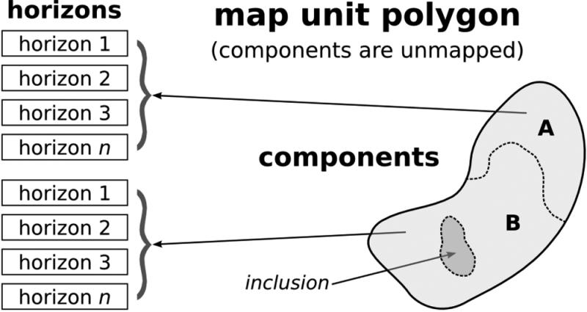 . [fig:ssurgo_{s}chematic]
[h] 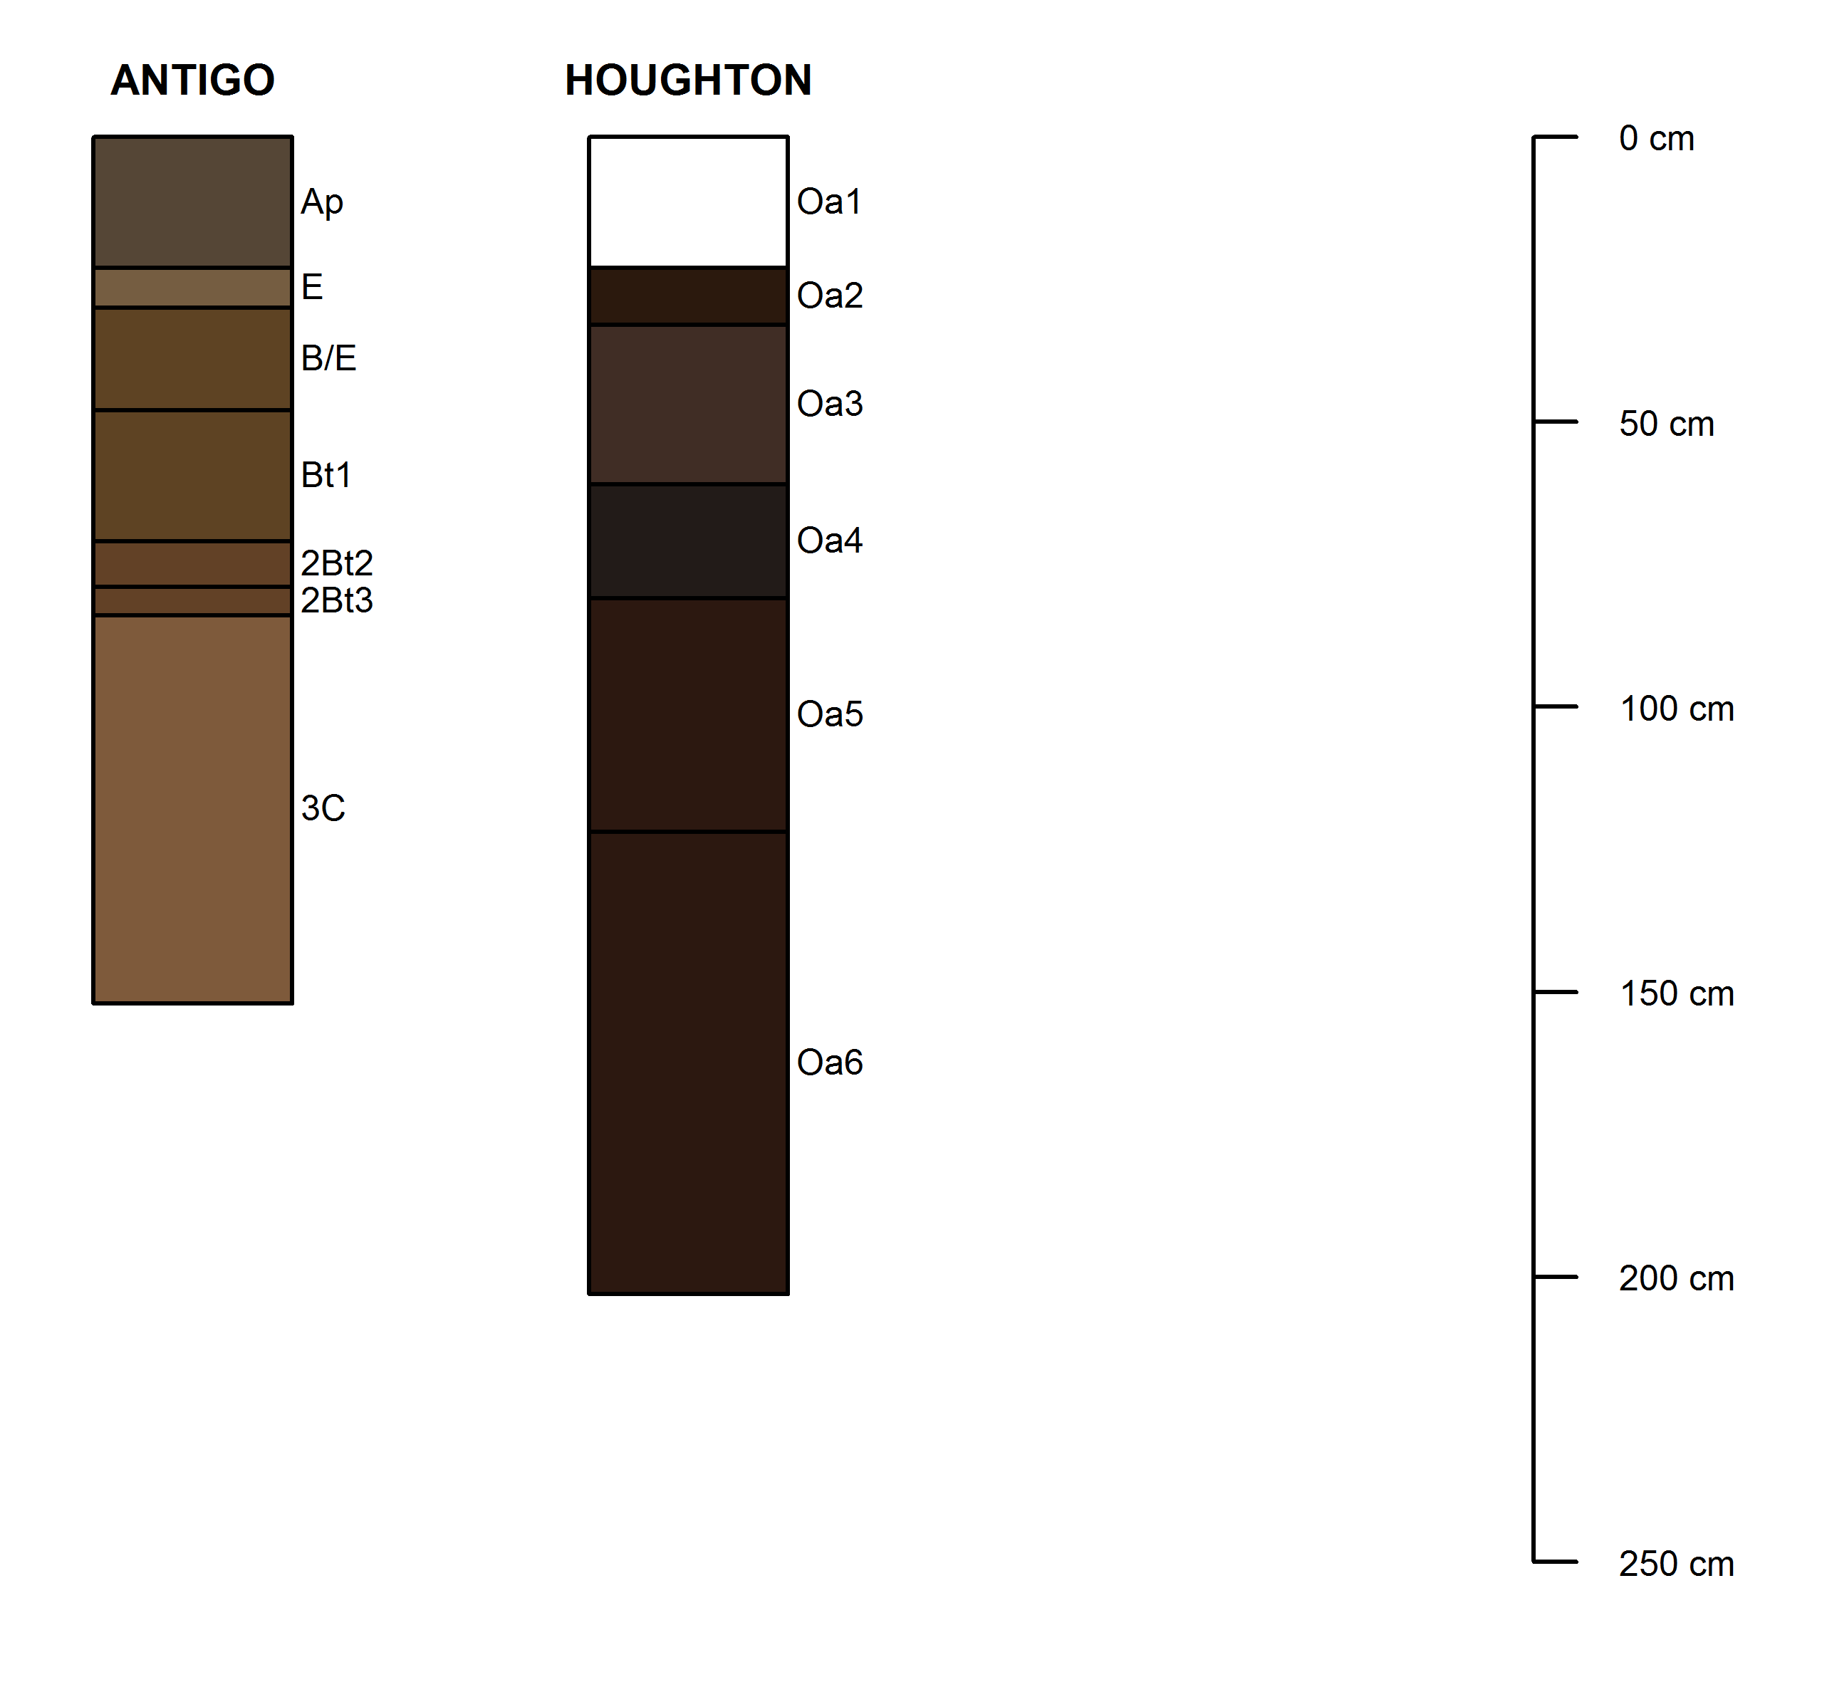 [fig:component_{s}chematic]
[H] 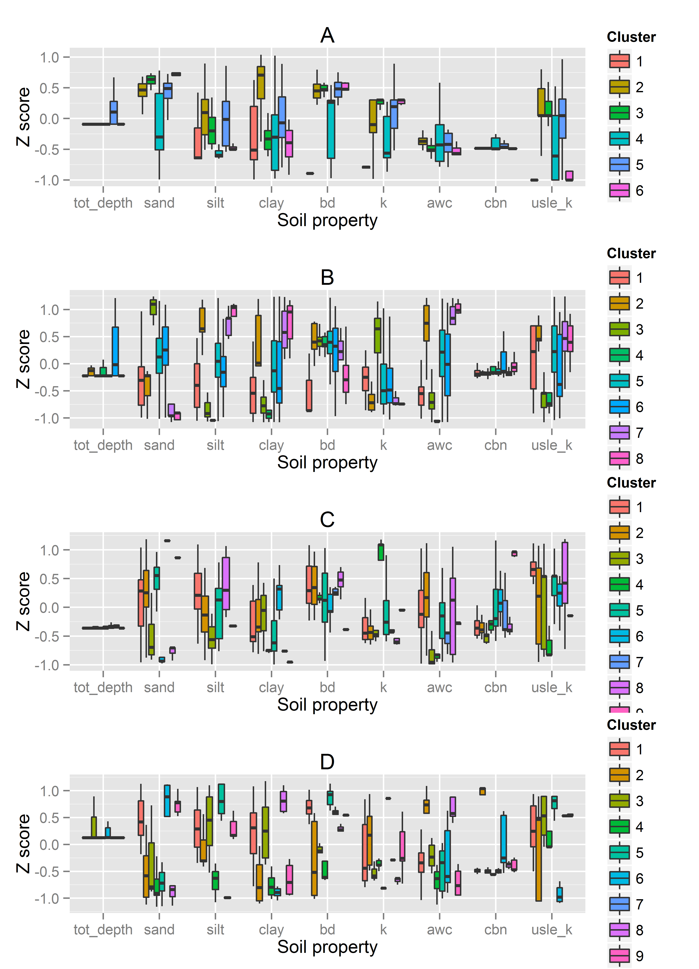 [fig:soil_{b}oxplots]
[h]
image | image
[fig:climate_{m}issing]
image | image | image | image
Hargreaves | Penman–Monteith | Priestley–Taylor
image | image | image | image
[fig:et_{m}ethods]
[H] [fig:volume_{r}egressions]
[H] 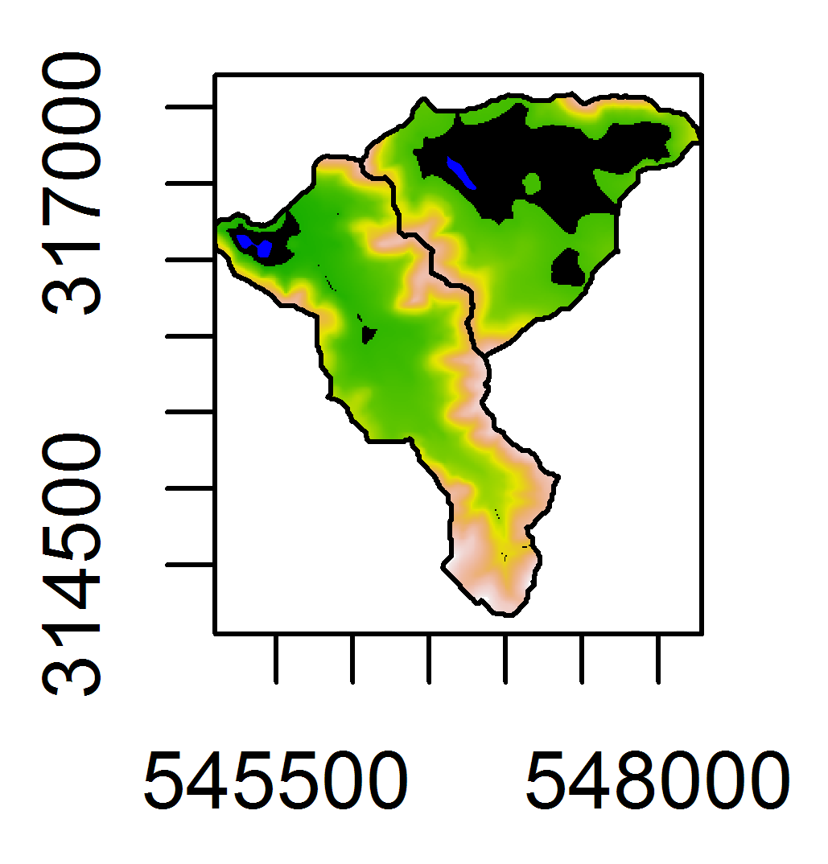 [fig:maximum_{p}ond_{v}olume]
[h!] 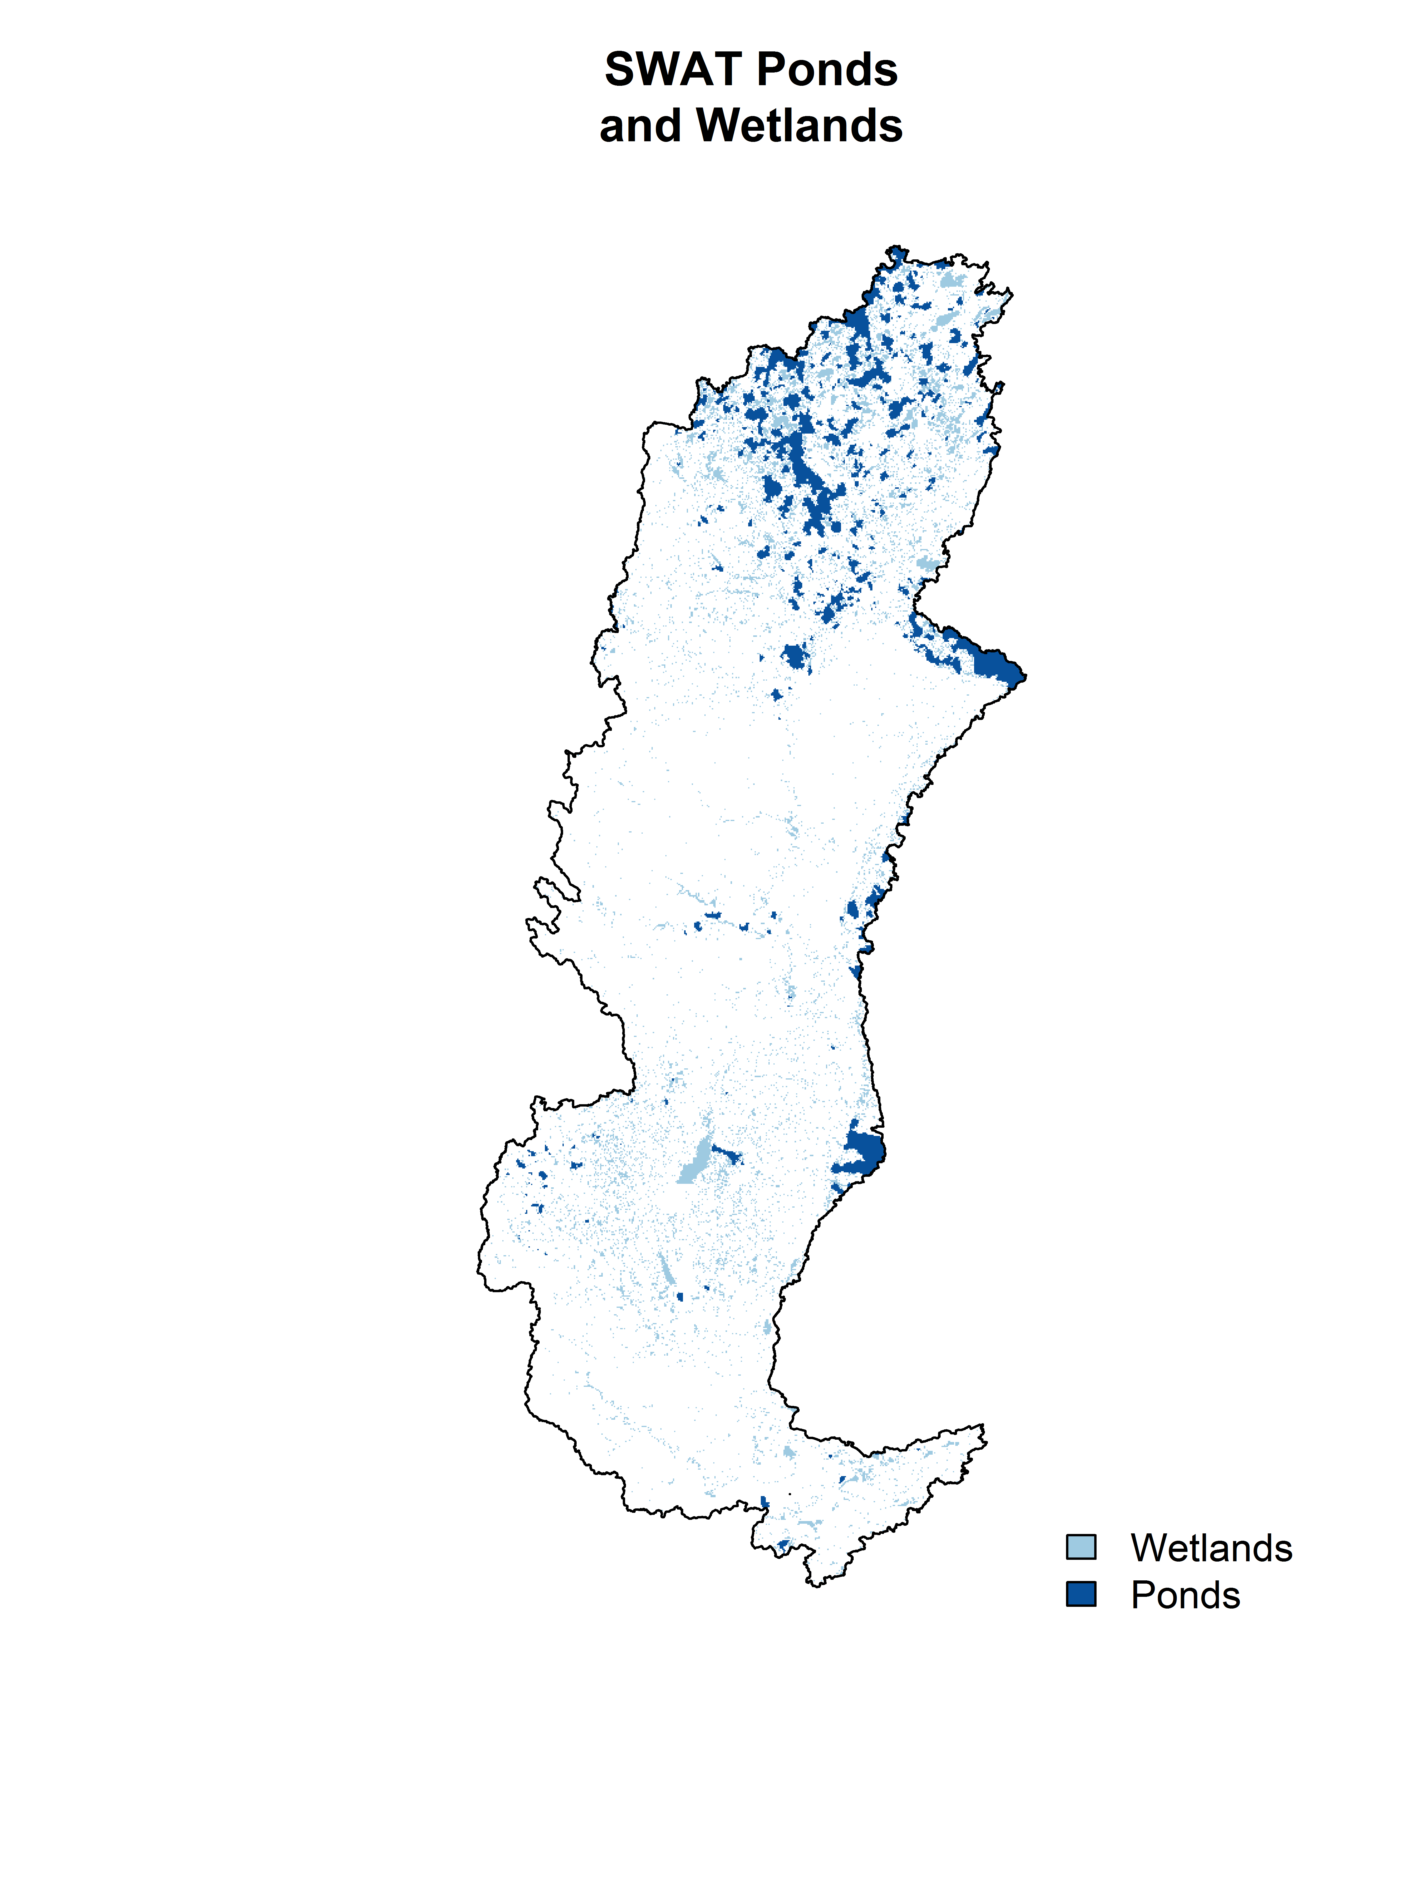 [fig:wetlands_{a}nd_{p}onds]
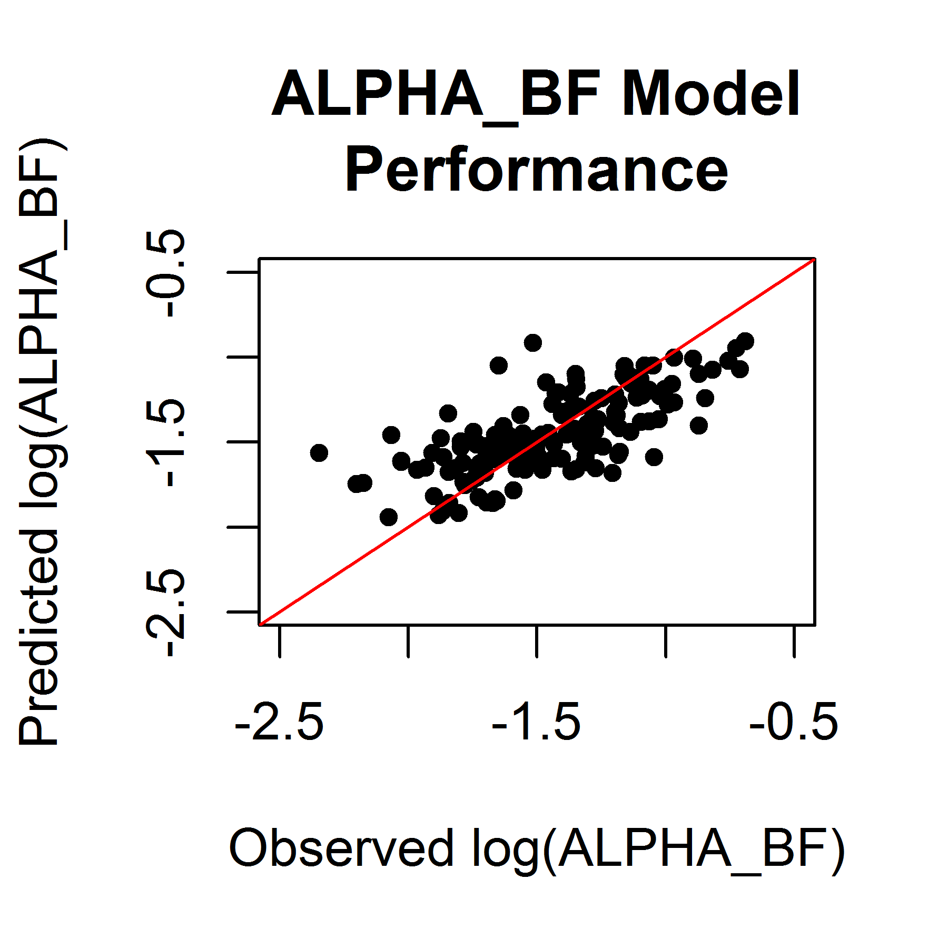 [fig:alpha_{b}f_{s}catterplot]
[h!] 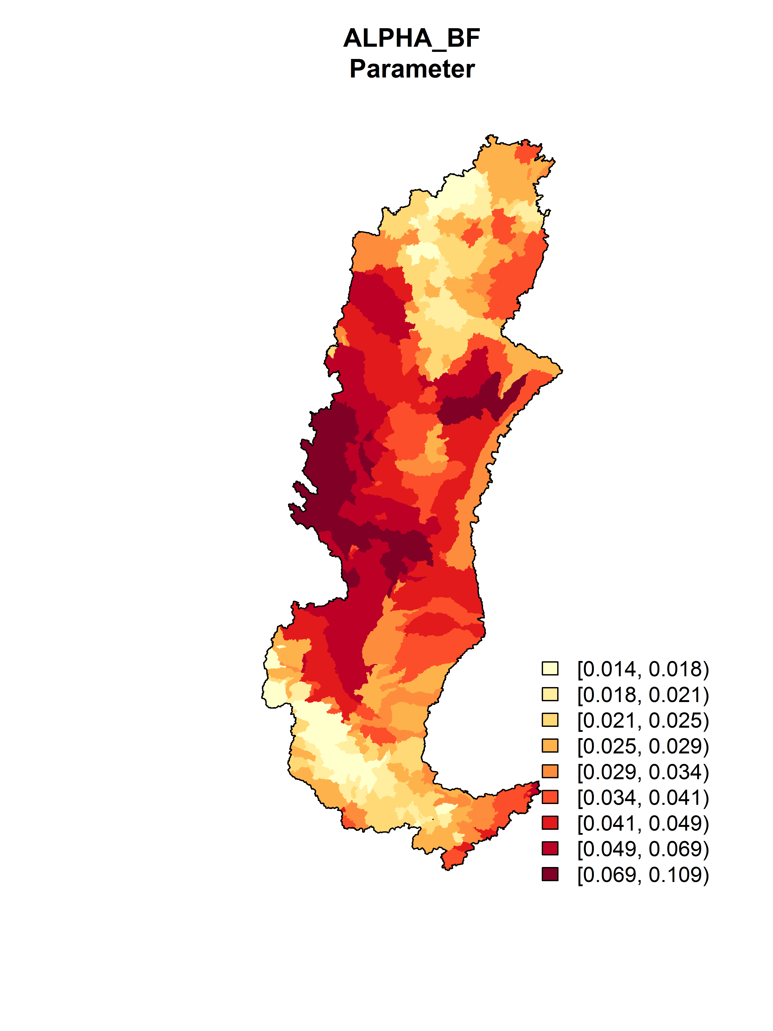 [fig:alpha_{b}f]
[h!] 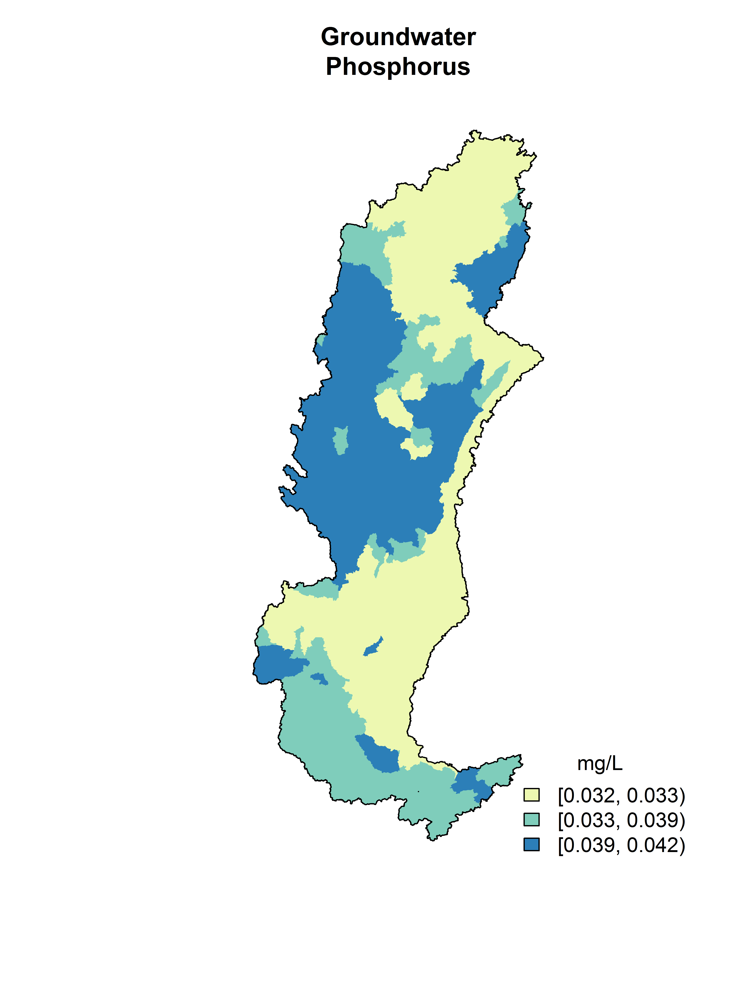 [fig:groundwater_{p}]
[h] Flow monitoring sites. The sites marked “Included” are currently considered calibration sites. Those marked “Excluded” are downstream of reservoirs or other structures that regulate flow and so are not used for calibration. For more detailed information see Table [tab:streamflow_{c}alibration_{s}ites]. [fig:calibration_{s}ite_{m}ap]

http://swat.tamu.edu/
http://dnr.wi.gov/topic/TMDLs/WisconsinRiver/
https://github.com/dnrwaterqualitymodeling
https://github.com/dnrwaterqualitymodeling/wisconsinRiverTMDL/tree/model_setup_public
The generalized rotation algorithm used was the algorithm from within the EVAAL tool. The script can be found here https://github.com/dnrwaterqualitymodeling/EVAAL/blob/master/__EVAAL__.pyt
http://www.nrcs.usda.gov/wps/portal/nrcs/detail/soils/survey
http://www.nrcs.usda.gov/wps/portal/nrcs/detail/soils/survey/?cid=nrcs142p2_053631
https://github.com/dnrwaterqualitymodeling/wisconsinRiverTMDL/blob/master/soils/step1_aggregate_gSSURGO.R
https://github.com/dnrwaterqualitymodeling/wisconsinRiverTMDL/blob/master/soils/step2_aggregate_gSSURGO.R
http://swat.tamu.edu/media/63316/SWAT_US_SSURGO_Soils.zip
http://uwlab.soils.wisc.edu/
“Urbanized areas” is defined herein as an area classified as “urbanized” by the 2010 Decennial Census. For the purpose of this document “urbanized area” and “urban model area” are not the same.
According to the USGS National Hydrography Dataset
Based on visual inspection of 2010 Wisconsin Regional Orthophotography Consortium.
Areas completely surrounded on all sides by areas mapped as open water.
Specifically, the remotely sensed imagery was from the WISCLAND data set; a dataset of landcover determined from LANDSAT imagery.
The code used to carry out these and the following tasks is available here: https://github.com/dnrwaterqualitymodeling/wisconsinRiverTMDL/tree/master/groundWater/baseFlow
http://dnr.wi.gov/topic/Dams/documents/StatewideDamData.zip

