LT SPICE SIMULATION AND PCB DESIGN OF

CLOSED LOOP BOOST CONVERTER

# Table of Contents:

1. Introduction
2. Calculations
3. LT spice circuit diagram
4. Waveforms of simulation
5. PCB design
6. Selection of components
7. Conclusion
8. References

**Introduction**

**Boost Converter** is a converter which converts variable DC voltage to required DC voltage. Boost converter is used to get DC output voltage greater than input voltage. Closed loop control is a process by which the output voltage is maintained constantly by obtaining the feedback of the loop.

Closed loop control of Boost Converter is used to obtain a constant DC output voltage. The switching frequency and duty cycle decides the output voltage. In the closed loop process the output voltage is compared with a set voltage and the error value is reduced by controlling the switching pulse. The basic operation is if the error value is positive the duty cycle is reduced and if the error value is negative the duty cycle is increased by continuing the process continuously the output voltage is maintained constant.

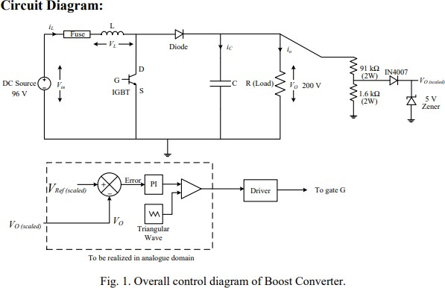

**LT spice circuit diagram:**

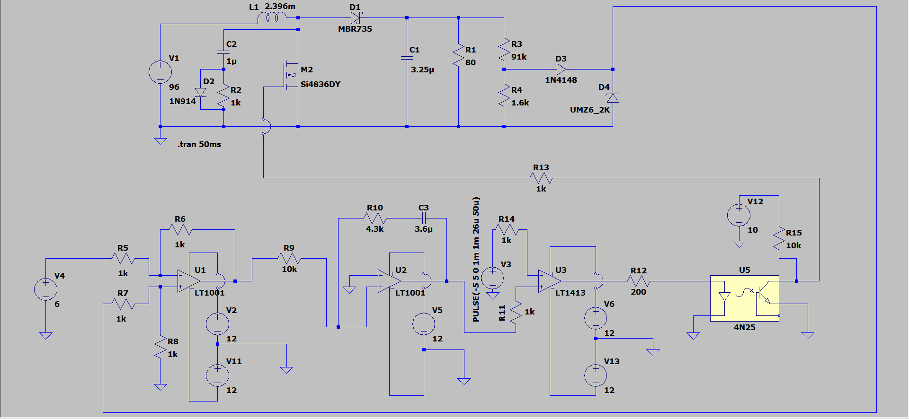

# Procedure for LT spice design:

* **Firstly the complete circuit is being designed in the LT spice software.**
* **Using the calculations as shown above we design a controller that suits are requirements.**
* **We obtained the value of Kp and Ki.**
* **Finally after completing all the above steps we ran the simulations in LT spice and verified the operation of the controller with input voltage fluctuations and load variations.**

Waveforms:

Comparison of triangular waveform with PI output:

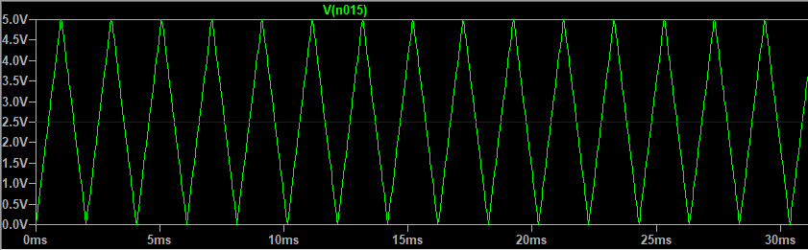

Gate pulses:

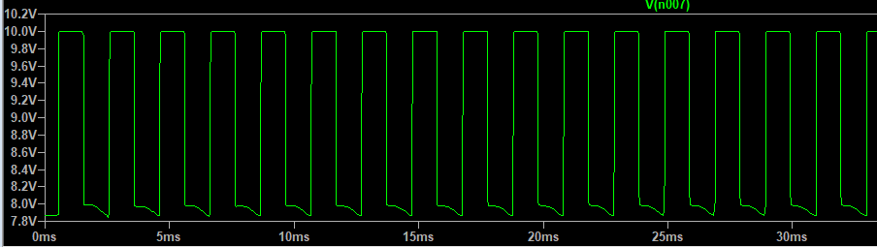

Optocoupler input:

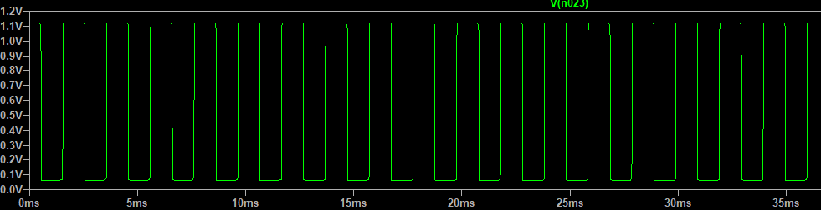

Output of controller:

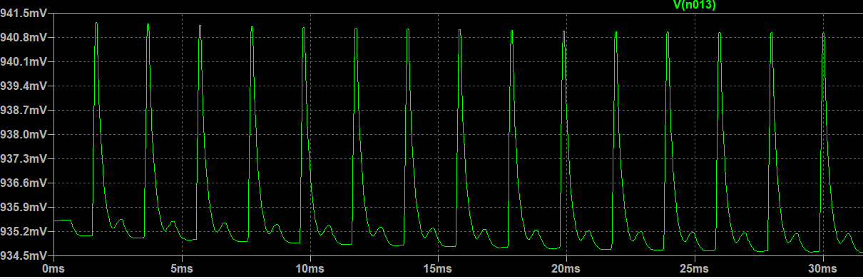

Output Voltage at 80 ohms:

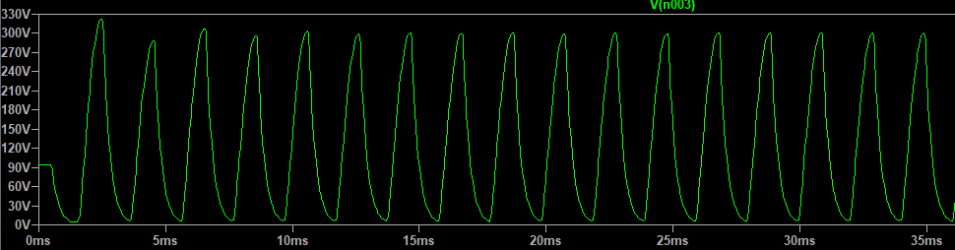

Output Voltage at Zener:

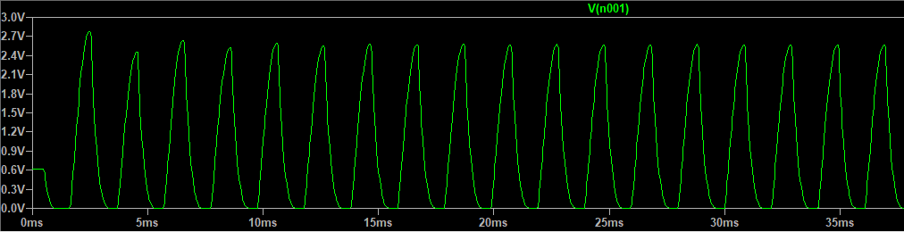

Observations:

|  |  |  |  |  |
| --- | --- | --- | --- | --- |
| **Sr No** | **Vo (ref)**  **(scaled)** | **Vin** | **Load** | **Vo(scaled)** |
| **1. Nominal** | **6 V** | **96 V** | **80 ohms** | **6.19 V** |
| **2. Load**  **Variation** | **6 V** | **96 V** | **100**  **ohms** | **6.05 V** |
| **3. Vin**  **variation** | **6V** | **120 V** | **80 ohms** | **6.21 V** |

## Schematic Design:

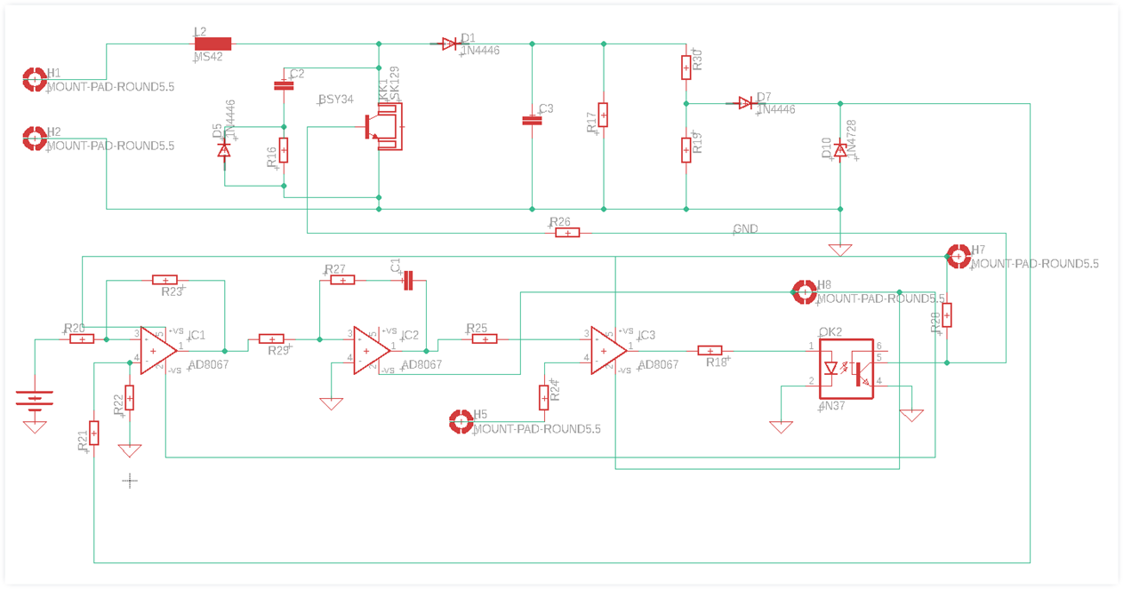

### PCB Design

**Procedure for PCB design:**

* **After completing the simulation in LT Spice we move onto the PCB design.**
* **Firstly a schematic is designed on the Eagle software as shown above.**
* **The components are selected so as to suit our design requirements using their datasheets.**
* **After generating the schematic, we move on to the switchboard so as to design our PCB.**
* **We organize and place each and every component on the PCB so that our design is efficient and with proper wiring and connections.**
* **We use the auto-routing option after placing each and every component on the switch board.**
* **We have increased the thickness of the wires as and where necessary so as to make sure that the wires have the desired current carrying capability.**
* **It is to be noted that in place of DC voltage sources as shown in the LT spice diagram we have used mount pads in the PCB design.**
* **We used a heat sink so that our circuit dissipates the excess amount of heat.**
* **Finally, we have generated the Gerber image file for different layers.**
* **These Gerber image files can be used for final hardware design of our PCB.**

### Main Design:

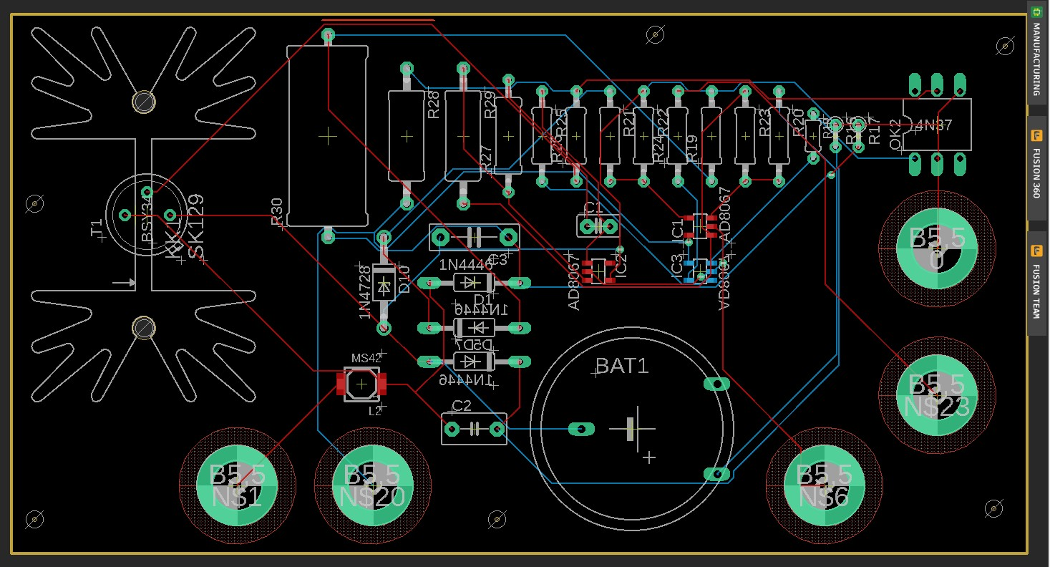

Gerber Image files:

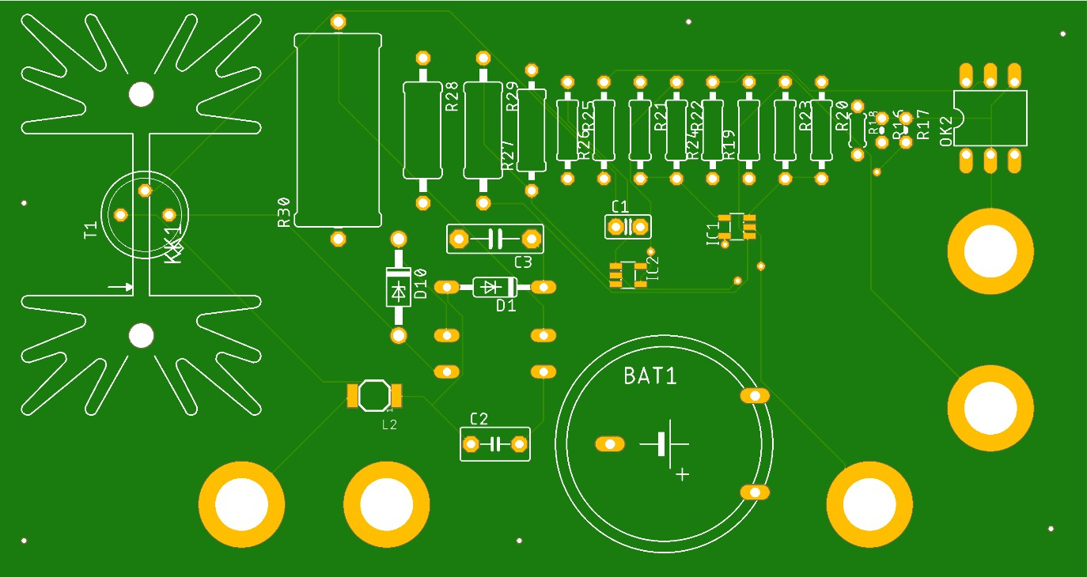

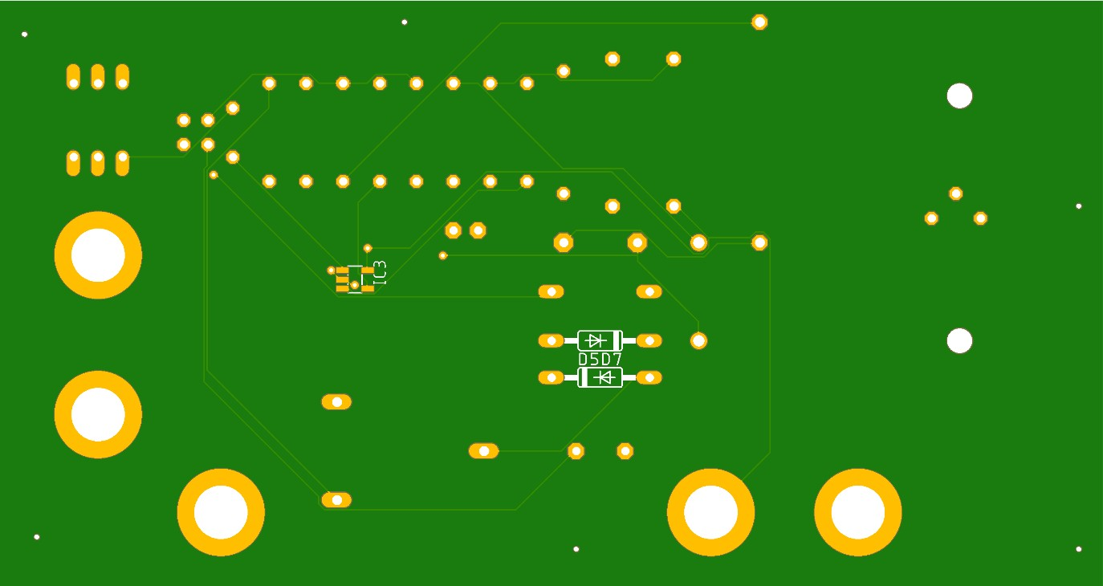

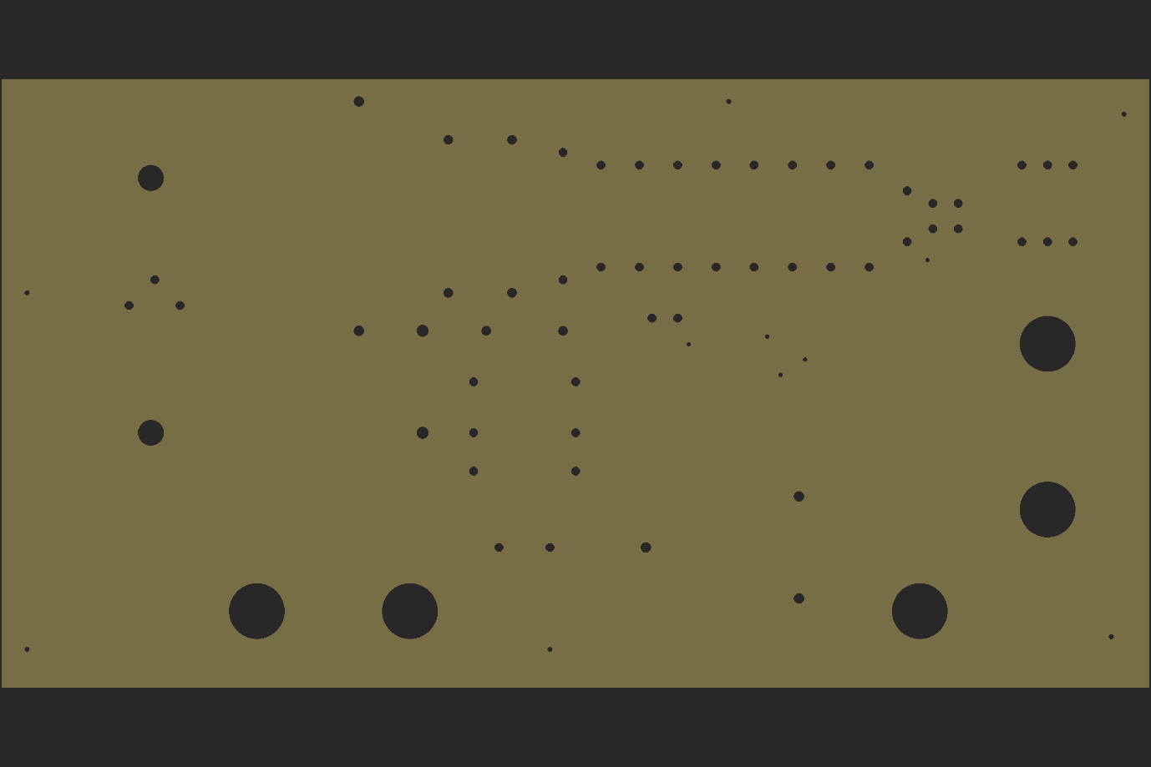

**Diode N4446**

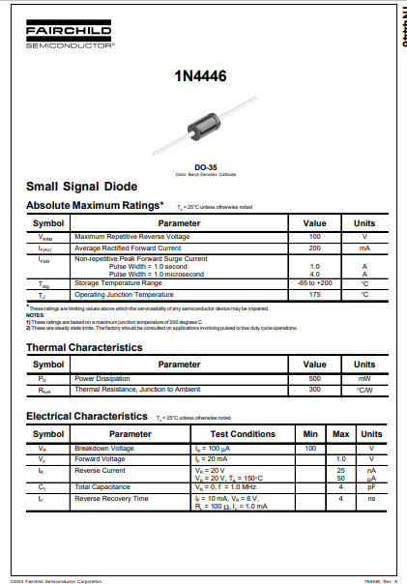

**AD8067 Op-amp**

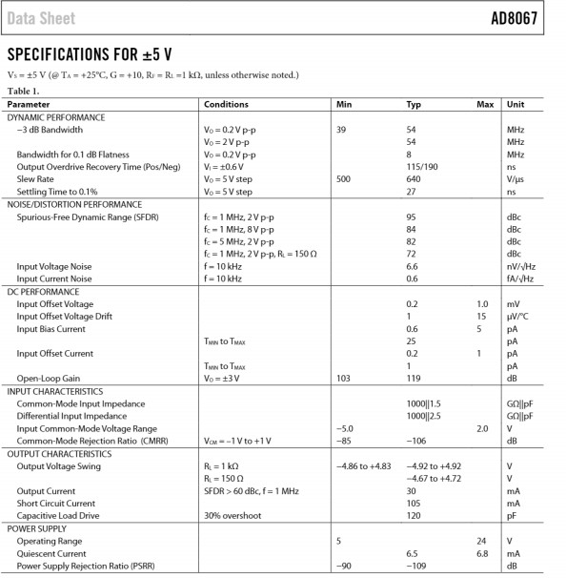

**Optocoupler 4N37**

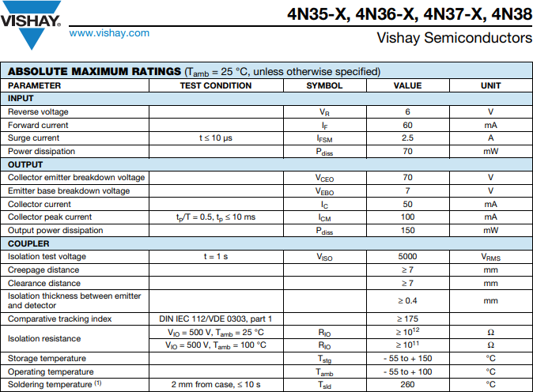

**Heat sink SK129**

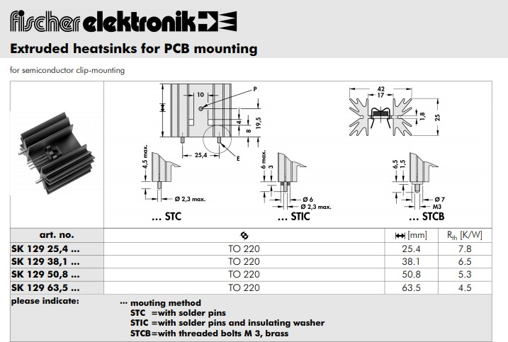

**Zener diode N4728**

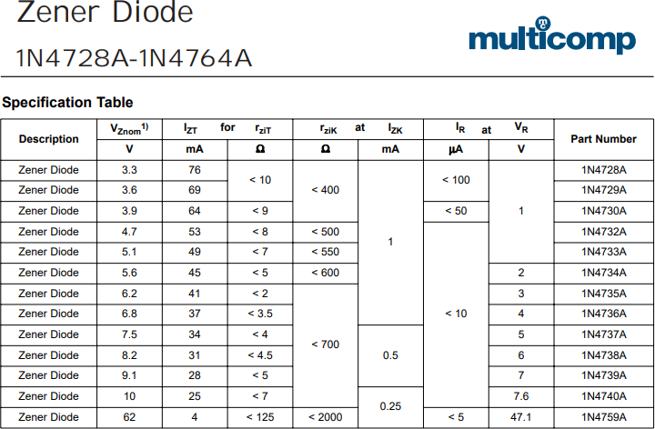

**Inductor MS42**

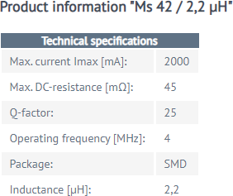

**IGBT BSY34**

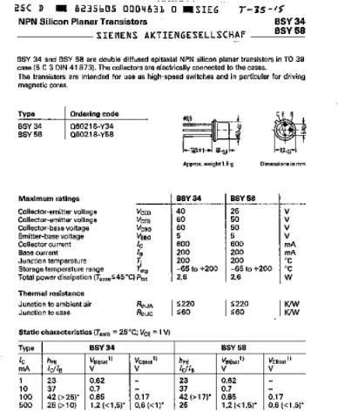

## Conclusions:

* **We obtained the LT spice circuit diagram ran the simulations and verified the operation of controller with input voltage fluctuations and load variations.**
* **We obtained a schematic of our PCB design in Eagle selecting each and every component that suited our requirements.**
* **We obtained the final PCB design and verified each and every connection of our PCB board.**
* **Finally we generated the gerber image files for our design which can be sent to the manufacturer to get the required hardware PCB design.**

## References:

* [**https://www.google.co.in/url?sa=t&rct=j&q=&esrc=s&source**](https://www.google.co.in/url?sa=t&rct=j&q&esrc=s&source=web&cd&cad=rja&uact=8&ved=2ahUKEwiq1pvDm4LwAhWvxDgGHRNEChsQFjAAegQIAxAD&url=http%3A%2F%2Feagle.autodesk.com%2Feagle%2Freference-designs&usg=AOvVaw2DxOy4Cg5TC54q7h8ukB8j)

[**=web&cd=&cad=rja&uact=8&ved=2ahUKEwiq1pvDm4LwAhW**](https://www.google.co.in/url?sa=t&rct=j&q&esrc=s&source=web&cd&cad=rja&uact=8&ved=2ahUKEwiq1pvDm4LwAhWvxDgGHRNEChsQFjAAegQIAxAD&url=http%3A%2F%2Feagle.autodesk.com%2Feagle%2Freference-designs&usg=AOvVaw2DxOy4Cg5TC54q7h8ukB8j)[**vxDgGHRNEChsQFjAAegQIAxAD&url=http%3A%2F%2Feagle.a**](https://www.google.co.in/url?sa=t&rct=j&q&esrc=s&source=web&cd&cad=rja&uact=8&ved=2ahUKEwiq1pvDm4LwAhWvxDgGHRNEChsQFjAAegQIAxAD&url=http%3A%2F%2Feagle.autodesk.com%2Feagle%2Freference-designs&usg=AOvVaw2DxOy4Cg5TC54q7h8ukB8j)[**utodesk.com%2Feagle%2Freference-**](https://www.google.co.in/url?sa=t&rct=j&q&esrc=s&source=web&cd&cad=rja&uact=8&ved=2ahUKEwiq1pvDm4LwAhWvxDgGHRNEChsQFjAAegQIAxAD&url=http%3A%2F%2Feagle.autodesk.com%2Feagle%2Freference-designs&usg=AOvVaw2DxOy4Cg5TC54q7h8ukB8j)[**designs&usg=AOvVaw2DxOy4Cg5TC54q7h8ukB8j**](https://www.google.co.in/url?sa=t&rct=j&q&esrc=s&source=web&cd&cad=rja&uact=8&ved=2ahUKEwiq1pvDm4LwAhWvxDgGHRNEChsQFjAAegQIAxAD&url=http%3A%2F%2Feagle.autodesk.com%2Feagle%2Freference-designs&usg=AOvVaw2DxOy4Cg5TC54q7h8ukB8j)

* [Easier PCB Design: EAGLE CAD Tips and Tricks Part 3 - Technical Articles (allaboutcircuits.com)](https://www.allaboutcircuits.com/technical-articles/easier-pcb-design-eagle-cad-tips-and-tricks-part-3/)
* [Using EAGLE: Schematic - learn.sparkfun.com](https://learn.sparkfun.com/tutorials/using-eagle-schematic/all)