AWS ASSIGNEMENT

- IAM service within the AWS console

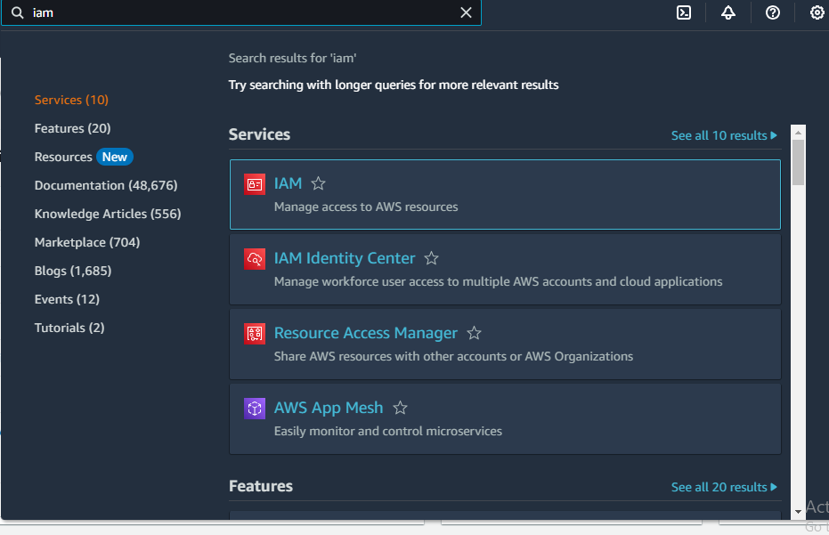

- user for developer team,QA team and Admin team

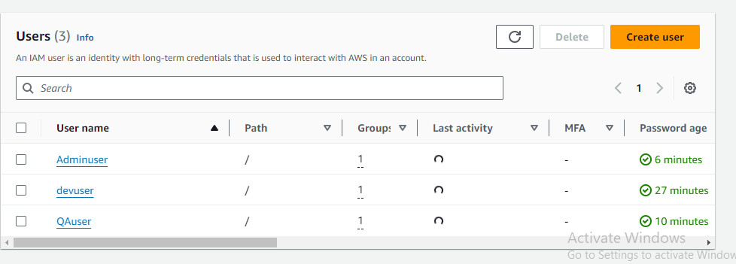
- user group for developer,QA and Admin within the IAM console

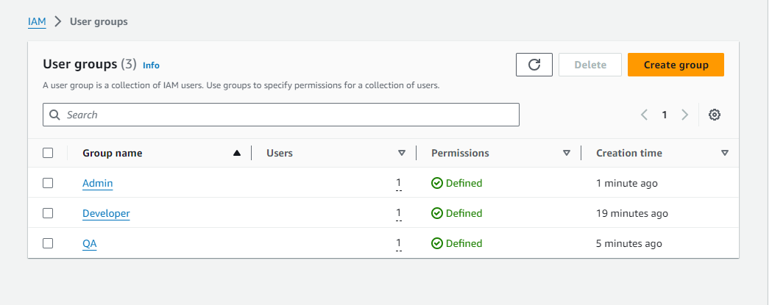

Developer usergroup permissions:

- developer cannot delete s3 buckets,EC2instance and vpc's

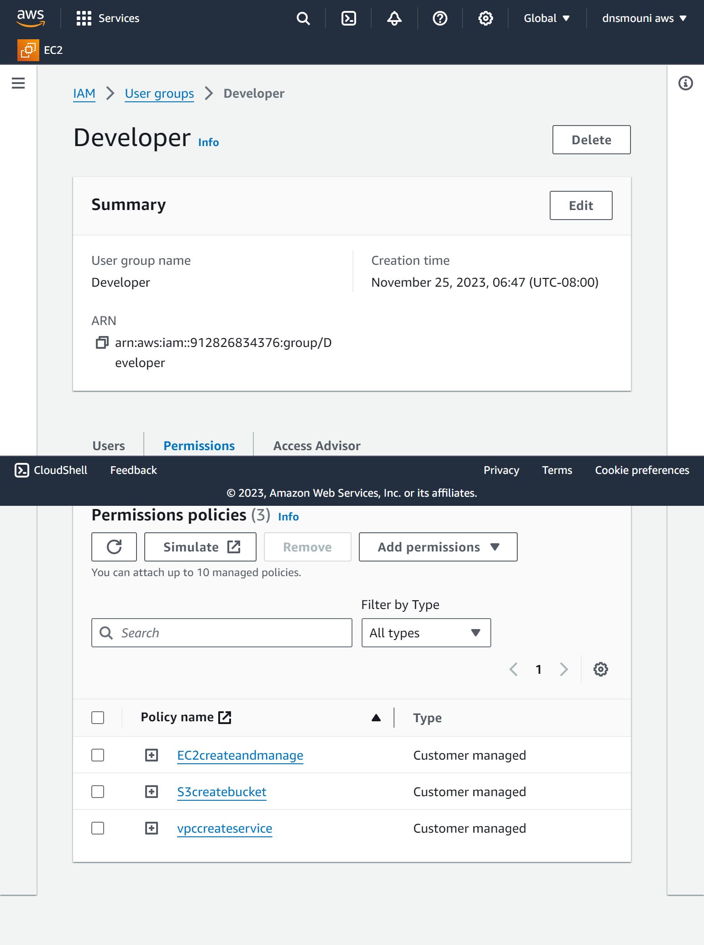
QA user group permissions:

- QA cannot delete s3 bucket,EC2 instance and vpc's(read only).

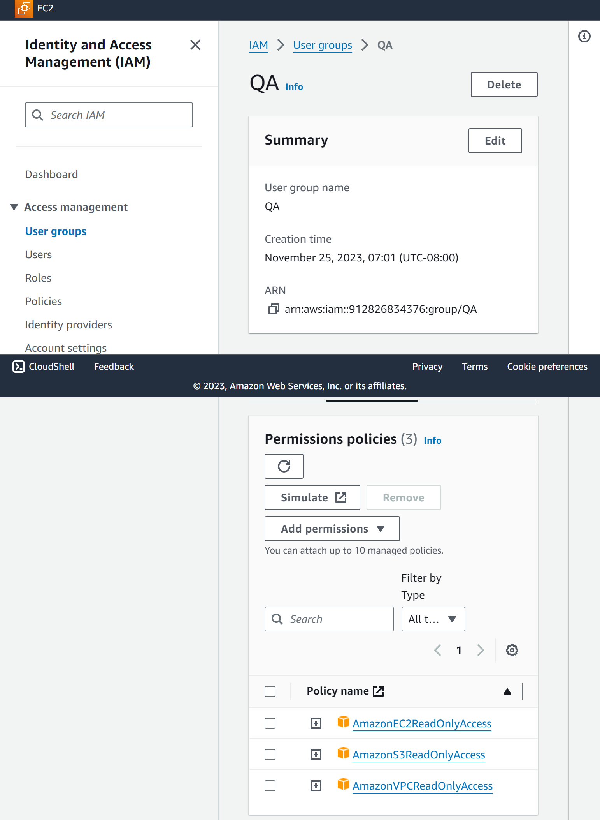

Admin user group permissions:

- Admin, full access for s3 bucket,EC2 instance and vpc's.

