3.1 Overview

People who use the program are divided into users and administrators. And the use section is divided into library and reading room.

Through the program, the user checks if the book is available for loan now, Where the book is located, and you can search how many books are currently available for loan. You can also borrow or return books through a program or administrators.

The administrator will enter the book's unique number into the program and check how many books are currently overdue.

In addition, the user can use a program such as which seat is empty in the reading room, reservation of a seat, and the like.

3.2 Functional requirements (“shall lists”)

Actor is divided into user and administrator. Also, system is divided into reading room, library server.

The user can connect to the system to reserve a seat in the reading room, and in the library server, user can sign up for membership, search for books, lend and return.

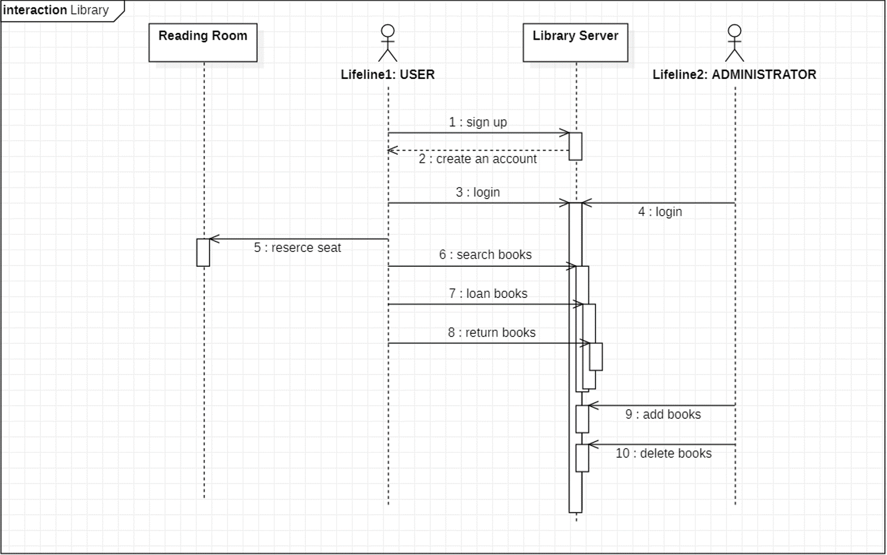Administrator can add / remove books after logging into the program. In addition, administrator can keep track of the current state of library’s operations by managing the current state of library’s books.

* 1. Nonfunctional requirements
     1. Usability (사용성)

We will implement the program using Java. It will be implemented in the form of an application, but if it can be expanded, it will also work in the form of a web.

Stakeholders who are not developers do not have background knowledge about the program, so we will use the GUI to supplement the interface.

In addition, the database will be configured and linked separately from the program. This connection will be implemented with Client – server architecture. If we do this, it will be easier to manage the storage of the program

* + 1. Reliability (신뢰성)

Programs used by users and administrators will be separated from each other. In order to access the programs used by administrators, a password must be entered.

In addition, the user’s personal information, etc. must enter the password of the final administrator, not the general administrator. This program uses a layered architecture to put sensitive information such as user’s personal information at the bottom of the program.

Because of this, security will be better. In addition, safety will be secured through a lot of testing.

* + 1. Performance

In the process of implementation, the function of the system is very important. But we will not miss both consistency and completeness.

And if possible, we will support both web and app to increase user convenience. Also, when user access the app, user will be able to easily view PDF files for periodicals.

It will show performance as a more advanced program from the general library operation program