RPILCD
2.2 inch, 2.4 inch and 2.8 inch LCD with touch library

Manual
PREFACE:
This library is the communication of 2.2 LCD module, 2.4 LCD module and 2.8 LCD module.
This library supports 8 bit LCD module and it will work with raspberry pi.
DEFINED LITERALS:
Set the pin link to the LCD
SetPinNU(P0, P1, P2, P3, P4, P5, P6, P7, Prs, Pcs, Pwr, Prst, Pdout, Pirq, Pdin, Pclk);
Parameters:
P0: the D8 of the LCD module;
P1: the D9 of the LCD module;
P2: the D10 of the LCD module;
P3: the D11 of the LCD module;
P4: the D12 of the LCD module;
P5: the D13 of the LCD module;
P6: the D14 of the LCD module;
P7: the D15 of the LCD module;
Prs: the RS of the LCD module;
Pcs: the CS of the LCD module;
Pwr: the WR of the LCD module;
Prst: the RST of the LCD module;
Pdout: the T_DOUT of the LCD module;
Pirq: the T_IRQ of the LCD module;
Pdin: the T_DIN of the LCD module;
Pclk: the T_CLK of the LCD module;
Choose the size of the LCD
SetLCDSize(int a );
Parameters: LCD_22:2.2 inch LCD
LCD_24:2.4 inch LCD
LCD_28:2.8 inch LCD
Initialize LCD
LCDInit(void);
Parameters: NULL
Initialize the touch of the LCD
Touch_Init(void);
Parameters: NULL
Set font
setFont(unsigned short int mxsize,unsigned short int mysize,unsigned short int moffset)
parameters: mxsize: the wide of the font
mysize: the high of the font
moffset: the offset is 32
Set VGA Colors
setColor() and setBackColor();
Parameters: r: Red component of an RGB value (0-255)
g: Green component of an RGB value (0-255)
b: Blue component of an RGB value (0-255)
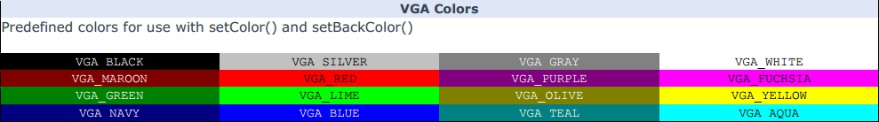
INCLUDED FONTS:
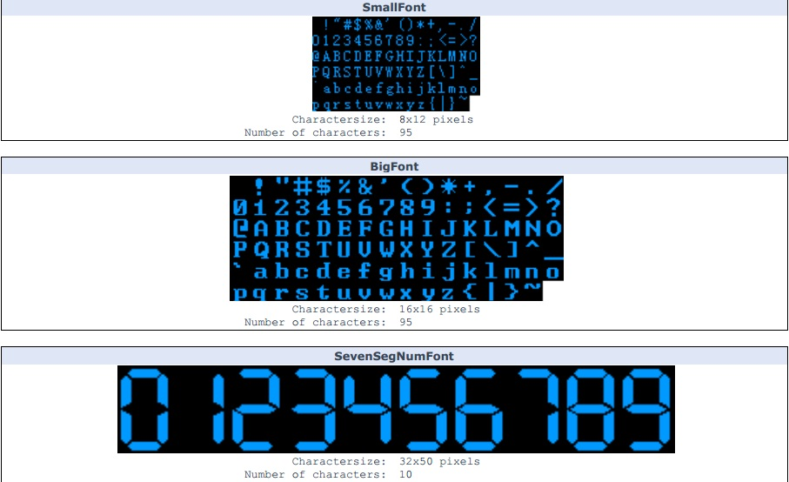
Display orientarion:
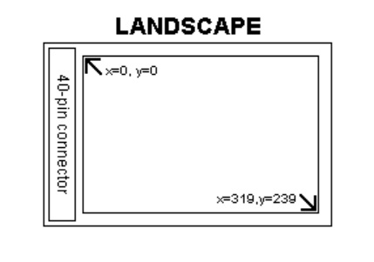
FUNCTIONS:
SetPinNU(P0, P1, P2, P3, P4, P5, P6, P7, Prs, Pcs, Pwr, Prst, Pdout, Pirq, Pdin, Pclk)
Set the pin link to the LCD
Parameters:
P0: the D8 of the LCD module;
P1: the D9 of the LCD module;
P2: the D10 of the LCD module;
P3: the D11 of the LCD module;
P4: the D12 of the LCD module;
P5: the D13 of the LCD module;
P6: the D14 of the LCD module;
P7: the D15 of the LCD module;
Prs: the RS of the LCD module;
Pcs: the CS of the LCD module;
Pwr: the WR of the LCD module;
Prst: the RST of the LCD module;
Pdout: the T_DOUT of the LCD module;
Pirq: the T_IRQ of the LCD module;
Pdin: the T_DIN of the LCD module;
Pclk: the T_CLK of the LCD module;
Usage: SetPinNU(0,1,2,3,4,5,6,7,8,10,9,11,15,16,14,12)
SetLCDSize(size)
Choose the size of the LCD
Parameters: LCD_22:2.2 inch LCD
LCD_24:2.4 inch LCD
LCD_28:2.8 inch LCD
Usage: SetLCDSize(LCD_22); // choose 2.2 inch LCD to display
Lcd_Init ();
Initialize the LCD.
Parameters: NULL
Usage: Lcd_Init (); // Initialize the display
getDisplayXSize();
Get the width of the screen.
Parameters: None
Returns: Width of the screen in pixels
Usage: Xsize = getDisplayXSize(); // Get the width
getDisplayYSize();
Get the height of the screen.
Parameters: None
Returns: Height of the screen in pixels
Usage: Ysize = getDisplayYSize(); // Get the height
clrScr();
Clear the screen. The background-color will be set to black.
Parameters: None
Usage: clrScr(); // Clear the screen to black.
fillScr(r, g, b);
Fill the screen with a specified color.
Parameters:
r: Red component of an RGB value (0-255)
g: Green component of an RGB value (0-255)
b: Blue component of an RGB value (0-255)
Usage: fillScr(255,127,0); // Fill the screen with orange
fillScr(color);
Fill the screen with a specified pre-calculated RGB565 color.
Parameters: color: RGB565 color value
Usage: fillScr(0x0000); // Fill the screen with black
setColorRGB(r, g, b);
Set the color to use for all draw*, fill* and print commands.
Parameters:
r: Red component of an RGB value (0-255);
g: Green component of an RGB value (0-255);
b: Blue component of an RGB value (0-255);
Usage: setColorRGB(0,255,255); // Set the color to cyan.
setColor(color);
Parameters:
color: RGB565 color value
Usage: setColor(0x0000); // Set the color to black
getColor();
Get the currently selected color.
Parameters: None
Returns: Currently selected color as a RGB565 value (word)
Usage:Color = getColor(); // Get the current color
setBackColorRGB(r, g, b);
Set the background color to use for all print commands.
Parameters:
r: Red component of an RGB value (0-255)
g: Green component of an RGB value (0-255)
b: Blue component of an RGB value (0-255)
Usage: setBackColorRGB(255,255,255); // Set the background color to white
setBackColor(color);
Set the specified pre-calculated RGB565 background color to use for all print commands.
Parameters:
color: RGB565 color value
Usage: setBackColor(0xffff); // Set the background color to white
getBackColor();
Get the currently selected background color.
Parameters: None
Returns: Currently selected background color as a RGB565 value (word)
Usage: BackColor = getBackColor(); // Get the current background color
drawPixel(x, y);
Draw a single pixel.
Parameters:
x: x-coordinate of the pixel
y: y-coordinate of the pixel
Usage: drawPixel(119,159); // Draw a single pixel
drawLine(x1, y1, x2, y2);
Draw a line between two points.
Parameters:
x1: x-coordinate of the start-point
y1: y-coordinate of the start-point
x2: x-coordinate of the end-point
y2: y-coordinate of the end-point
Usage: drawLine(0,0,239,319); // Draw a diagonal line
drawRect(x1, y1, x2, y2);
Draw a rectangle between two points.
Parameters:
x1: x-coordinate of the start-corner
y1: y-coordinate of the start-corner
x2: x-coordinate of the end-corner
y2: y-coordinate of the end-corner
Usage: drawRect(119,159,239,319); // Draw a rectangle
drawRoundRect(x1, y1, x2, y2);
Draw a rectangle with slightly rounded corners between two points. The minimum size is 5 pixels in both directions. If a smaller size is requested the rectangle will not be drawn.
Parameters:
x1: x-coordinate of the start-corner
y1: y-coordinate of the start-corner
x2: x-coordinate of the end-corner
y2: y-coordinate of the end-corner
Usage: drawRoundRect(0,0,119,159); // Draw a rounded rectangle
fillRect(x1, y1, x2, y2);
Draw a filled rectangle between two points.
Parameters:
x1: x-coordinate of the start-corner
y1: y-coordinate of the start-corner
x2: x-coordinate of the end-corner
y2: y-coordinate of the end-corner
Usage: fillRect(119,0,239,159); // Draw a filled rectangle
fillRoundRect(x1, y1, x2, y2);
Draw a filled rectangle with slightly rounded corners between two points. The minimum size is 5 pixels in both directions. If a smaller size is requested the rectangle will not be drawn.
Parameters:
x1: x-coordinate of the start-corner
y1: y-coordinate of the start-corner
x2: x-coordinate of the end-corner
y2: y-coordinate of the end-corner
Usage: fillRoundRect(0,159,119,319); // Draw a filled, rounded rectangle
drawCircle(x, y, radius);
Draw a circle with a specified radius.
Parameters:
x: x-coordinate of the center of the circle
y: y-coordinate of the center of the circle
radius: radius of the circle in pixels
Usage: drawCircle(119,159,20); // Draw a circle with a radius of 20 pixels
fillCircle(x, y, radius);
Draw a filled circle with a specified radius.
Parameters:
x: x-coordinate of the center of the circle
y: y-coordinate of the center of the circle
radius: radius of the circle in pixels
Usage: fillCircle(119,159,10); // Draw a filled circle with a radius of 10 pixels
print(st, x, y, [deg]);
Print a string at the specified coordinates. An optional background color can be specified. Default background is black. You can use the literals LEFT, CENTER and RIGHT as the x-coordinate to align the string on the screen.
Parameters:
st: the string to print
x: x-coordinate of the upper, left corner of the first character
y: y-coordinate of the upper, left corner of the first character
deg: <optional>Degrees to rotate text (0-359). Text will be rotated around the upper left corner.
Usage: print(“Hello, World!”,CENTER,0); // Print “Hello, World!”
printNumI(num, x, y[, length[, filler]]);
Print an integer number at the specified coordinates. An optional background color can be specified. Default background is black. You can use the literals LEFT, CENTER and RIGHT as the x-coordinate to align the string on the screen.
Parameters:
num: the value to print (-2,147,483,648 to 2,147,483,647) integers only;
x: x-coordinate of the upper, left corner of the first digit/sign
y: y-coordinate of the upper, left corner of the first digit/sign
length: <optional>minimum number of digits/characters (including sign) to display
filler: <optional>filler character to use to get the minimum length. The character will be inserted in front of the number, but after the sign. Default is ' ' (space).
Usage: printNumI(num,CENTER,0,0); // Print the value of “num”
printNumF(num, dec, x, y[, divider[, length[, filler]]]);
Print a floating-point number at the specified coordinates. An optional background color can be specified. Default background is black. You can use the literals LEFT, CENTER and RIGHT as the x-coordinate to align the string on the screen.
WARNING: Floating point numbers are not exact, and may yield strange results when compared. Use at your own discretion.
Parameters:
num: the value to print (See note)
dec: digits in the fractional part (1-5) 0 is not supported. Use printNumI() instead.
x: x-coordinate of the upper, left corner of the first digit/sign
y: y-coordinate of the upper, left corner of the first digit/sign
divider: <Optional>Single character to use as decimal point. Default is '.'
length:<optional>minimum number of digits/characters (including sign) to display
filler:<optional>filler character to use to get the minimum length. The character will be inserted in front of the number, but after the sign. Default is ' ' (space).
Usage: printNumF(num, 3, CENTER,0,0); // Print the value of “num” with 3 fractional digits
Notes:Supported range depends on the number of fractional digits used. Approx range is +/- 2*(10^(9-dec))
setFont(x,y,offset);
Select font to use with print(), printNumI() and printNumF().
Parameters:
X: The x seize of the Font;
Y: The Y size of the Font;
Offset: We set it to 32;
Usage: setFont(16,16,32); // Select the font called BigFont
getFont();
Get the currently selected font.
Parameters: None
Returns: Currently selected font
Usage: CurrentFont = getFont(); // Get the current font
getFontXsize();
Get the width of the currently selected font.
Parameters: None
Returns: Width of the currently selected font in pixels
Usage: Xsize = getFontXsize (); // Get font width
getFontYsize();
Get the height of the currently selected font.
Parameters: None
Returns: Height of the currently selected font in pixels
Usage: Ysize = getFontYsize (); // Get font height
drawBitmap (x, y, sx, sy, data[scale]);
Draw a bitmap on the screen.
Parameters:
x: x-coordinate of the upper, left corner of the bitmap
y: y-coordinate of the upper, left corner of the bitmap
sx: width of the bitmap in pixels
sy: height of the bitmap in pixels
data: array containing the bitmap-data
scale: <optional>Scaling factor. Each pixel in the bitmap will be drawn as <scale>x<scale> pixels on screen.
Usage: drawBitmap(0, 0, 32, 32, bitmap); // Draw a 32x32 pixel bitmap
drawBitmap (x, y, sx, sy, data, deg, rox, roy);
Draw a bitmap on the screen with rotation.
Parameters:
x: x-coordinate of the upper, left corner of the bitmap
y: y-coordinate of the upper, left corner of the bitmap
sx: width of the bitmap in pixels
sy: height of the bitmap in pixels
data: array containing the bitmap-data
deg: Degrees to rotate bitmap (0-359)
rox: x-coordinate of the pixel to use as rotational center relative to bitmaps upper left corner
roy: y-coordinate of the pixel to use as rotational center relative to bitmaps upper left corner
Usage: drawBitmap(50, 50, 32, 32, bitmap, 45, 16, 16); // Draw a bitmap rotated 45 degrees around its center

For Touch:
Touch_Init ();
Initialize the touch screen.
Parameters:NULL
Returns: Nothing
Usage: Touch_Init ();// Initialize the touch screen
Touch_DataAvailable();
Check to see if new data from the touch screen is waiting.
Parameters: None
Returns:NULL
Boolean: true means data is waiting, otherwise false
Usage: check = Touch_DataAvailable() // See if data is waiting
Touch_Read();
Read waiting data from the touch screen. This function should be called if dataAvailable() is true. Use Touch_GetX() and Touch_GetY() to get the coordinates.
Parameters: None
Returns: Touch read data;
Usage: Touch_Read(); // Read data from touch screen
Notes: After calling read(), raw data from the touch screen is available in the variables TP_X and TP_Y. Do not use these if you do not know how to handle the raw data. Use Touch_GetX() and Touch_GetY() instead.
Touch_GetX();
Get the x-coordinate of the last position read from the touch screen.
Parameters: None
Returns: Integer
Usage: x = Touch_GetX(); // Get the x-coordinate
Touch_GetY();
Get the y-coordinate of the last position read from the touch screen.
Parameters: None
Returns: Integer
Usage: y = Touch_GetY(); // Get the y-coordinate
Touch_SetPrecision(precision);
Set the precision of the touch screen.
Parameters: precision: PREC_LOW, PREC_MEDIUM, PREC_HI, PREC_EXTREME
Returns: Nothing
Usage: Touch_SetPrecision(PREC_MEDIUM); // Set precision to medium

