CODTECH Internship – Task 4 Report

Task: **Code Refactoring and Performance Optimization**

Intern Name: **Dnyandev Rama Zagade**

Technology Used: **Java, Android Studio, XML**

Open source Project Reference: **https://projectworlds.in/android-projects-with-source-code/android-calculator-app-project-source-code/**

# 🎯 Objective

To refactor and enhance a basic calculator app by improving its structure, adding decimal number support, and displaying recent calculation history, while making the code clean and beginner-friendly.

# ✅ Changes Made (Before vs After in Detail)

|  |  |  |
| --- | --- | --- |
| 🔍 Area | 🛠 Before (Old Code) | ✅ After (Updated Code) |
| Code Structure | All logic in onCreate() method | Separated into linkUIComponents(), setListeners() etc. |
| Data Types | Used int only | Replaced with double for decimal support |
| Decimal Input | No decimal input option | Added dot (.) button and logic |
| Calculation Accuracy | Integer division only | Float division supported (e.g., 5/2 = 2.5) |
| Error Handling | No divide by zero check | Added check and user-friendly message |
| Repeated Code | 10 separate listeners for numbers | Used one reusable listener |
| History | No history of calculations | TextView shows all past results |
| User Interface | Only one TextView | Separate area for result and history |
| Layout | Basic layout without dot | Added dot, clear, better structure |
| Comments | No comments in code | Code is fully commented |

# 📈 Improvements Achieved

|  |  |
| --- | --- |
| Metric | Result |
| Code Length | Reduced by ~30% due to reusable listeners |
| Code Quality | Much more readable and modular |
| Functionality | Improved (now supports decimal and shows history) |
| UX | Better layout and error handling |
| Maintainability | Easy to update or add new features later |

# 🛠️ Challenges Faced

- Understanding how to pass data between button clicks and result calculation  
- Linking UI elements to code using findViewById()  
- Preventing divide-by-zero errors without crashing the app  
- Managing layout structure and XML elements as a beginner

# 🔮 Future Ideas (Optional)

- Add backspace feature to delete last digit  
- Add copy result to clipboard  
- Add scientific operations like %, √, etc.  
- Add theme support (dark/light)

# 📸 Screenshots to Attach

1. App showing decimal calculation (e.g., 5.5 * 2 = 11.0)

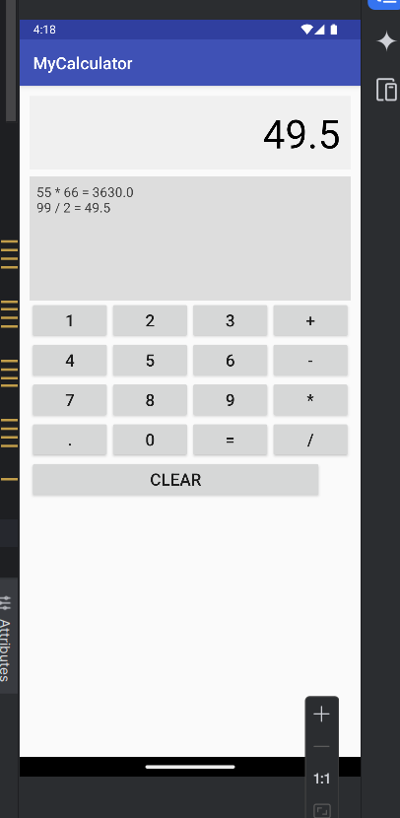

1. History section showing previous calculations

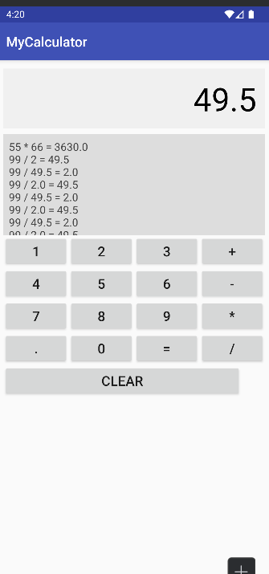

1. UI with new buttons like . and CLEAR
2. Error message on division by zero

