Create a professional modern horizontal logo for a wildlife conservation website named exactly “BUSTARD BEACON”.

The logo should feature a solid black silhouette of a Great Indian Bustard bird standing with its long legs, long neck, distinctive body and tail. Place the bird inside a simple circular golden-orange sun shape on the LEFT side of the logo.

On the RIGHT side, place the exact text:

BUSTARD
BEACON

Stack the two words vertically. Use bold, expressive hand-painted brush typography with a slightly rough natural brush texture. Make “BUSTARD” black and “BEACON” golden-orange. The typography should feel strong, memorable, energetic, and suitable for a wildlife conservation organization.

Keep the bird and orange sun compact on the left, with the text clearly positioned on the right. Maintain excellent visual balance, clean spacing, and a professional horizontal composition.

Style: minimalist wildlife conservation logo, flat vector-style graphic, bold black silhouette, golden-orange accent, clean white background, modern branding, high contrast, sharp edges, simple and recognizable.

The final logo must contain ONLY:
- the Great Indian Bustard silhouette
- the golden-orange circular sun
- the words “BUSTARD BEACON”

Do not add any tagline, slogan, extra symbols, extra words, scenery, trees, mountains, people, borders, mockups, shadows, 3D effects, gradients, or photographs.

The spelling must be EXACTLY:
BUSTARD BEACON

Generate a high-resolution, crisp, professional logo suitable for use in a website navigation bar, desktop website header, mobile header, social media profile, and official branding.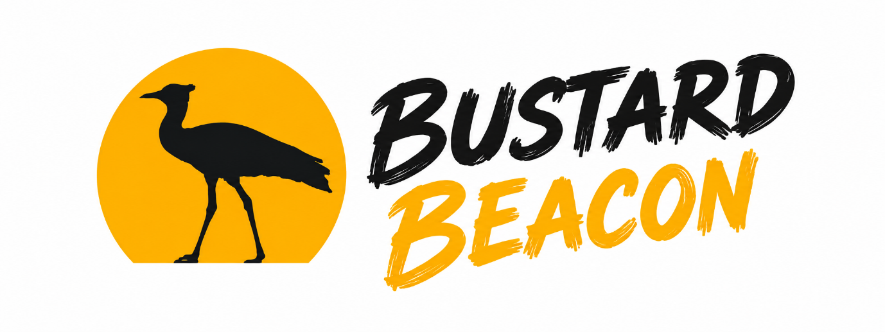

1. Great Indian Bustard
- Scientific Name: Ardeotis nigriceps
- Description: A flagship grassland species and one of the heaviest flying birds in the world. It is easily recognized by its large size, horizontal body, long white neck, and distinct black crown. Endemic to the Indian subcontinent, it is now critically endangered.
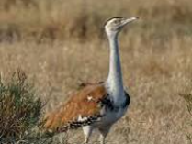

Great Indian bustard - Wikipedia
Wikipedia

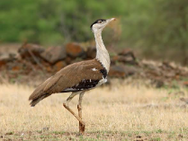

Great Indian bustard | Natural History, Conservation Status, & Facts ...
Britannica

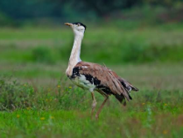

The Rann, Thar, and the Great Indian Bustard I Roundglass Sustain
Roundglass Sustain

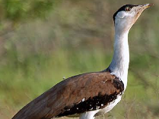

Birds of India - Indian Bustard - Ardeotis nigriceps - Otididae ...
Bird watching

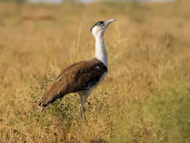

Great Indian Bustard - Ardeotis nigriceps - Birds of the World
Birds of the World

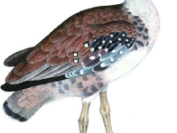

Great Indian Bustard, Ardeotis nigriceps. This painting appears in ...
ResearchGate

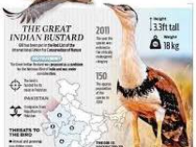

Great Indian Bustards
Drishti IAS

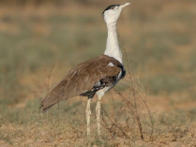

Great Indian Bustard Ardeotis nigriceps
eBird

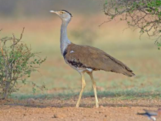

The Great Indian Bustard (Ardeotis nigriceps), a critically ...
ResearchGate

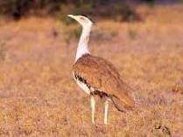

Great Indian Bustard | State of India's Birds
State of India's Birds

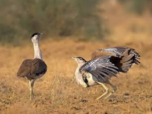

The Great Indian Bustard Project
Rural India Supporting Trust

2. Lesser Florican
- Scientific Name: Sypheotides indicus (or Sypheotides indica)
- Description: The smallest member of the bustard family. Males feature an entirely black head and neck adorned with distinct ribbon-like feathers curved upward from behind the ears. They are famous for their remarkable vertical leaping displays during the monsoon breeding season.
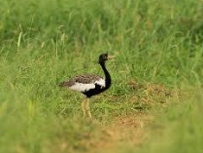

Lesser florican - Wikipedia
Wikipedia

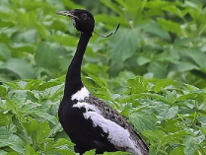

Lesser Florican Sypheotides indicus Species Factsheet | BirdLife ...
DataZone | BirdLife - BirdLife International

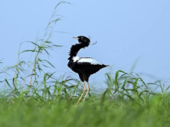

Lesser Florican - Sypheotides indicus - Birds of the World
Birds of the World

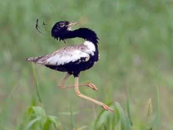

Lesser Florican - eBird
eBird

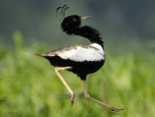

Lesser Florican - Sypheotides indicus - Birds of the World
Birds of the World

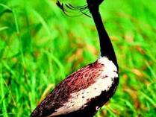

Distribution, Status and Conservation of Lesser Florican ...
Springer Nature

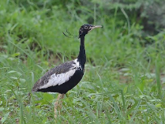

Lesser Florican / Sypheotides indicus photo call and song
DiBird.com

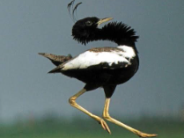

The Land Of The Lesser Florican — Nature inFocus
Nature inFocus

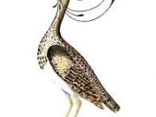

Lesser florican - Wikipedia
Wikipedia

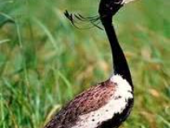

Lesser Florican | Animal Database | Fandom
Animal Database - Fandom

3. Bengal Florican
- Scientific Name: Houbaropsis bengalensis
- Description: A rare and elusive bustard heavily adapted to the alluvial, tall grasslands of northern and northeastern India. Males showcase striking jet-black plumage with pure white wings that contrast vividly when in flight. It faces extreme threats from habitat fragmentation.
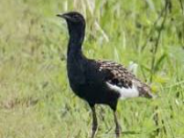

Bengal florican - Wikipedia
Wikipedia

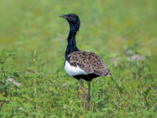

Bengal Florican - Houbaropsis bengalensis - Birds of the World
Birds of the World

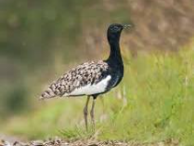

File:Bengal Florican (Houbaropsis bengalensis bengalensis ...
Wikimedia Commons

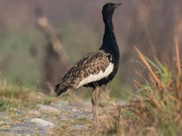

Bengal Florican - eBird
eBird

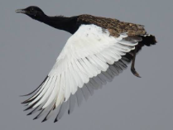

Bengal Florican Houbaropsis bengalensis Species Factsheet ...
BirdLife Data Zone - BirdLife International

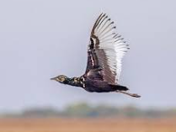

Bengal florican - Wikipedia
Wikipedia

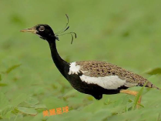

Bengal Florican,Male Houbaropsis bengalensis
Facebook

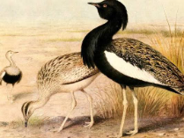

Bengal Florican - India's Endangered
India's Endangered

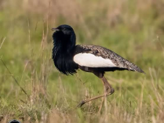

A Bengal Florican (Houbaropsis bengalensis) also known as Bengal ...
Facebook

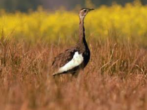

Bengal Florican - eBird
eBird

4. Macqueen's Bustard
- Scientific Name: Chlamydotis macqueenii
- Description: Also known as the Asian Houbara. Unlike the other three resident species, it is a winter migrant to India, settling in the hyper-arid deserts and salt flats of Rajasthan and Gujarat. It features cryptic sandy-buff coloration perfectly designed for camouflage against desert terrain.
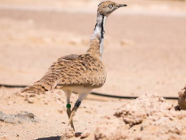

Macqueen's Bustard (Houbara Bustard) - eBird
eBird

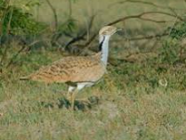

Asian houbara - Wikipedia
Wikipedia

