1. In the below elements which of them are values or an expression? eg:- values can be integer or string and expressions will be mathematical operators.

*

**Ans.**  is a expression

'hello'

**Ans.**  is a value

-87.8

**Ans.**  is a value

-

**Ans.**  is a expression

/

**Ans.**  is a expression

+

**Ans.**  is a expression

6

**Ans.**  is a value

2. What is the difference between string and variable?

**Ans.**  String is a value given to the variable whereas variable is assigned to the string value.

3. Describe three different data types.

Tuple, List, Dictionary, Set etc.,

4. What is an expression made up of? What do all expressions do?

**Ans.**  Expression is made up of operands, operators and results.

Eg. A(operand) +(operator) B = 10(Result)

5. This assignment statements, like spam = 10. What is the difference between an expression and a statement?

**Ans.**  Spam = 10 is a statement

a + 7 = 10 is a expression

6. After running the following code, what does the variable bacon contain?

bacon = 22

bacon + 1

**Ans.**  After running code variable bacon gives 22. As value is stored/assigned for variable bacon. And, in case of bacon +1 becomes expression which is not assigned to anything, so the value comes 22.

7. What should the values of the following two terms be?

'spam' + 'spamspam'

**Ans.**  'spam' + 'spamspam' = 'spamspamspam'

'spam' * 3 = 'spamspamspam'

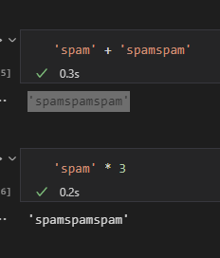

8. Why is eggs a valid variable name while 100 is invalid?

**Ans.**  Because Python will treat 100 as integer value

9. What three functions can be used to get the integer, floating-point number, or string version of a value?

Ans.

a = 123

print(int(a))

a = 123

print(float(a))

a = 123

b = str(a)

print(b)

10. Why does this expression cause an error? How can you fix it?

'I have eaten ' + 99 + ' burritos.'

Ans. By we can convert int into string and it will work.

'I have eaten ' + '99' + ' burritos.'