1.What are the two values of the Boolean data type? How do you write them?

Ans. T**rue and False**

2. What are the three different types of Boolean operators?

Ans. **And, or, not, isnot etc.,**

3. Make a list of each Boolean operator's truth tables (i.e. every possible combination of Boolean values for the operator and what it evaluate ).

Ans.

|  |  |  |  |
| --- | --- | --- | --- |
| Variable A | Variable B | and | or |
| T | T | T | T |
| T | F | F | T |
| F | T | F | T |
| F | F | F | F |

not

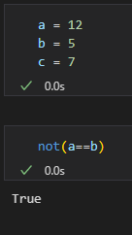

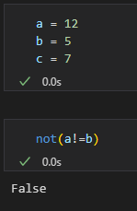

== (equal to)

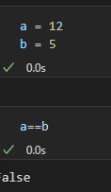

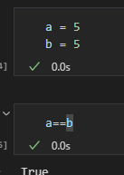

!= (not equal to)

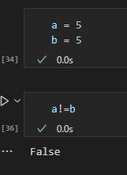

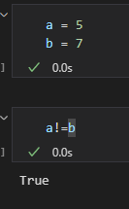

4. What are the values of the following expressions?

(5 > 4) and (3 == 5) **False**

not (5 > 4) **False**

(5 > 4) or (3 == 5) **True**

not ((5 > 4) or (3 == 5)) **False**

(True and True) and (True == False) **False**

(not False) or (not True) **True**

5. What are the six comparison operators?

Ans. **<, >, =<, =>, ==, !=**

6. How do you tell the difference between the equal to and assignment operators? Describe a condition and when you would use one.

Ans.

**Equal to** with double equal sign“ == ” It is used as bool, it give True or False based on condition.

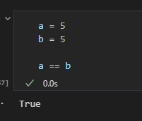

**Assigned to** a variable with single “=”

7. Identify the three blocks in this code:

Ans.

**First block:**

spam = 0

if spam == 10:

print('eggs')

if spam > 5:

print('bacon')

else:

print('ham')

**Second block**

print('spam')

**Third Block**

print('spam')

8. Write code that prints Hello if 1 is stored in spam, prints Howdy if 2 is stored in spam, and prints Greetings! if anything else is stored in spam.

Ans.

spasm = int(input())

if spasm == 1:

    print("Hello")

elif spasm == 2:

    print("Howdy")

else:

    print("Greetings!")

9.If your programme is stuck in an endless loop, what keys you’ll press?

Ans. **Ctrl + C**

10. How can you tell the difference between break and continue?

Ans. **Iteration stops where we have given break point.**

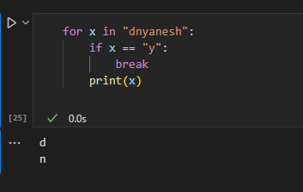

**And in case of continue; iteration skips the condition and completes the loop.**

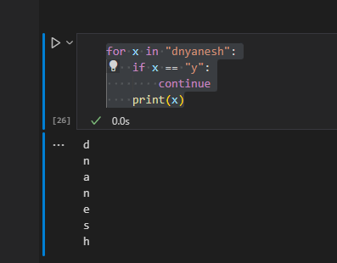

11. In a for loop, what is the difference between range(10), range(0, 10), and range(0, 10, 1)?

Ans.

**Range is a inbuilt function which gives numbers from default 0 in case of range(10).**

**range(0,10) defines, starts at 0 and go upto 10 th index which is 9.**

**Range(0,10,1) here, the last numbers suggests skipping the indexes by last number count.**

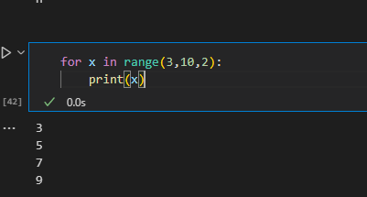

12. Write a short program that prints the numbers 1 to 10 using a for loop. Then write an equivalent program that prints the numbers 1 to 10 using a while loop.

Ans.

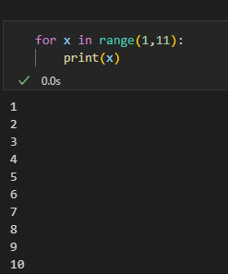

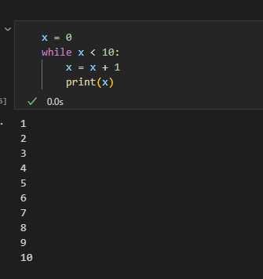

13. If you had a function named bacon() inside a module named spam, how would you call it after importing spam?

Ans. **spam.bacon()**