**Don Bosco Institute of Technology**

Kurla (W), Mumbai 400 070

**Internet Programming**

Name: Suhani Desale

Class: TE-IT

Roll no.: 11

Date : 08/10/2022

**Experiment no. 1**

**Title:** Design a Basic web page using HTML5

**Problem Definition:** Design a Basic Web page using [HTML](https://elearn.dbit.in/mod/folder/view.php?id=382) 5 tags Head, Body, Hyperlink, Formatting styles, Images and Table.

**Pre-requisites:** Basic HTML and Tags

**Theory:** HTML stands for Hypertext Markup Language. It is used to design web pages using a markup language. HTML is the combination of Hypertext and Markup language. Hypertext defines the link between web pages. A markup language is used to define the text document within the tag which defines the structure of web pages.

**Head :** The <head> element is a container for metadata (data about data) and is placed between the <html> tag and the <body> tag.

Metadata is data about the HTML document. Metadata is not displayed. Metadata typically defines the document title, character set, styles, scripts, and other meta information.

**Body :** The <body> tag defines the document's body.

The <body> element contains all the contents of an HTML document, such as headings, paragraphs, images, hyperlinks, tables, lists, etc.

**Hyperlink :** HTML links are hyperlinks.You can click on a link and jump to another document.When you move the mouse over a link, the mouse arrow will turn into a little hand.

**Images :** The HTML <img> tag is used to embed an image in a web page.Images are not technically inserted into a web page; images are linked to web pages. The <img> tag creates a holding space for the referenced image.

**Table :** A table in HTML consists of table cells inside rows and columns.Each table cell is defined by a <td> and a </td> tag.

**Procedure:**

1. Open any text editor
2. Write some HTML Code
3. Save the file with name ending .HTML
4. Open the HTML Page in your browser

**Program:**

<!DOCTYPE html>

<html lang="en">

<head>

<meta charset="UTF-8" />

<meta http-equiv="X-UA-Compatible" content="IE=edge" />

<meta name="viewport" content="width=device-width, initial-scale=1.0" />

<link rel="stylesheet" href="https://cdnjs.cloudflare.com/ajax/libs/font-awesome/4.7.0/css/font-awesome.min.css">

<title>Suhani</title>

<link rel="stylesheet" href="style.css">

</head>

<body>

<h1></h1>

<nav class="navigation container">

<div class="nav-brand">Suhani Desale</div>

<ul class="list-non-bullet nav-pill">

<li class="list-item-inline"><a class="link link-active" href="/">Home</a></li>

<li class="list-item-inline"><a class="link" href="#projects">Project</a></li>

<li class="list-item-inline"><a class="link" href="#social">Socials</a></li>

</ul>

</nav>

<header class = "main-image">

<img class="main-imagefinal" src="res/undraw_proud_coder_7ain.svg" alt="">

<!-- <h2 class="heading-image"> I am Programmer and Web Developer</h2>

<h3 class="about-me"> Currently I am Currently learning DSA along with languages like Java and Python </h3> -->

</header>

<section>

<div class="fulloffwhite">

<h1 class="offwhite">

I am Programmer and Web Developer

</h1>

<p class="offwhite-sect">

Currently I am Currently learning DSA along with languages like Java and Python

</p>

</div>

</section>

<h2> </h2>

<h2> </h2>

<section>

<div id="projects"></div>

<div class="fullwhite">

<h1 class="white">

Projects

</h1>

<p class="white-sect">

<p><a class="link_proj" href="https://suhanidesale.github.io/minion-js/">Minion Speaks</a></em></p>

<p><a class = "link_proj"href="https://replit.com/@suhanidesale/Samplequiz#index.js">Quiz Application</a></em></p>

<p><a class = "link_proj"href="https://suhanidesale.github.io/Random-Quote-Generator/">Random Quote Generator</a></em></p>

</p>

</div>

</section>

<h2> </h2>

<section>

<div id = "social"></div>

<footer class="navigation container">

<div class="nav-brand">Contact Me</div>

<ul class="list-non-bullet nav-pill">

<li class="list-item-inline"><a class="link link-active" href="https://www.linkedin.com/in/suhani-desale/"><i class="fa fa-linkedin-square"></i></a></li>

<li class="list-item-inline"><a class="link link-active" href="https://github.com/suhanidesale"><i class="fa fa-github-square"></i></a></li>

<li class="list-item-inline"><a class="link link-active" href="https://www.instagram.com/suhani_desale/"><i class="fa fa-instagram"></i></a></li>

</ul>

</footer>

</section>

<div style="height: 40vh;"></div>

</body>

</html>

**Output:**

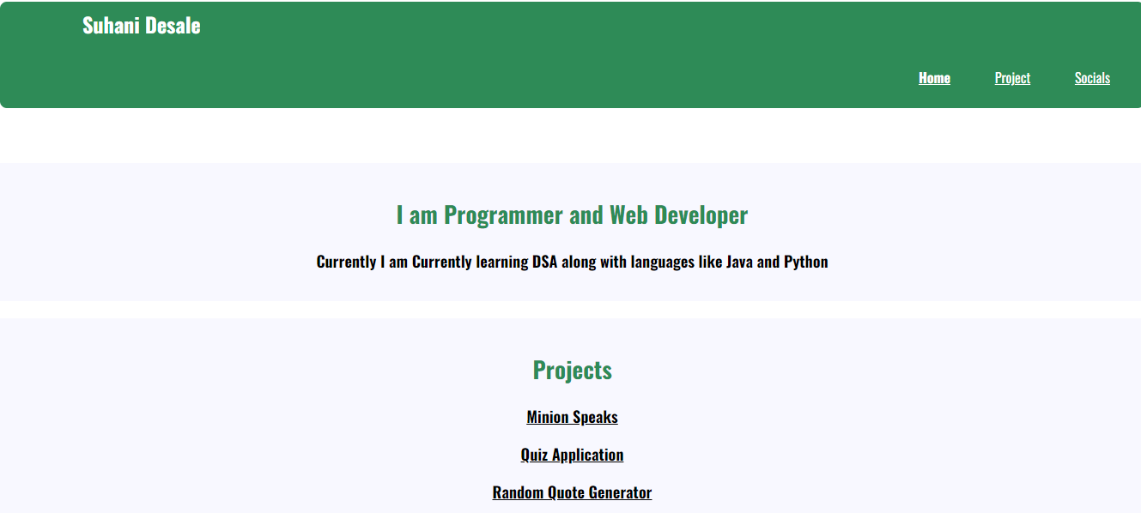

**Results:** A Basic HTML Web page using tags Head, Body, Hyperlink, Formatting styles, Images and Table is demonstrated successfully in this experiment.

**References:**

1. [HTML Introduction - GeeksforGeeks](https://www.geeksforgeeks.org/html-introduction/)
2. [HTML Styles (w3schools.com)](https://www.w3schools.com/html/html_styles.asp)