Q1. Create an abstract class pen with methods write () and refill () as abstract methods

Use the pen class from to create a concrete class fountain pen with additional method change Nib ()Create a class monkey with jump ( ) and bite ( ) methods

Create a class human whichinherits this monkey class

and another abstract class basicanimal i with eat ( ) and sleep methods

Create a class telephone with ( ) , lift ( ) and disconnected ( ) methods as abstract methods create another class smart telephone and demonstrate polymorphism Demonstrate polymorphism using using monkey

clss from

Q2. Write a class Worker and derive classes DailyWorker and SalariedWorker from it.

Every worker is has a name and a salary rate. Write method ComPay( int hours) to computethe week pay of every worker.

A DailyWorker is paid on the basis of number of days s/he work.

The SalariedWorker g ets paid the wage for 40 hours a week no matter what actual hours is.

Test this program to calculate the pay of workers. You are expected to use concept of polymorphism to write this program.

Q3. Suppose that we are required to model students and teachers in our application. We can define a superclass called Person to store common properties such as name and address, and subclasses Student and Teacher for their specific properties. For students, we need to maintain the courses taken and their respective marks,   
For teachers, we need to maintain the courses taught currently.  
Return false if course is already exit   
Return false if course doesn't exit

**Question 1**

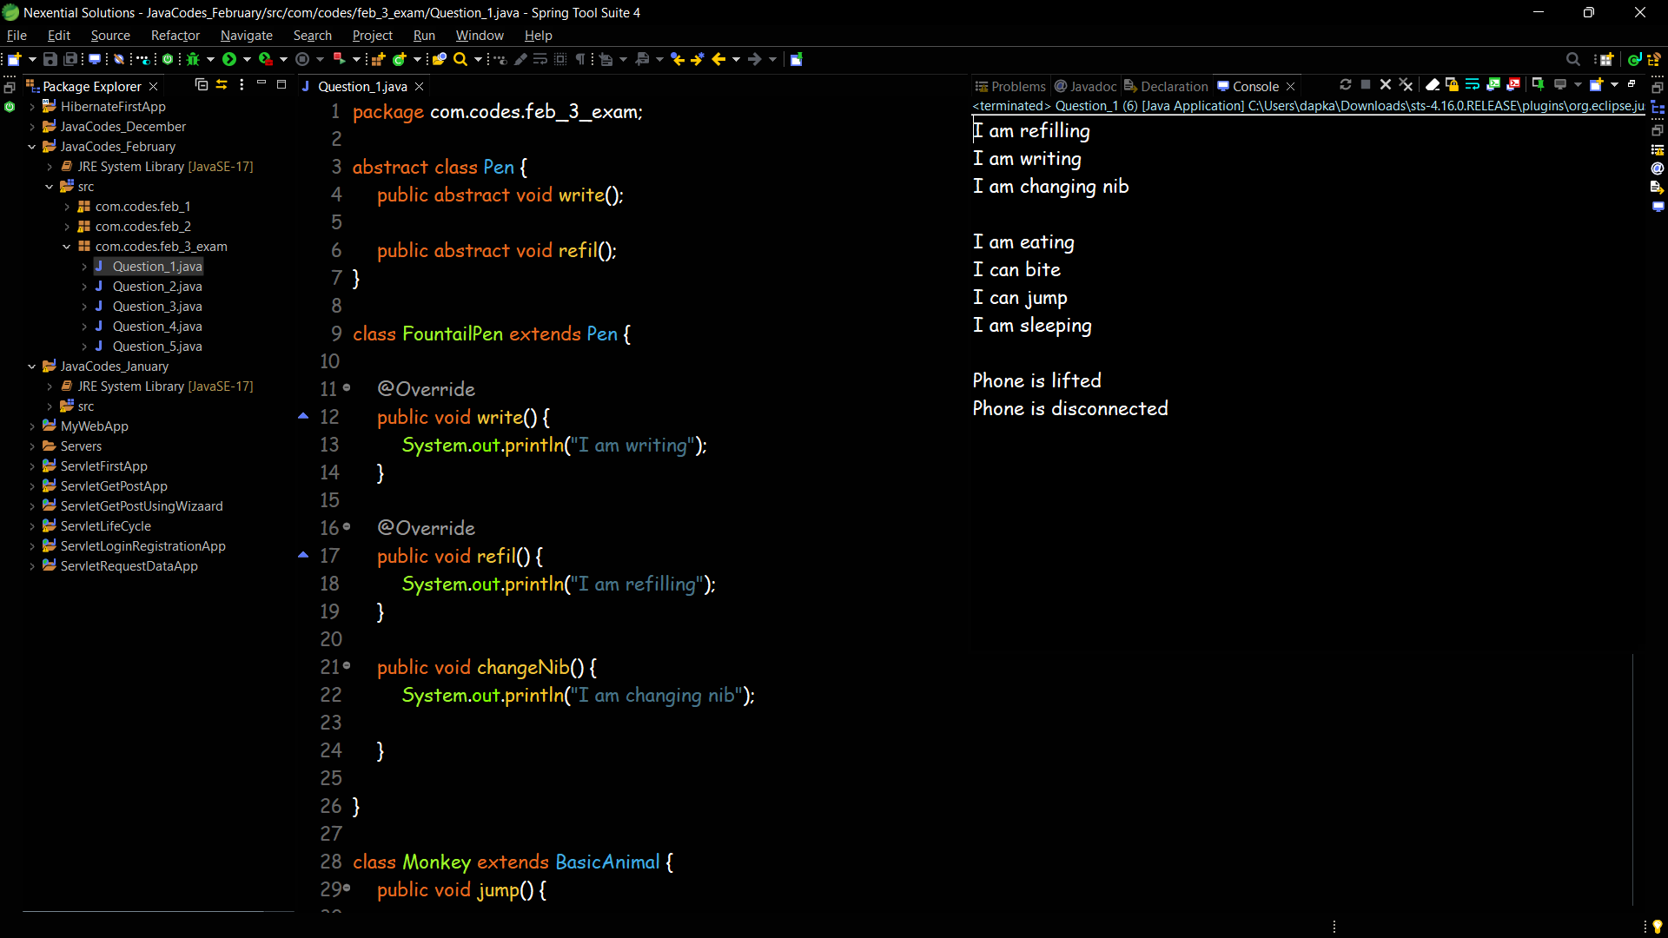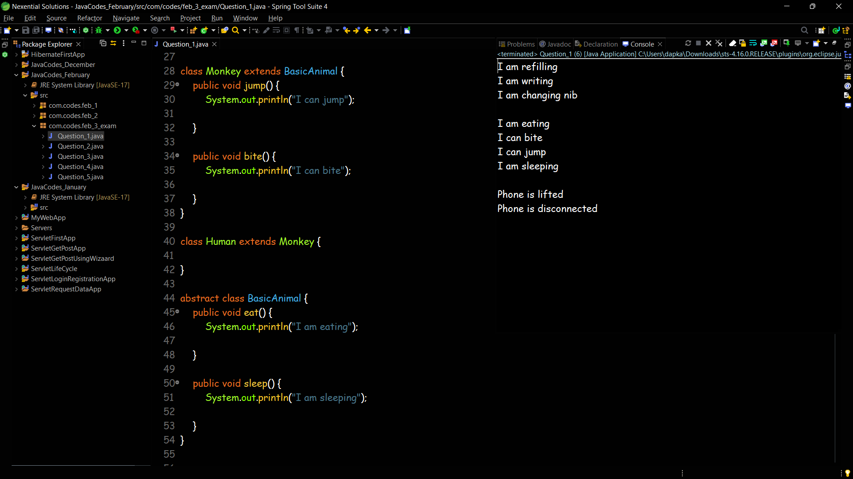

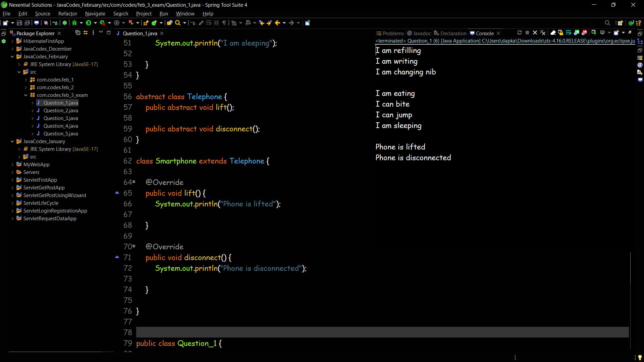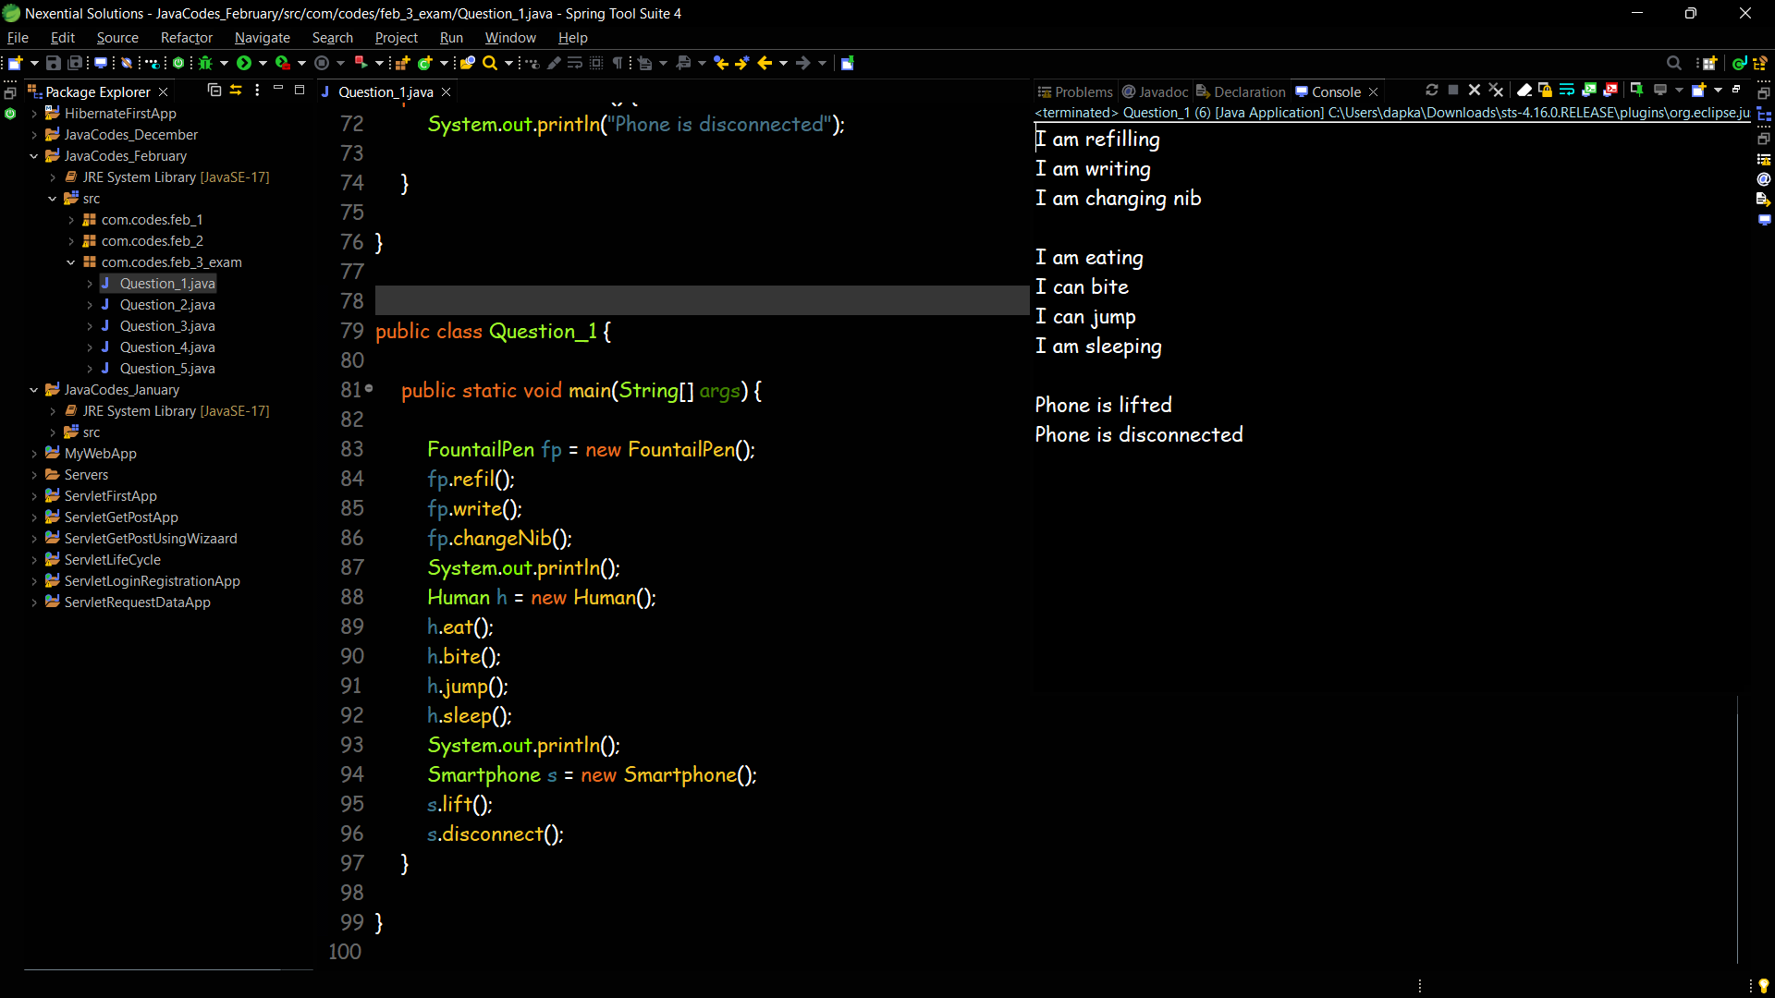

**Question 2**

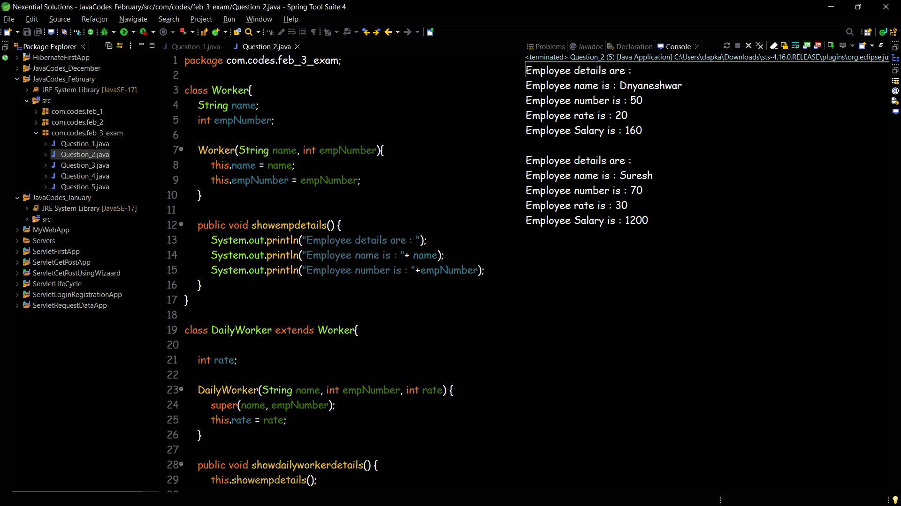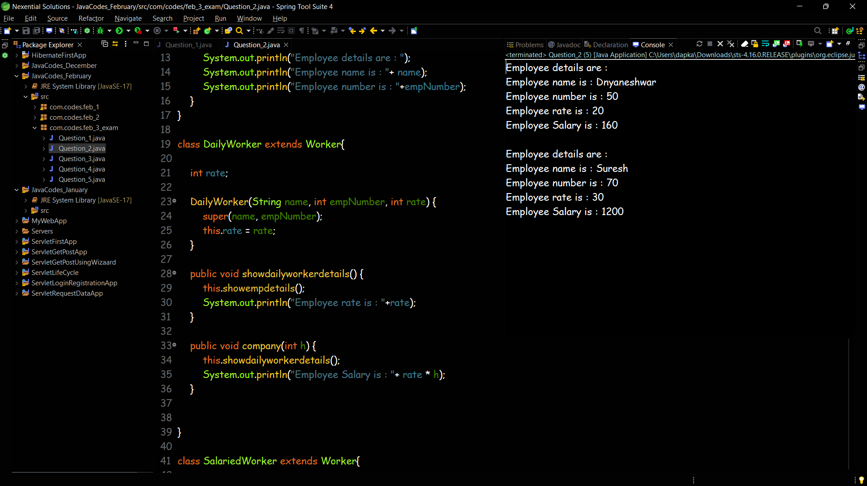

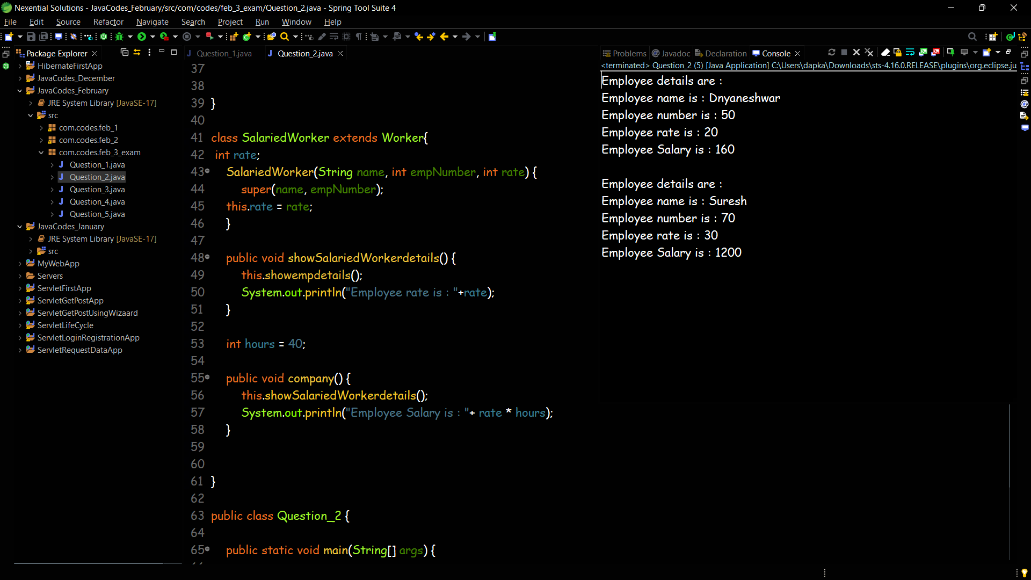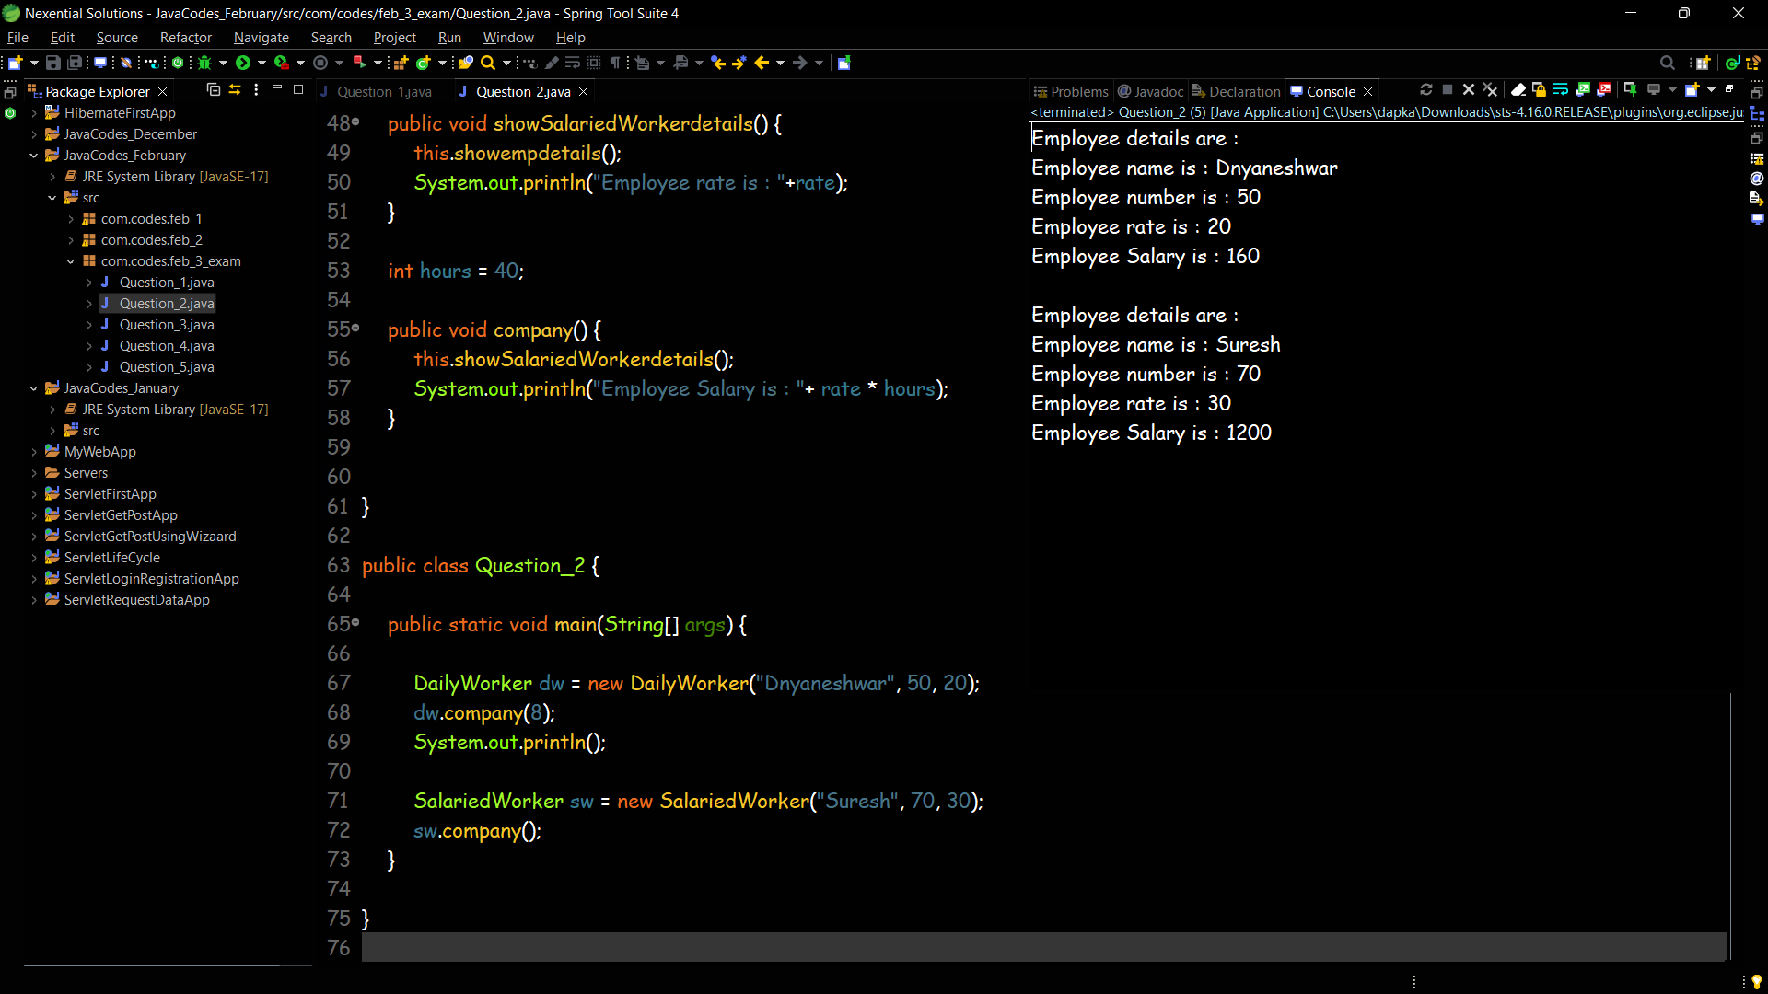

**Question 3**

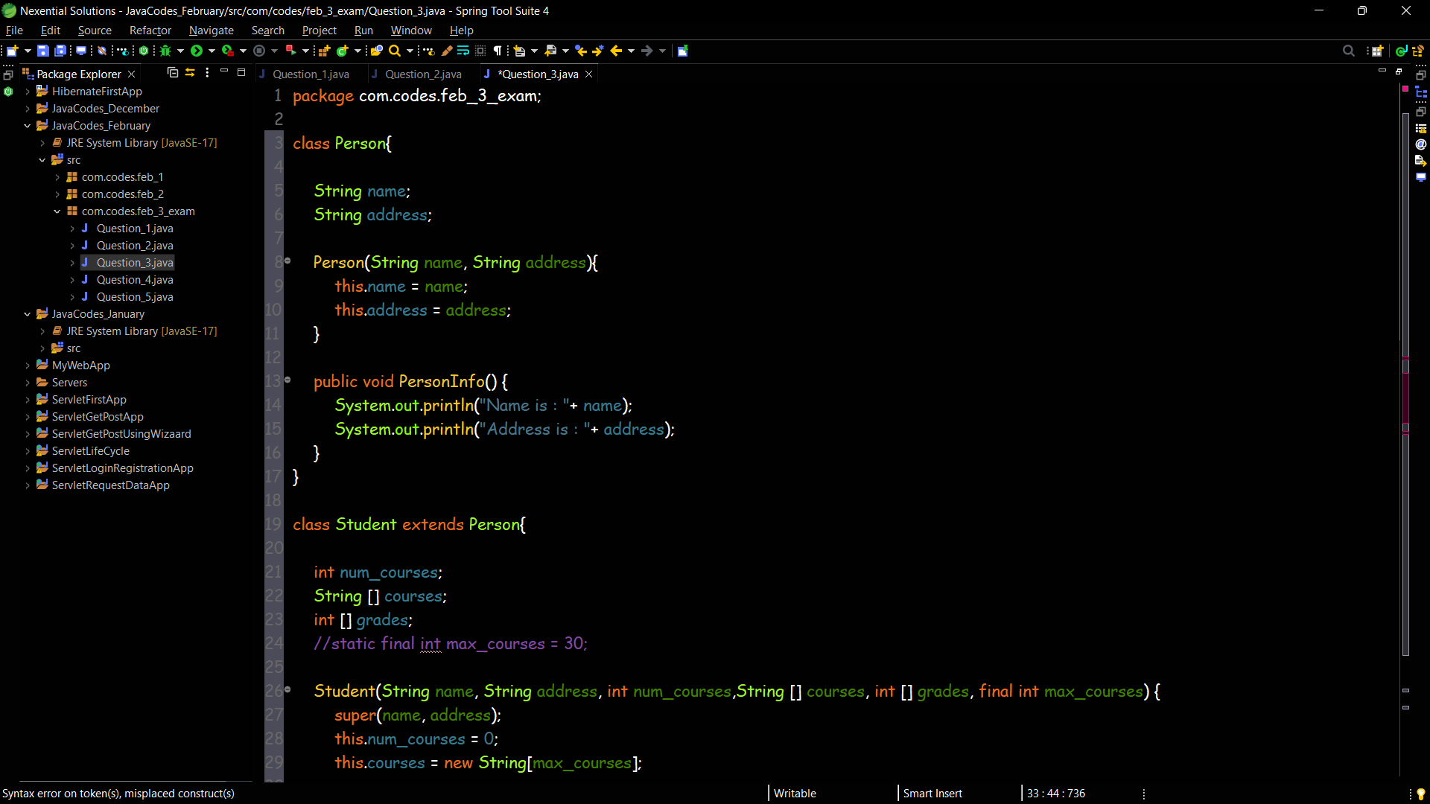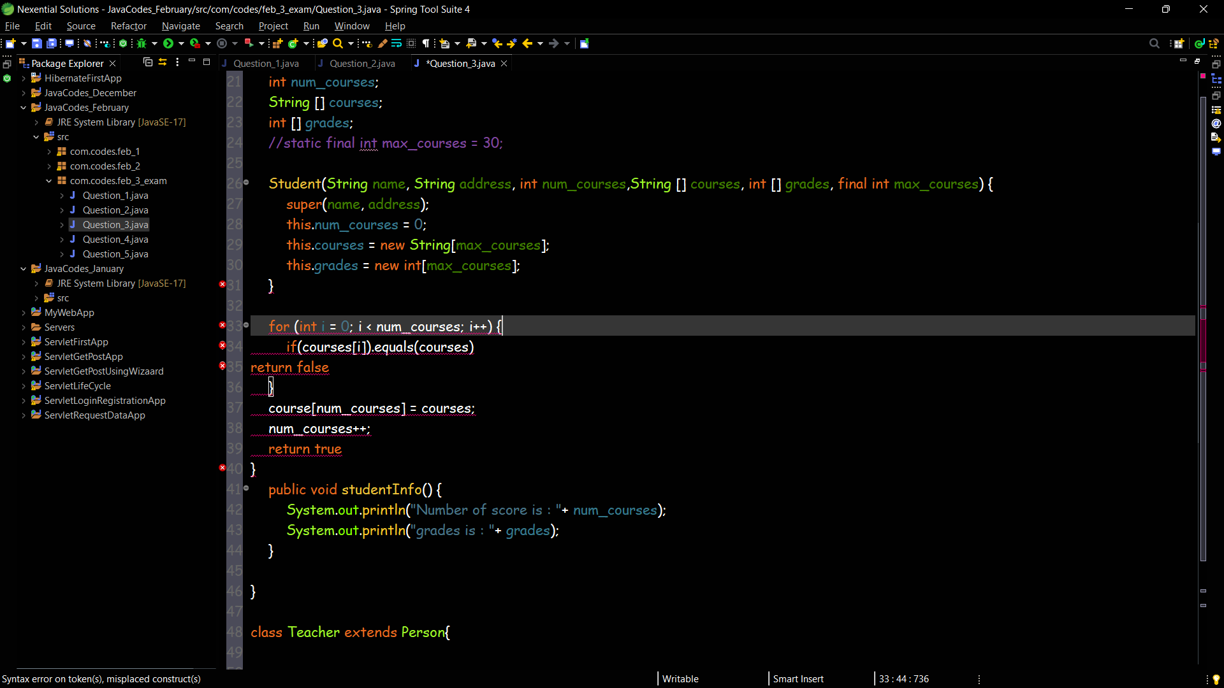

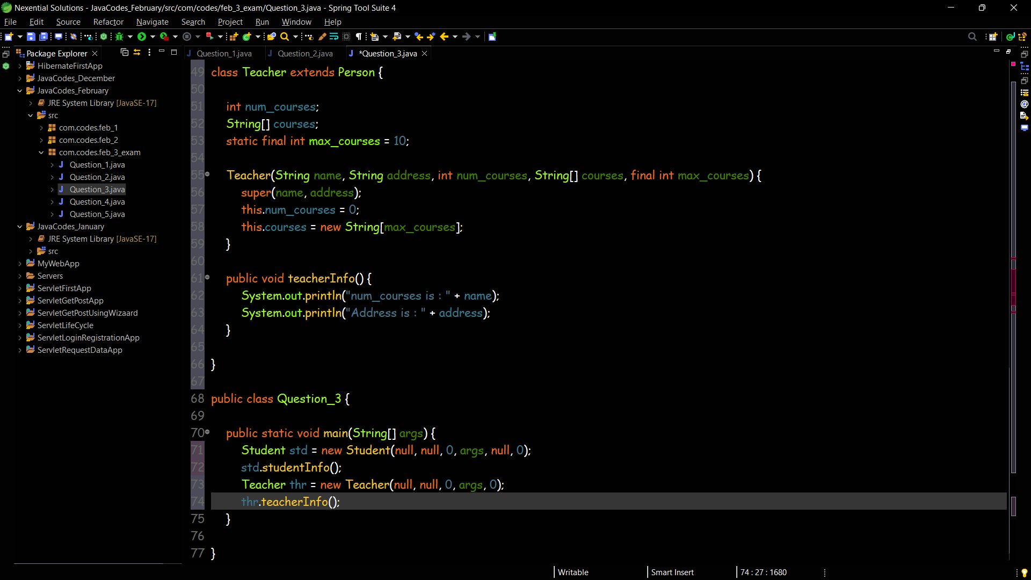

**Question 4**

