**Questions**

Q1. write a program to implement multithreading concepts.create 2 threads with name as 'child thread' and 'main thread' print the value in the reverse order check whether current thread is active or not if it's complete it's execution or it is not in active stateprint current thread name along with message thread is exiting apply sleep and join method and display output with and without use of above mentioned method

Q2. Java Program to check the validity of a Password using User Defined Exception Password checker program basically checks if the password is valid or not based on password policies mention below: Password should not contain any space. Password should contain at least one digit(0-9). Password length should be between 8 to 15 characters. Password should contain at least one lowercase letter(a-z). Password should contain at least one uppercase letter(A-Z). Password should contain at least o

Q3. Write a Java program to perform employee payroll processing using packages. In the java file, Emp.java

creates a package employee and creates a class Emp.

Declare the variables name,empid, category, bpay, hra, da, npay, pf, grosspay, incometax, and allowance.

Calculate the values in methods.

Create another java file Emppay.java. Create an object e to call the methods to perform and print values.

da = bpay*0.05; hra = bpay*0.09;

pf = bpay*0.11;

allowance = bpay*0.10;

grosspay = bpay+da+hr

Q4. Imagine a couple, Ranjeet and Reema, who both have access to the account and want to make withdrawals. But they don't want the account to ever be overdrawn. Below AccountTesting.java class will start two threads and both threads trying to withdraw money from the same account object in the loop. Withdrawal is two steps process : Check the balance. If there's enough in the account (withdraw10), make the withdrawal.

**Question 1**

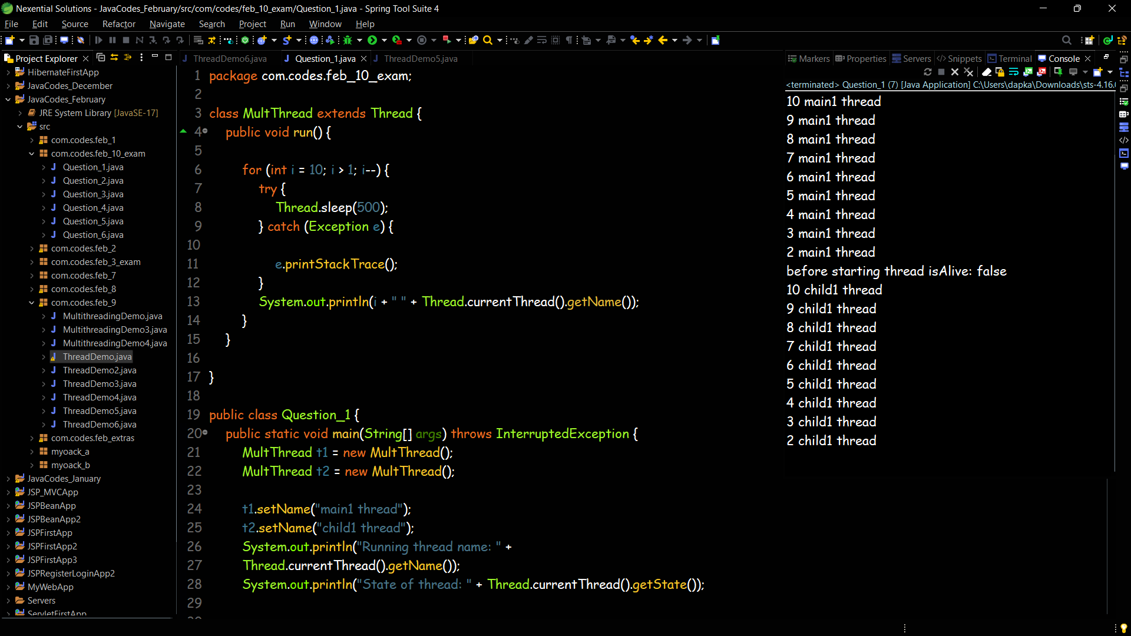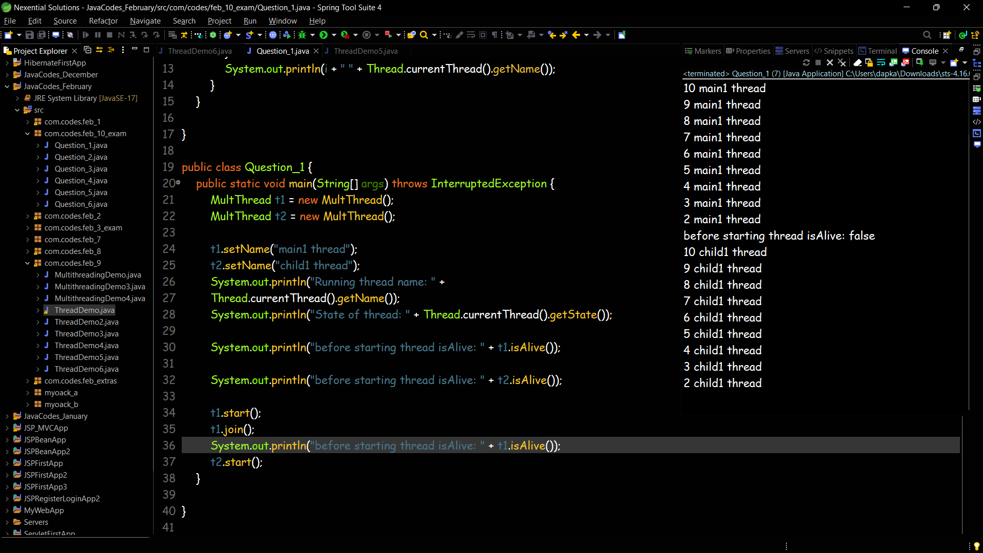

**Question 2**

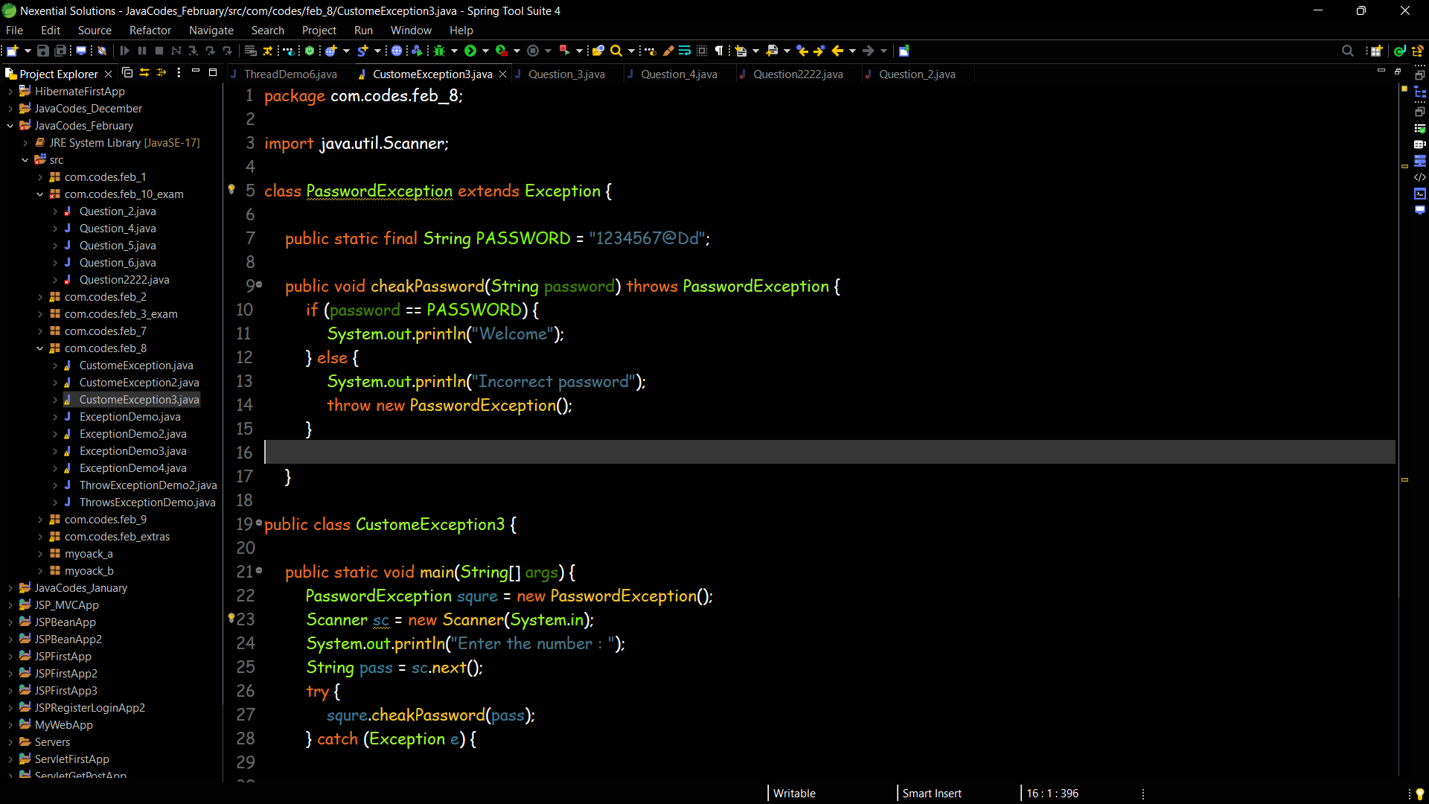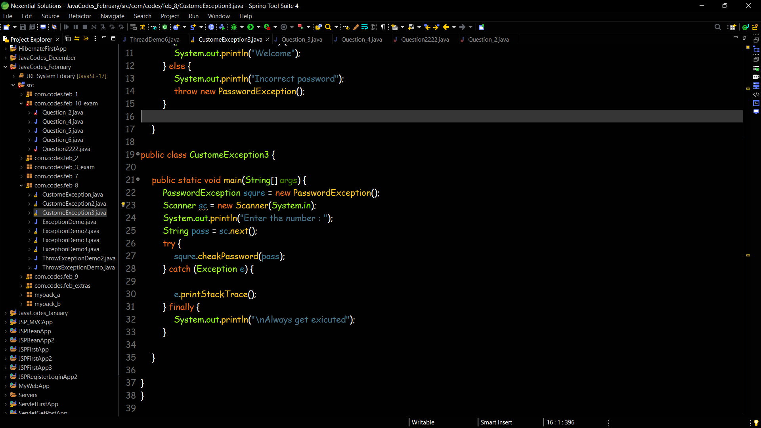

**Question 3**

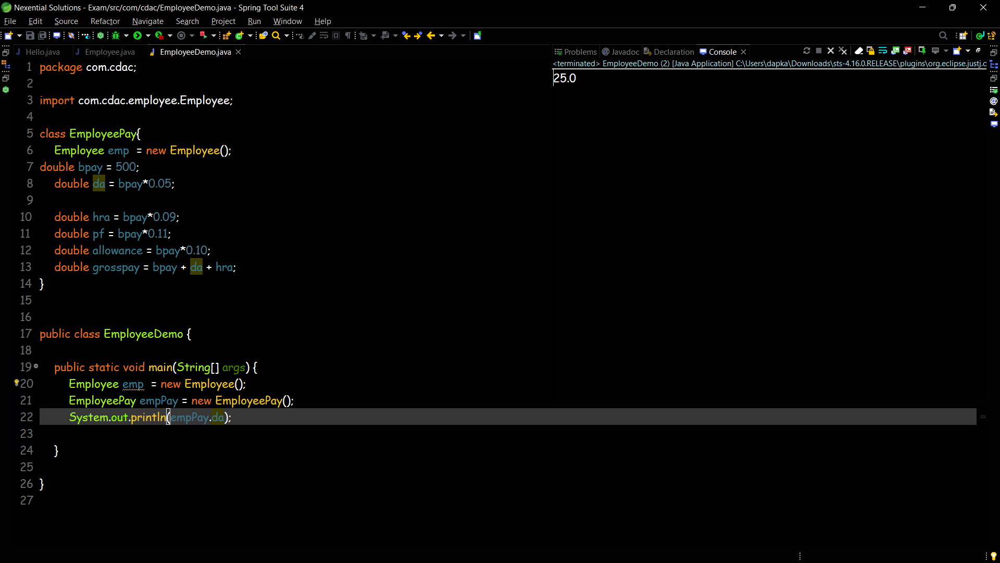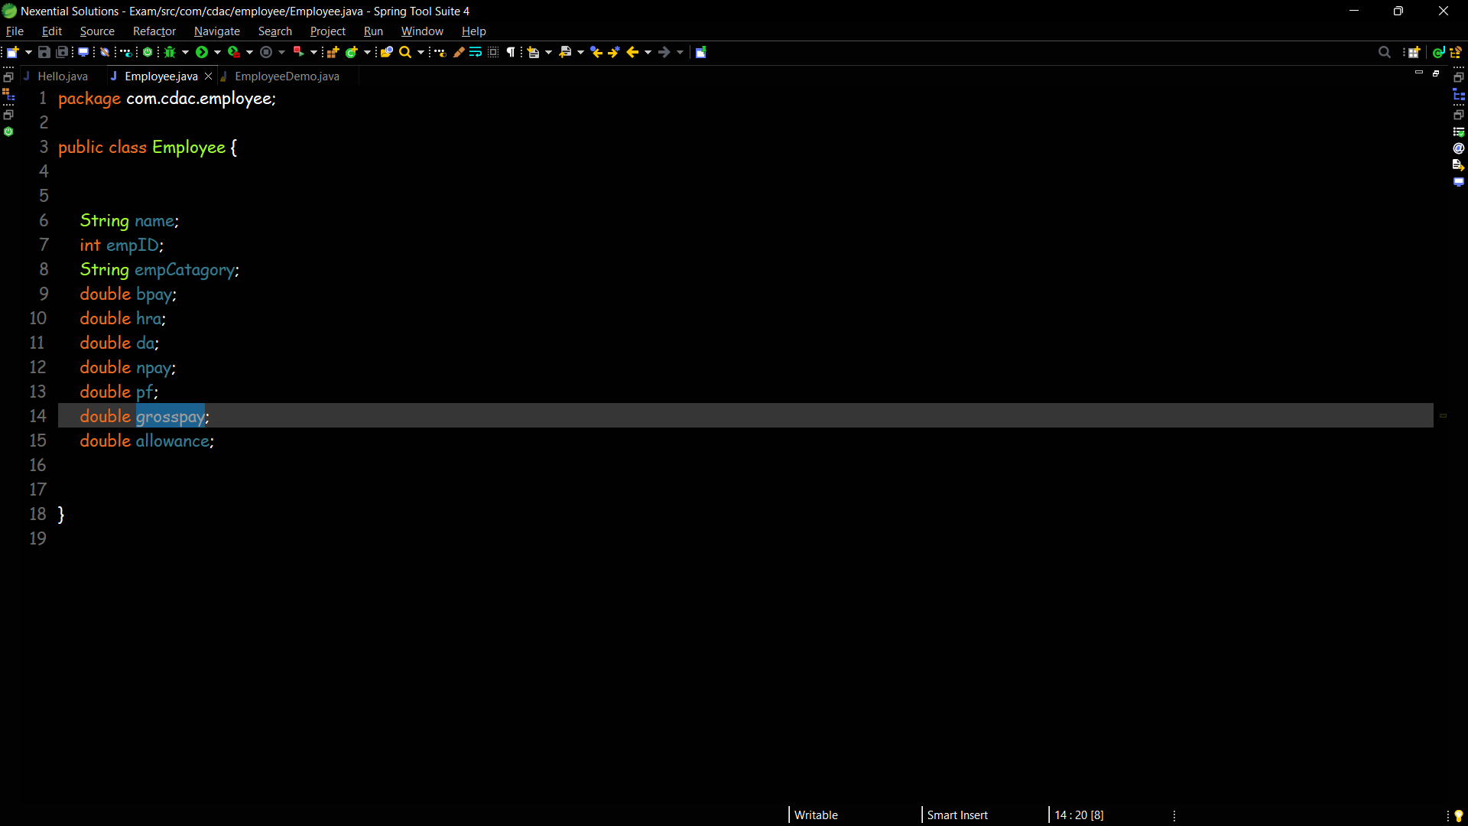

**Question 4**

