**Question 1**

Write a do-while loop that asks the user to enter two numbers. The numbers should be added and the sum displayed. The loop should ask the user whether he or she wishes to perform the operation again. If so, the loop should repeat; otherwise it should terminate.

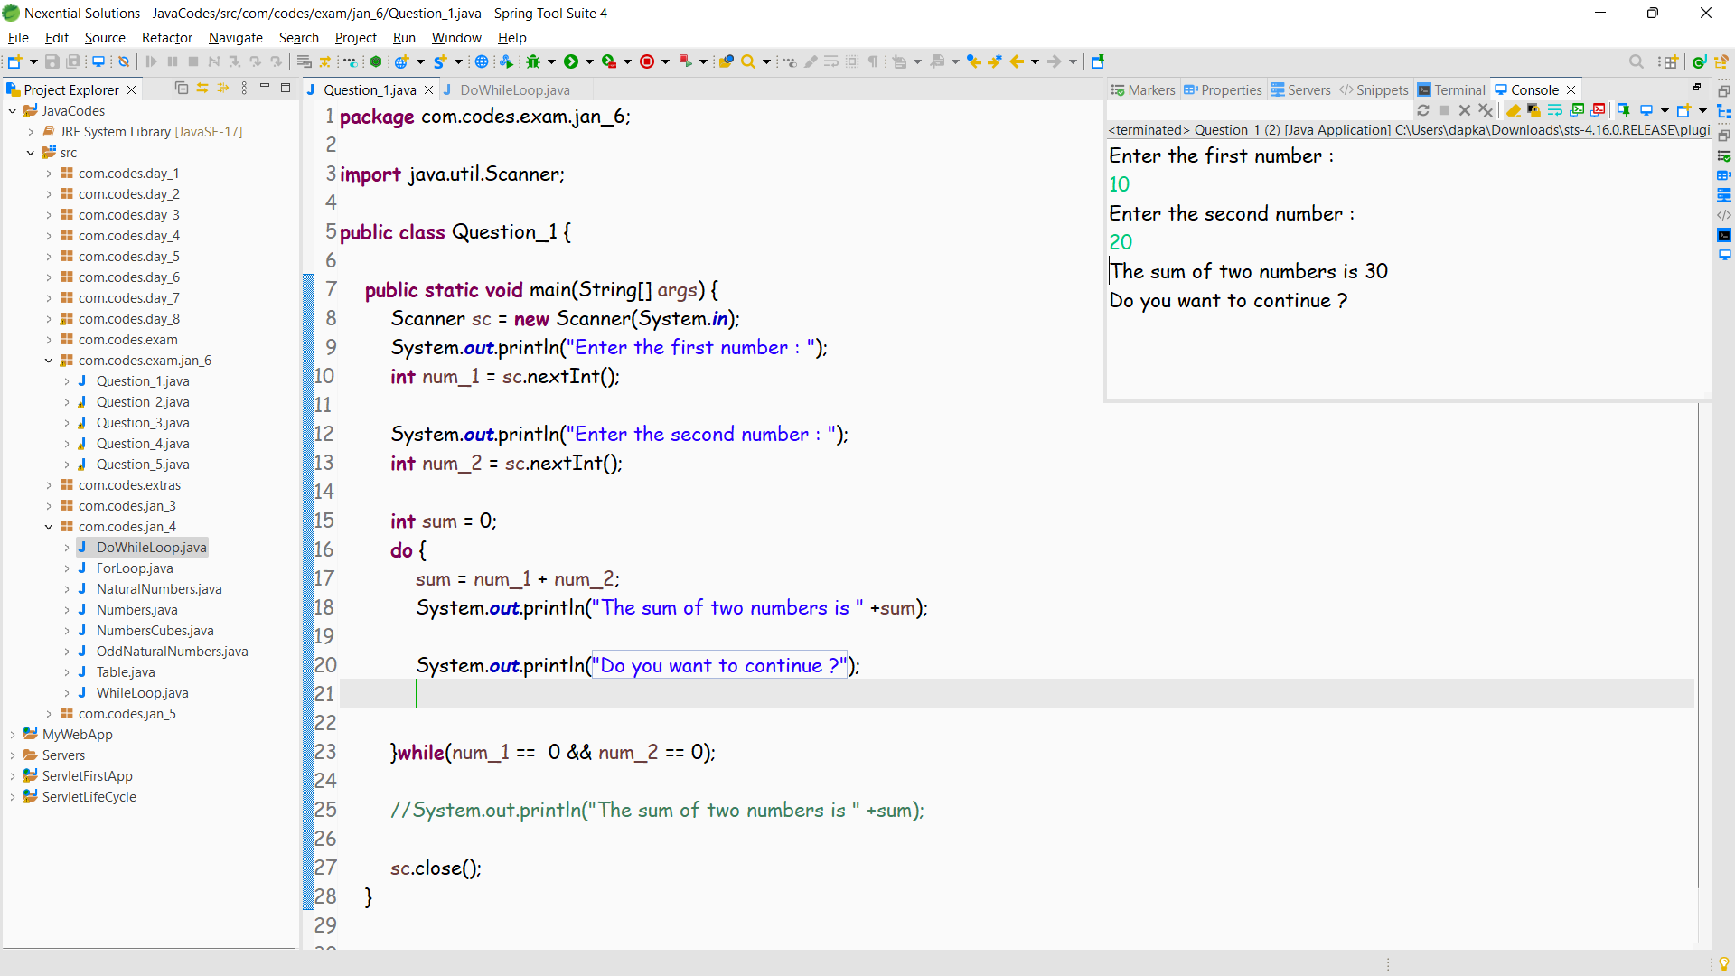

**Question 2**

You are to write a program that generates the second, third, and fourth powers of a list of whole numbers from 1 to n where n is input by the user.

n n^2 n^3 n^4

1 1 1 1

2 4 8 16

3 9 27 81

4 16 64 256

5 25 125 625

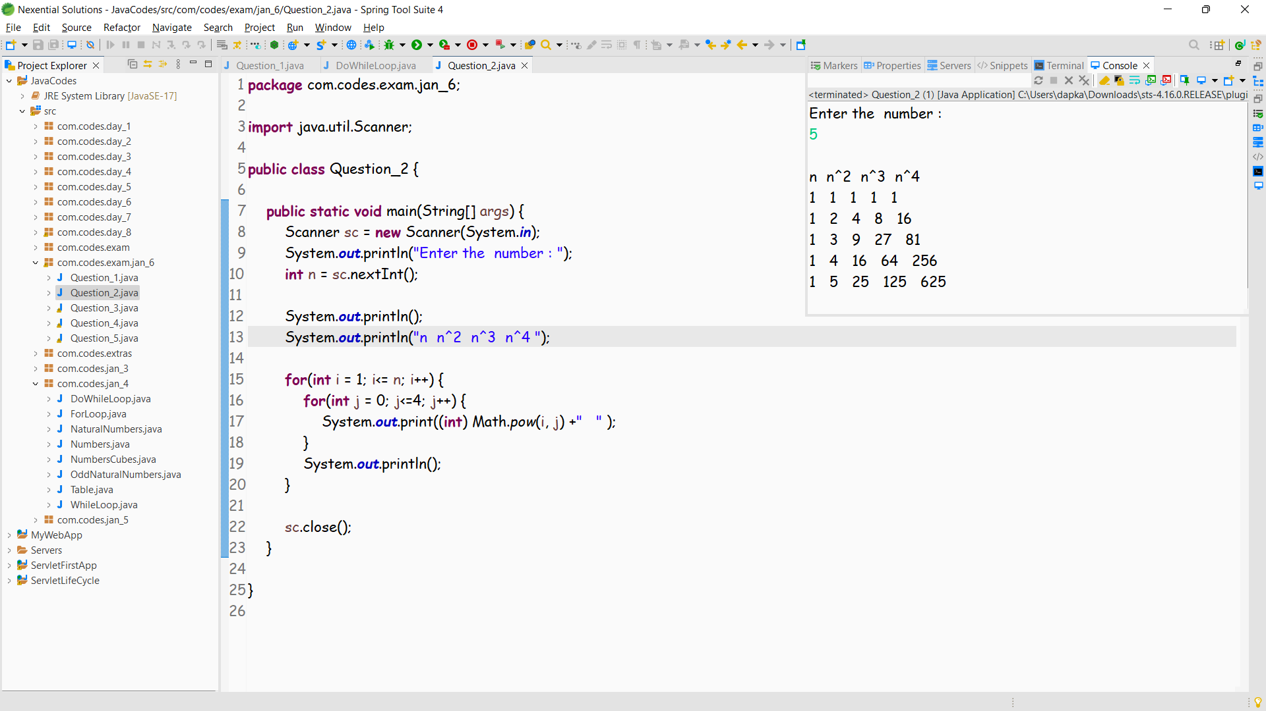

**Question 3**

As activity directory at Lake LazyDays Resort, it is your job to suggest appropriate activities to guests based on the weather: temp >= 80: swimming 60 <= temp < 80: tennis 40 <= temp < 60: golf temp < 40: skiing

1.Write a program that prompts the user for a temperature, then prints out the activity appropriate for that temperature. Use switch, and be sure that your conditions are no more complex than necessary.

2. Modify your program so that if the temperature is greater than 95 or less than 20, it prints "Visit our shops!". (Hint: Use a boolean operator in your condition.) For other temperatures print the activity as before.

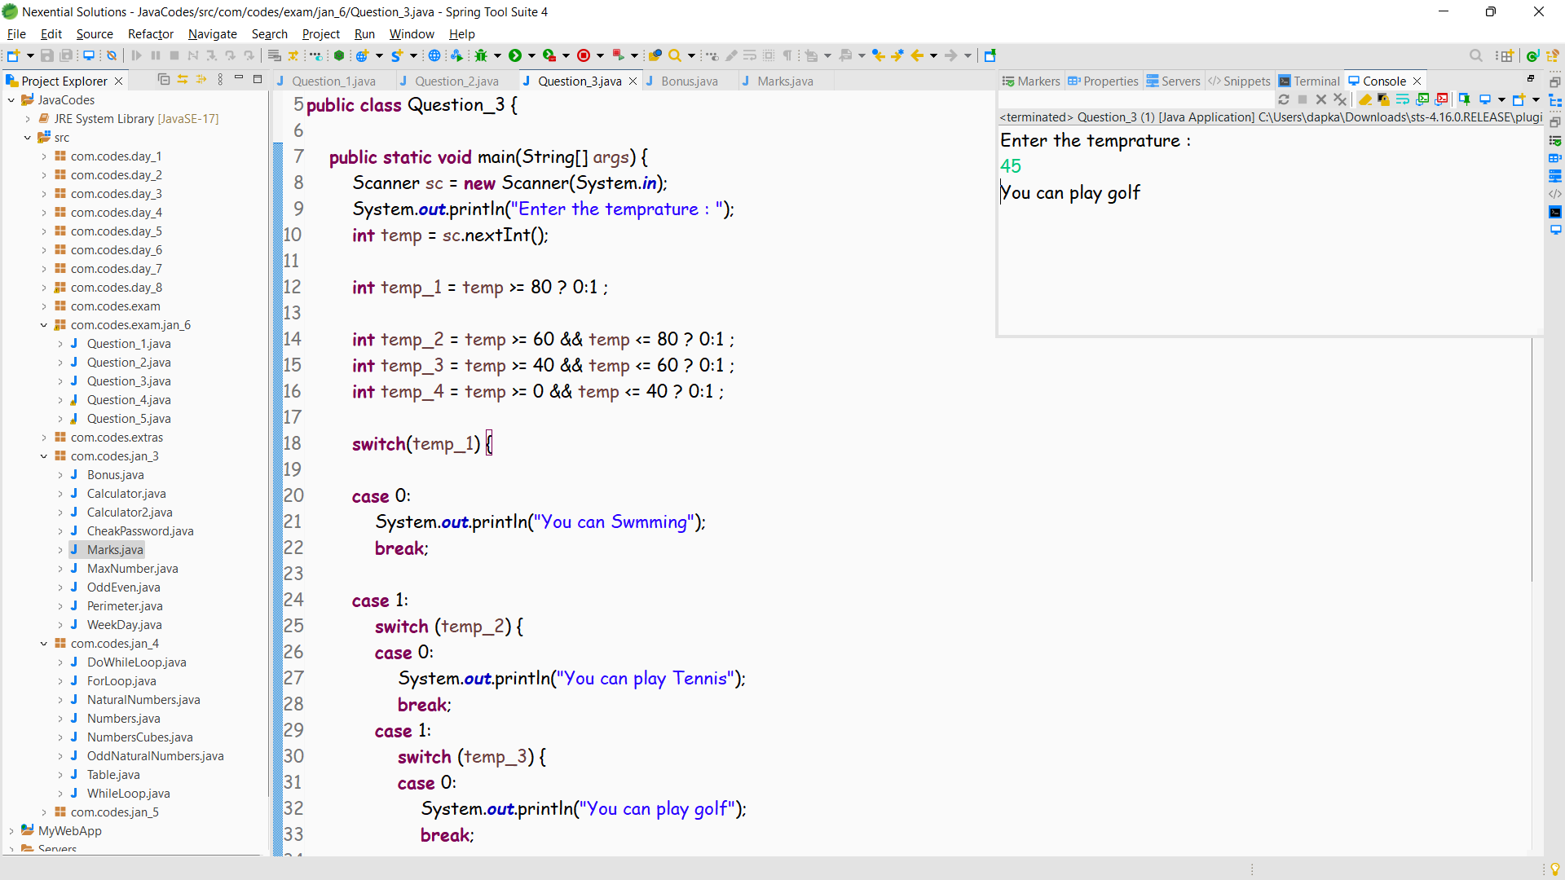

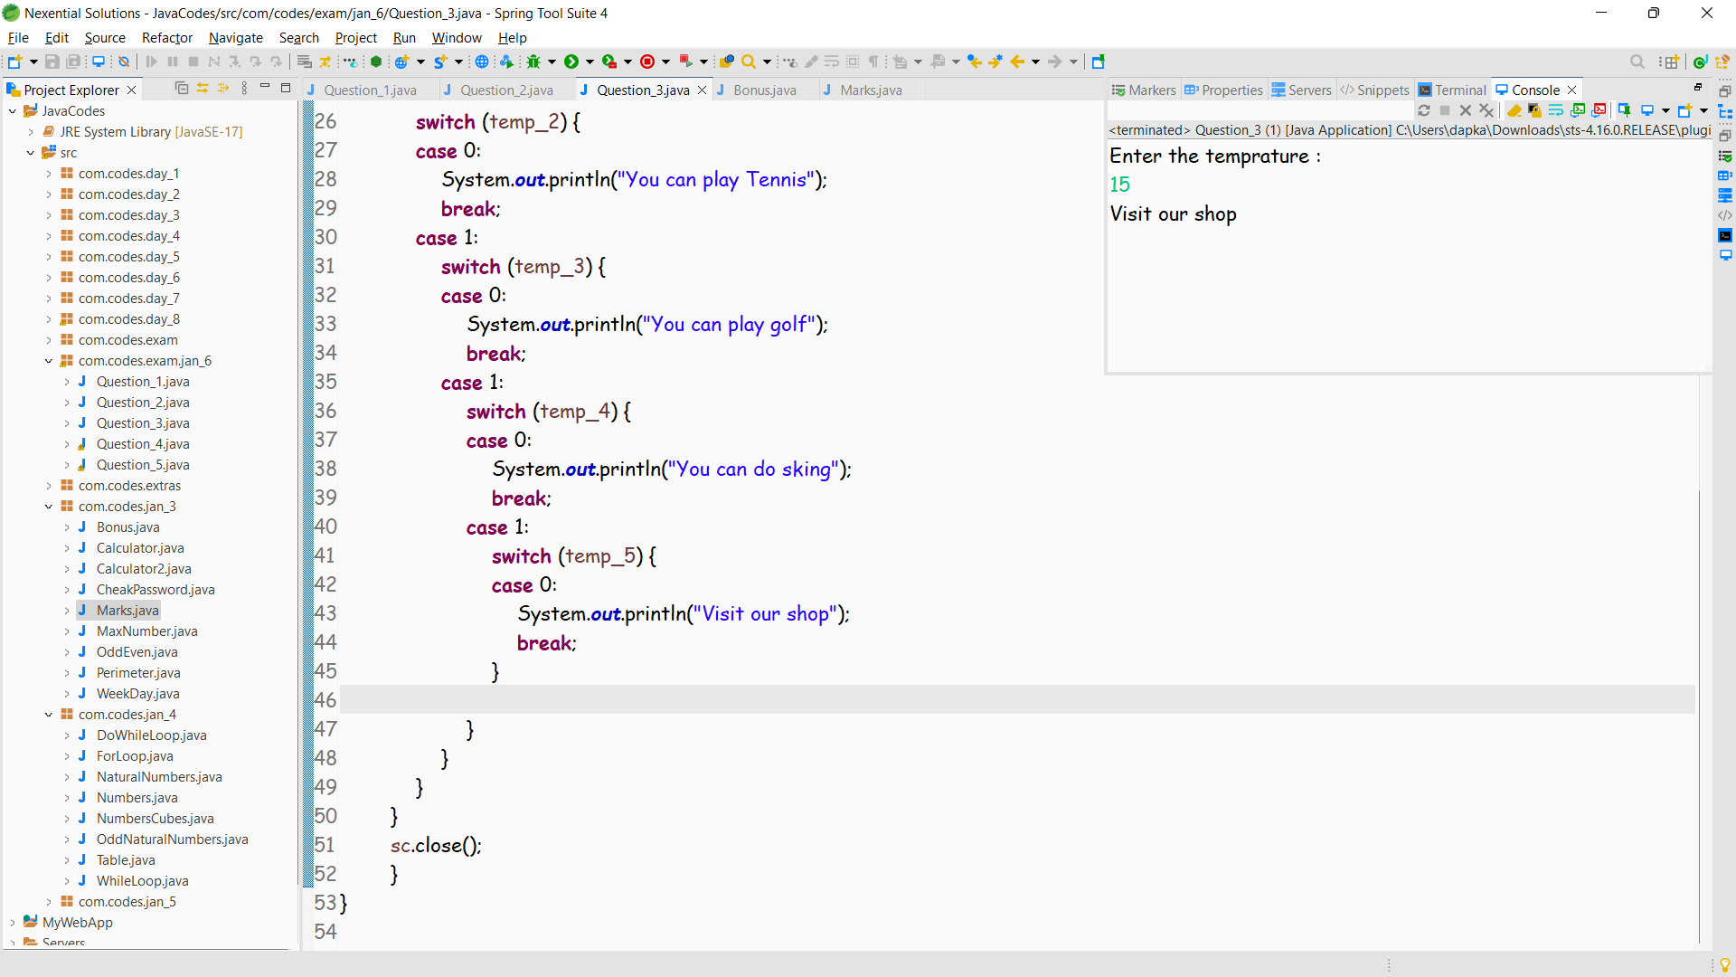

**Question 4**

It's almost election day and the election officials need a program to help tally election results. There are two candidates for office—Polly Tichen and Ernest Orator. The program's job is to take as input the number of votes each candidate received in each voting precinct and find the total number of votes for each. The program should print out the final tally for each candidate—both the total number of votes each received and the percent of votes each received.

Clearly a loop is needed. Each iteration of the loop is responsible for reading in the votes from a single precinct and updating the tallies.

1. Add the code to control the loop. You may use either a while loop or a do...while loop. The loop must be controlled by asking the user whether or not there are more precincts to report (that is, more precincts whose votes need to be added in). The user should answer with the character y or n though your program should also allow uppercase repsonses. The variable response (type String) has already been declared.

2. Add the code to read in the votes for each candidate and find the total votes. Print out the totals and the percentages after the loop.

3. Test your program to make sure it is correctly tallying the votes and finding the percentages AND that the loop control is correct (it goes when it should and stops when it should).

4. The election officials want more information. They want to know how many precincts each candidate carried (won). Add code to compute and print this. You need three new variables: one to count the number of precincts won by Polly, one to count the number won by Ernest, and one to count the number of ties. Test your program after adding this code.

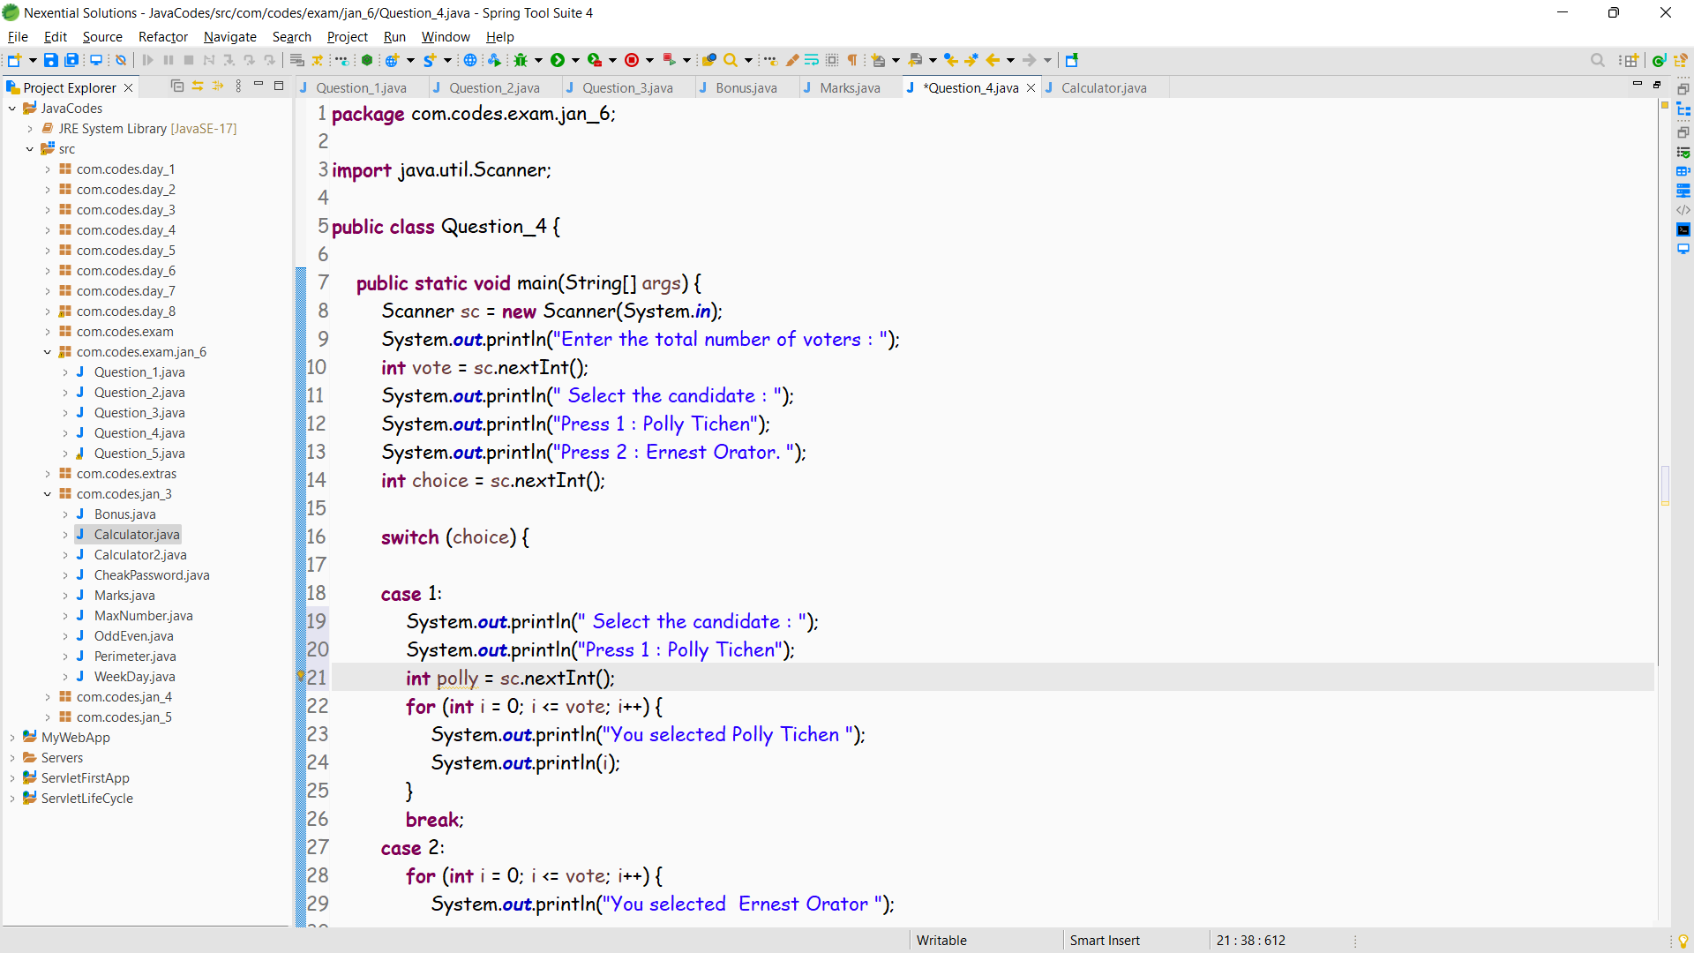

**Question 1**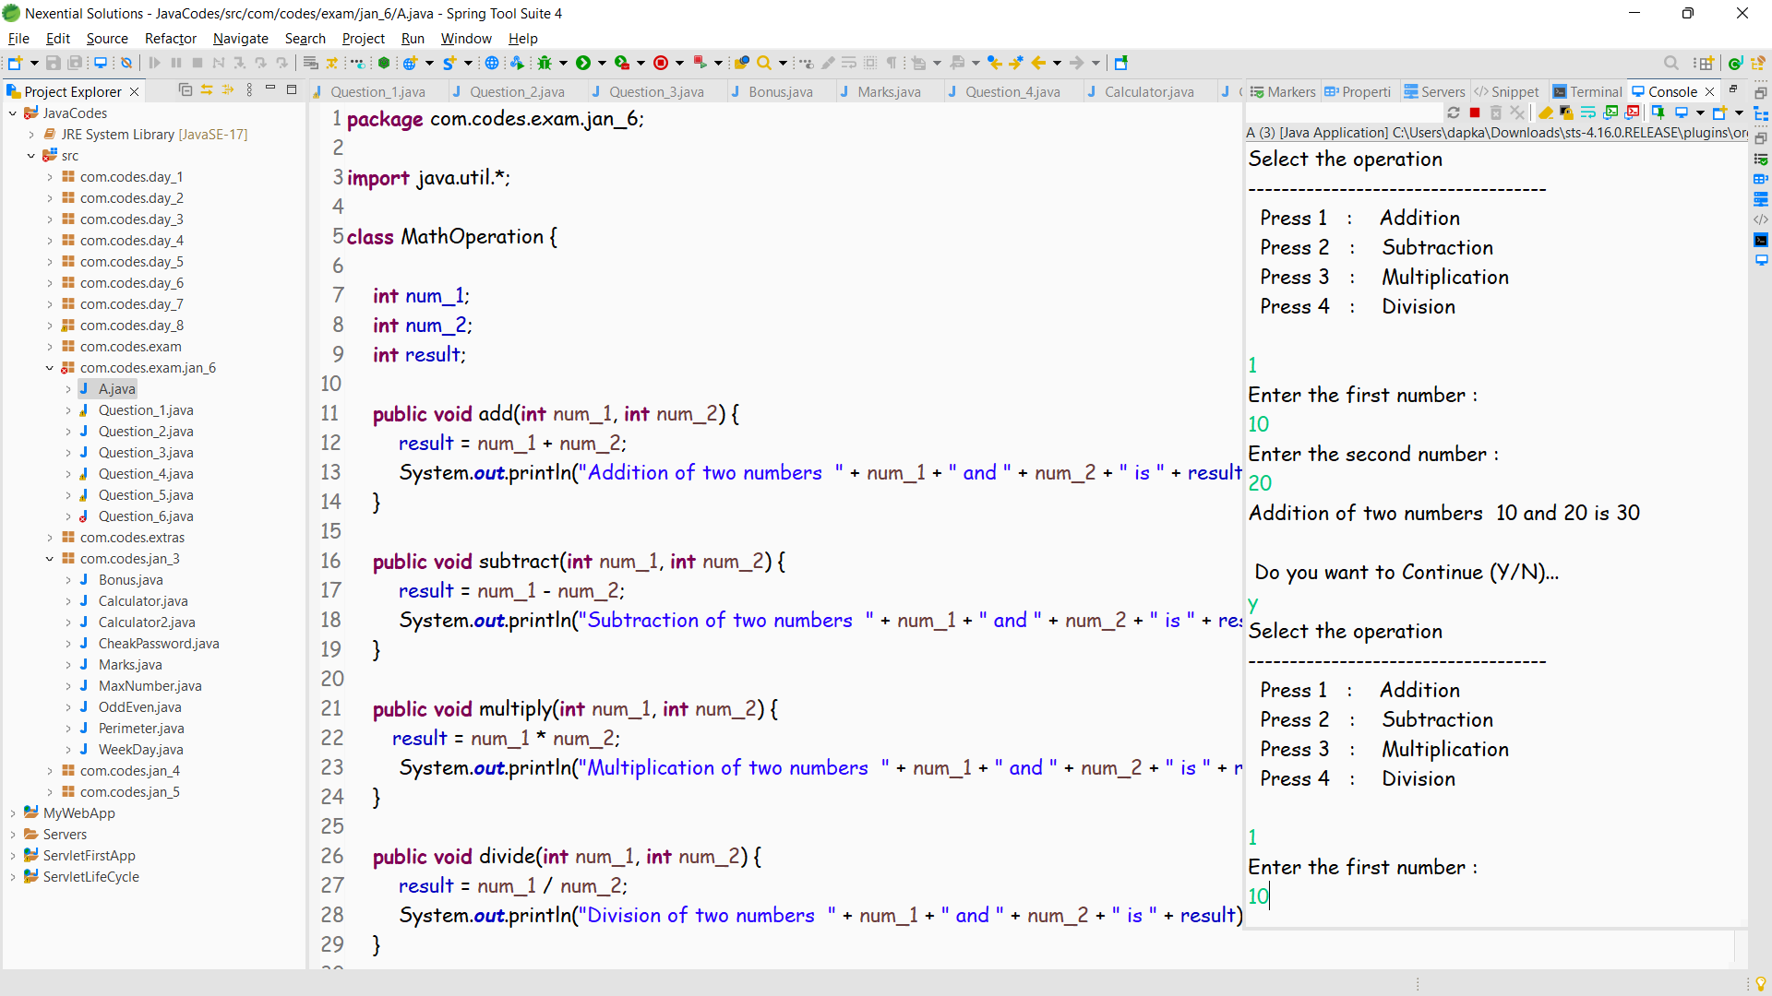

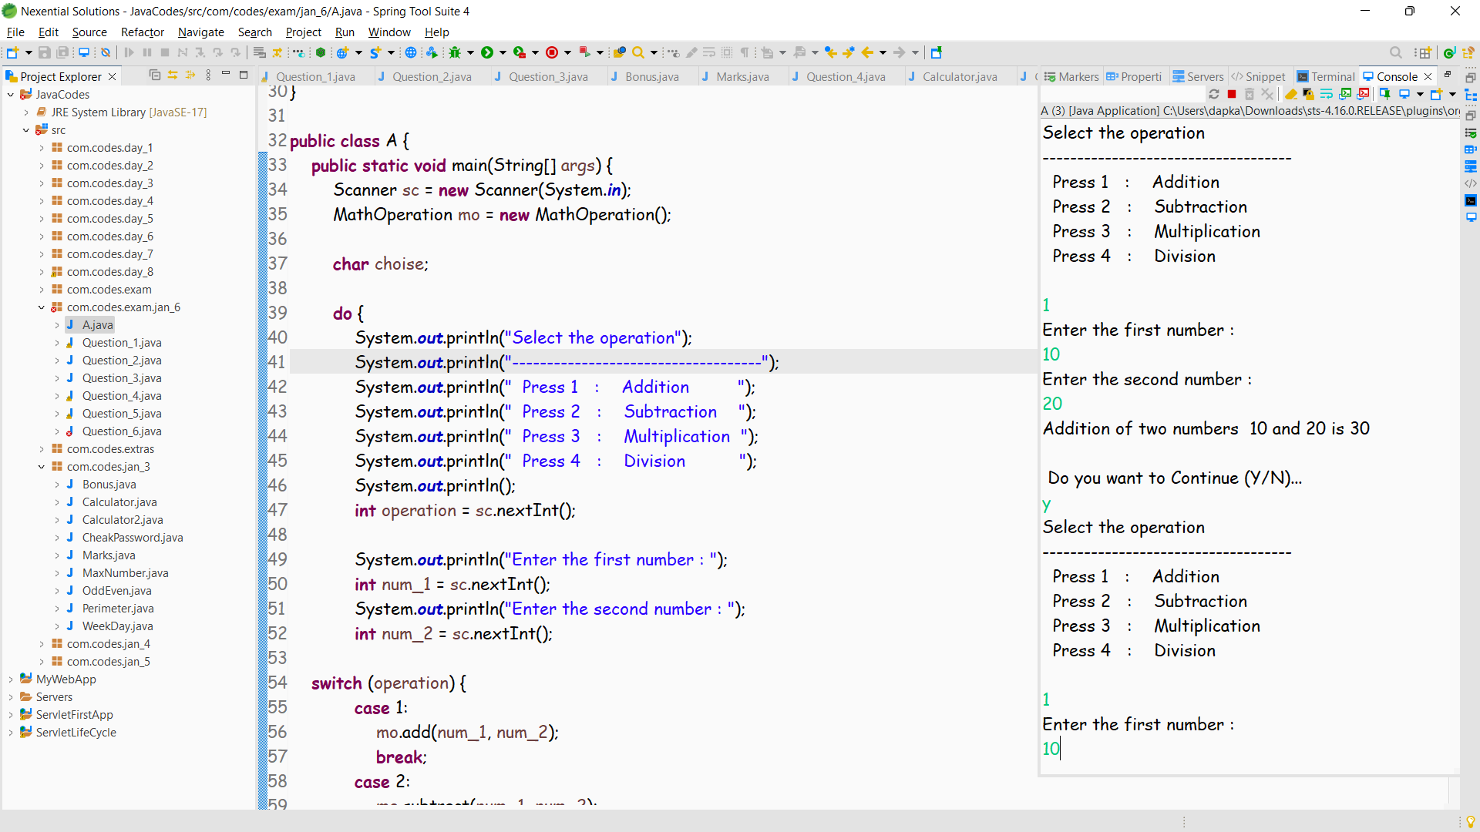

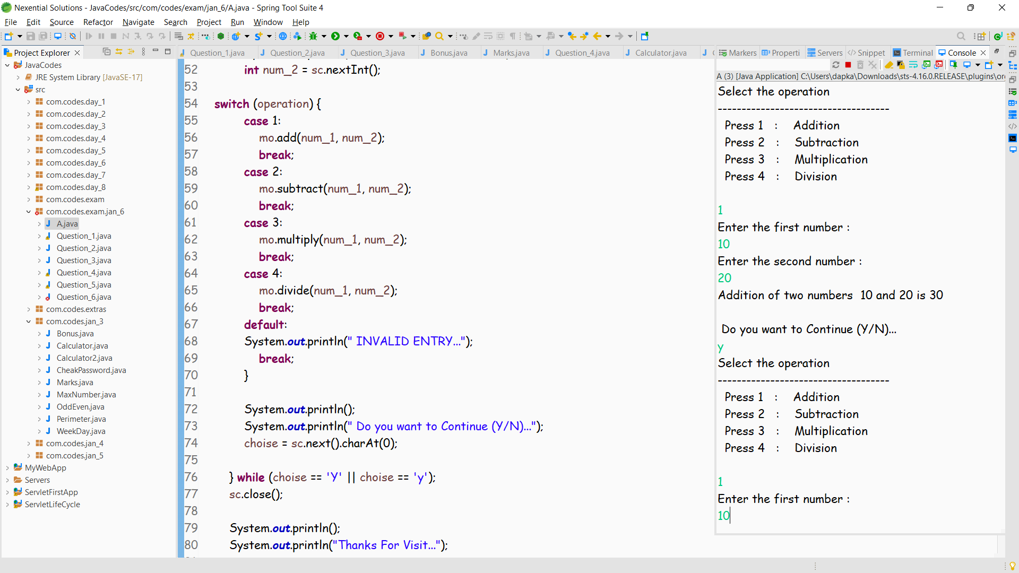

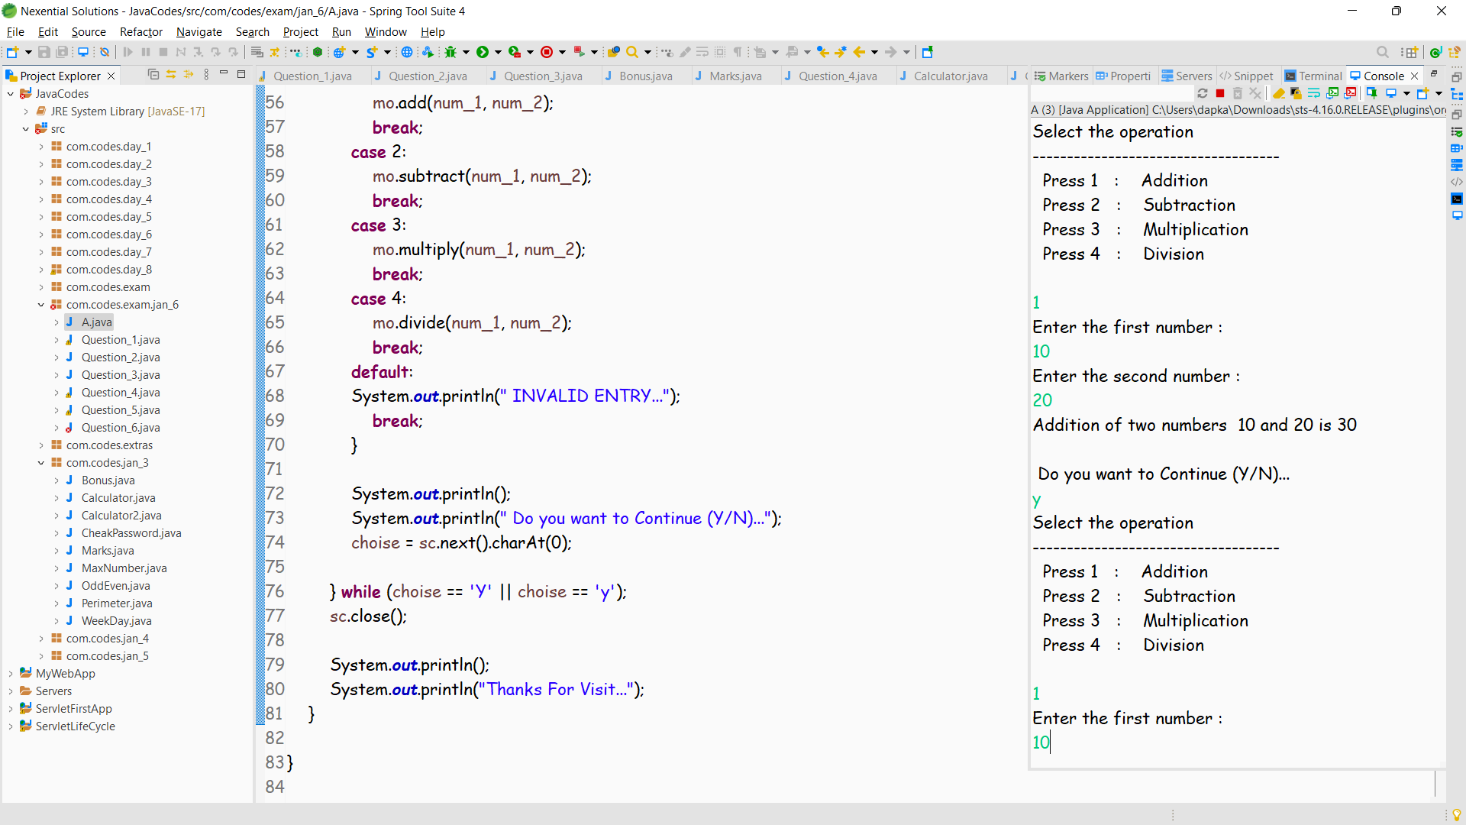

**Another version :**

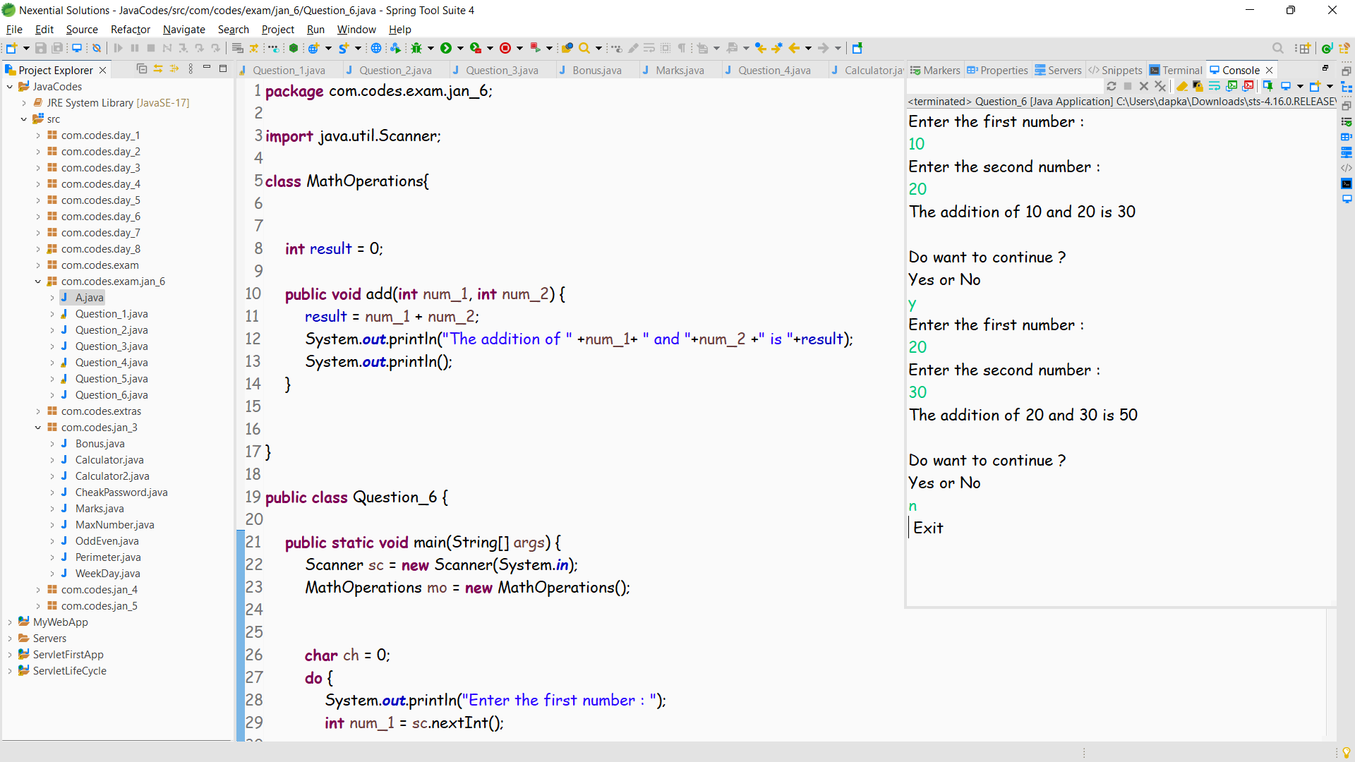

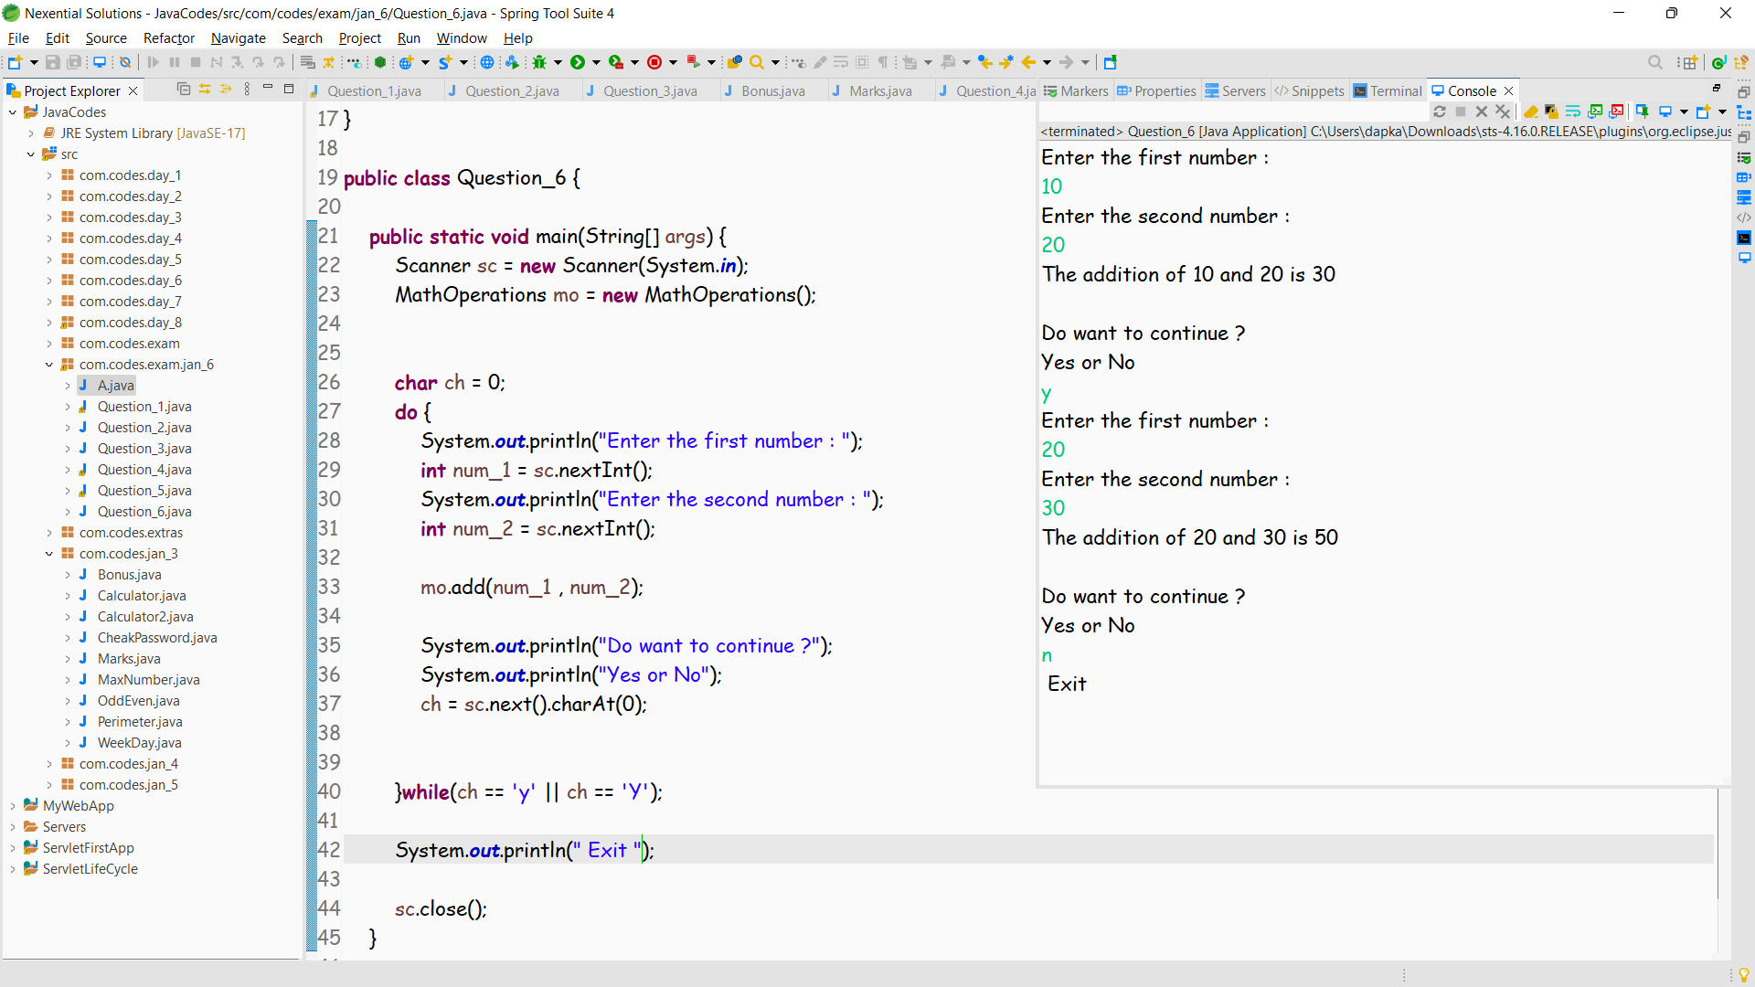

**Question 2**

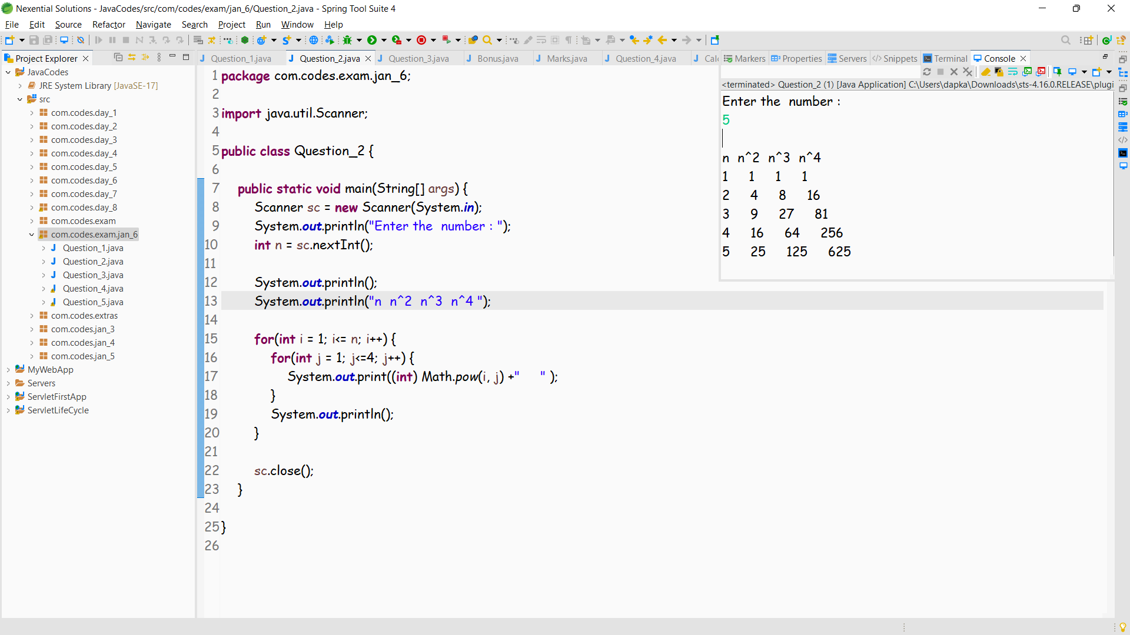

**Question 3**

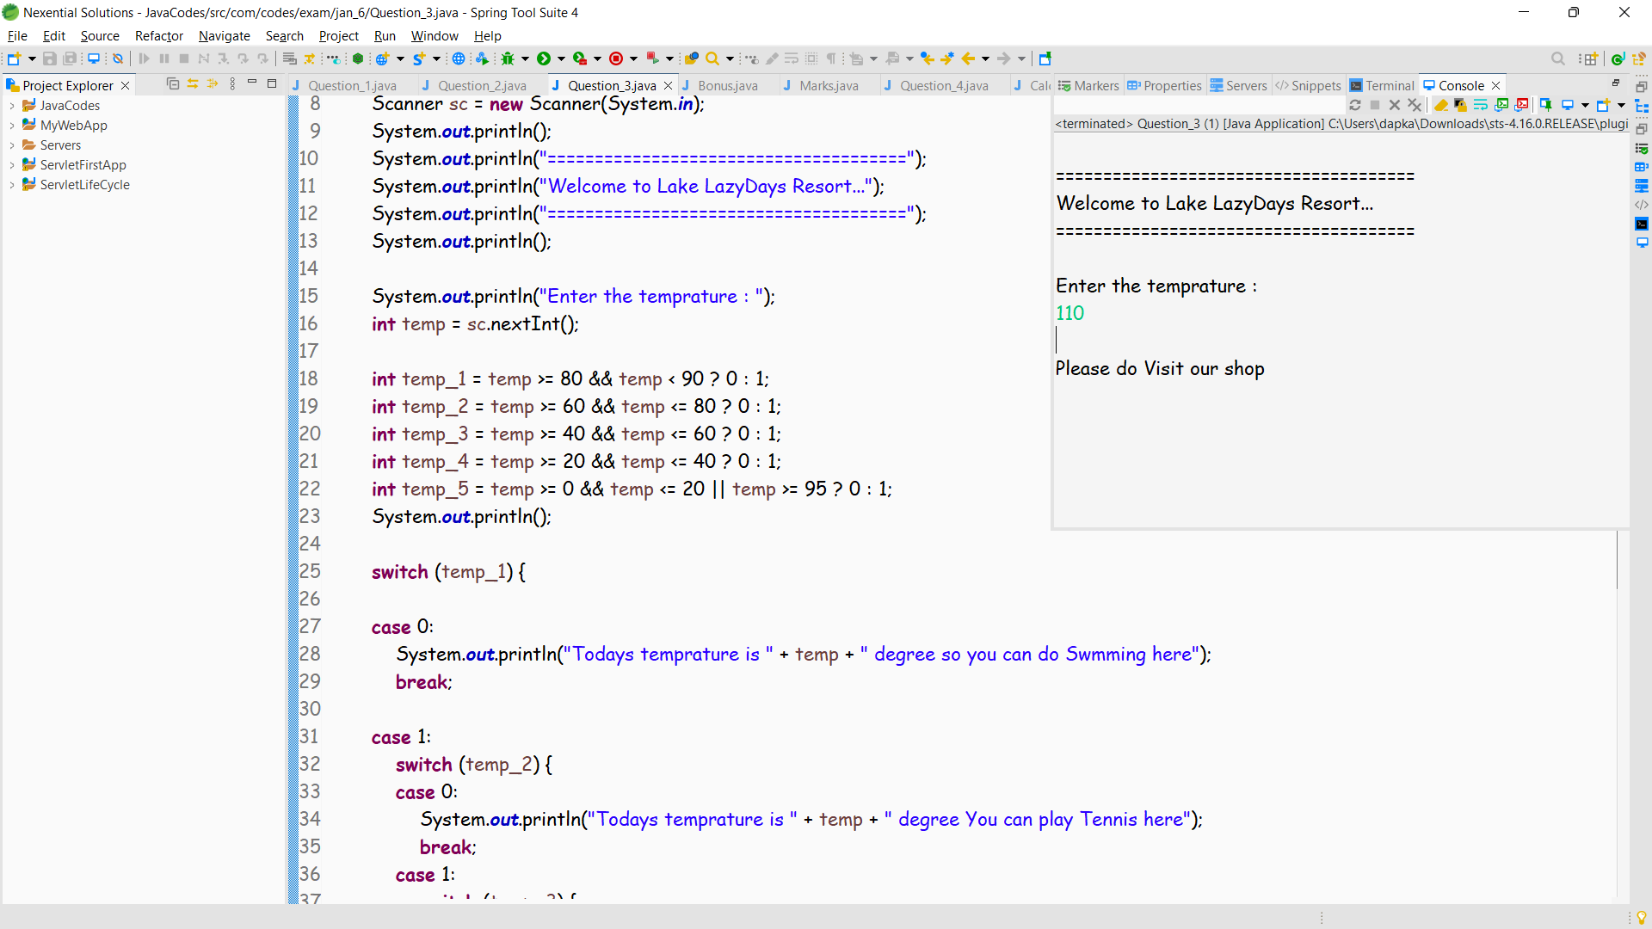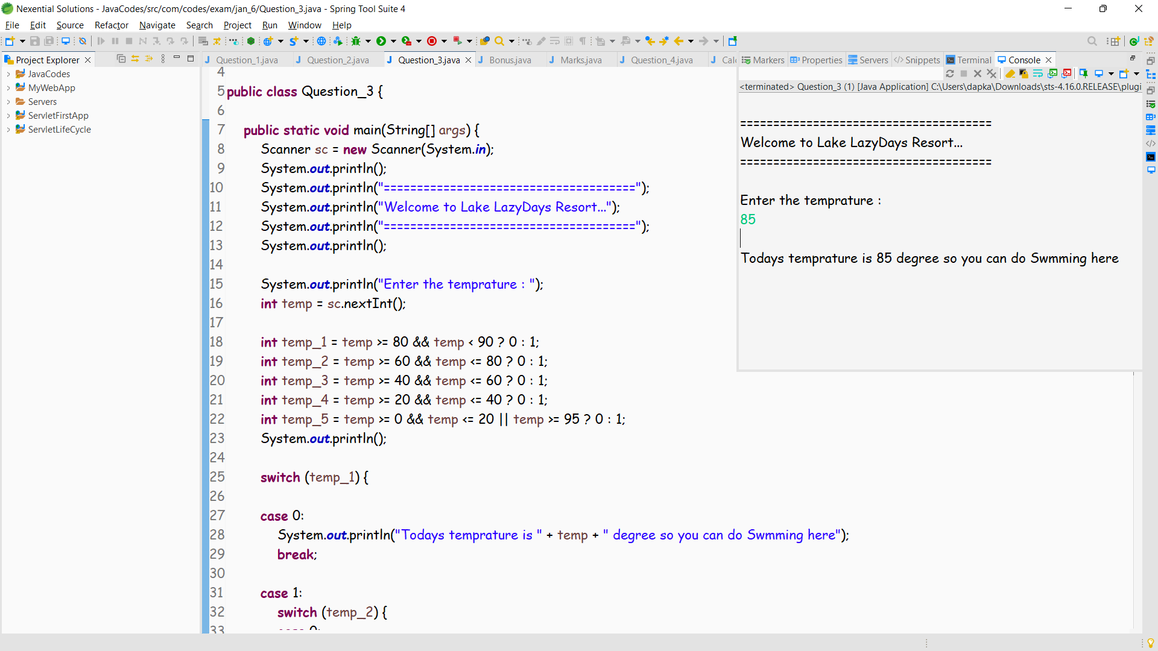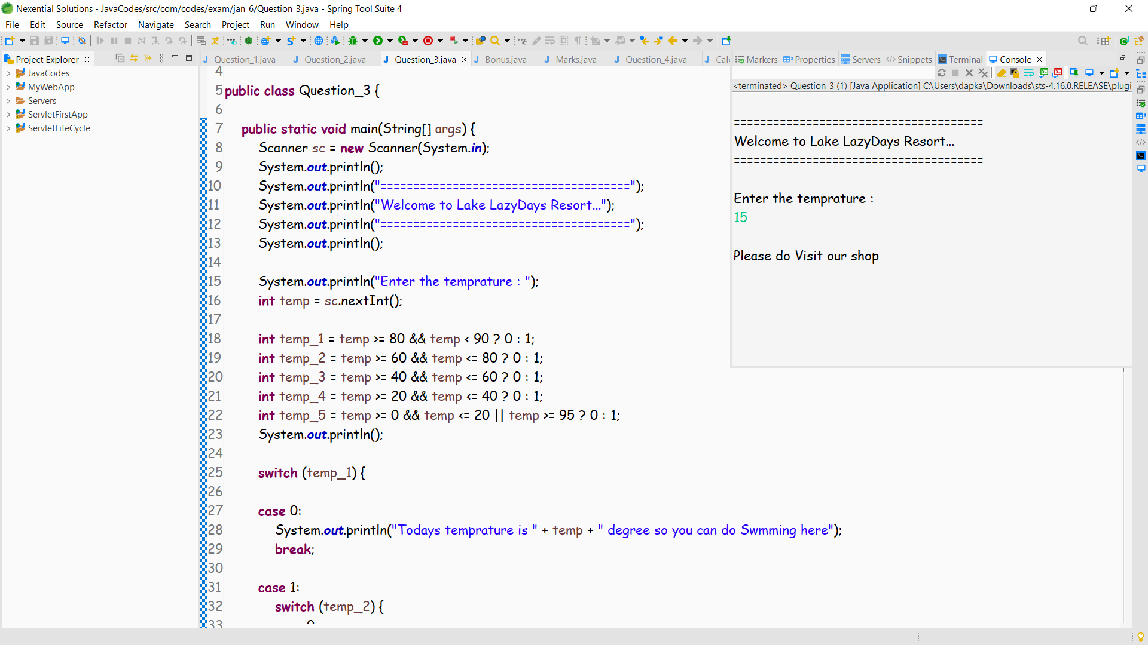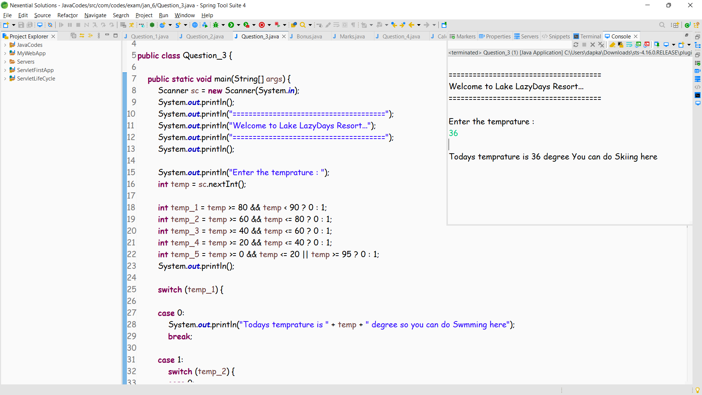

**Question 4**

