**Question 1**

Write a class named Commission with the following features: ¬ It has two instance variable, one is the total sales the employee has made (type double) and the second is the commission rate for the employee (the commission rate will be type double and will represent the percent (in decimal form) commission the employee earns on sales (so . it would mean the employee earns 20% commission on sales)). ¬ Write program with constructor overloading :

the one constructor has 6 parameters which are name, address, phone number, social security number, hourly pay rate) and the second constructor has parameter as is the commission rate for the employee.

One additional method is needed: public void addSales (double totalSales) that adds the parameter to the instance variable representing total sales. ¬ The pay method must call the pay method to compute the pay for hours worked then add to that the pay from commission on sales.

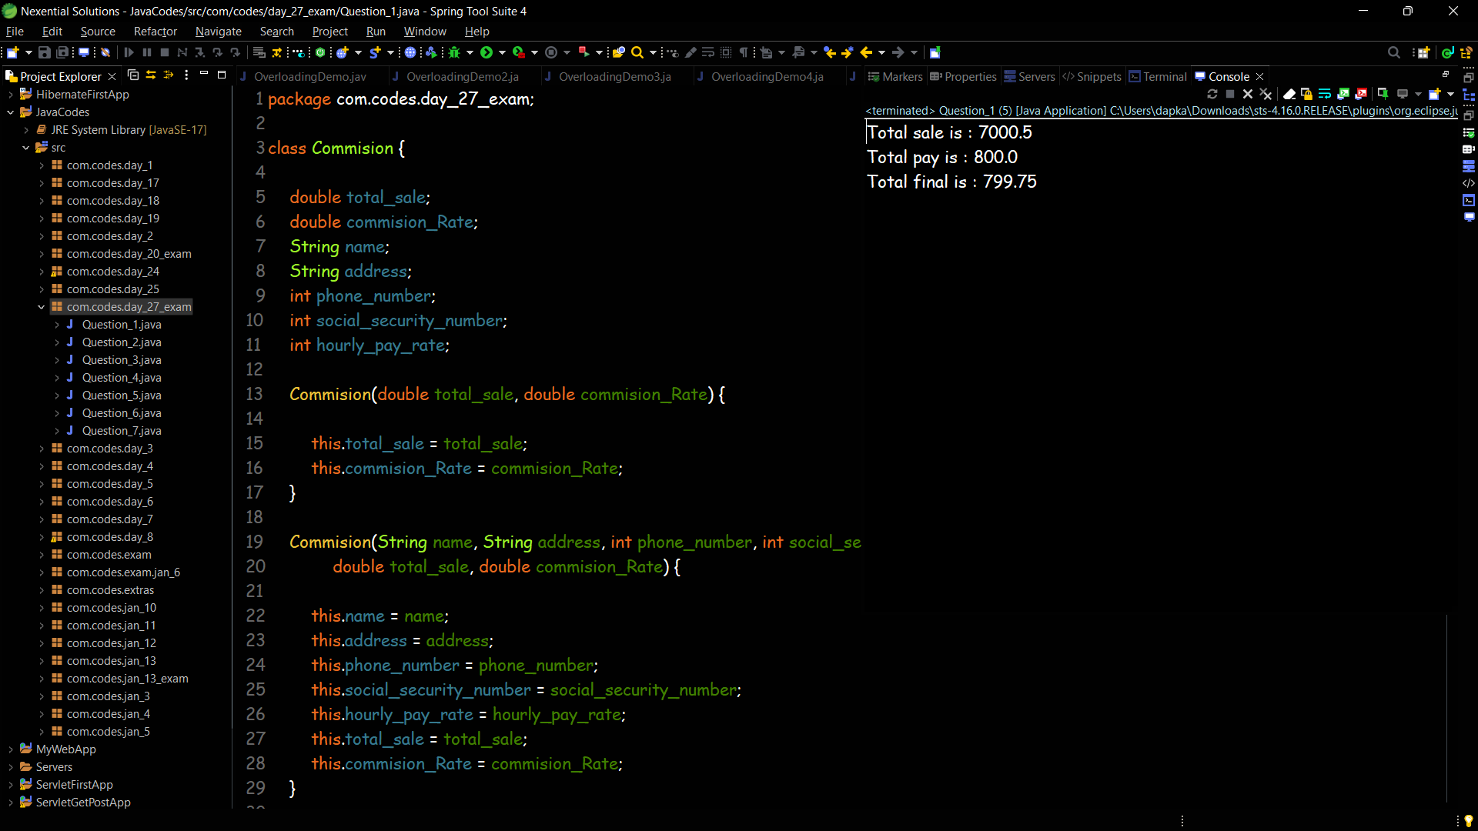

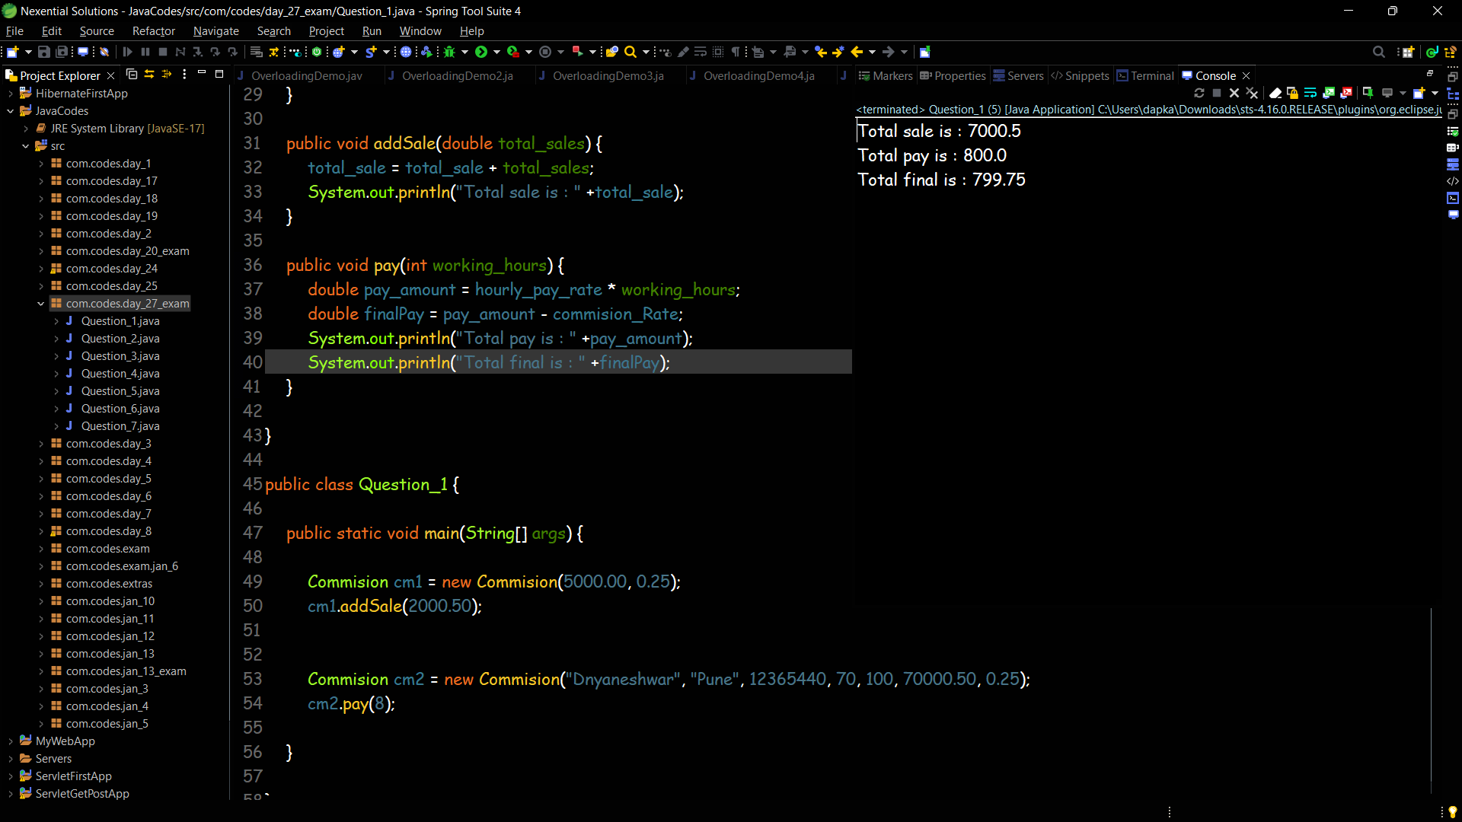

**Question 2**

Design a class to overload a function joyString() as follows: (i) void joyString(String s, char ch1, char ch2)- with one string argument and two character arguments that replaces the character argument ch1 with the character argument ch2 in the given string s and prints the new string. Example: INPUT:s = “TECHNALAGY” ch1 = ‘A’ ch2 = ‘O’ OUTPUT:“TECHNOLOGY”

(ii) void joyString(String s)- with one string argument that prints the position of the first space and the last space of the given string s. Example: INPUT: s = “Cloud computing means Internet-based computing” OUTPUT: First index: 5 Last index: 36

(iii) void joyString(String s1, String s2)- with two string arguments that combines the two strings with a space between them and prints the resultant string. Example: INPUT: s1 = “COMMON WEALTH” s2 = “GAMES” OUTPUT: COMMON WEALTH GAMES (use library functions)

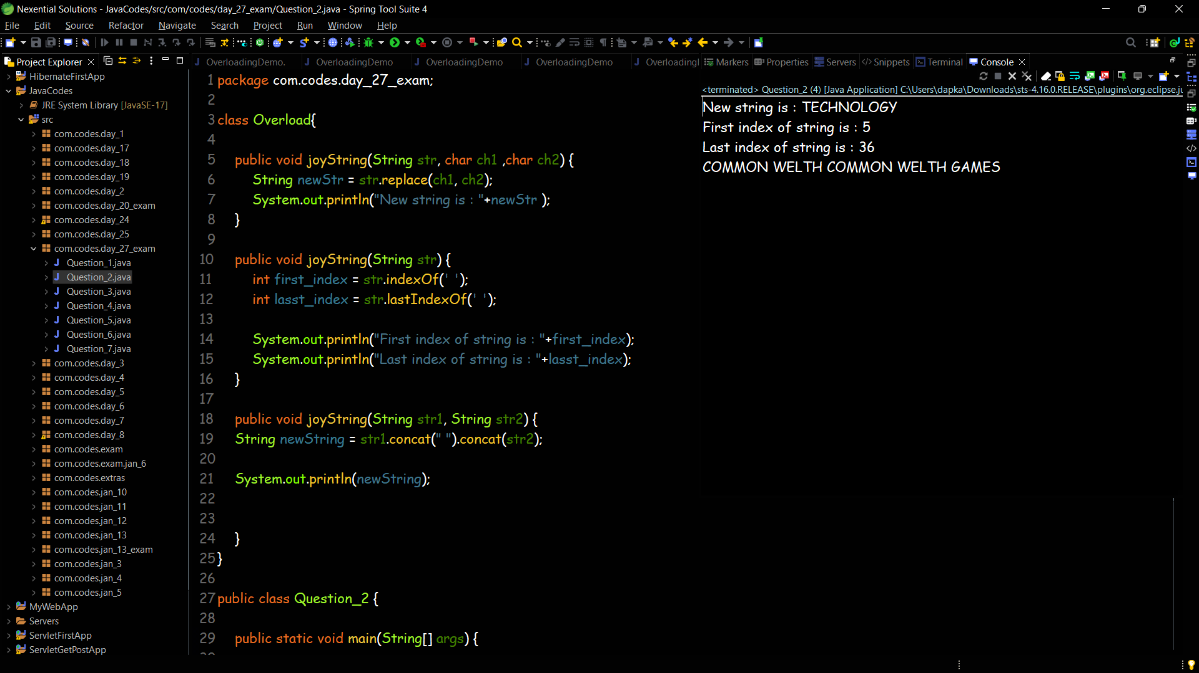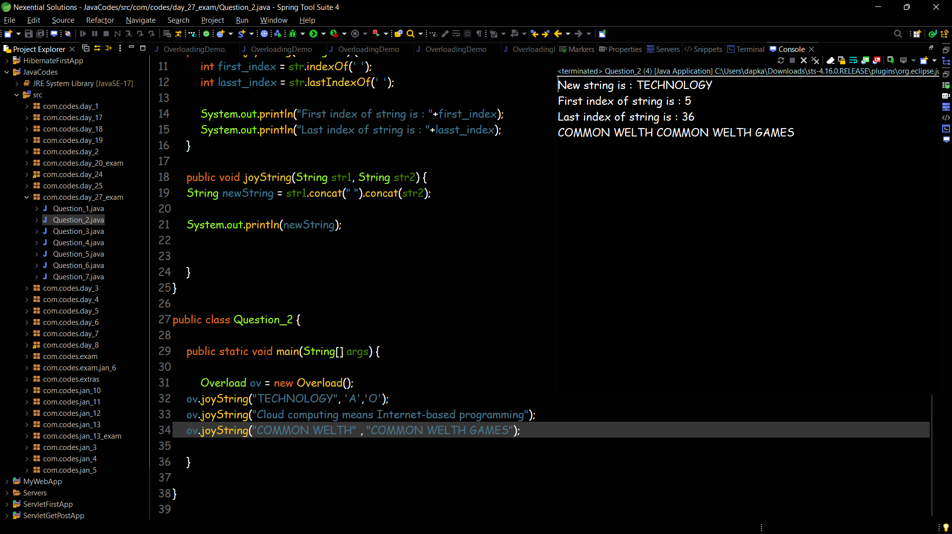

**Question 3**

Write a java program that contains different methods to calculate area of different shapes, fora sphere which is has a radius and its area (surface area) is given by the formula 4*PI*radius^2. A rectangle is defined by its length and width and its area is length times width.

A cylinder is defined by a radius and height and its area (surface area) is PI*radius^2*height. Area of a Trapezoid = 1/2 × Sum of Parallel Sides (a + b) × Height(h).

Ellipse area formula: A = a × b × π. Use static and final variables if it necessary.

Also use overload methods to calculate volume of different shapes as using formula

volume of sphere using the formula: v = 4 / 3 × 22 / 7 × r3

volume of a cylinder using the formula: v = 22 / 7 × r2 × h

volume of a cuboid using the formula: v = l × b × h. Use scanner class to input appropriate values.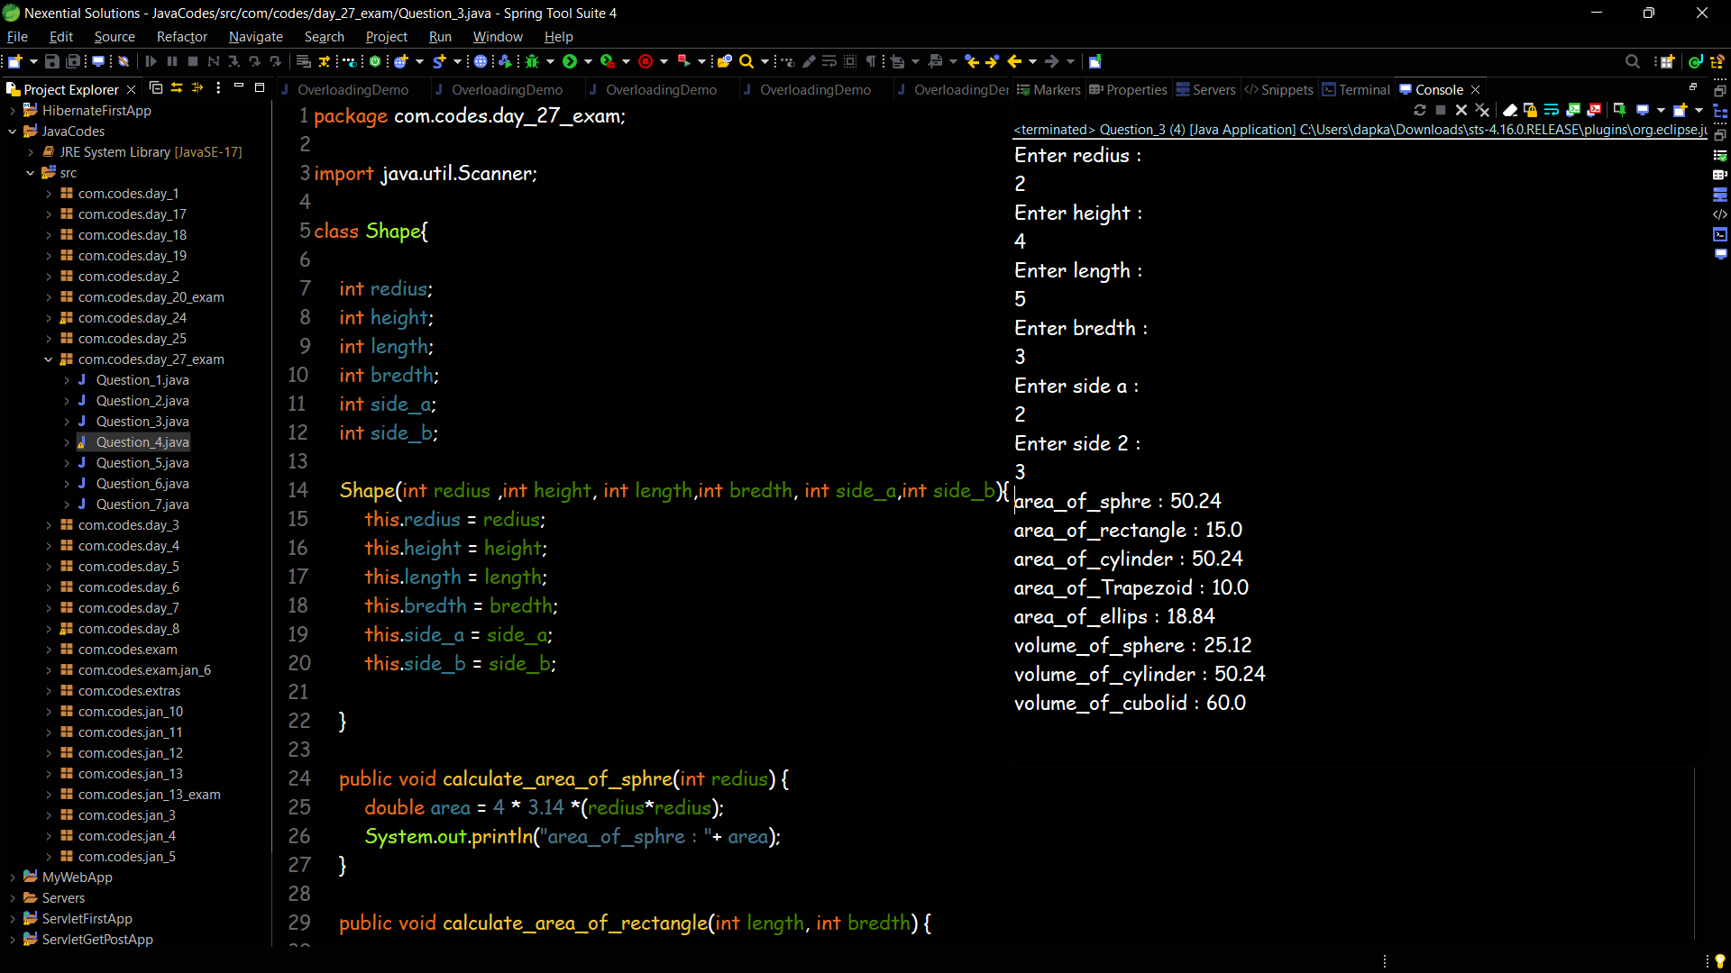 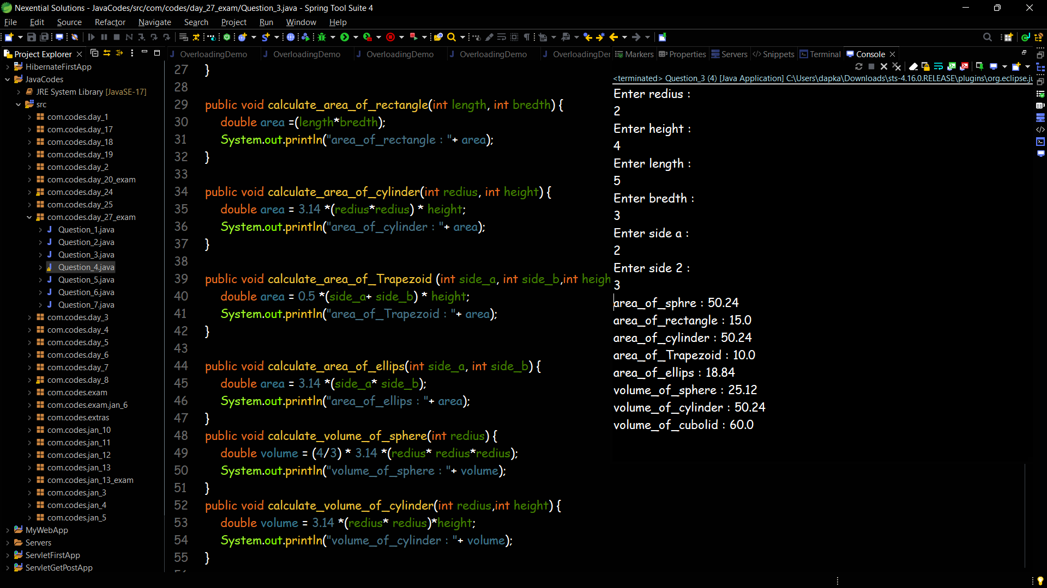

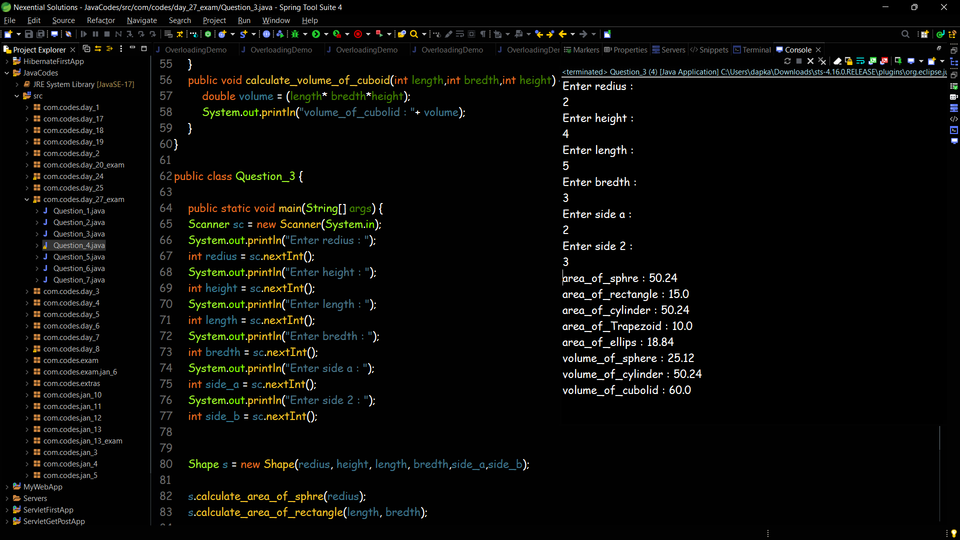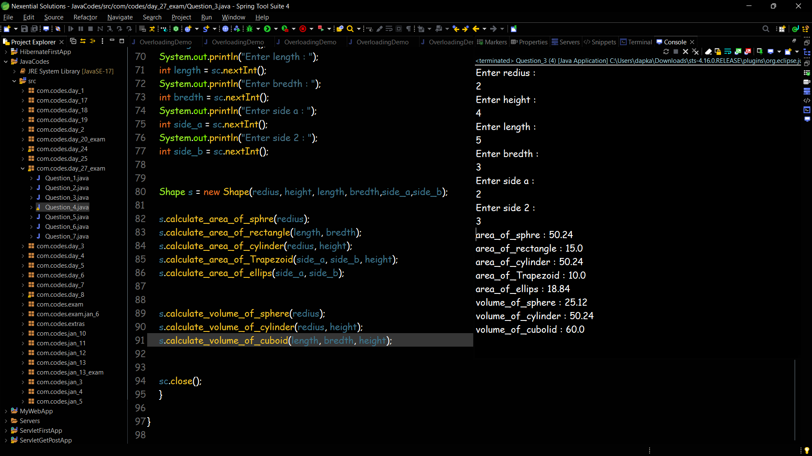

**Question 4**

Write a Java method to check whether a string is a valid password. Password rules: A password must have at least ten characters. A password consists of only letters and digits. A password must contain at least two digits. Expected Output: 1. A password must have at least eight characters. 2. A password consists of only letters and digits. 3. A password must contain at least two digits Input a password (You are agreeing to the above Terms and Conditions.): abcd1234

Password is valid: abcd1234

