**Pom.xml**

<project xmlns="http://maven.apache.org/POM/4.0.0" xmlns:xsi="http://www.w3.org/2001/XMLSchema-instance" xsi:schemaLocation="http://maven.apache.org/POM/4.0.0 https://maven.apache.org/xsd/maven-4.0.0.xsd">

<modelVersion>4.0.0</modelVersion>

<groupId>com.cdac</groupId>

<artifactId>First-Hibernate</artifactId>

<version>0.0.1-SNAPSHOT</version>

<name>First-Hibernate</name>

<properties>

<mysql.connector.version>8.0.13</mysql.connector.version>

<hibernate.version>4.3.0.Final</hibernate.version>

</properties>

<dependencies>

<!-- https://mvnrepository.com/artifact/org.hibernate/hibernate-core -->

<dependency>

<groupId>org.hibernate</groupId>

<artifactId>hibernate-core</artifactId>

<version>5.6.9.Final</version>

</dependency>

<!-- https://mvnrepository.com/artifact/mysql/mysql-connector-java -->

<dependency>

<groupId>mysql</groupId>

<artifactId>mysql-connector-java</artifactId>

<version>${mysql.connector.version}</version>

</dependency>

<dependency>

<groupId>org.hibernate</groupId>

<artifactId>hibernate-entitymanager</artifactId>

<version>${hibernate.version}</version>

</dependency>

<dependency>

<groupId>org.hibernate</groupId>

<artifactId>hibernate-ehcache</artifactId>

<version>${hibernate.version}</version>

</dependency>

</dependencies>

</project>

**Persistence.xml**

<persistence xmlns="http://xmlns.jcp.org/xml/ns/persistence"

xmlns:xsi="http://www.w3.org/2001/XMLSchema-instance" version="2.2"

xsi:schemaLocation="http://xmlns.jcp.org/xml/ns/persistence http://xmlns.jcp.org/xml/ns/persistence/persistence_2_2.xsd">

<persistence-unit name="learning-hibernate">

<!-- Specifying which ORM we will be using -->

<provider>org.hibernate.jpa.HibernatePersistenceProvider</provider>

<properties>

<!-- Database settings -->

<property name="javax.persistence.jdbc.driver"

value="com.mysql.cj.jdbc.Driver" />

<property name="javax.persistence.jdbc.url"

value="jdbc:mysql://localhost:3306/pune" />

<property name="javax.persistence.jdbc.user" value="root" />

<property name="javax.persistence.jdbc.password"

value="cdac" />

<!-- Additional settings -->

<property name="hibernate.hbm2ddl.auto" value="update" />

<!-- Auto creation of tables -->

<property name="hibernate.show_sql" value="true" />

<!-- Log generated SQL -->

</properties>

</persistence-unit>

</persistence>

**Employee.java**

package com.cdac.entity;

import java.time.LocalDate;

import javax.persistence.Column;

import javax.persistence.Entity;

import javax.persistence.Id;

import javax.persistence.Table;

@Entity

@Table(name = "tbl_emp")

public class Employee {

@Id

@Column(name = "empno")

private int empno;

@Column(name = "name")

private String name;

@Column(name = "salary")

private double salary;

@Column(name = "date_of_joining")

private LocalDate dateOfJoining;

public int getEmpno() {

return empno;

}

public void setEmpno(int empno) {

this.empno = empno;

}

public String getName() {

return name;

}

public void setName(String name) {

this.name = name;

}

public double getSalary() {

return salary;

}

public void setSalary(double salary) {

this.salary = salary;

}

public LocalDate getDateOfJoining() {

return dateOfJoining;

}

public void setDateOfJoining(LocalDate dateOfJoining) {

this.dateOfJoining = dateOfJoining;

}

}

**insertEmployee.java**

package com.cdac.app;

import java.time.LocalDate;

import javax.persistence.EntityManager;

import javax.persistence.EntityManagerFactory;

import javax.persistence.EntityTransaction;

import javax.persistence.Persistence;

import com.cdac.entity.Employee;

public class InsertEmployee {

public static void main(String[] args) {

//During this step, the persistence.xml file will be read

EntityManagerFactory emf = Persistence.createEntityManagerFactory("learning-hibernate");

EntityManager em = emf.createEntityManager();

EntityTransaction tx = em.getTransaction();

tx.begin();

Employee emp = new Employee();

emp.setEmpno(1002);

emp.setName("Dnyaneshwar");

emp.setSalary(10000);

emp.setDateOfJoining(LocalDate.of(2019, 10, 10));

em.persist(emp); //persist method will generate insert query

tx.commit();

emf.close();

}

}

**Project structure**

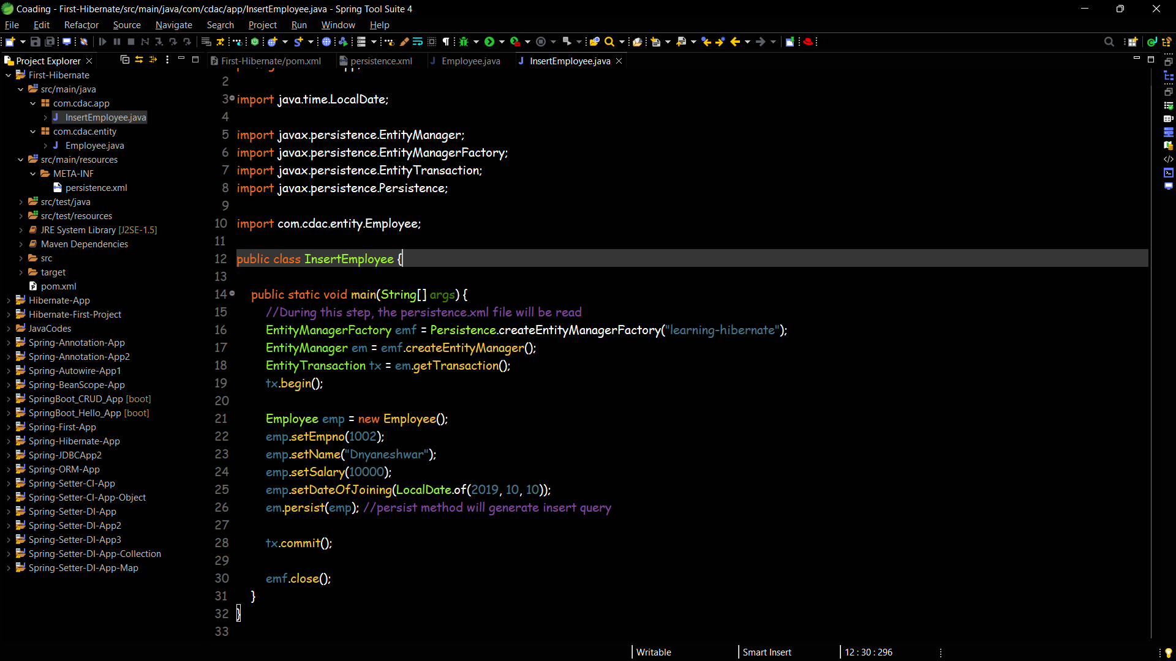

**Database tables**

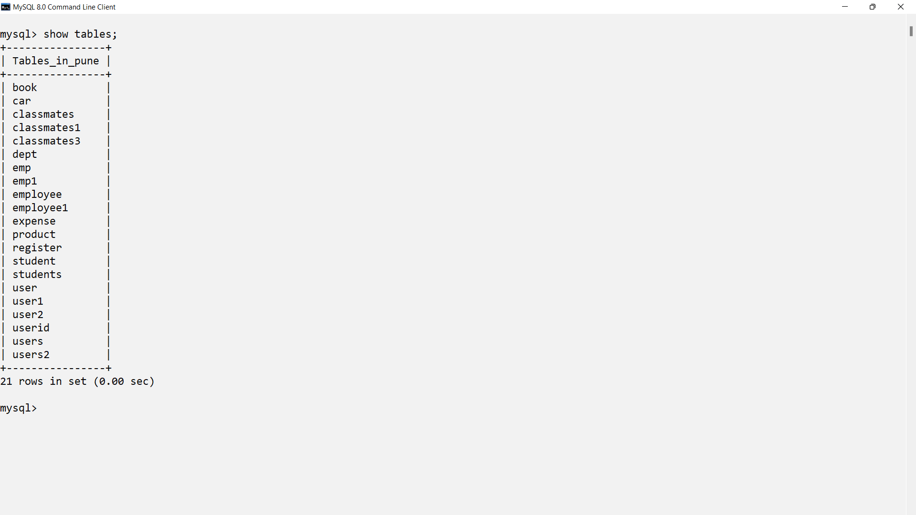 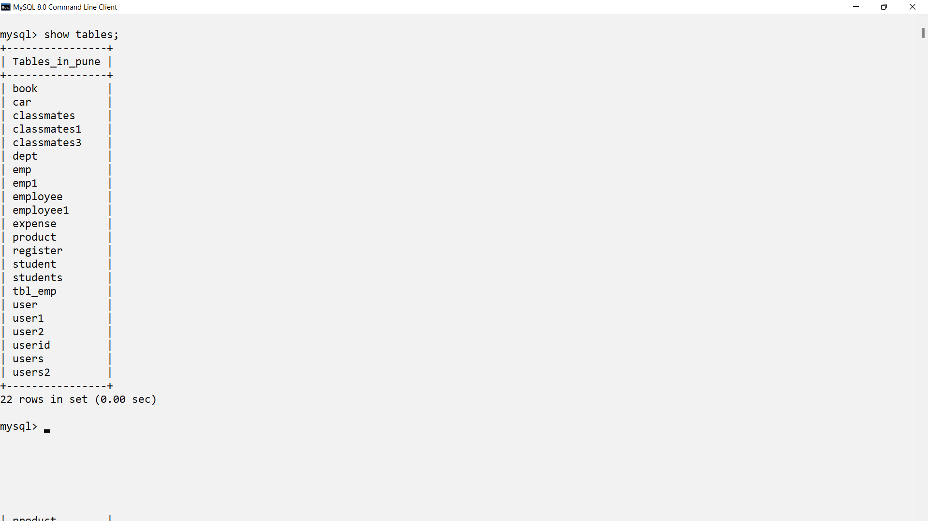

**Database table Data**

