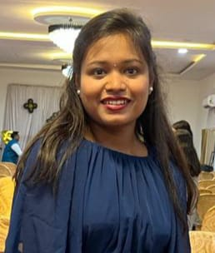

**Bhakti Raut**

**Email id:** [rautbhakti3006@gmail.com](mailto:rautbhakti3006@gmail.com)

**Mobile No:** +91 93590 82090

**Address:** At post murti, Pune Maharashtra.

**CAREER OBJECTIVE**

To obtain a position in a Health Care Facility where I can utilize my skills, knowledge and experience to provide quality health care.

**ACADEMIC QUALIFICATION:**

* 10th passout Mahatma Gandhi Vidyalaya
* 12th passout Mahatma Gandhi College 81.00%

**PROFESSIONAL SKILLS:**

leadership ,good speaker as well as good listener , general knowledge, basic knowledge of computer

**WORK EXPERIENCE:**

* Fresher

**Area Intrested:**

Healthcare system

**PERSONAL DETAILS:**

Father’s Name : Sanjay Raut

Address : At post murti,Pune,Maharashtra.

Date of birth : 30 oct 2003

Gender : Female

Nationality : Indian

Marital Status : Unmarried

Languages Known : Marathi, English, Hindi

Hobbies : Reading , sports.

Place:

Date: