Final OutPut

- CSV File Read Sucessfully :-
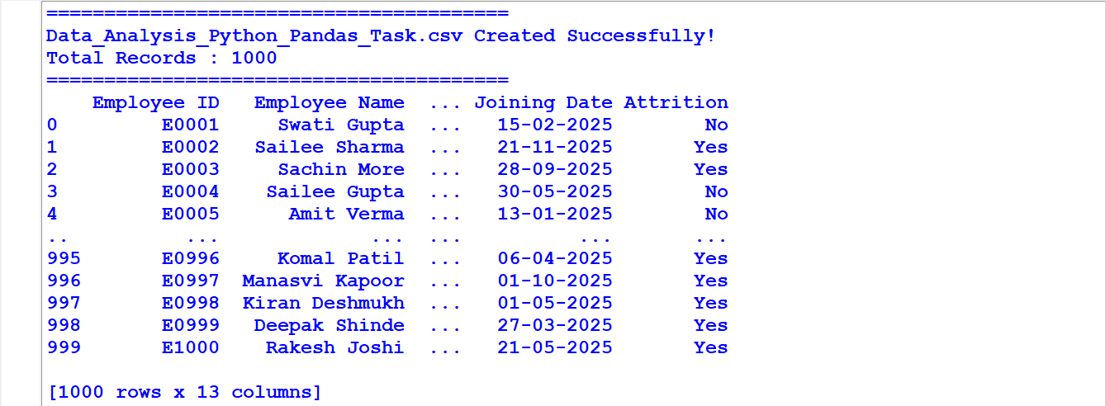

1.First 10 Records:-
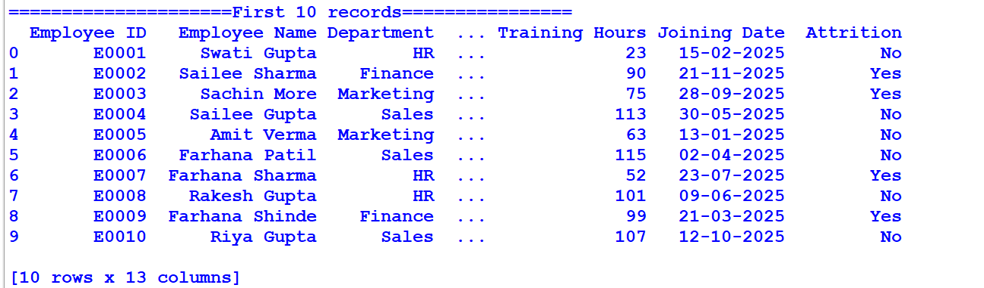

2.Last 5 Records :-
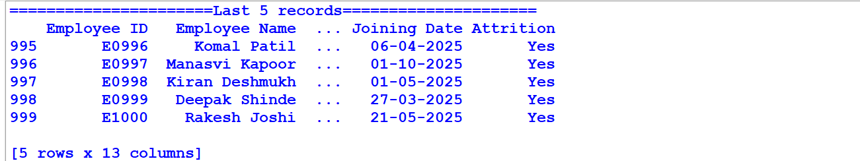

3.Number of Rows And Columns :-
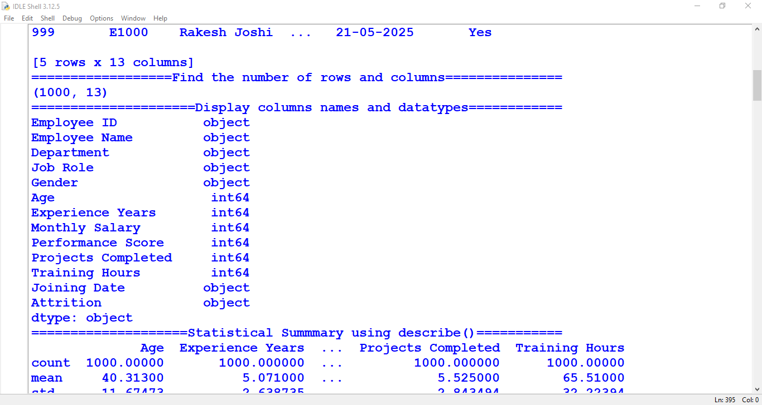

4.Columns Name And Datatypes:-

5.Statistical Summary Using Describe :-
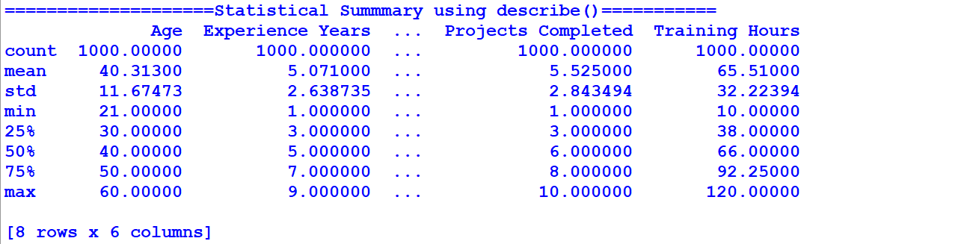

6.Identify And Remove Duplicate Record :-
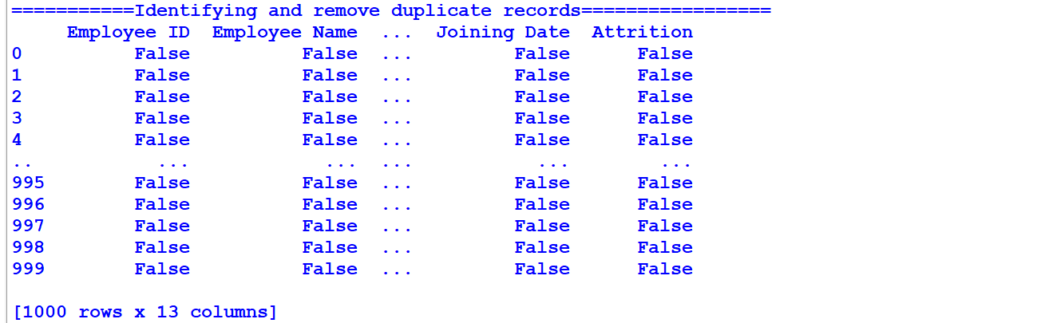

7.Find Missing Values In each Columns:-
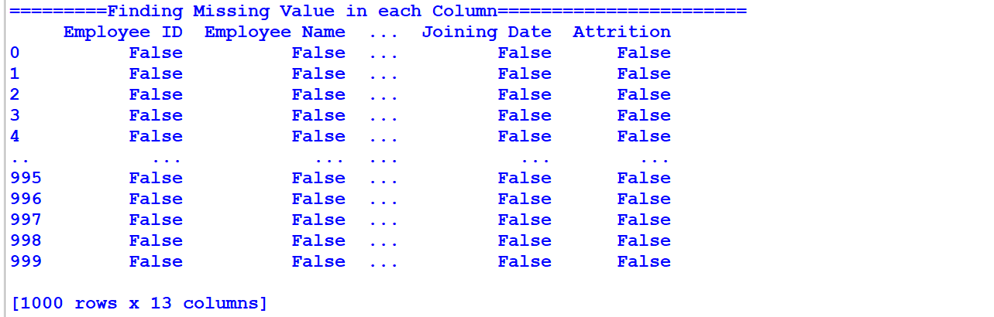

8.Correct Inconsistant Department Name And Extra Spaces:-
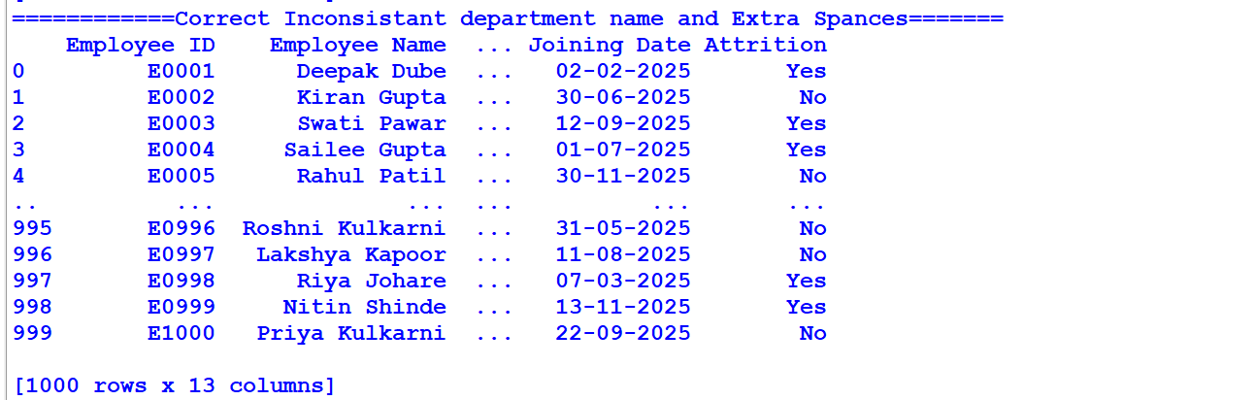

9.Negative Salary And Invalid Performance Score :-
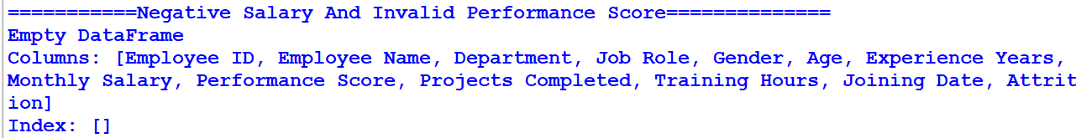

10.Create Annual Salary Column :-
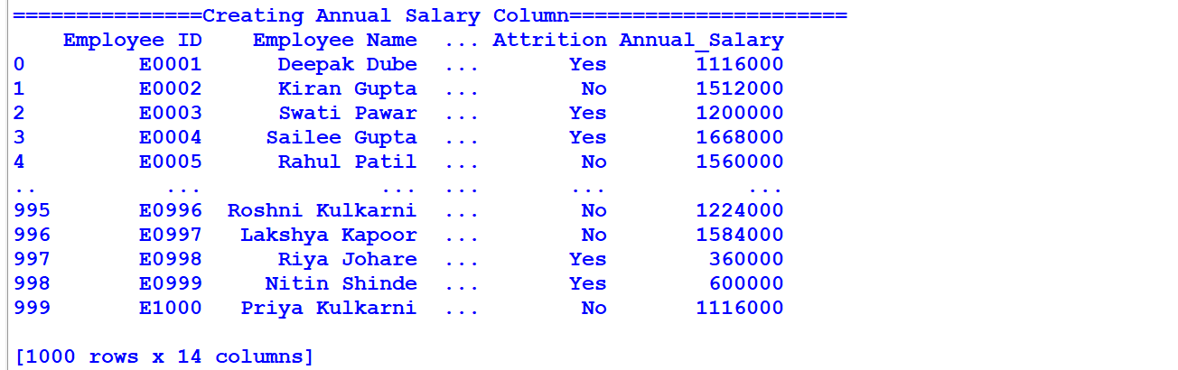
11. Create Experience Level Column :-
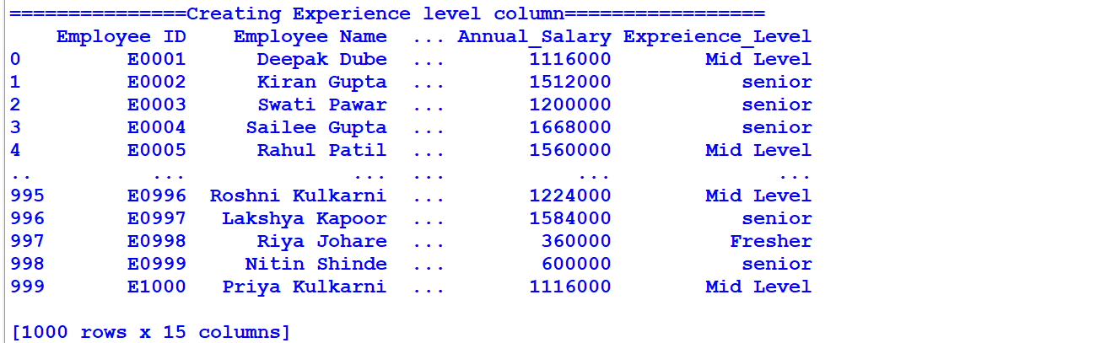

12. Create Performance Category Column :-
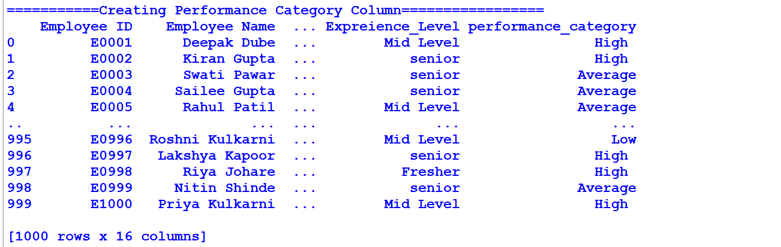

13. Create Salary Band Column :-
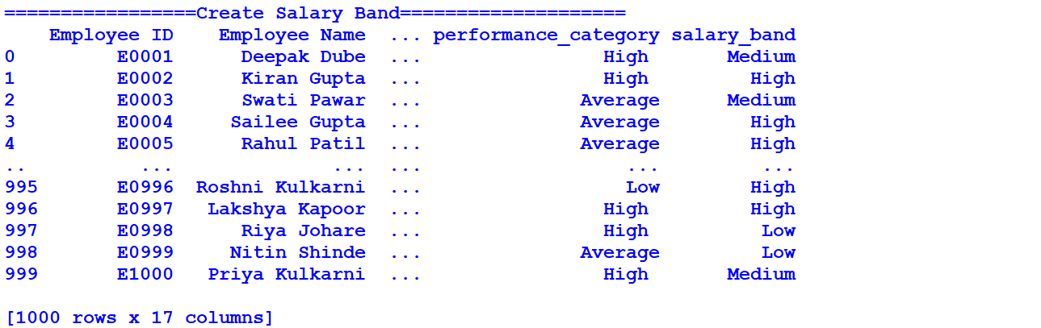

14. Average Salary By Department :-
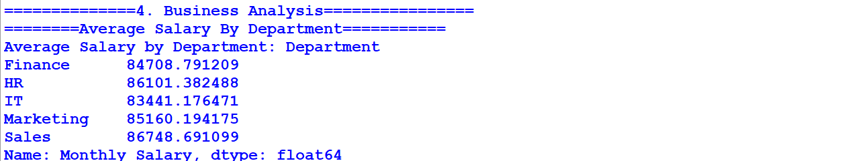

15. Highest Paid Employee:-
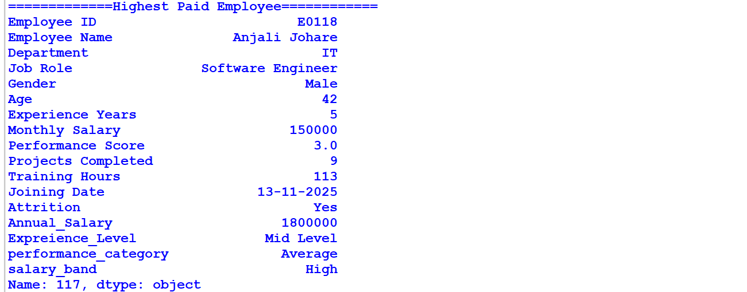

16. Top 10 Performance Score :-
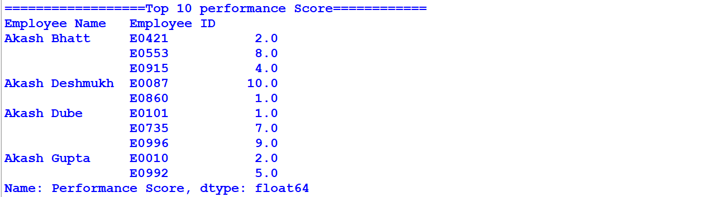

17. Average Salary By Job Role:-
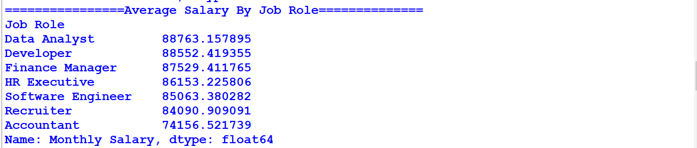

18. Compare Average Experience Across Department :-
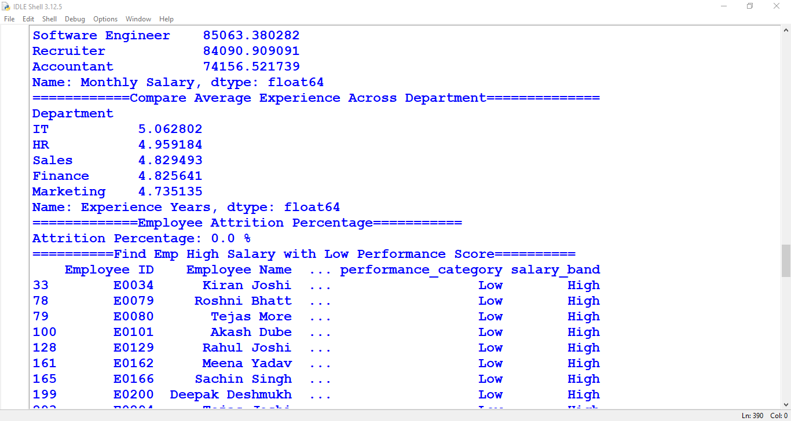

19. Employee Attrition Percentage :-
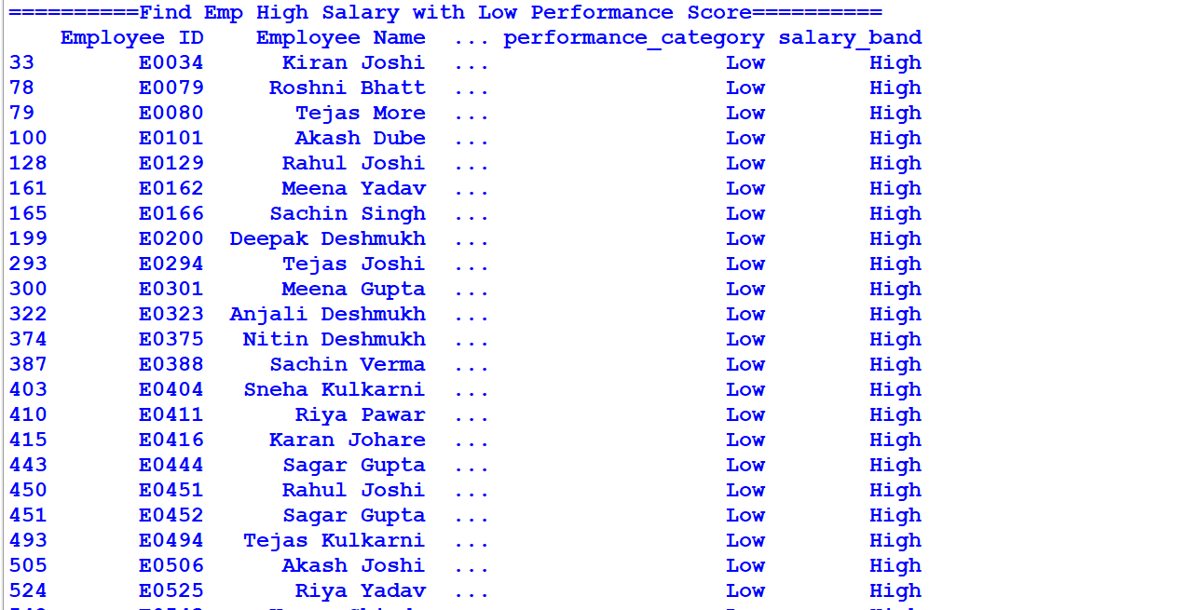

20. Summarise Department Performance :-
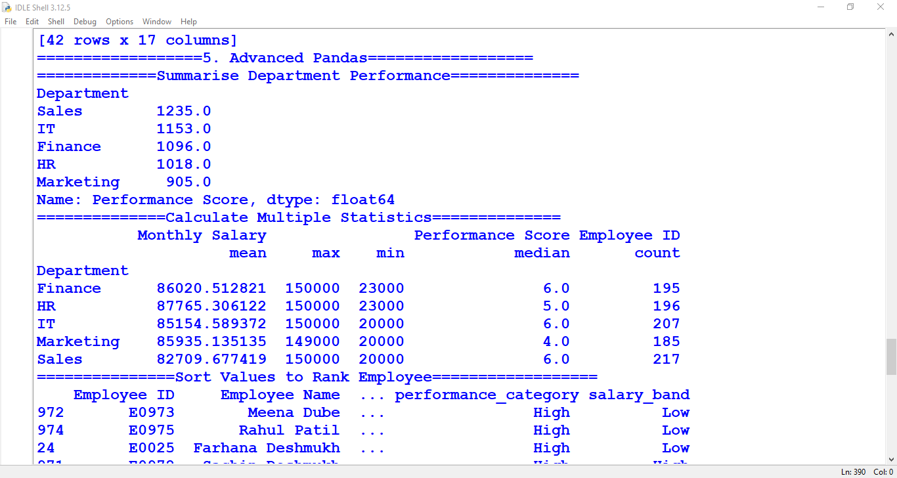

21. Calculate Multiple Statistics :-
22. Sort Values to Employee Rank :-
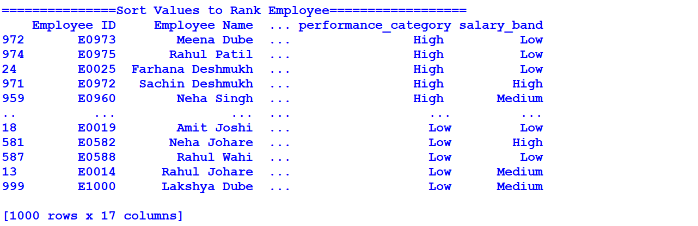

23. Use loc and iloc to filter Record :-
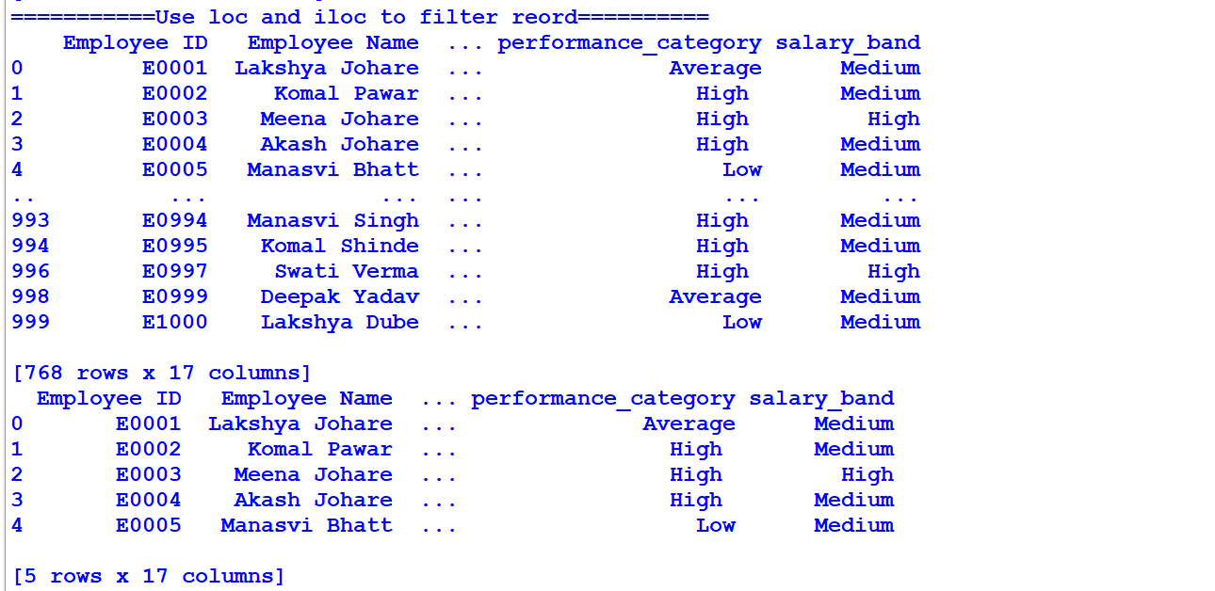

24. Use Pivot Table to Compare Salary And Performance :-
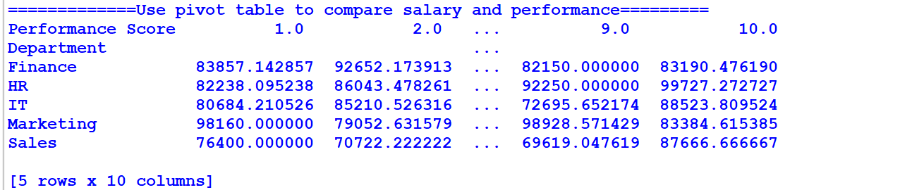

25. Use Merge to Combine Employee And Department Budget Dataset:-
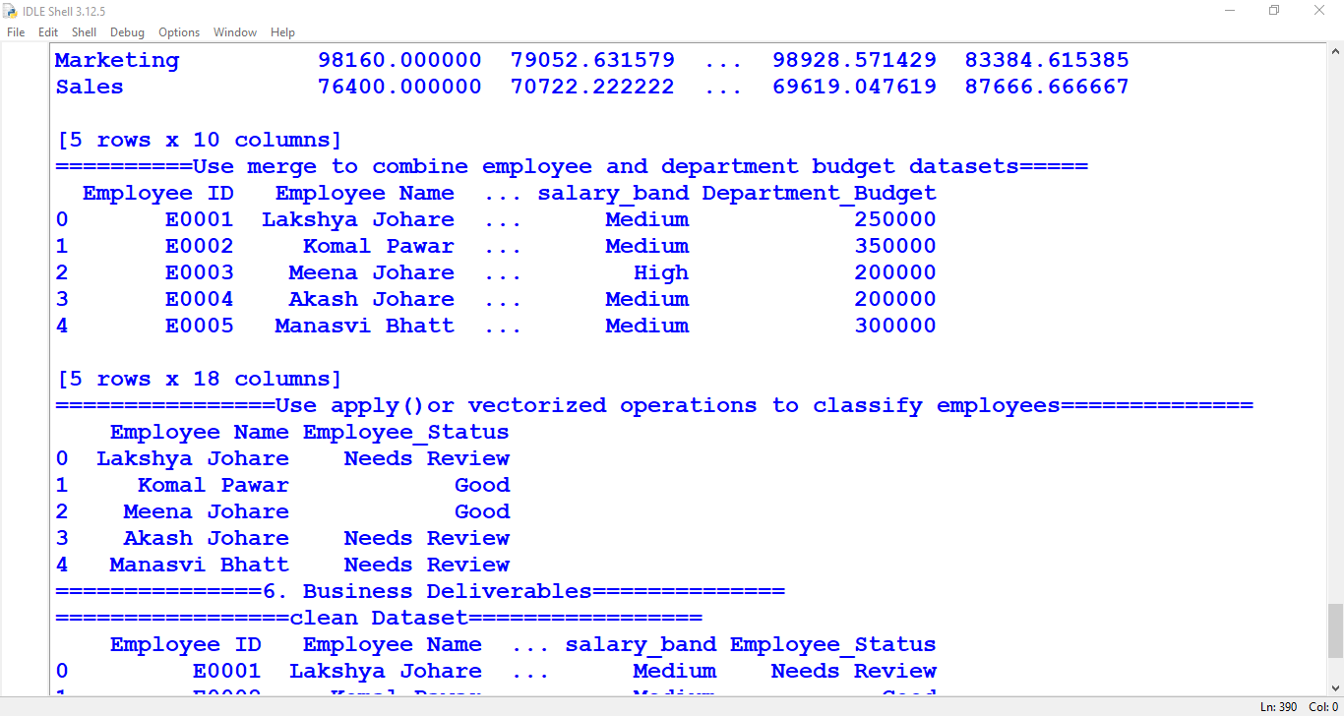

26. Use Apply or Vectorized Operations to classify Employee:-

27. Clean Dataset :-
