CS348 Computer Networks
Lab Excercises 1

Name : Dnyaneshwar D Shnedurwadkar
Roll No : 1401CS43

Circuit Switching TDM :
In Circuit Switching every source sends data after getting it’s time division(TDM). While one source is sending others have to wait till it’s time come(Round robin manner). Assume for all source sending rate(in packets per unit time), data generating rate(packet per unit time) and bandwidth is taken as input which is constant. Packet size is taken as input and same for all packets. Total time units for witch simulation works and time division is constant(10).
Instead of taking system clock I used while loop,
assume each iteration of while loop is 1 unit time.
In while first I created packets for each source as given generating rate and then send the packet as per round robin manner using given time division.
In each source one queue is generated for storing packets which are yet to send.
For gererating data : boolean generatePacketCs(int time,int size)
For sending data : void sendpacketCs(int time)

Packet Switching:
In this any source can send packets to switch.
We need to consider queue in switch which contains packets from any source.
In packet switched mode, the switch uses a single
queue. Packets arriving from the sources are inserted in the queue in order of their arrival and dispatched to the sink by dequeuing one at a time.

My tar file contains 4 folders for source code of 1.a , 1.b, 2.a, 2.b.

Following are graphs based on some imput

1)
a) Average sending delay Vs Number of sources for circut switching
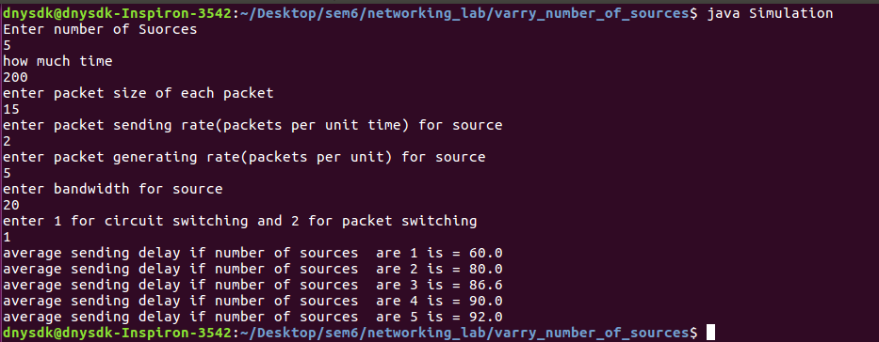

Graph :
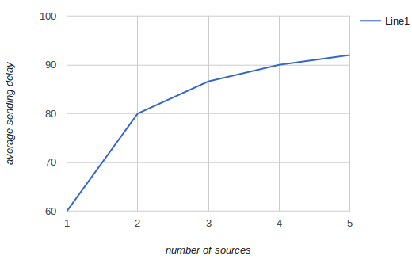
for circuit switching

For circuit switching average sending delay will increase as number sources increases

Average sending delay Vs Number of sources for packet switching
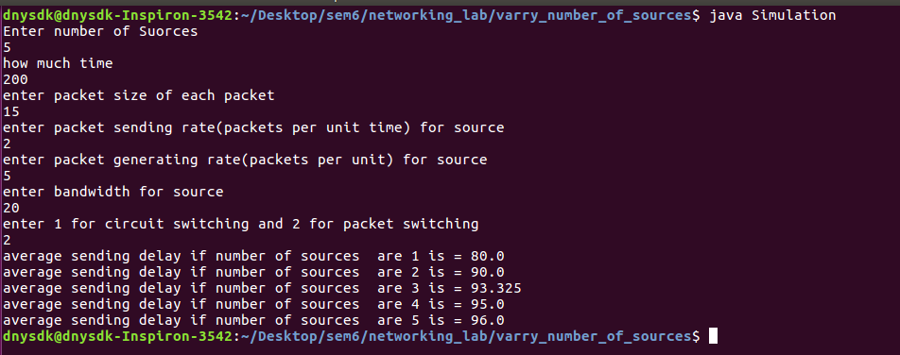
graph:

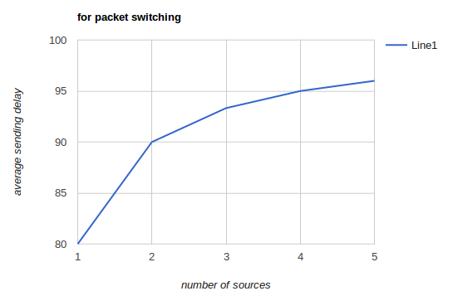

For packet switching average sending delay will increase as number sources increases

1)
B)
average sending delay Vs sending rate for circuit switching
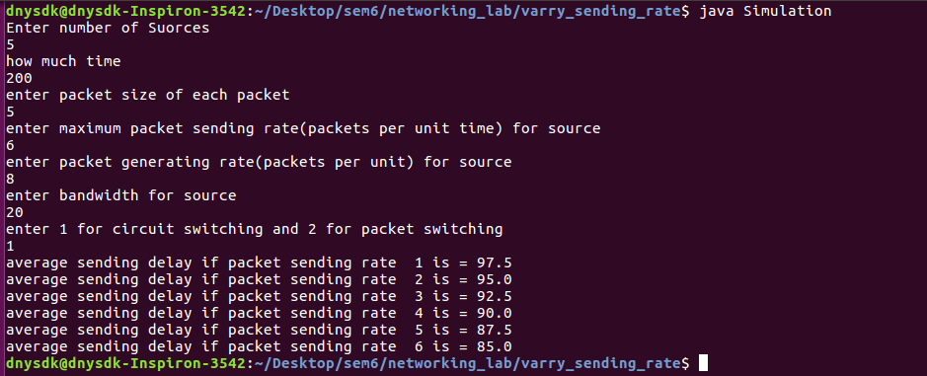

graph :

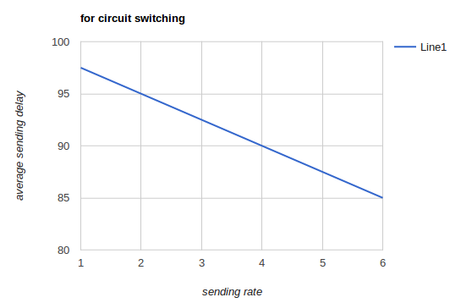

Average sending delay decreases if sending rate increases as more number of packets can be send per unit time.

average sending delay Vs sending rate for packet switching

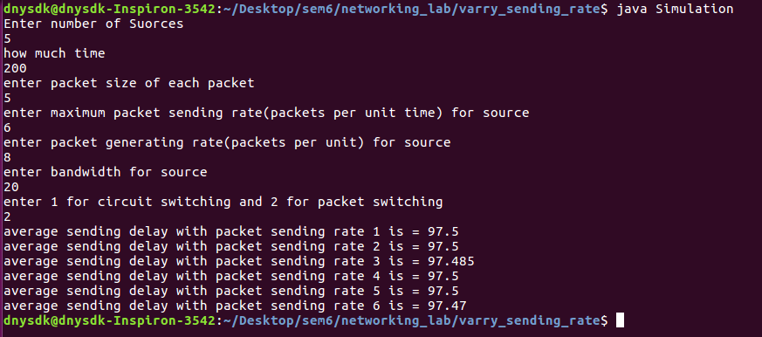
graph :

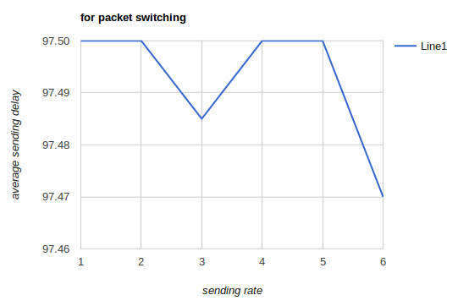

For packet switching average sending delay is almost same.

2
A )
Packet loss rate vs queue size

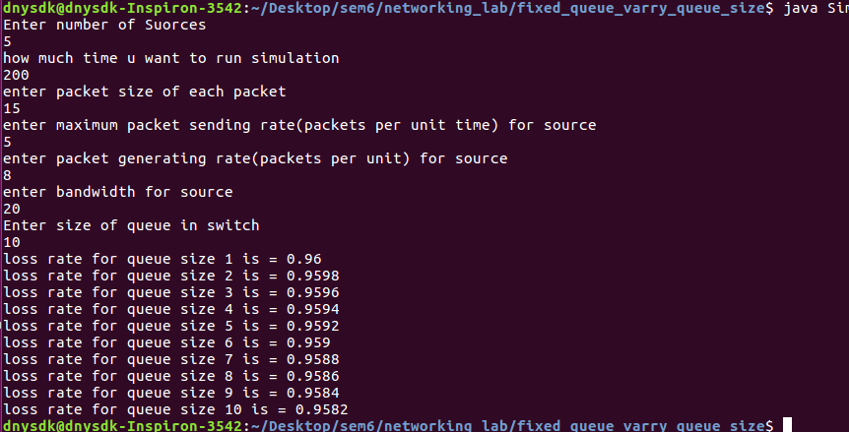

Graph :

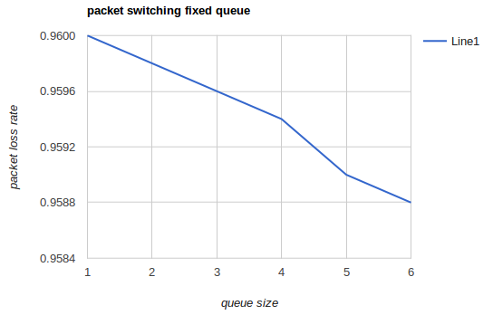

Here we can see that less packet will get loss as queue size is increases for fixed queue packet switching

B) packet loss rate vs packet sending rate

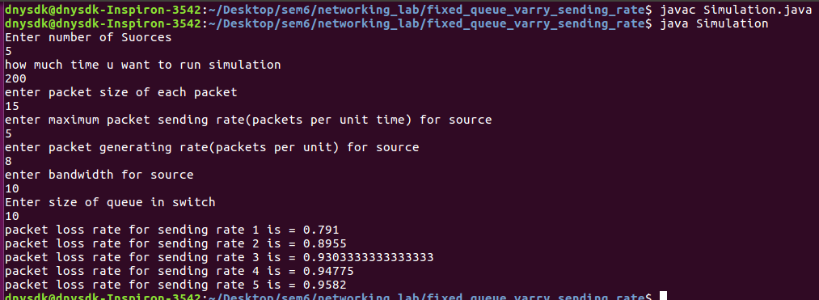
graph :

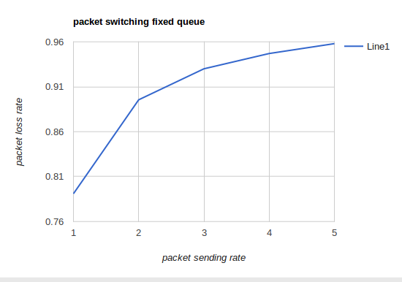

Here we can see that more packet will get loss if seding rate is increases for fixed queue packet switching

