Software Development (A2)

**Quality Assurance Documentation:**

Issue tracking:

Our group made use of the in-built GitLab issue reporting tool to assign, track and fix errors with our code as show in the photo below. If someone encountered a substantial issue within our code or documentation, they would be able to propose and assign an issue to the person whose job it was to fix it for example if it was a database problem Safiya would as the database manager be assigned to fix it:

If an issue was solved it would then be checked over someone who would leave a comment either asking for additional verification or stating how the issue was solved before it would be closed.

Code reviews:

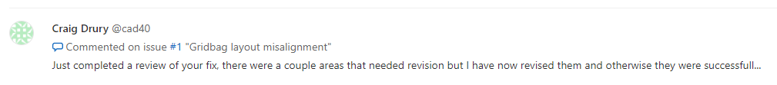When submitting code, we often went back over to check and comment code in order to make sure it was up to standard and work as intended. This was often done by the quality assurance lead who would be in charge of looking over code as it was added to the GitLab:

Refactoring:

We often reworked methods to remove errors and better streamline the code or to implement new features to a method, this was done through refactoring:

Here code was refactored to better reflect the specification with additional features. This corrected previous errors with our code and made sure it was more in line with what we needed to be doing thus improving the quality of our overall code.