1. We have used the turtle module in our discussion to recursively draw trees. In this problem you are tasked with implementing a program that recursively draws a fern as defined below, using the turtle module. The specification of the fern is as follows:
   1. the recursive function should be called as fern(n,l)
   2. n = order or age
   3. l = length

Hints: Below are a few examples of ferns based on the initial call of the fern(n,l) function. Good angles to try out are 55, 40, and 5 degrees.

Fern(1,10)



Fern(3,10)

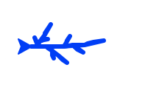

Fern(5,10)  
