TrackIT
Use Case
Create User Profile

Version 2.0

Revision History
Date | Version | Description | Author
October 25, 2004 | 1.0 | Created | Team 2
November 8, 2004 | 2.0 | Update Use Cases from Facade to Filled | Team 2

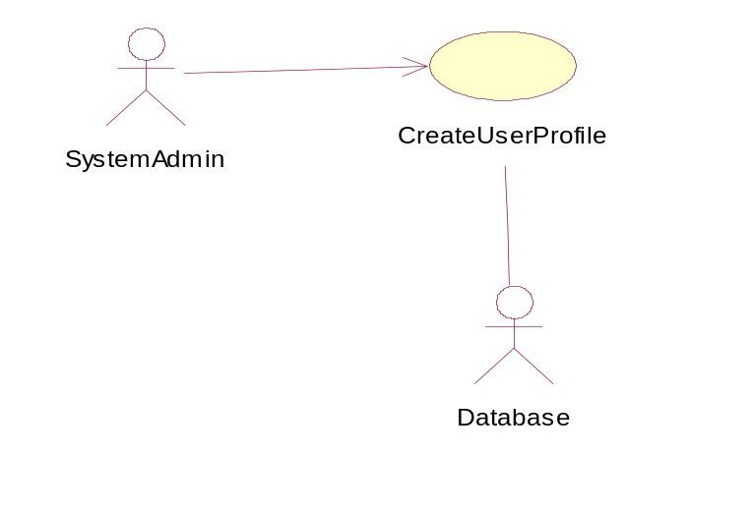
Use Case Number: | 6
Use Case Name: | Create User Profile
Actor (s): | Database, System Administrator
Maturity: (Façade/Focused/… | Filled
Summary: | The System Administrator will be able to enter user profiles into the TrackIT system and will be able to maintain these profiles. This will include granting users access to the system.
Basic Course of Events: | Actor Action | System Response
Basic Course of Events: | The actor (System Administrator) selects to create a new User Profile.
Basic Course of Events: |  | The system displays a template to add a new user’s information.
Basic Course of Events: | The actor (System Administrator) enters in the information.
Basic Course of Events: |  | The system validates each entry according to data validation rules.  E1
Basic Course of Events: | When satisfied with the entered data, the actor (System Administrator) submits the criteria.  A1, A2
Basic Course of Events: |  | The system gathers the entered data and submits it to the actor (Database).  E2
Basic Course of Events: | The actor (Database) saves the data.
Basic Course of Events: |  | The system displays a success message.  E3
Alternative Paths: | A1. The actor (System Administrator) decides to cancel the changes instead of saving them. In this case, the system will not save the changes to the database. A screen will be displayed to indicate that the changes were not saved.  A2. The actor (System Administrator) interrupts the current task by selecting an unrelated menu option. In this case, the system will abandon the current task and will proceed to the first task triggered by the user action.
Exception Paths: | E1. The actor (System Administrator) enters invalid data in a field. The system alerts user that the data entered is invalid and redisplays the page so that the user may correct the data.  E2. The actor (System Administrator) submits the data without completing all required fields. The system will alert the actor that data is missing and will redisplay the page so that the actor (System Administrator) may correct the information.  E3. The actor (Database) was unable to save the information; therefore, a message will be displayed to the user.
Extension Points:
Triggers: | The actor (System Administrator) selects to create a new User Profile.
Assumptions: | The actor (System Administrator) has logged into the system.  The actor (System Administrator) possesses the required authority level to create a User Profile.
Preconditions: | The actor (System Administrator) logs in to the system.
Post Conditions: | A new User Profile is added to the system.
Reference: Business Rules:
Reference: Risks | 2.1 Inadequate Requirements Gathering  2.6 Performance
Activity Diagram:
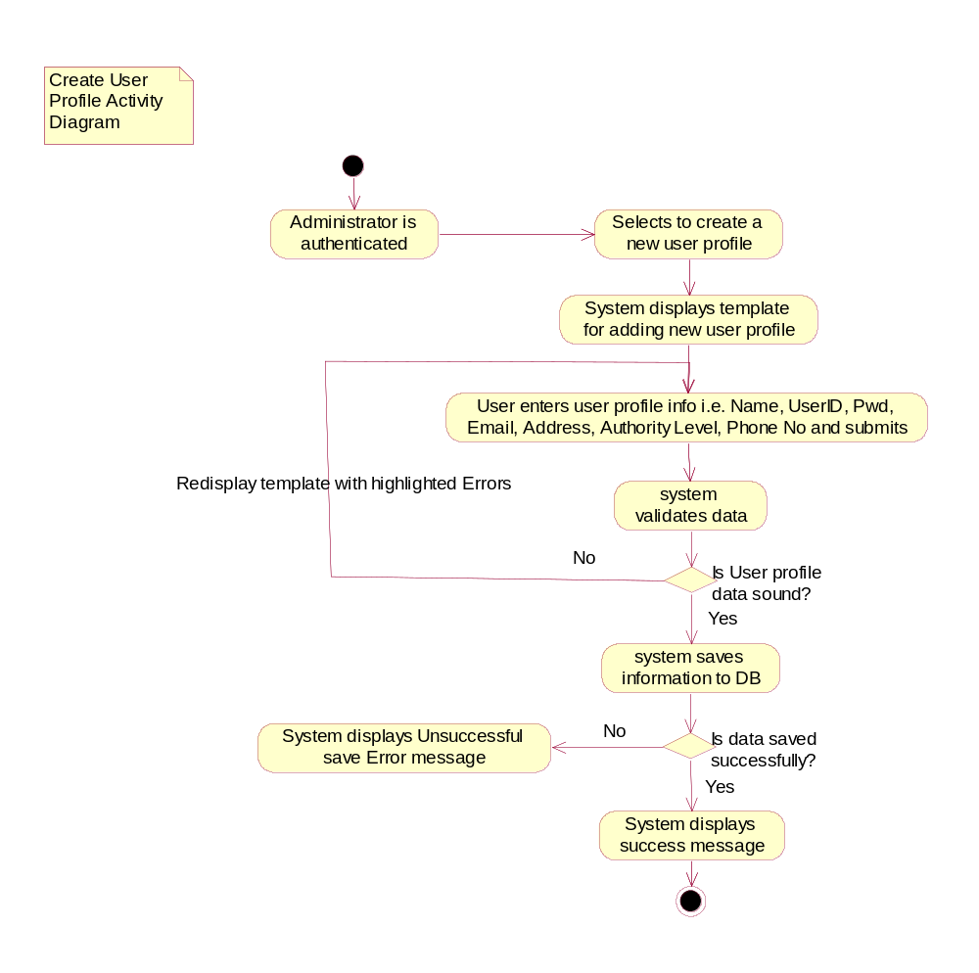
Author(s): | Team 2
Date: | 11/01/04

