

**Computer Science Apprenticeship (CAP).**

**An-Najah National University.**

**Doaa eid 11926144**

Assignment-4: QA

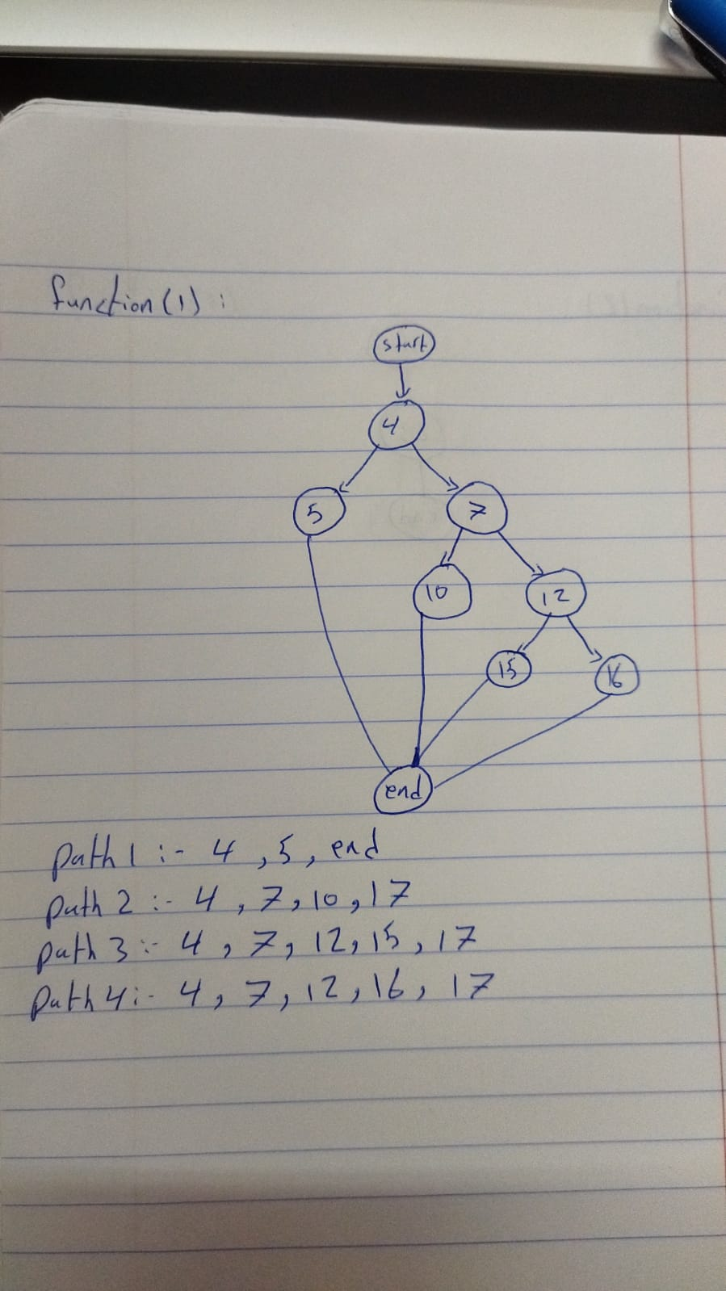

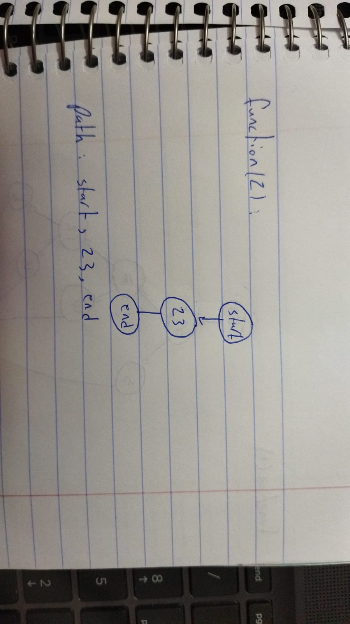

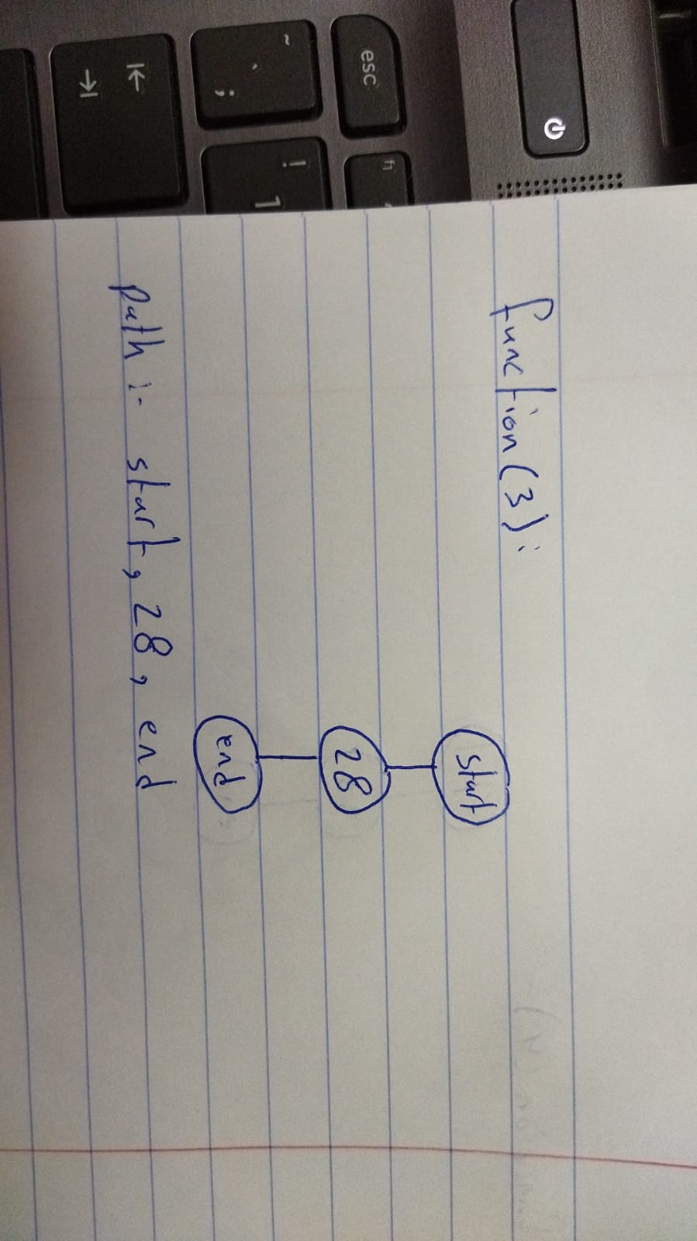

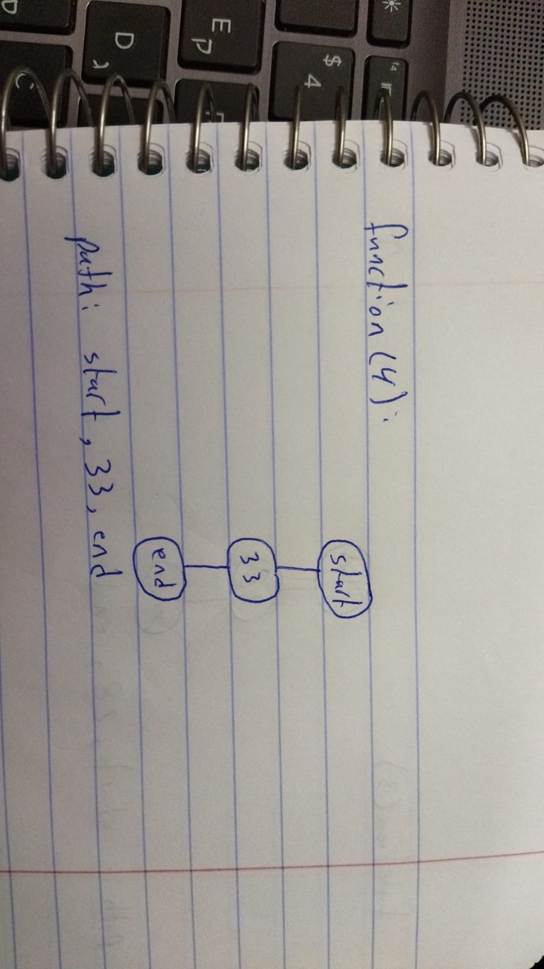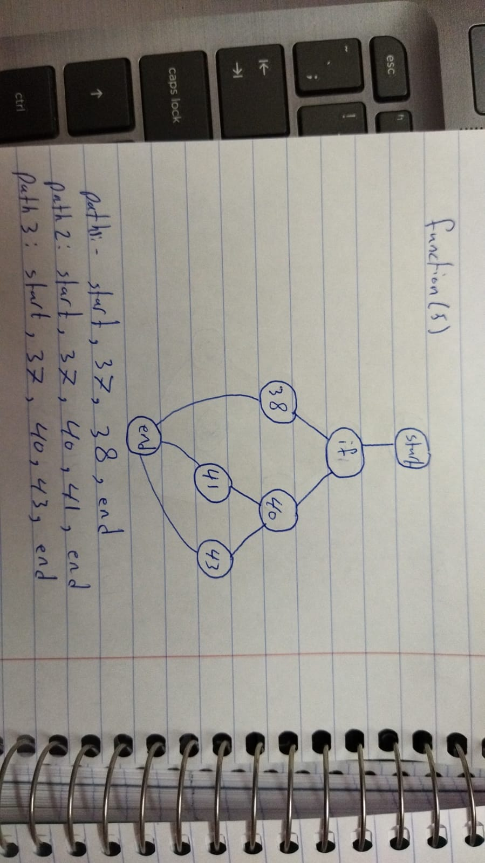

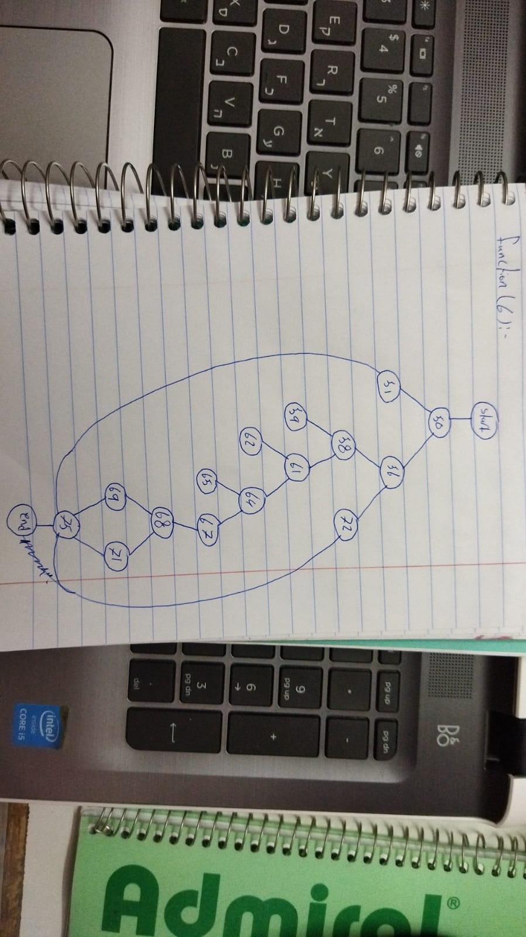

Path 1: start, 50, 51, 75, end.

Path 2: start, 50, 56, 58, 59.

Path 3: start, 50, 56, 58, 61, 62.

Path 4: start, 50, 56, 58, 61, 64, 65.

Path 5: start, 50, 56, 58, 61, 64, 67, 68, 69, 75, end.

Path 6: start, 50, 56, 58, 61, 64, 67, 68, 71, 75, end.

Path 7: start, 50, 56, 72, 75, end.

