

**An-Najah National University**

**Advanced software development**

**Student Name: Doaa Eid**

**University ID: 11926144**

**Course Teacher: D.Mustafa Assaf**

**Part2**

**2.1 class**

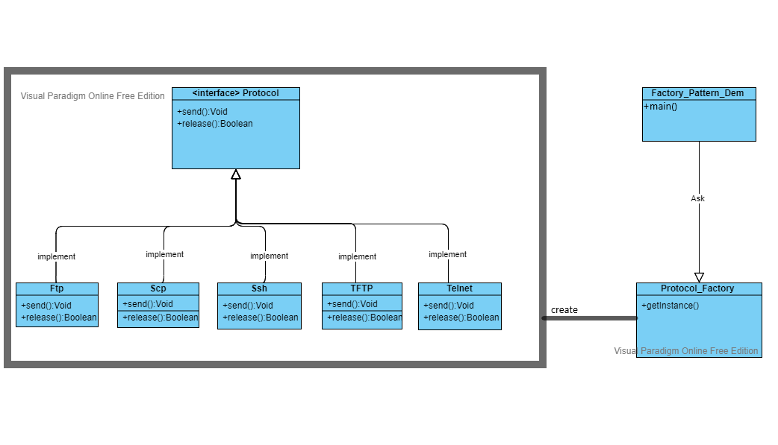

**Part 2**

**2.2 SOLID**

**The Factory Class has been reformed from the Five Principles of the SOLID of class connection which single responsibility principle because he took a job, the factory took the job of the instance of the protocol he took from the original class in which the function was**

**As he was doing more than one different task, and when he separated the Instagram job, this problem was solved**

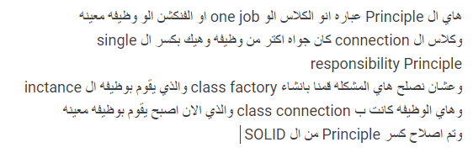

**SOLID**

**SOLID principle(s) is solved by the Factory**

1. **Open and Closed Principle**
2. **Dependency Inversion Principle**

**1**

**Open and Closed Principle:**

**Do an action of the type of ftp,Telmet,Sst,Scp ,TFTP,Protocol_Factory connection, each one of them is a class separately, even if you want to add a new connection type, I want to make an extension and add a new class and use the functions taken from the interface Separate each class individually as parts**

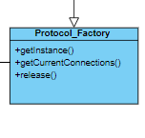

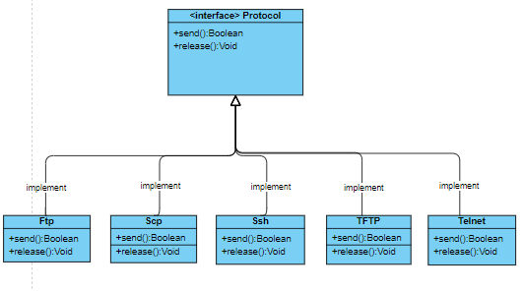

**2**

**Dependency Inversion Principle:**

**Each of the classes Protocol Which also depends on the protocol class ftp, Telmet, Sst,Scp ,TFTP depends on Protocol_Factory**

