**Collector Application**

1. A screenshot of a computer

   Description automatically generated**Setting Tab**

* **Setting Tab Content:**
* RX Log file path **"Browse":** Button to select or create file in specific path in which Received data to the collector is logged.
* TX Log file path **"Browse"**: Button to select or create file in specific path in which transmitted data to the collector is logged.
* **"Getaway Number":** Combo box to select the Getaway Number which is responsible about some Aggregators which is linked to some Meters, so this selection is very important in selecting specific meter numbers.
* **"UART Setting":** Section to select the UART Configurations as:
* **“COM Port”:** Combo box (if it is empty and you are sure in connecting the USB TTL, you must go to "Device Manager" and check if COM Port connected needs to be updated or not).
* **“Buadrate” :** 115200,9600,1200,2400,38400,4800,57600,19200
* **“Data Bits” :** 8,9
* **“Stop Bits” :** 1,2
* **“Parity” :** Even, Odd, None

**Default Values:**

* **“Buadrate” :** 115200
* **“Data Bits” :** 8
* **“Stop Bits” :** 1
* **“Parity” :** None
* the "Refresh" button is responsible for update the data selected in all configurations in the Json file called **"JsonConfig.json"**

**-JsonConfig.json** Configurations:

* COM Port
* Buadrate
* Data Bits
* Stop Bits
* Parity
* Getaway Number
* TX Log file path
* RX Log file path

1. A screenshot of a computer

   Description automatically generated**Automatic Tab:**

**- “Getaway Configuration”:** group box the display the configured data not to edit in it.

- **“Automatic Rich box”:** rich box to display the sent and received data in run time which is stored in the “Tx File” and “Rx File” and if the connection started or closed.

**- “Start Button”**: button to start connection to USB COM Port, launch all data configured data in the “Setting” tab, launch all data set in Json file and calculates the “Remain” and “Frequency Now” fields then start thread of the collector schedule.

- **“Stop Button”**: button to stop connection of the COM Port.  
  
- **“Remain”:** field to define the remaining meters drops through collecting data, to iterate on them again.

**- “Frequency”:** field to define the number of readings happen in one day (ex-frequency= 2 this means that i want to get reading of all meters connected to the getaway number twice so that 🡪 every 24/2=12hr i will get the reading of all meters.).

**- “Frequency Now”:** field to define which phase i collect the meter data (if the frequency =2, if frequency now =1 this means that the now is the first phase of collecting data in this day which define the first 12 hr from this day, if frequency now =2 this means that the now is the second phase of collecting meters data in this day which define the second 12 hr from this day.).

* **Collector Scheduler:**

This schedular try to collect readings of all meters connected the getaway number selected in “Setting” tab, and all meter orders (Add Client, Edit Meter, delete ……...) not served up till his moment of time.

|  |  |  |  |  |  |  |  |  |  |  |  |  |
| --- | --- | --- | --- | --- | --- | --- | --- | --- | --- | --- | --- | --- |
| **Sent Frame** | **Packet ID** | **AggregatorID** | **CMD** | **Meter ID** | **MeterType** | **messageID** | **Messrepnum** | **Spare fields** | **Sequence No** | **AA** | **Request Data (Payload)** | **BB** |
| **Length** | 4 | 4 | 2 | 4 | 1 | 4 | 1 | 6 | 4 | 1 | variable | 1 |
| **index** | 0 | 4 | 6 | 10 | 11 | 15 | 16 |  |  |  |  |  |

* **Sent Frame**

|  |  |  |  |  |  |  |  |  |  |  |  |  |
| --- | --- | --- | --- | --- | --- | --- | --- | --- | --- | --- | --- | --- |
| **Received Frame** | **Packet ID** | **AggregatorID** | **CMD** | **Meter Type** | **MeterID** | **messageID** | **Messrepnum** | **Spare fields** | **Sequence No** | **AA** | **Request Data (Payload)** | **BB** |
| **Length** | 4 | 4 | 2 | 1 | 4 | 4 | 1 | 6 | 4 | 1 | variable | 1 |
| **index** | 0 | 4 | 6 | 10 | 11 | 15 | 16 | 22 |  |  |  |  |

* **Received Frame**

If CMD ACK >> 0x1F // this means that no errors found through receiving data from meter.

If Not:

* **Error Codes:**
* METER_NOT_FOUND 0xE0
* CMD_NOT_FOUND 0xE1
* CHECKSUM_ERROR 0xE2
* WRONG_INPUT 0xE3
* INCORRECT_PACKETID 0xE4
* INCOMPATIBLE_CMD 0xE5
* DATA_NOT_SENT 0xE6
* EMPTY_PAYLOAD 0xE7

1. Manual Tab

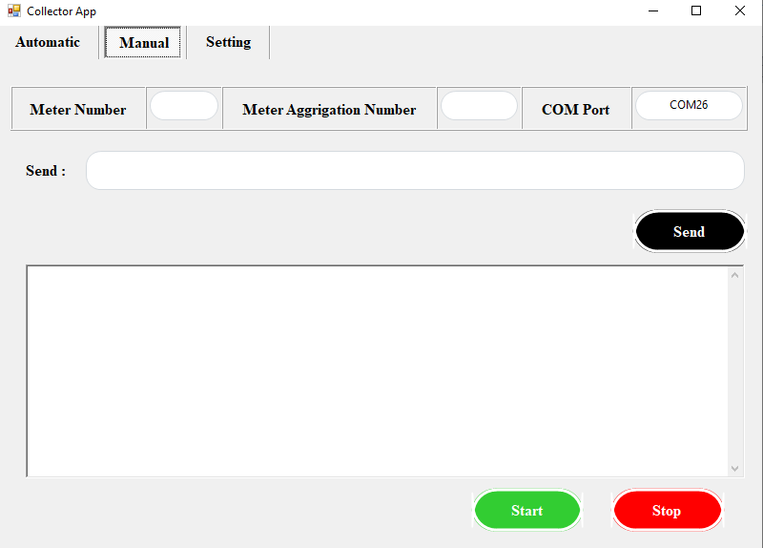

Here we don’t have schedular, here we specify defined meter related to defined aggregator   
  
- **“Start “:** button has same function of automatic “Start” button regardless schedular functions.

- “Stop”: button has same function of automatic "Stop" button.

- “Send”: field to represent sent frame with data input of “Meter Number” field and “Meter aggregation Number” field after creating full frame.  
n