Required Pbc image

1- home

1- 1920 x 1080 in general for home page
2-1920 x 1080 represent service
3-1920 x1080 represent portfolio

2-About us

1- 1680 x 980 in general for about us
2- 700 x 800 for each one in company
3- 900 x 650 represent services or solutions that PBC make
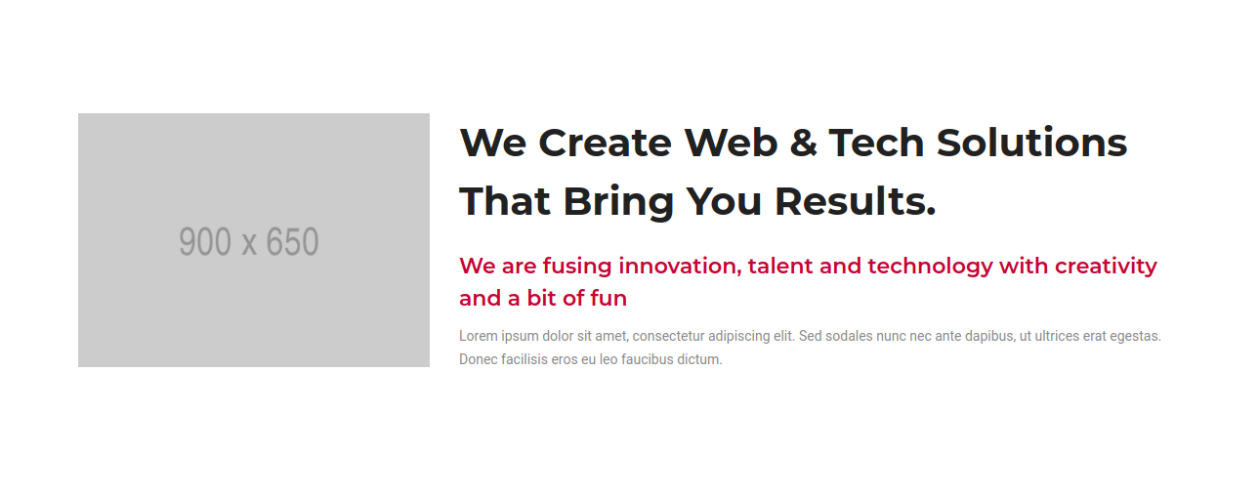

3-Services

1- 1680 x 980 in general for services page

4-Contact us

1- 1920 x 1080 in general for contact us page

public function getCaptinorders(Request $request){

try{

$captain= Auth()->user();
if($captain->active == 1 ){
if($captain->type == 4){
$agent_captain = $this->checkcaptain($captain->id);

$this->object($agent_captain);
dd($agent_captain);

}else{

$statusCode = 200;
$response['status'] = -1;
$response['message'] = "not Avaliable";
return response()->json($response, $statusCode);

}
}

}catch(Exception $e){

$statusCode = 200;
$response['status'] = -1;
$response['message'] = $e->getMessage();
return response()->json($response, $statusCode);

}finally {
return response()->json($response, $statusCode);
}
}

