**Sunday, April 30, 2023**

**Bash Command Line Tutorials**

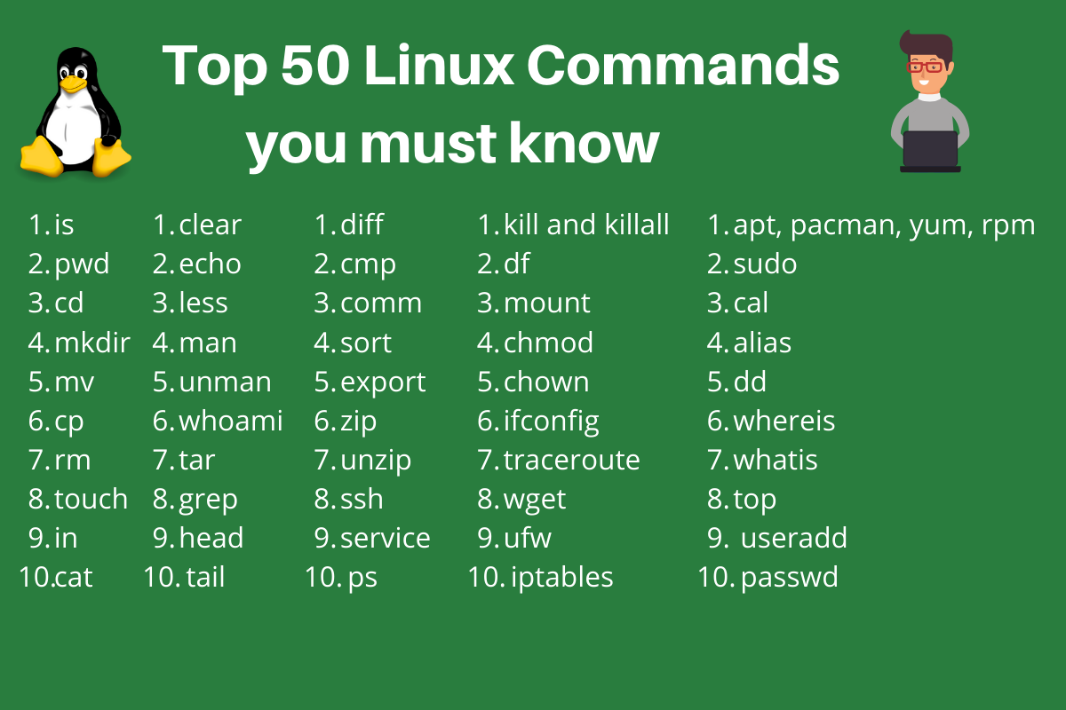

**The Command Line:**

**The command line is a text-based interface used to interact with a computer's operating system.**

**It provides more flexibility and power than a graphical user interface (GUI).**

**To access the command line on a Linux or Mac OS, you can open the Terminal application.**

**On Windows, you can use the Command Prompt or PowerShell.**

**Commands are typed into the terminal and executed by pressing enter.**

**Basic Navigation:**

1. **The Linux file system is organized hierarchically, with the root directory at the top.**
2. **Directories are separated by forward slashes (/).**
3. **The pwd command shows the current working directory.**
4. **The ls command lists the contents of the current directory.**
5. **The cd command is used to change directories.**
6. **cd .. moves up one level in the directory tree.**
7. **The tab key can be used for auto-completion.**

**More About Files:**

1. **The ls -l command shows the permissions for files and directories.**
2. **Directories have a special permission bit that allows users to list their contents.**
3. **Hidden files in Linux start with a dot (.) and can be shown with the ls -a command.**
4. **File and directory names are case-sensitive.**

**Manual Pages:**

1. **Manual pages (man pages) provide documentation for Linux commands.**
2. **They can be accessed with the man command followed by the name of the command you want to learn about.**
3. man **is used to access the manual pages for a command.**
4. **Manual pages can be searched using the / key followed by the search term.**
5. **Manual pages can be exited by typing q**

**File Manipulation:**

1. **Files can be created with the touch command and directories with the mkdir command.**
2. **Files can be copied with the cp command and directories with the cp -r command.**
3. **Files and directories can be moved or renamed with the mv command.**
4. **Files and directories can be removed with the rm command (use with caution!).**
5. **The grep command can be used to search for text within files.**