
● SERVICE DESK · USER GUIDE
Whistleblowing
Reporting Portal
How to submit, review and investigate reports in Jira Service Management
DRAFT · SANDBOX

Item | Detail
Document | Whistleblowing Reporting Portal – User Guide
Version | 1.0 (draft)
Date | 19 October 2026
Prepared by | Doaa Mokhtar
Client | ERC
Environment | Sandbox (erc-sd-sandbox.atlassian.net)
Status | Draft – to be updated with live ERC data before release

Contents
1. About the portal 3
2. How to submit a report 3
3. What happens after you submit 4
4. For the Compliance Manager 4
5. For investigation teams 5
6. Groups: who sees what and who can do what 6
7. Service levels and escalation 7

Right-click the list and choose Update Field if page numbers are missing.
DRAFT. This guide is based on the sandbox environment (erc-sd-sandbox). Links, groups and screenshots will be updated with the live ERC data before release.

1. About the portal
The Whistleblowing Reporting Portal lets anyone report misconduct at ERC without signing in and without giving their name. Every report is reviewed first by the Compliance Manager, then investigated by the team responsible for that type of concern.
- Anonymous by default. The email field is pre-filled with Anonymous@Anonymous.com. Leave it as it is to stay anonymous.
- Confidential. Only the Compliance team and the one team assigned to investigate can see a report. Other staff, and other investigation teams, cannot.
- Optional contact. A reporter who wants to be contacted can leave a phone number; nothing else identifies them.

Who | Section to read
Anyone reporting a concern | 2. How to submit a report
Compliance Manager (GRC-Compliance) | 4. For the Compliance Manager
Investigation teams | 5. For investigation teams
Head of Compliance (HO-Compliance) | 7. Service levels and escalation

2. How to submit a report
Anyone can submit a report in about two minutes, with no account and no sign-in.
- Open the reporting form: https://erc-sd-sandbox.atlassian.net/helpcenter/WhistleblowingReporting/portal/169/group/274/create/474?email=Anonymous%40Anonymous.com
  - Use this exact link. Opening the portal from its home page leaves the email field empty.
- Email confirmation to is already filled with Anonymous@Anonymous.com. Leave it as it is to stay anonymous, or replace it with your own email.
- Summary | الموضوع: a short title, for example "Supplier invoice inflated".
- Phone number | رقم الجوال (optional): fill it in only if you want the Compliance team to be able to contact you.
- What are the details of your request? What happened, when, where and who was involved. Write as much as you know.
- Attachments (optional): add documents or photos that support the report.
- Click Send. A reference number such as WB-30 is shown. Keep it if you want to refer to your report later.

Screenshot to add: the reporting form with the email pre-filled, and the confirmation screen after Send.

3. What happens after you submit
Your report is reviewed twice: first by the Compliance Manager, then by the team that investigates that type of concern.
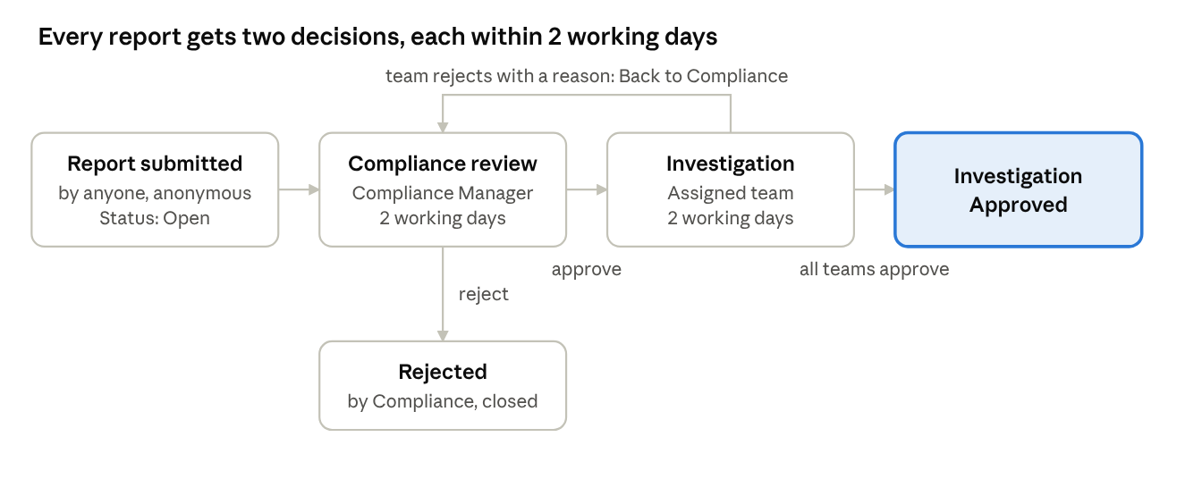
Figure 2 – Report workflow: two decisions, one return path
If the investigating team rejects the report, it goes back to the Compliance Manager with a reason, who can correct the classification and approve it again or close it. Each review has 2 working days before the Head of Compliance is alerted.

4. For the Compliance Manager
The Compliance Manager classifies every new report and decides whether it goes to investigation. You have 2 working days to decide.
- Open the queue and open a report with status Open (or Back to Compliance).
- Under Attached forms, open the Compliance Approval form. It is internal: the reporter never sees it.
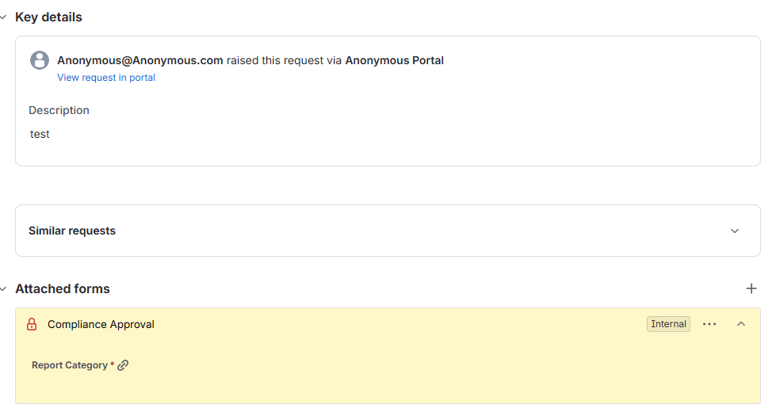
Figure 3 – The Compliance Approval form on a new report, not yet submitted
- Choose Report Category.
  - If you choose Other, a second question appears: Investigating Function. Choose which team investigates. The form will not submit without it.
- Click Submit on the form. Within a few seconds, Investigating Function is filled in on the report from the agreed table.
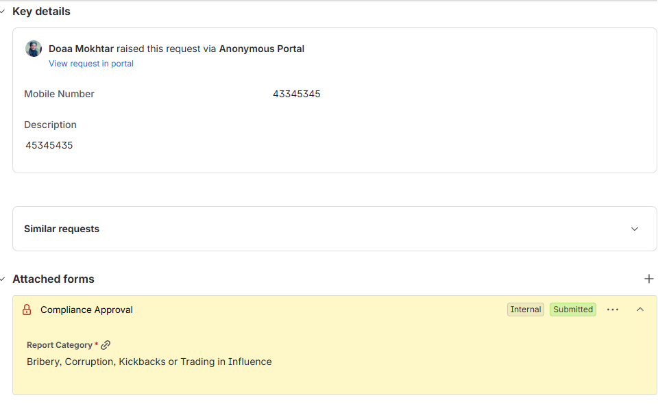
Figure 4 – The form after submission: Report Category recorded
- Approve: the report moves to Under Investigation, is routed to the right team, and that team gets an email.
- Reject: choose a Rejection Reason and add a comment; the report closes as Rejected by Compliance.

Good to know: Approve is blocked until the form is submitted. Investigating Function and Investigation Group cannot be edited directly; they change only through the form and the automatic routing. While a report is Under Investigation, the decision belongs to the investigating team.

5. For investigation teams
An investigation team sees a report only after the Compliance Manager approves it and routes it to them. You have 2 working days to approve or reject.
- You receive an email: Report WB-xx assigned to your team. Click Open the report, or find it in the queue.
- Read the report and its attachments.
- Approve: in the approval panel on the report, click Approve. For a Retaliation report, both Human Resources and Employee Relations must approve.
- Reject: click Reject, choose a Rejection Reason (insufficient information, duplicate, out of scope, or Wrong category), add a comment, and confirm. The report returns to the Compliance Manager as Back to Compliance.
- When all assigned teams approve, the report moves to Investigation Approved.

Good to know: Reject cannot be saved without a reason. Teams cannot change the category, the investigating function, the group or the form; if the category is wrong, reject with "Wrong category". Teams cannot see reports assigned to other teams.

Screenshot to add: the approval panel on a report, and the Reject screen with Rejection Reason.

6. Groups: who sees what and who can do what
Access comes only from group membership; each investigation team sees only the reports routed to it.
Group | Role | Sees | Can do
GRC-Compliance | Compliance Manager | All reports | Fill the Compliance Approval form, Approve or Reject new reports, be assignee, receives the new-report email
Internal Audit | Investigation team | Reports routed to Internal Audit | Approve in the approval panel, Reject with a reason, be assignee, receives the assignment email
Human Resources | Investigation team | Reports routed to HR, including Retaliation | Same as Internal Audit
Employee Relations | Investigation team | Retaliation reports only | Same as Internal Audit; both HR and Employee Relations must approve Retaliation
Health and Safety Representative | Investigation team | Reports routed to Health and Safety | Same as Internal Audit
Information Security | Investigation team | Reports routed to Information Security | Same as Internal Audit
HO-Compliance | Head of Compliance | Escalation emails only | Receives an escalation email when a stage passes its 2-working-day target
FollowUP TKT | Oversight | All reports | View and edit; keep this group small

Which team investigates is set by the report category:
Report category | Investigating function | Group
Fraud, Theft, Embezzlement or Asset Misappropriation | Internal Audit | Internal Audit
Bribery, Corruption, Kickbacks or Trading in Influence | Internal Audit | Internal Audit
Money Laundering, Terrorist Financing or Sanctions Concerns | GRC-Compliance Manager | GRC-Compliance
Procurement Manipulation, Collusion, Bid Rigging or Conflict of Interest | Internal Audit | Internal Audit
Harassment, Discrimination, Bullying or Abuse of Authority | Human Resources | Human Resources
Health, Safety, Environmental or Heritage-Protection Breach | Health and Safety representative | Health and Safety Representative
Information Security, Data Protection or Systems Misuse | Information Security | Information Security
Other Regulatory or License Compliance Breach | GRC-Compliance Manager | GRC-Compliance
Retaliation Against a Reporter or Witness | Human Resources | Human Resources + Employee Relations
Other | Chosen by the Compliance Manager in the form | Follows the chosen function

Note: Every member needs a Jira Service Management agent licence to open reports, approve or reject. Do not put one person in more than one investigation group unless intended: they would see both groups’ reports.

7. Service levels and escalation
Each decision stage has 2 working days (16 working hours, Sunday to Thursday, 08:00–16:00 Riyadh time). When a stage passes its target, the Head of Compliance is emailed automatically.
Service level | Clock runs while the report is | Target | When the target is missed
Time to Compliance Decision | Open, or Back to Compliance (the clock restarts on each return) | 2 working days | Escalation email to HO-Compliance
Time to Investigation Decision | Under Investigation | 2 working days | Escalation email to HO-Compliance

- Fridays, Saturdays and the hours outside 08:00–16:00 do not count.
- The escalation email shows the reference number, the current status and who the report is waiting on, with a link. It never includes the report’s content.
- The time remaining for each service level is shown on the report in Jira.

