1. Consider the implementation of CircularlyLinkedList.addFirst, in

Code Fragment 3.16. The else body at lines 39 and 40 of that method

relies on a locally declared variable, newest. Redesign that clause to

avoid use of any local variable.

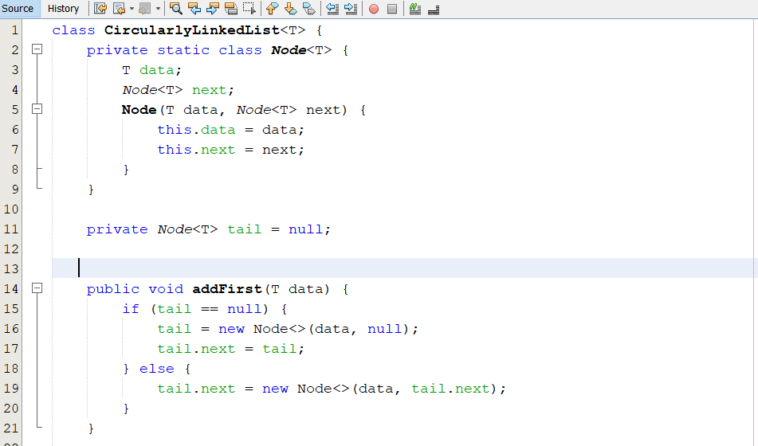

2. Give an implementation of the size( ) method for the

CircularlyLinkedList class, assuming that we did not maintain size as

an instance variable.

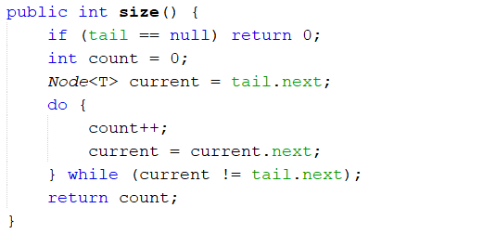

3. Implement the equals( ) method for the CircularlyLinkedList class,

assuming that two lists are equal if they have the same sequence of

elements, with corresponding elements currently at the front of the

list.

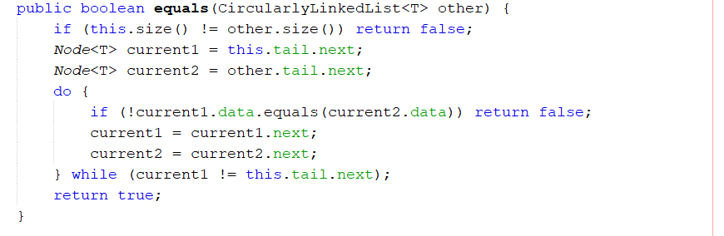

4. Suppose you are given two circularly linked lists, L and M. Describe

an algorithm for telling if L and M store the same sequence of

elements (but perhaps with different starting points).

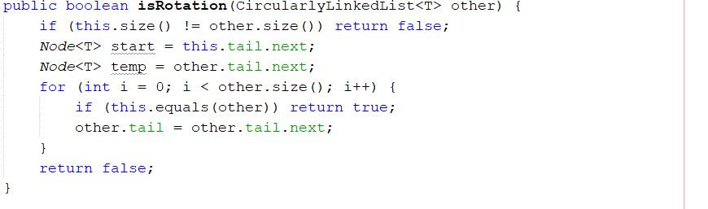

5. Given a circularly linked list L containing an even number of nodes,

describe how to split L into two circularly linked lists of half the size.

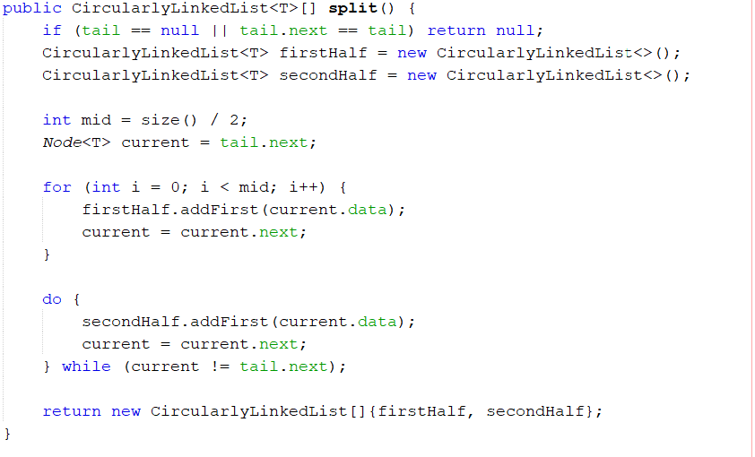

6. Implement the clone( ) method for the CircularlyLinkedList class.

