Homework

1. Describe a method for finding the middle node of a doubly linked list

with header and trailer sentinels by “link hopping,” and without relying

on explicit knowledge of the size of the list. In the case of an even

number of nodes, report the node slightly left of center as the

“middle.”

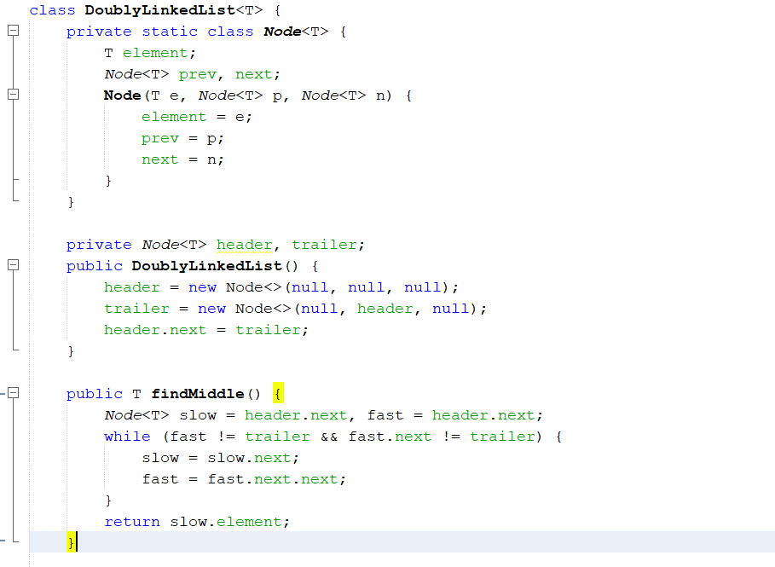

2. Give an implementation of the size( ) method for the

DoublyLinkedList class, assuming that we did not maintain size as an

instance variable.

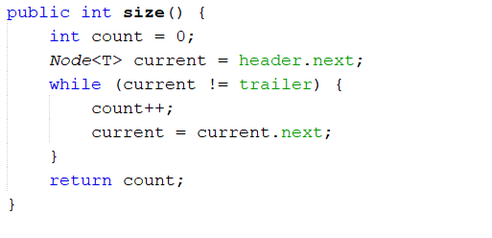

3. Implement the equals( ) method for the DoublyLinkedList class.

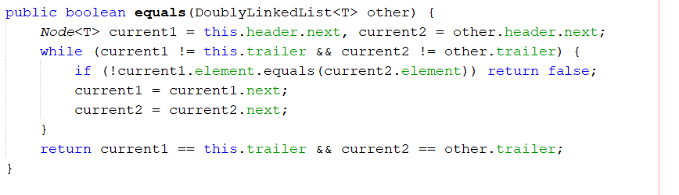

4. Give an algorithm for concatenating two doubly linked lists L and M,

with header and trailer sentinel nodes, into a single list L′.

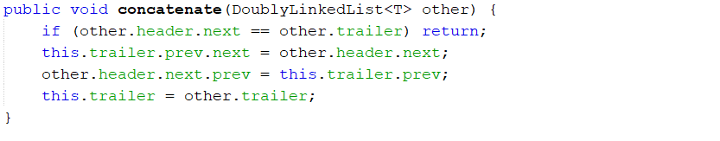

5. Our implementation of a doubly linked list relies on two sentinel

nodes, header and trailer, but a single sentinel node that guards both

ends of the list should suffice. Reimplement the DoublyLinkedList

class using only one sentinel node.

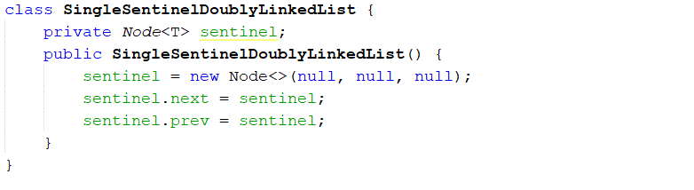

Data Structure Lab6 : Doubly Linked List 2022-2023

6. Implement a circular version of a doubly linked list, without any

sentinels, that supports all the public behaviors of the original as well

as two new update methods, rotate( ) and rotateBackward.

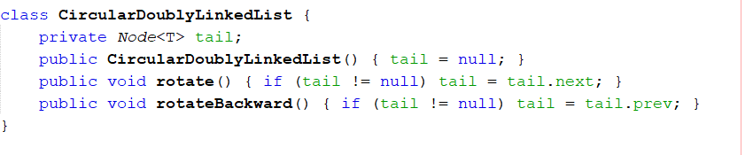

7. Implement the clone( ) method for the DoublyLinkedList class

