Homework

1. Implement a method with signature transfer(S, T) that transfers all

elements from stack S onto stack T, so that the element that starts at

the top of S is the first to be inserted onto T, and the element at the

bottom of S ends up at the top of T.

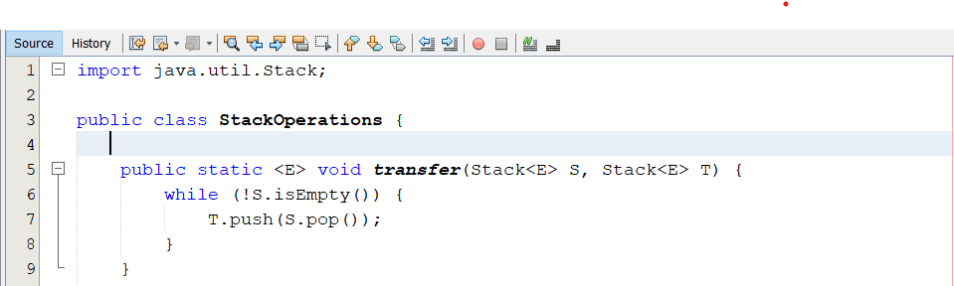

2. Give a recursive method for removing all the elements from a stack.

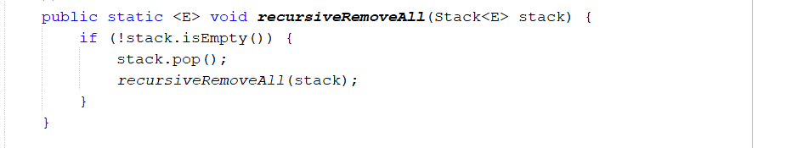

3. Postfix notation is an unambiguous way of writing an arithmetic

expression without parentheses. It is defined so that if

“(exp1)op(exp2)” is a normal fully parenthesized expression whose

operation is op, the postfix version of this is “pexp1 pexp2 op”, where

pexp1 is the postfix version of exp1 and pexp2 is the postfix version

of exp2. The postfix version of a single number or variable is just that

number or variable. So, for example, the postfix version of “((5 + 2)

(8 − 3))/4” is “5 2 + 8 3 − 4 /”. Describe a nonrecursive way of

evaluating an expression in postfix notation.

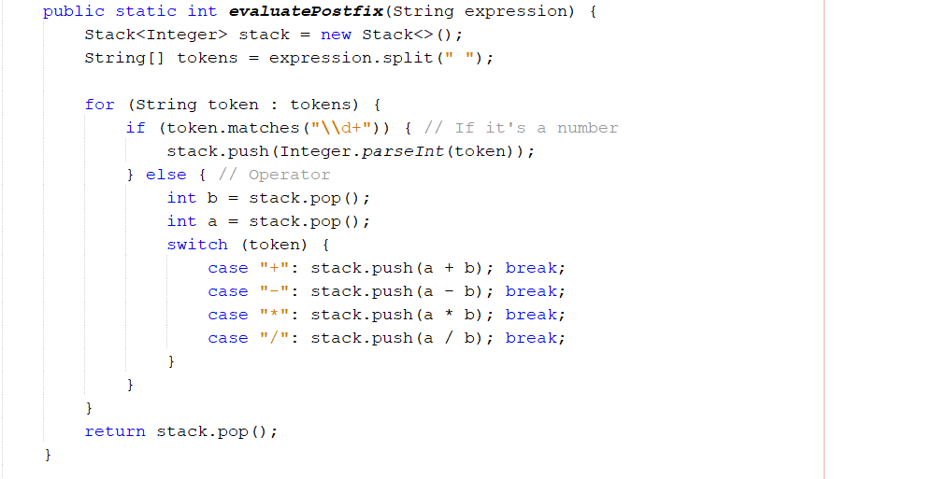4. Implement the clone( ) method for the ArrayStack class.

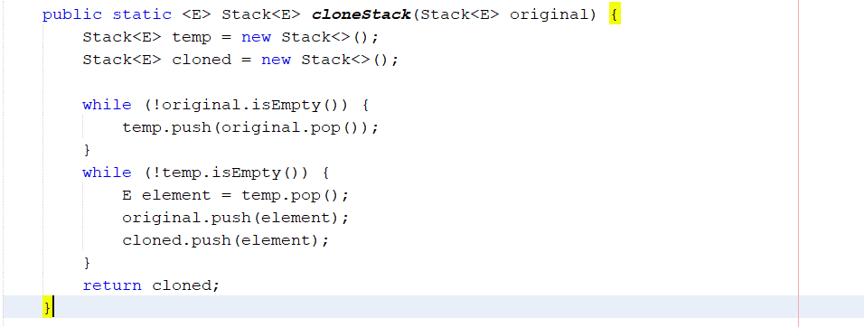

5. Implement a program that can input an expression in postfix notation

(see Exercise C-6.19) and output its value

