Homework

1. Augment the ArrayQueue implementation with a new rotate( ) method

having semantics identical to the combination, enqueue(dequeue( )).

But, your implementation should be more efficient than making two

separate calls (for example, because there is no need to modify the

size).

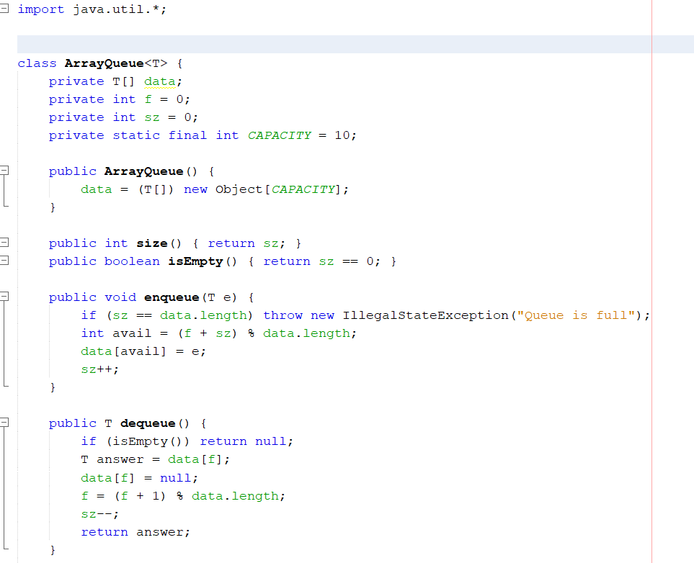

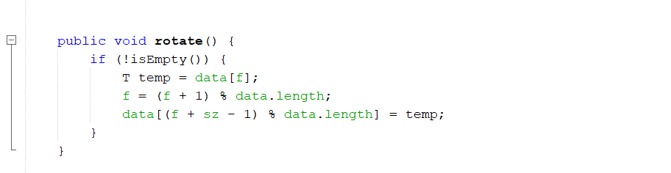

2. Implement the clone( ) method for the ArrayQueue class.

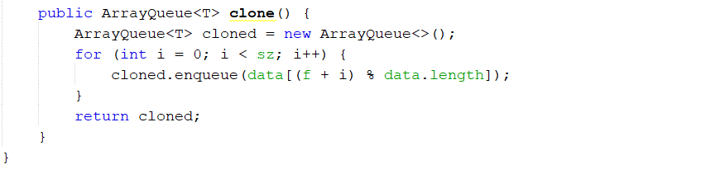

3. Implement a method with signature concatenate(LinkedQueue Q2)

for the LinkedQueue class that takes all elements of Q2 and appends

them to the end of the original queue. The operation should run in

O(1) time and should result in Q2 being an empty queue.

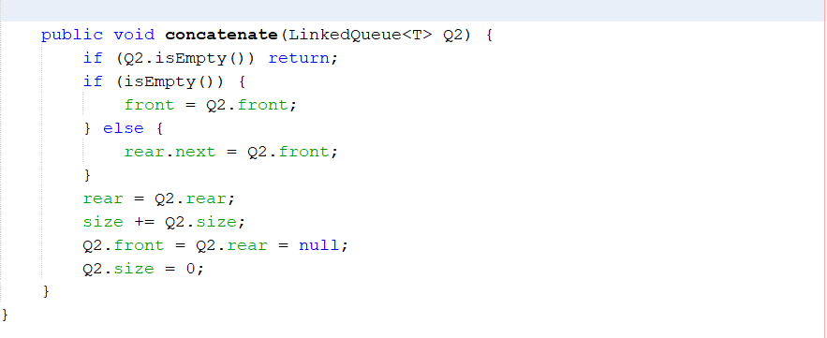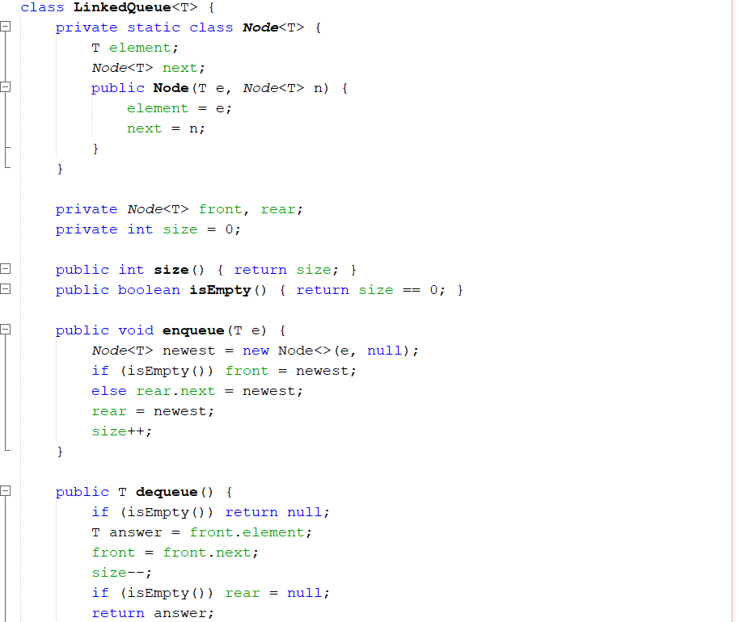

4. Use a queue to solve the Josephus Problem.

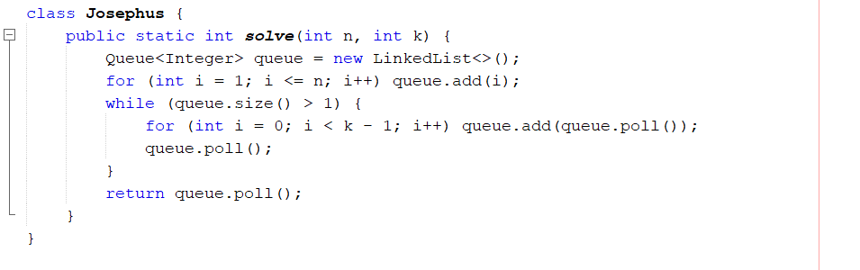

5. Use a queue to simulate Round Robin Scheduling.

