The Islamic University of Gaza.  Programming III Lab.  CSCI 2108. |  | Faculty of Information Technology  Instructor: Aya N. Alharazin
FINAL PROJECT

Gaza Humanitarian Aid Distribution System (GHADS)

Course: Programming III Lab — CSCI 2108
Instructor: Aya N. Alharazin
Student Name: Doaa Raed Shehada Shafout
Student ID: 220213922

System Overview
GHADS is a JavaFX desktop application that manages humanitarian aid distribution for families in Gaza. It solves the problem of tracking which families receive aid from which organizations, preventing duplicate aid within a short period, and prioritizing vulnerable families.
The system supports two user roles:
Admin: full CRUD on organizations, users, families, and aid distributions; sees all statistics.
Coordinator: assigned to one organization; can register aid distributions for their org only, view their own distribution list/statistics.
Technologies: Java 8, JavaFX + Scene Builder, MySQL (XAMPP), JDBC.

3. Architecture & Design
Three architectural patterns were used:
a) MVC (Model-View-Controller)
- What: Separates the application into three layers: Models (data entities), Views (FXML files), Controllers (event handling + UI logic).
- Why we used it: Makes the code modular — the UI can be redesigned in Scene Builder without touching the logic, and the business rules stay in Controllers/Services, not scattered in FXML.
b) DAO (Data Access Object)
- What: A dedicated class per entity (OrganizationDAO, UserDAO, FamilyDAO, AidDistributionDAO) that contains all SQL queries.
- Why we used it: Isolates database code from the rest of the application. If the database changes (e.g. to PostgreSQL), only the DAO files need updating, not the controllers or views.
Duplicate Check Implementation
Rule:
- HIGH vulnerability families → always allowed (they need urgent aid regardless of frequency).
- MEDIUM or LOW families → if they received the same aid type within the last 30 days, the distribution is rejected.
Where: DistributionService.java (src/services/DistributionService.java:20-39).
How it works:
- distService.checkDuplicate(familyId, aidType, dateStr) is called from AidDistributionFormController.distributeHandle() (AidDistributionFormController.java:98).
- DistributionService.checkDuplicate() fetches the family's vulnerability level via FamilyDAO.findById().
- If the family is HIGH, it returns "ALLOWED" immediately.
- If MEDIUM/LOW, it calls AidDistributionDAO.hasRecentDistributionByType(familyId, aidType, 30), which runs:
SELECT COUNT(*) FROM aid_distributions
WHERE family_id=? AND aid_type=?
AND distribution_date >= DATE_SUB(CURDATE(), INTERVAL 30 DAY)
- If a recent record exists, it returns "REJECTED:FamilyName:VULN:OrgName:Date".
- In the controller, if the response starts with "REJECTED", a detailed error dialog is shown with family name, vulnerability level, previous org, and previous date; the distribution is not recorded.
Challenges & Solutions
Challenge | Solution
Java 8 compatibility — System.getLogger() requires Java 9+. The NetBeans platform runs Java 8. | Replaced all System.getLogger() / System.Logger with java.util.logging.Logger.getLogger() / java.util.logging.Logger, supported since Java 1.4.
DAO deleteOne | Changed all DAO deleteOne methods to accept the entity object and extract the ID inside; updated all controller calls to pass the selected entity.
FXML version warning — FXML files had xmlns="http://javafx.com/javafx/21" but runtime is JavaFX 8. | Changed to xmlns="http://javafx.com/javafx/8" in all 10 FXML files.
Screenshots
- . Login Screen — username/password fields
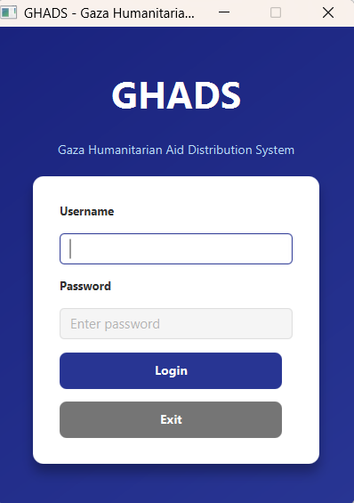
Admin Dashboard :
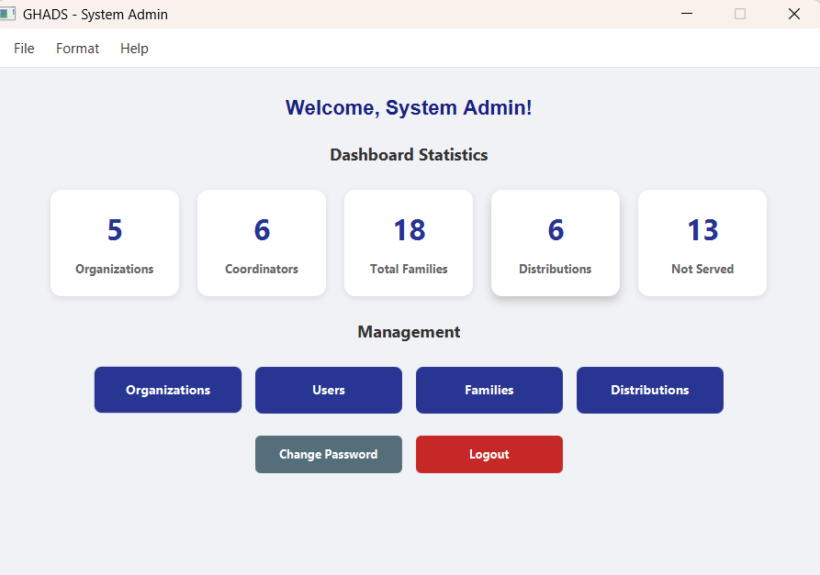
Organization Management:
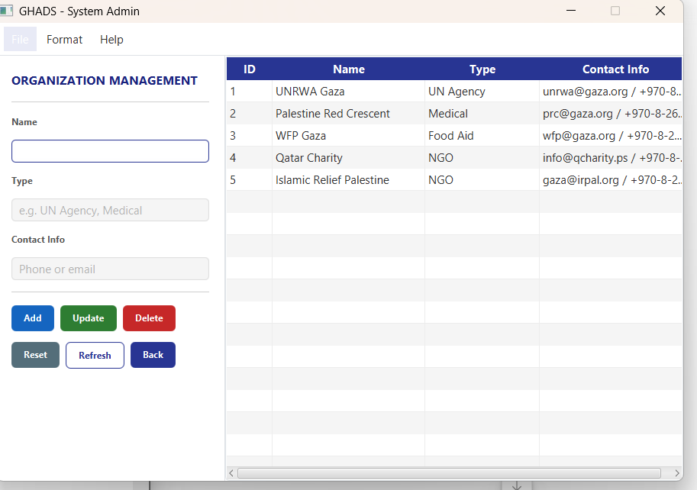
User Management :
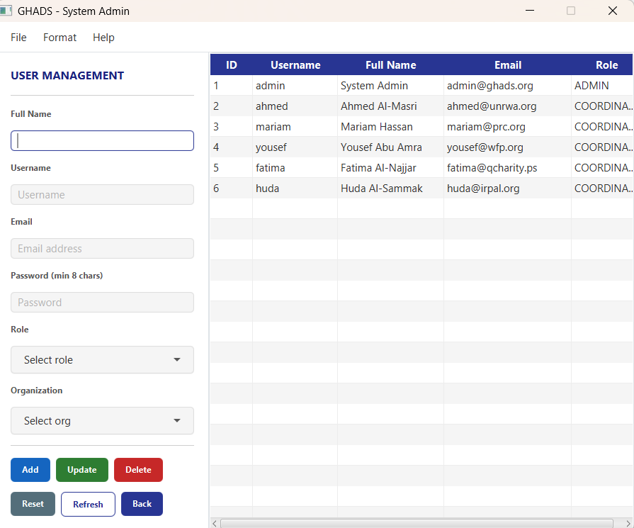
Family Management
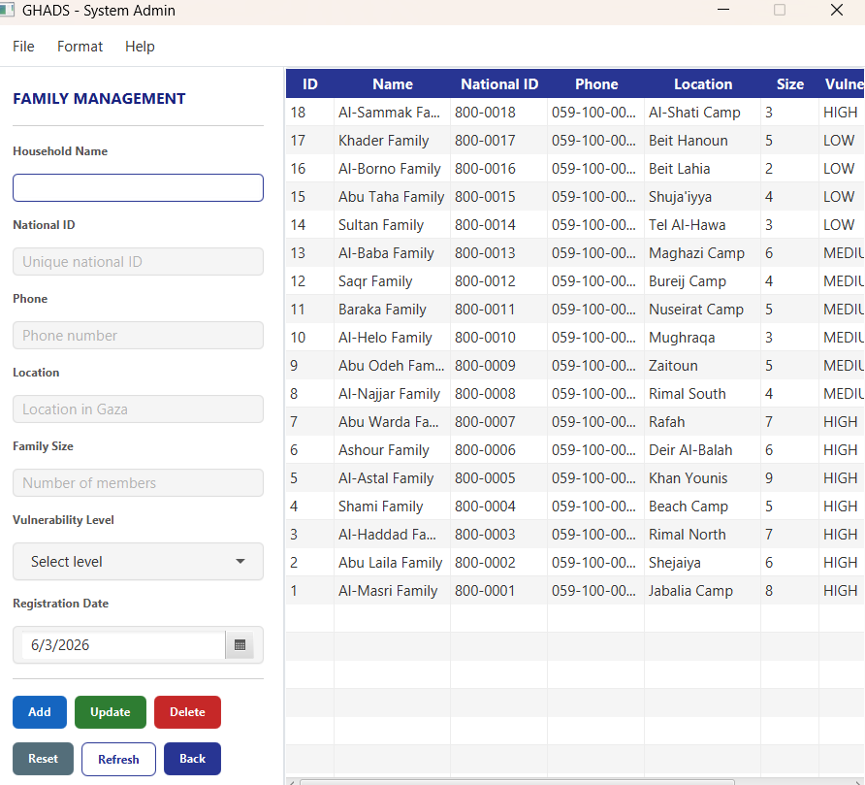
Aid Distribution Management :
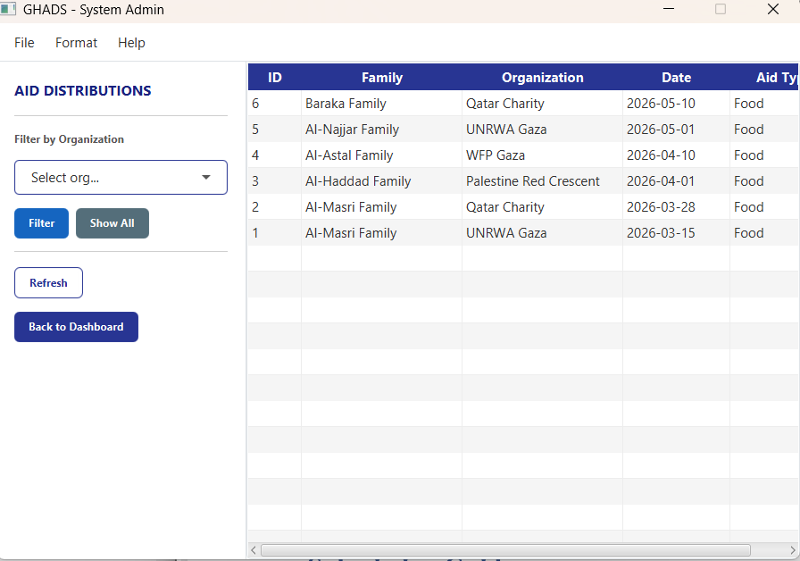
Coordinator Dashboard :
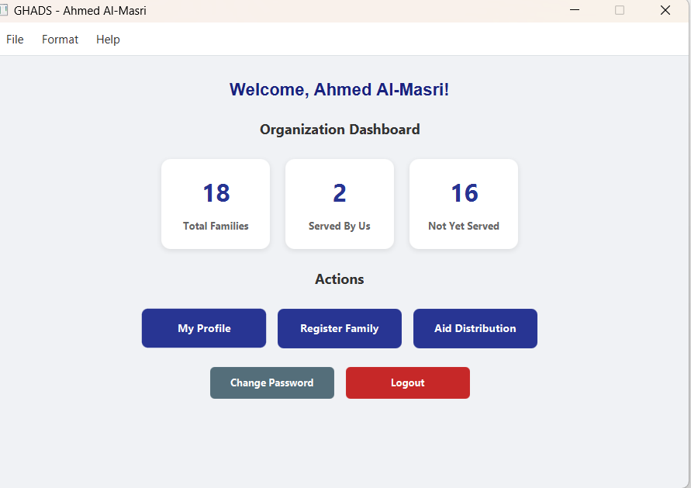

About dialog :
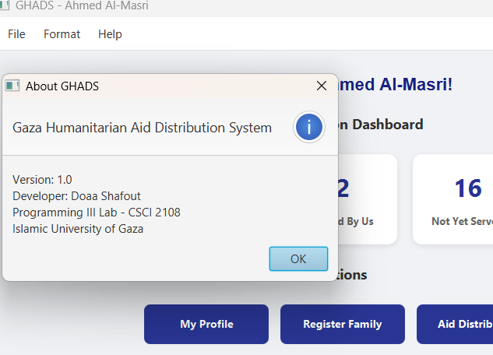
Change password:
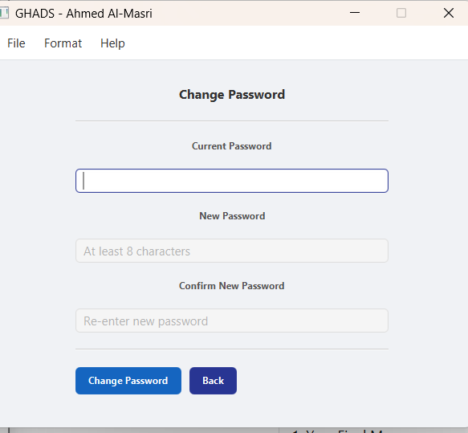
My profile:
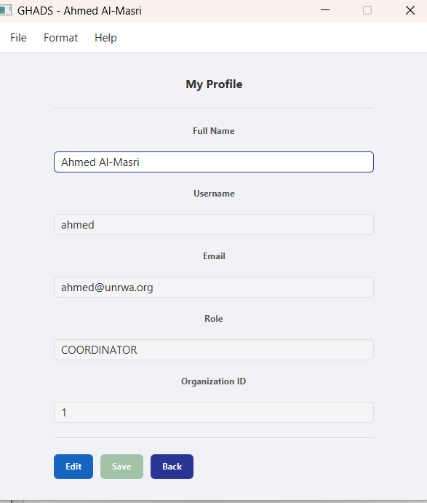

Final Message & Your Opinion
After completing your project, take a moment to write:
1. Your Final Message
Thank you for everything. You were an excellent instructor and conveyed the material in a clear and effective way.
2. Your Opinion on the Course
Share your honest opinion about the course:
- What did you enjoy most?
I enjoyed building a complete desktop application using JavaFX and connecting it to a real database. The transition from simple console programs to a GUI-based application with database integration was a valuable experience that helped me understand how real software systems are developed.
- What topics need more explanation or practice?

I believe JDBC error handling and database connection management need more explanation and practice. In addition.

- Did the project help you connect what you learned to a real-world problem?
Yes, absolutely. The project helped me apply theoretical concepts in a practical environment. Implementing CRUD operations, writing SQL queries, working with DAO and MVC patterns, and developing the duplicate-check feature demonstrated how Java can be used to solve real-world problems effectively.

- Any suggestions to improve the content or the way topics are explained?
- I have no suggestions for improvement, and I would like to sincerely thank the instructor for their support throughout the course.

Links
GitHub Repository | https://github.com/doaashafout/GHADS
Demo Video | https://drive.google.com/drive/folders/1d8xRQwm_oUy_KFIYiwV-hsudBwwCpbP8?usp=drive_link

