## **RESPOSTA QUESTÃo 1**

select ('O funcionario '||e.ename||' tem um salario de '||e.sal) as LISTA

from Scott.emp e

where e.job = 'MANAGER'

and e.sal > 2500

UNION

select ('Total de funcionarios '||e.job||' com salario maior que 2500: '||COUNT(*)) as LISTA

from Scott.emp e

where e.job = 'MANAGER'

and e.sal > 2500

group by e.job;

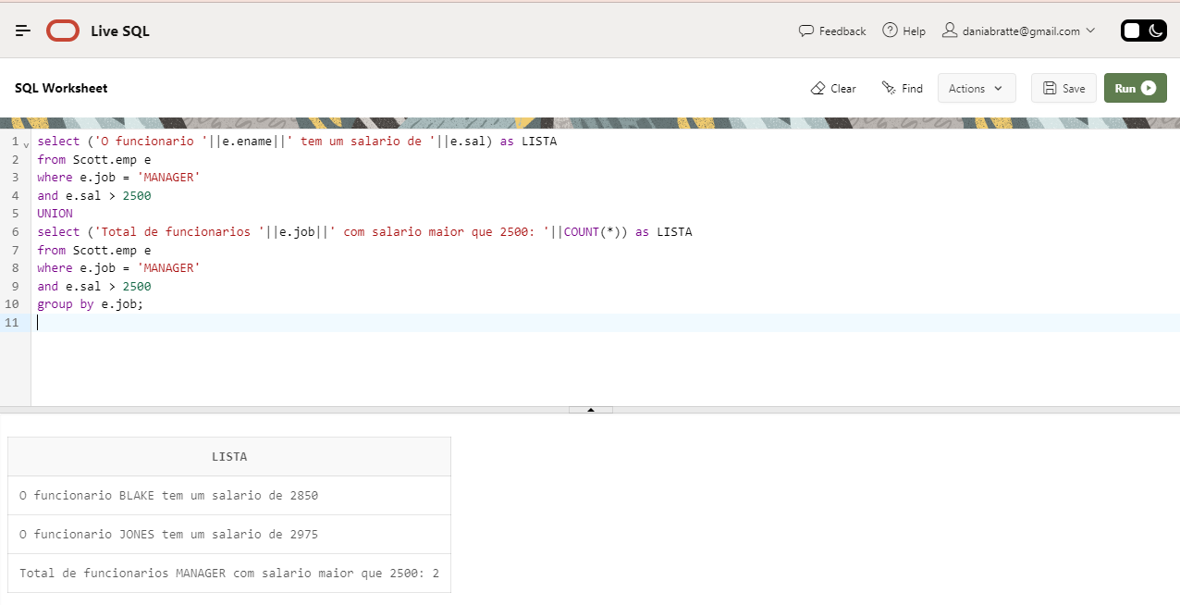

## **RESPOSTA QUESTÃo 2**

select e.ename as NOME, e.job as FUNCAO, e.sal as SALARIO

from Scott.emp e,

Scott.dept d

where 1=1

and e.deptno = d.deptno

and d.dname = 'SALES'

order by e.sal desc;

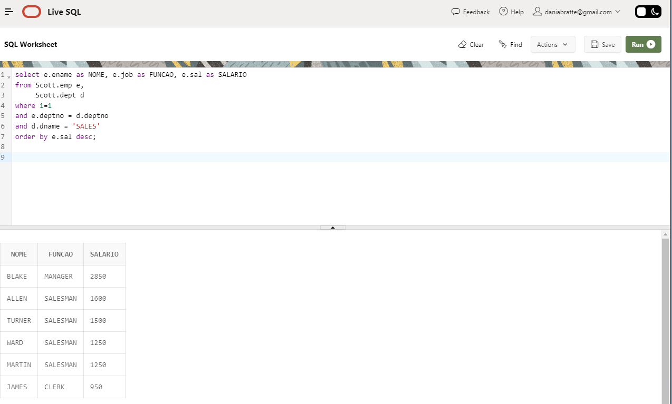

## **RESPOSTA QUESTÃo 3**

Para testar no site da Oracle:

select sc.classification, e.empno, e.ename, e.job, e.mgr, e.hiredate, e.sal,decode(e.comm, null, '-',e.comm) as COMM, e.deptno

from Scott.emp e,

Scott.sal_classification sc

where

e.sal between sc.min_sal and sc.max_sql;

*Para testar no banco de dados local:*

*select sc.classification, e.empno, e.ename, e.job, e.mgr, e.hiredate, e.sal,decode(e.comm, null, '-',e.comm) as COMM, e.deptno*

*from emp e,*

*sal_classification sc*

*where*

*e.sal between sc.min_sal and sc.max_sql;*

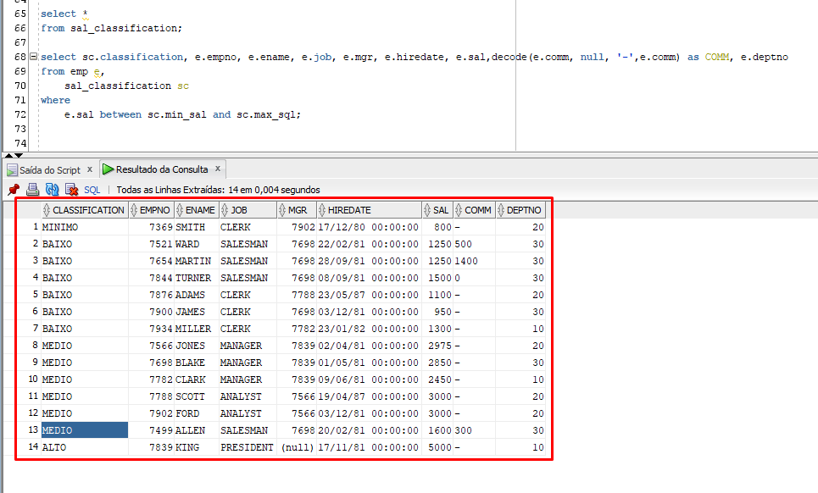

## **RESPOSTA QUESTÃo 4**

select e.ename, d.dname, e.sal, DENSE_RANK() OVER ( PARTITION BY d.dname ORDER BY e.sal DESC ) AS "RANK"

from Scott.emp e,

Scott.dept d

where 1=1

and e.deptno = d.deptno

order by d.dname, e.sal desc;

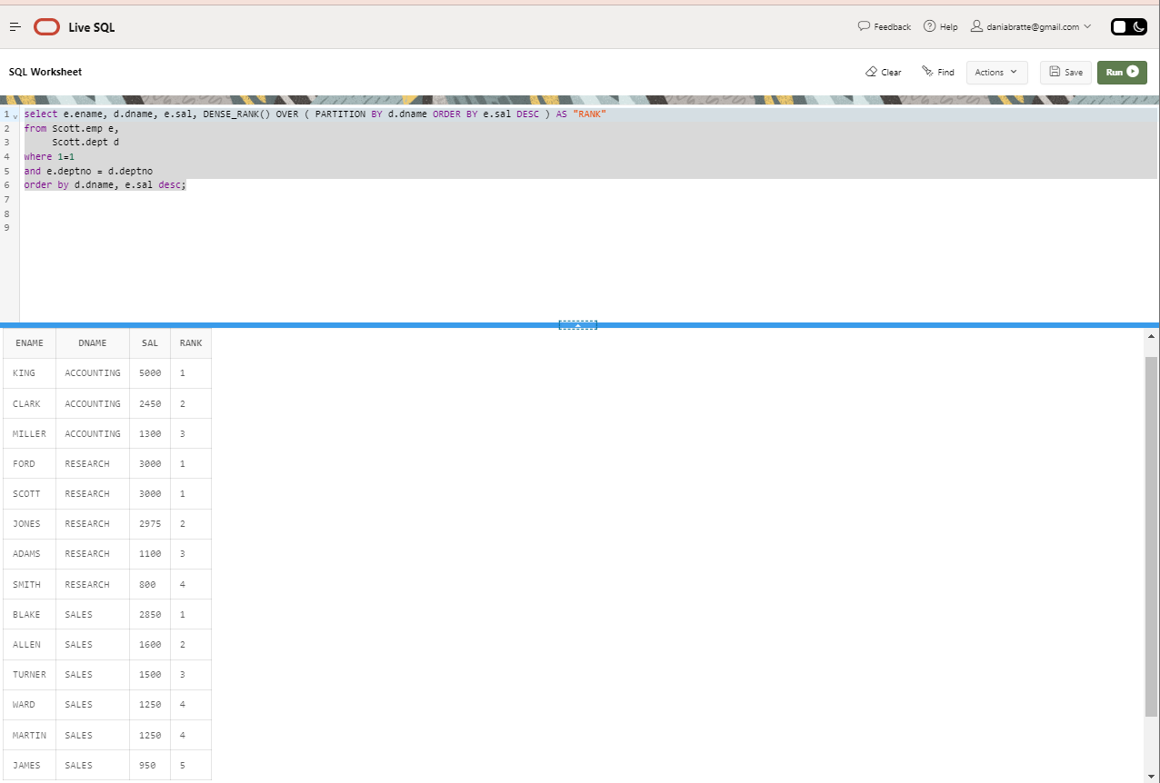

## **RESPOSTA QUESTÃo 5**

with temp

as (

select *

from Scott.emp

)

select temp.*

from temp

start with ename = 'ALLEN'

connect by prior mgr = empno

order by mgr;

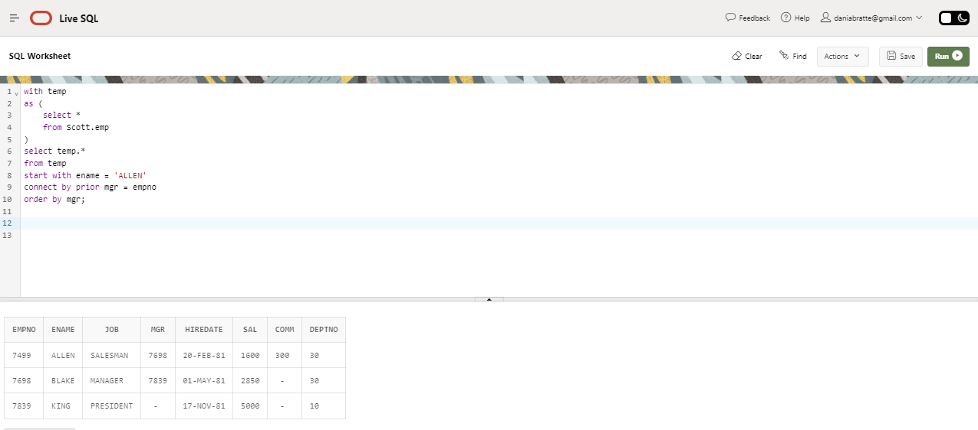

## **RESPOSTA QUESTÃo 6**

with dados

as (

select d.dname, e.names

from (select deptno, LISTAGG(ename, ',') within group (order by ename) as names

from Scott.emp

group by deptno) e,

Scott.dept d

where e.deptno = d.deptno

)

select *

from dados

pivot

(

listagg(names ,',') within group (order by names)

for dname in ('ACCOUNTING', 'RESEARCH', 'SALES', 'OPERATIONS')

)

