What is JDK, JRE, JVM

**JDK: Java Development Kit – Full set of tools for develop software in java. This contains JRE.**

**JRE: Java Runtime Environment – The runtime environment to compile, interpret, and execute java code. This is the implementation of JVM. It also includes libraries and necessary files for JVM.**

**JVM: Java Virtual Machine – An Environment for Java OS to execute the java bytecode**

Is JVM, a compiler or interpreter?

**JVM is an interpreter because it interprets the Java bytecode for machine to run.**

Why Java don't use pointers?

**Java don’t use pointers because the JVM takes care of the allocation of memory for us. Also, pointers are not safe, hence, Java has reference, but not pointers, to prevent injections.**

What are various types of Class loaders used by JVM?

**Bootstrap, Extension, and System**   
How are classes loaded by JVM?

**When JVM requests for a class, it invokes loadClass function of the ClassLoader by passing the fully classified name of the Class. The loadClass function calls for findLoadedClass() method to check that the class has been already loaded or not. It’s required to avoid loading the class multiple times. If the Class is not already loaded then it will delegate the request to parent ClassLoader to load the class. If the parent ClassLoader is not finding the Class then it will invoke findClass() method to look for the classes in the file system.**  
Which memory areas does instance and static variables use ?

**The Stack**  
What is PermGen or Permanent Generation?

**The pool containing all the reflective data of the virtual machine itself, such as class and method objects. With Java VMs that use class data sharing, this generation is divided into read-only and read-write areas.**  
What is metaspace?

**The new memory space that replace PermGen. Metaspace can resize itself, while PermGen is fixed size. (This does not mean Classloader leak error is fixed, just postpone it more)**

Describe what happens when an object is created in Java.

**It is created in the stack, then move to Heap for memory allocation and instantiation.**

Different types of memory used by JVM?

**Heap, Stack, Native**

Does Java Pass by Value or Pass by Reference

**Java pass by value**

What are native methods?

**Native methods are functions written in C/C++ and compiled into a library, then dynamically loaded by Java Runtime. This breaks Java’s property of platform independent.**

Lab work:

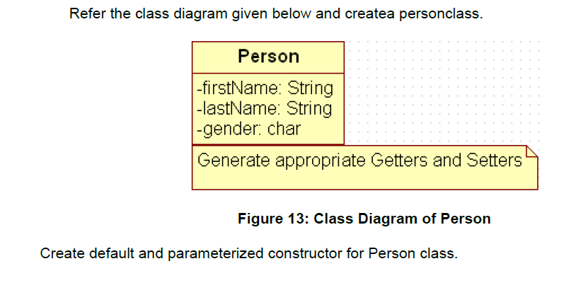

Also Create “PersonMain.java” program and write code for following operations:

a) Create an object of Person class and specify person details through constructor.

b): Modify to accept phone number of a person. Create a new method to implement the same and also define method for displaying persondetails.

c): Modify the above program, to accept only ‘M’ or ‘F’ as gender field values. Use Enumeration for implementing the same

--After spring--

d) Add a method called calculateAge which should accept person’s date of birth and calculate age of a person.

e) Add a method called getFullName(String firstName, String lastName) which should return full name of a person

f) Display person details with age and fullname.

.

|  |
| --- |
| Write a program to accept a number from user as a command line argument and check whether the given number is positive or negative number. |
|  |
|  |