**SEN233**

*2018-19 Spring Semester*



**VISUAL PROGRAMMING**

**NAME: BURAK DOĞAN**

**NUMBER: B1605.090048**

**LECTURER: ÖĞR. GÖR. SAJAD EINY**

**CALCULATE APP.**

**İnformation:**

* I aimed to make a calculator with this code.I defined 4 different processes.
* These include addition, subtraction, division, multiplication.
* The user can enter as many numbers as he wants.
* The user will enter the "d" pointer to notify the system when a new number is entered.

**----------------------------------------------Code-------------------------------------------**

using System;

using System.Collections.Generic;

using System.Linq;

using System.Text;

using System.Threading.Tasks;

namespace ConsoleApp1

{

class Program

{

private static int Toplama(int sonuc,int deger)

{

sonuc = deger + sonuc;

return sonuc;

}

private static int Cikarma(int sonuc, int deger)

{

sonuc = sonuc - deger;

return sonuc;

}

private static int Carpma(int sonuc, int deger)

{

sonuc = deger * sonuc;

return sonuc;

}

private static int Bolme(int sonuc, int deger)

{

if (deger == 0)

Console.WriteLine("0 bölme Hatası..");

else

sonuc = sonuc / deger;

return sonuc;

}

static void Main(string[] args)

{

int sonuc = 0, deger = 0, i = 0;

char islem, devam;

Console.Write("İslem Giriniz..:");

islem = Char.Parse(Console.ReadLine());

switch (islem)

{

case '+':

{

while (i != 1)

{

Console.Write("Devam için d..: ");

devam = Char.Parse(Console.ReadLine());

if (devam == 'd')

{

Console.Write("Sayı Giriniz..: ");

deger = int.Parse(Console.ReadLine());

sonuc = Toplama(sonuc, deger);

}

else

i = 1;

}

break;

}

case '-':

{

i = 2;

while (i != 1)

{

Console.Write("Devam için d..: ");

devam = Char.Parse(Console.ReadLine());

if (devam == 'd')

{

Console.Write("Sayı Giriniz..: ");

deger = int.Parse(Console.ReadLine());

if (i == 2)

{

sonuc = deger;

i = 3;

}

else

sonuc = Cikarma(sonuc, deger);

}

else

i = 1;

}

break;

}

case '*':

{

sonuc = 1;

while (i != 1)

{

Console.Write("Devam için d..: ");

devam = Char.Parse(Console.ReadLine());

if (devam == 'd')

{

Console.Write("Sayı Giriniz..: ");

deger = int.Parse(Console.ReadLine());

sonuc = Carpma(sonuc, deger);

}

else

i = 1;

}

break;

}

case '/':

{

i = 2;

while (i != 1)

{

Console.Write("Devam için d..: ");

devam = Char.Parse(Console.ReadLine());

if (devam == 'd')

{

Console.Write("Sayı Giriniz..: ");

deger = int.Parse(Console.ReadLine());

if(i==2)

{

sonuc = deger;

i = 3;

}

else

sonuc= Bolme(sonuc, deger);

}

else

i = 1;

}

break;

}

default:

Console.WriteLine("Hata Oluştu...");

break;

}

Console.WriteLine("Sonuc...: " + sonuc);

Console.ReadLine();

}

}

}

-------------------------------------------------------------OUTPUT--------------------------------------------------------------

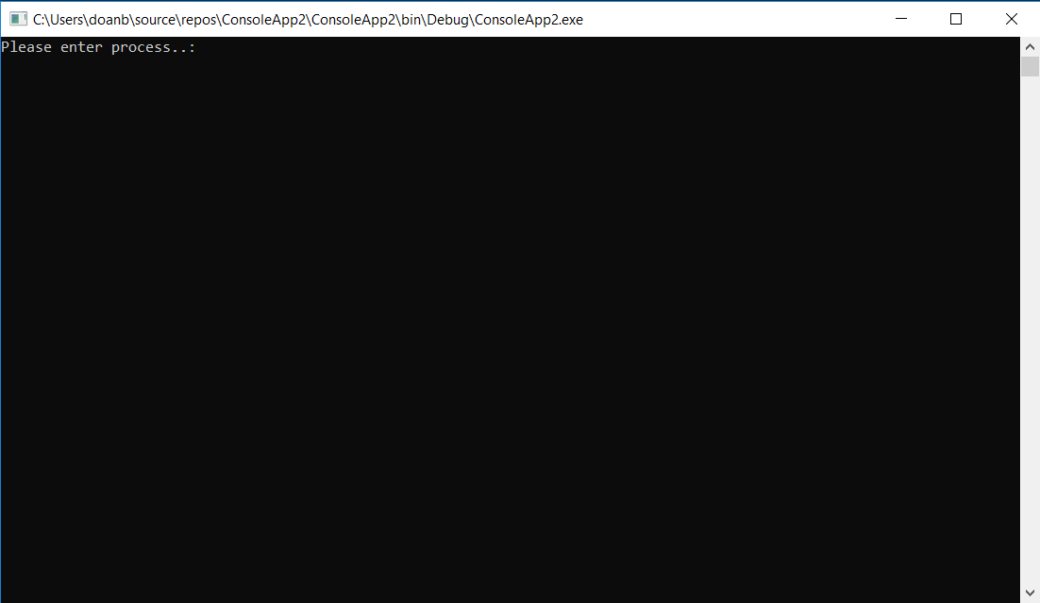

Step1:You should enter type of process which do you want to calculate process.(+,-,*,/)For example ı selected addition.Then;

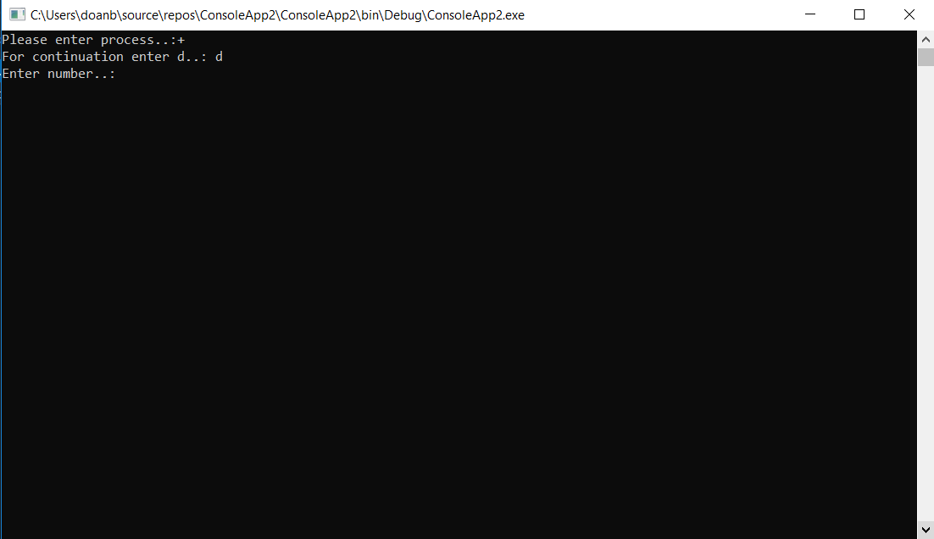

Step2:If you select type of process you should enter “d” pointer for continue process.Program want number to you.You can enter number as many numbers as you wants.

FOR ADDITION;

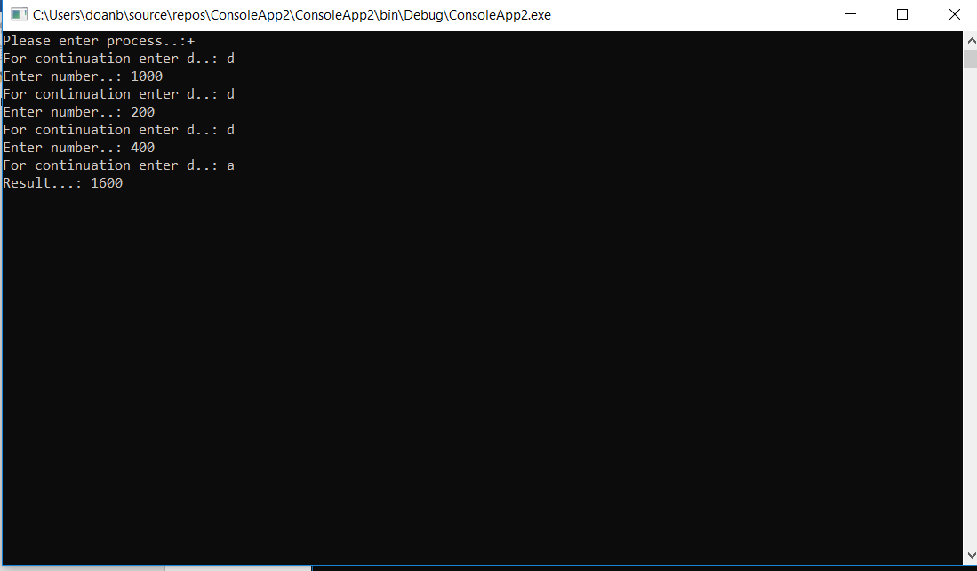

Step 3: If you want to end the program you should enter a value other then “d”.

FOR SUBTRACTION;

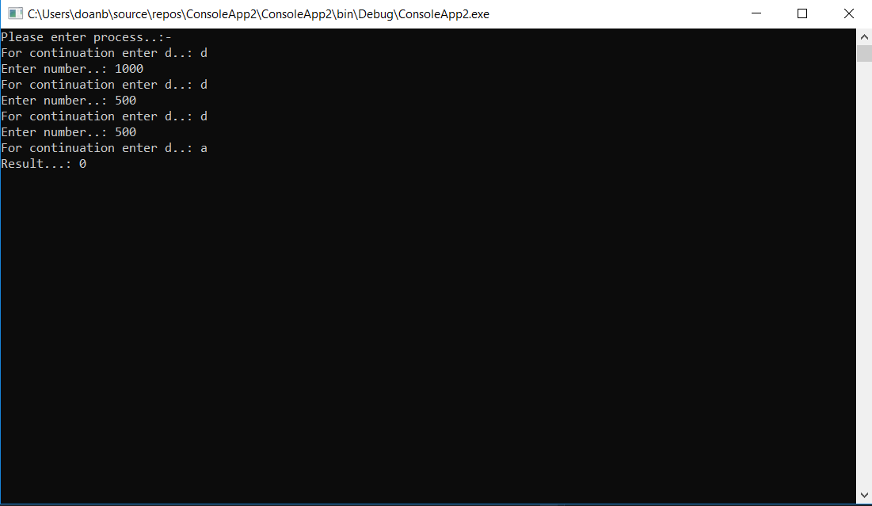

FOR MULTIPLACATION;

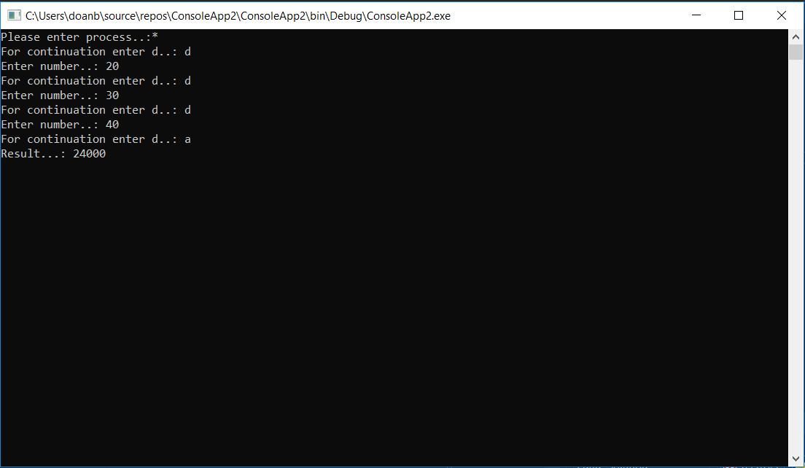

FOR DIVISION;

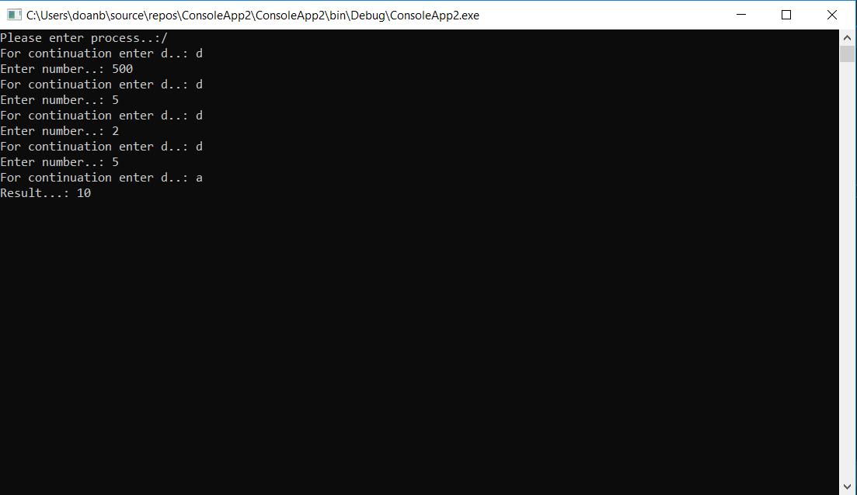

If you enter wrong process;

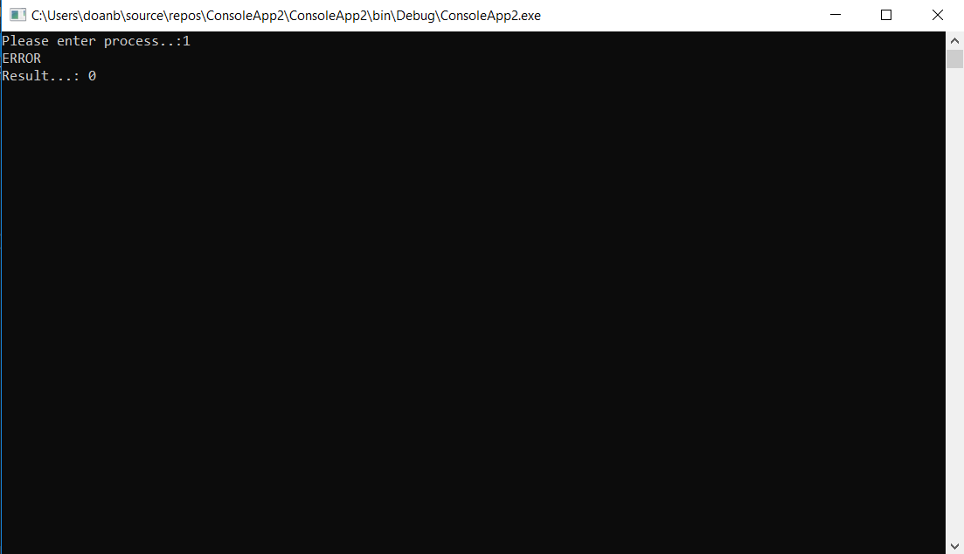

STRUCTUREL UML DIAGRAMS

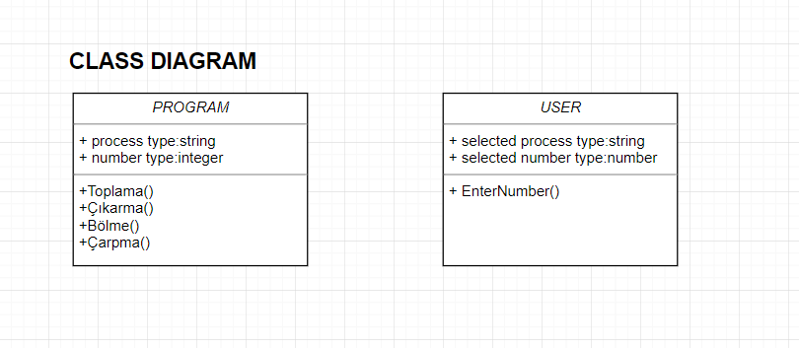

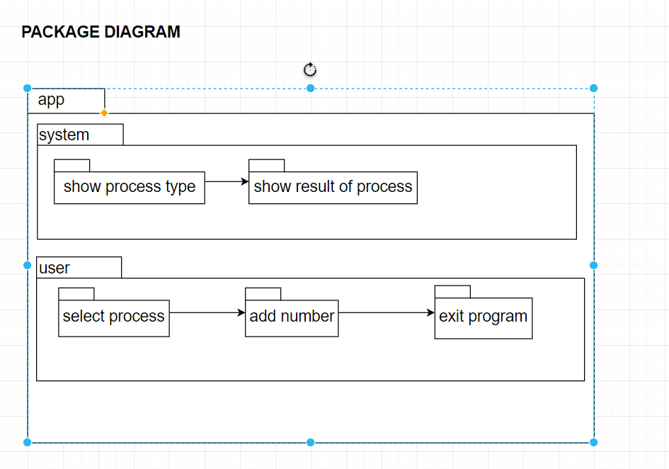

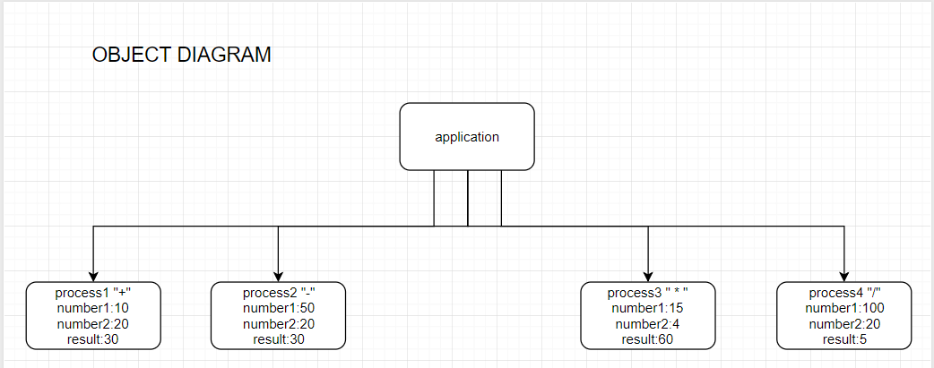

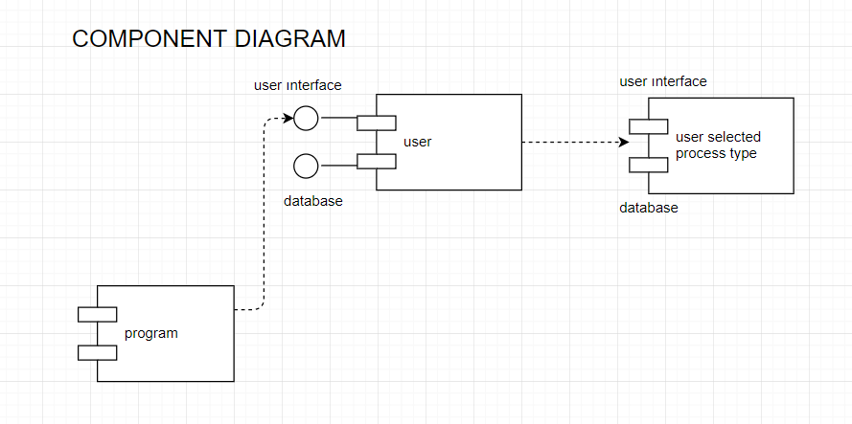

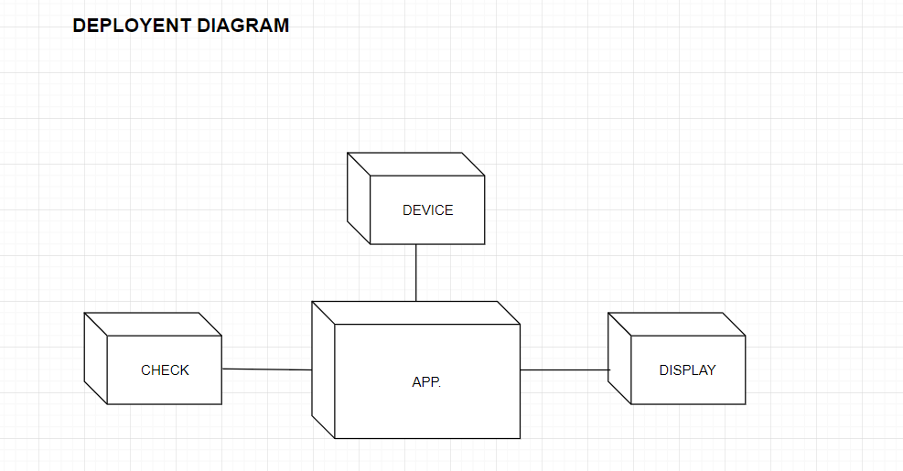

BEHAVIORAL UML DIAGRAMS

