**SEN233**

*2018-19 Spring Semester*



**VISUAL PROGRAMMING**

**NAME: BURAK DOĞAN**

**NUMBER: B1605.090048**

**LECTURER: ÖĞR. GÖR. SAJAD EINY**

Form Application

Warehouse Information Application:

The purpose of this application is;

* Install the user-entered product into the system.
* Show the products in the system to the user.
* Update the information of a product in the system.
* Deleting a product in the system.

------------------------------------CODE-------------------------------------------------

using System;

using System.Collections.Generic;

using System.ComponentModel;

using System.Data;

using System.Drawing;

using System.Linq;

using System.Text;

using System.Threading.Tasks;

using System.Windows.Forms;

using System.Data.SqlClient;

namespace FormProject

{

public partial class Form1 : Form

{

private SqlConnection baglanti = new SqlConnection("Data Source=LAPTOP-VSM6APCG\\SQLEXPRESS;Initial Catalog=warehouseDB;Integrated Security=True");

public Form1()

{

InitializeComponent();

}

private void label1_Click(object sender, EventArgs e)

{

}

private void button4_Click(object sender, EventArgs e)

{

baglanti.Open();

SqlCommand komutsil = new SqlCommand("Delete from warehouseDB Where ID=@k1",baglanti);

komutsil.Parameters.AddWithValue("@k1", textBox1.Text);

komutsil.ExecuteNonQuery();

baglanti.Close();

MessageBox.Show("Product has been deleted...");

}

private void Form1_Load(object sender, EventArgs e)

{

}

private void button1_Click(object sender, EventArgs e)

{

this.warehouseDBTableAdapter.Fill(this.warehouseDBDataSet.warehouseDB);

}

private void button3_Click(object sender, EventArgs e)

{

baglanti.Open();

SqlCommand komut = new SqlCommand("insert into warehouseDB (ID,BRAND,BARCODE,TYPE,STOCK) values (@p1,@p2,@p3,@p4,@p5)", baglanti);

komut.Parameters.AddWithValue("@p1", textBox1.Text);

komut.Parameters.AddWithValue("@p2", textBox2.Text);

komut.Parameters.AddWithValue("@p3", textBox3.Text);

komut.Parameters.AddWithValue("@p4", textBox4.Text);

komut.Parameters.AddWithValue("@p5", textBox5.Text);

komut.ExecuteNonQuery();

baglanti.Close();

MessageBox.Show("Product has been entered...");

}

private void button2_Click(object sender, EventArgs e)

{

baglanti.Open();

SqlCommand komutguncelle = new SqlCommand("Update warehoueseDB Set ID=@a1,BRAND=@a2,BARCODE=@a3,TYPE=@a4,STOCK=@a5", baglanti);

komutguncelle.Parameters.AddWithValue("@a1", textBox1.Text);

komutguncelle.Parameters.AddWithValue("@a2", textBox2.Text);

komutguncelle.Parameters.AddWithValue("@a3", textBox3.Text);

komutguncelle.Parameters.AddWithValue("@a4", textBox4.Text);

komutguncelle.Parameters.AddWithValue("@a5", textBox5.Text);

komutguncelle.ExecuteNonQuery();

baglanti.Close();

}

}

}

---------------------------------------OUTPUT---------------------------------------------

This is the user interface.

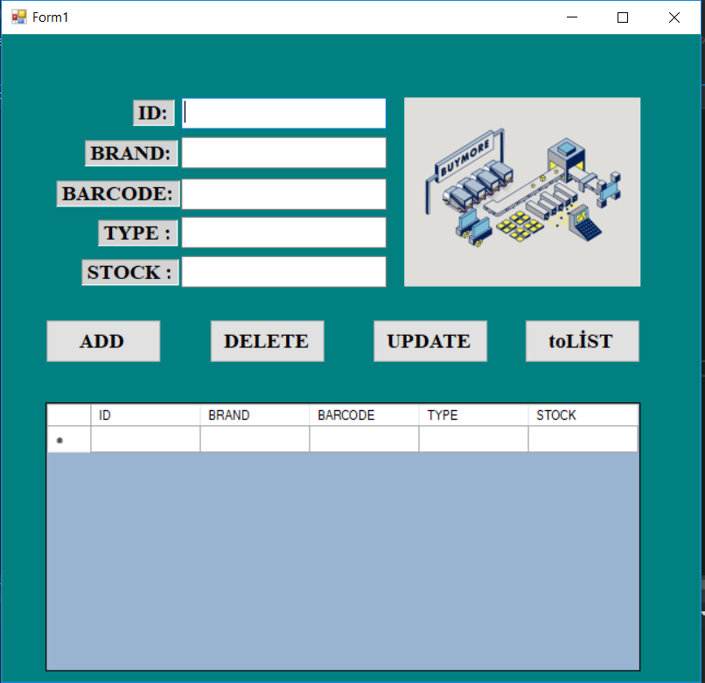

The system asks the user to select an option.If user want to see all product data press toList button.Then system show all information.

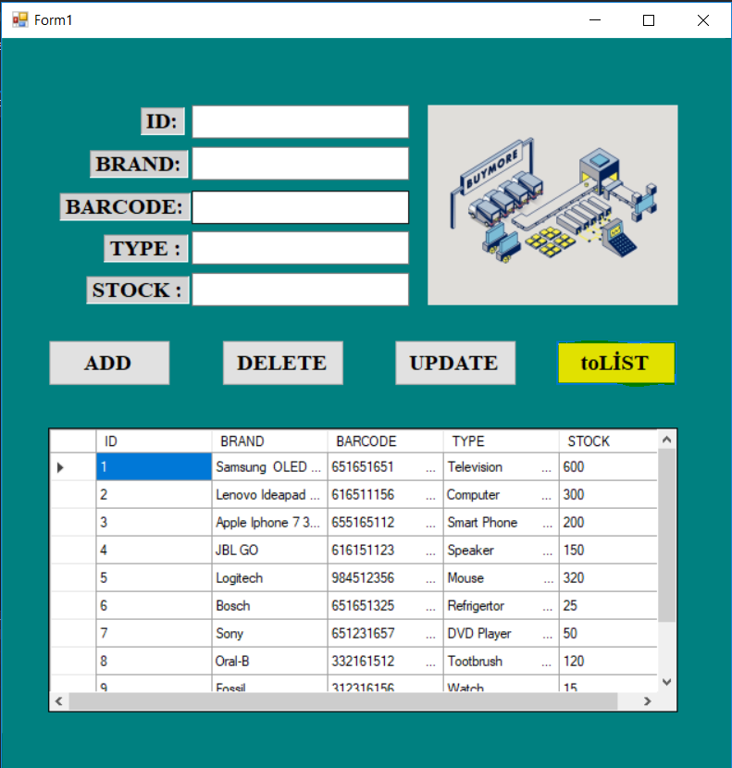

This data is the product information we previously created in Ms SQL.

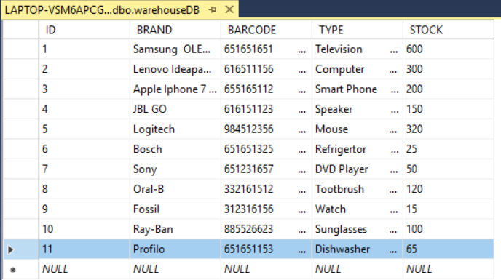

If user want to add new product in the system.He/She should fill in the textbox and press the ADD button.

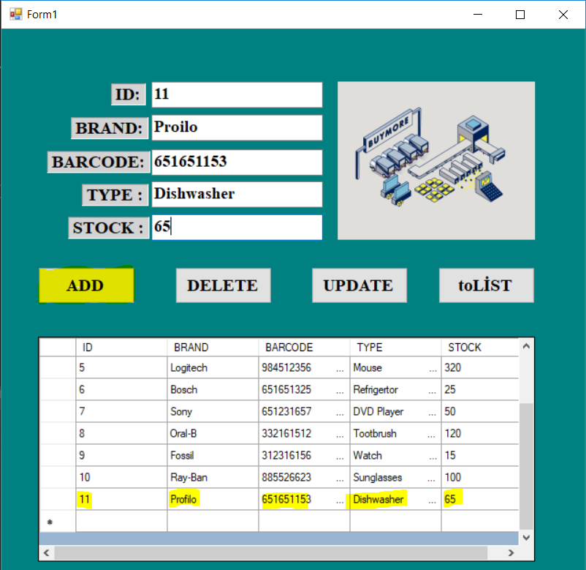

At the same time,data added also Ms SQL database.

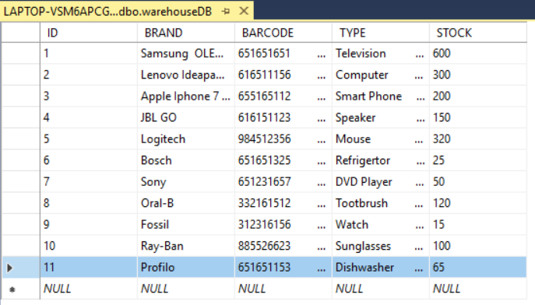

If user want to delete a product in the system.He/She should fill in the ID textbox and press the DELETE button.

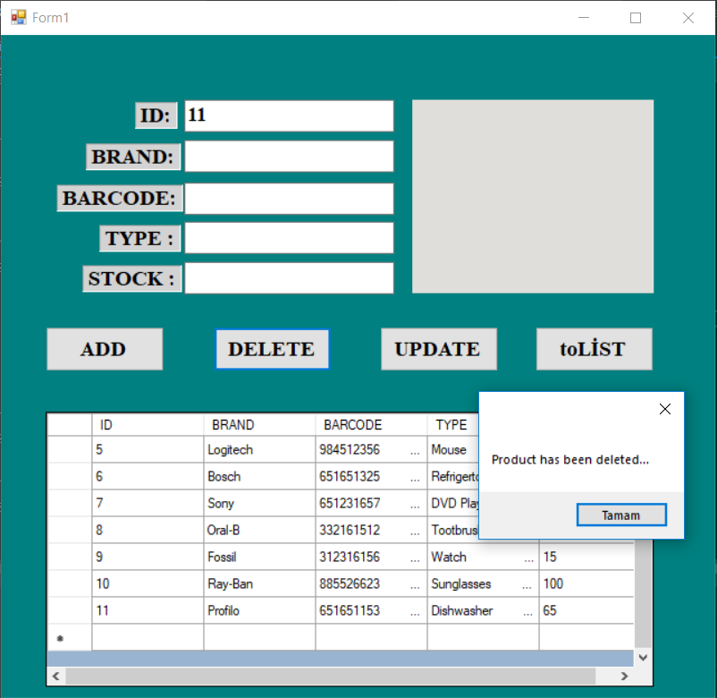

At the same time,data deleted also Ms SQL database.

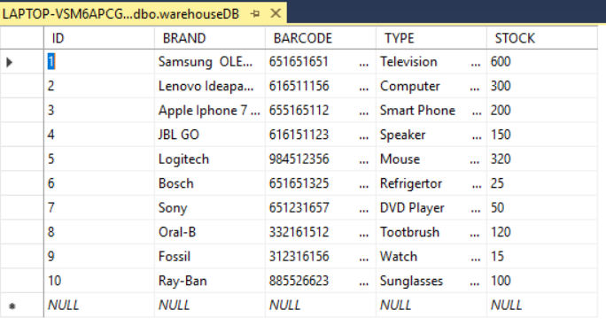

STRUCTUREL UML DIAGRAMS

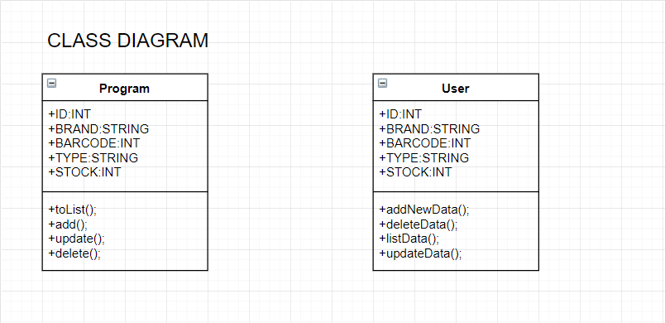

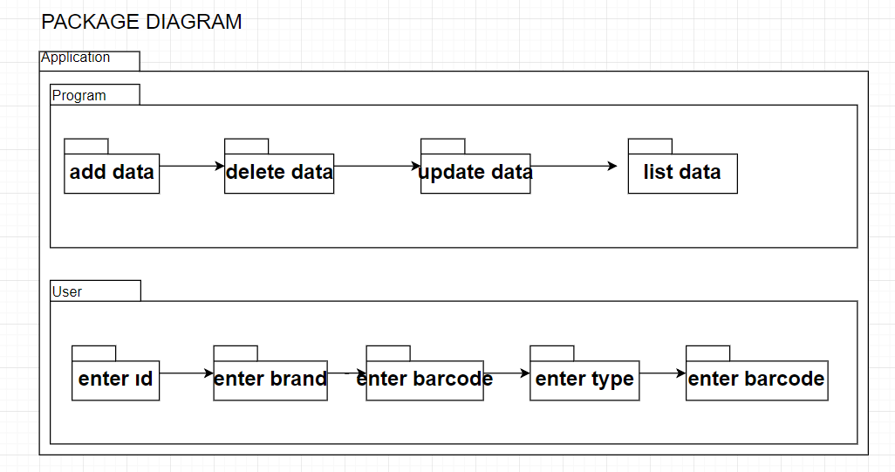

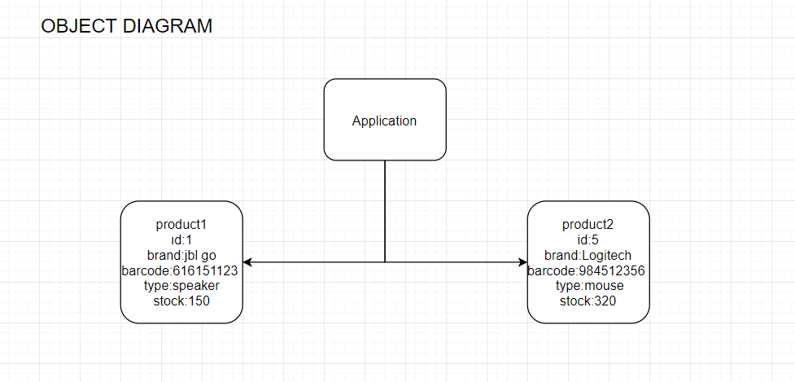

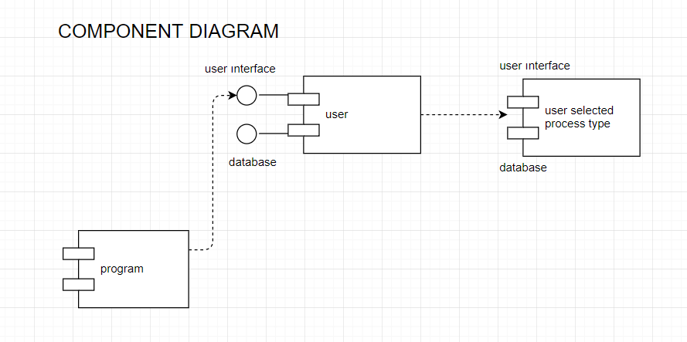

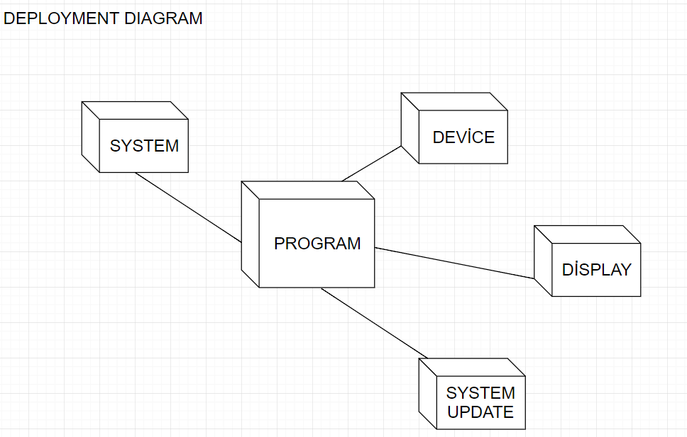

BEHAVIORAL UML DIAGRAMS

