**LAB 6**

Cài đặt bảng Sach trong CSDL QuanLyBanSach:

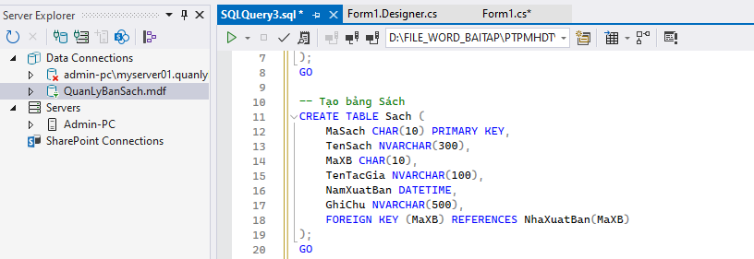

Cài đặt bảng NhaXuatBan trong CSDL QuanLyBanSach

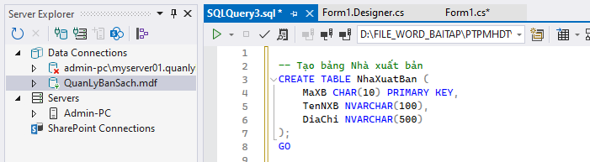

Thêm dữ liệu cho các bảng:

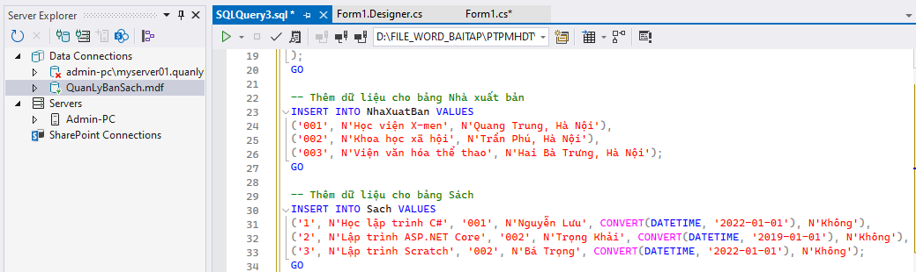

Thực hành 1: Hiển thị danh sách nhà xuất bản sách.

Code T-SQL:

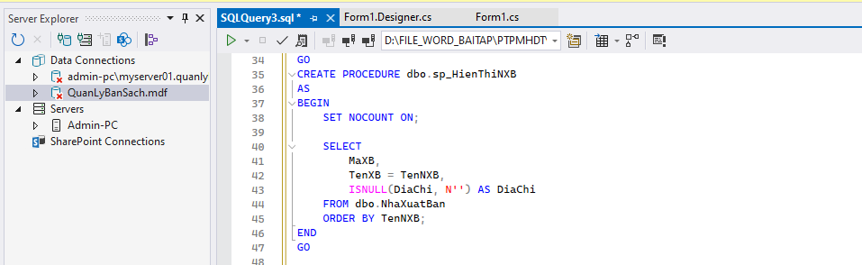

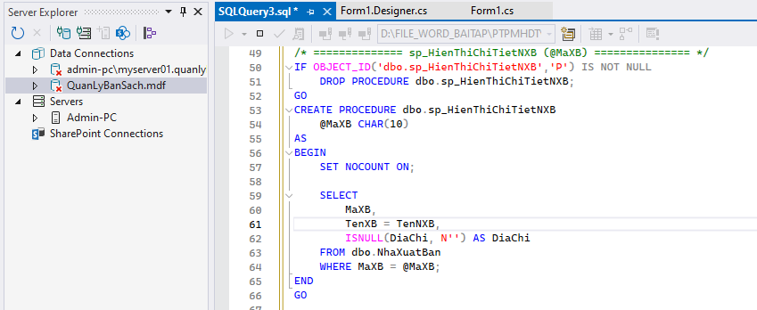

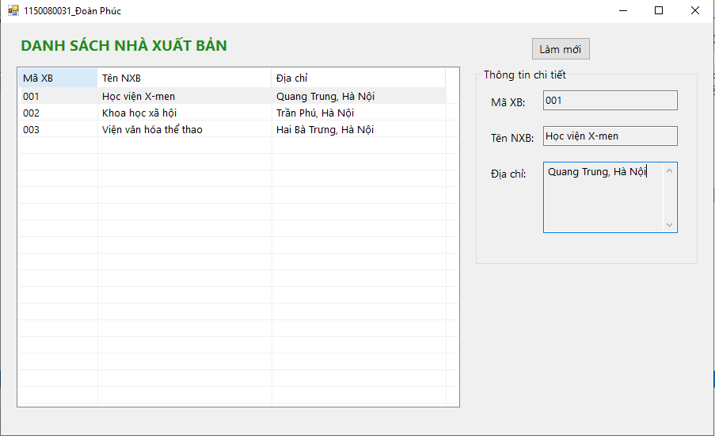

Code Form1:

using System;

using System.Collections.Generic;

using System.ComponentModel;

using System.Data;

using System.Data.SqlClient;

using System.Drawing;

using System.Linq;

using System.Text;

using System.Threading.Tasks;

using System.Windows.Forms;

namespace LAB6

{

public partial class Form1 : Form

{

// ===== Chuỗi kết nối: CHỈNH LẠI đường dẫn .mdf CHO ĐÚNG =====

private readonly string _connStr =

@"Data Source=(LocalDB)\MSSQLLocalDB;AttachDbFilename=D:\File_word_baitap\PTPMHDT\Lab_thuc_hanh\LAB6\LAB6\QuanLyBanSach.mdf;Integrated Security=True;Connect Timeout=30";

// ===== Điều khiển UI =====

private ListView lsvDanhSach;

private Label lblTitle;

private GroupBox grpChiTiet;

private Label lblMaXB;

private Label lblTenXB;

private Label lblDiaChi;

private TextBox txtMaXB;

private TextBox txtTenXB;

private TextBox txtDiaChi;

private Button btnRefresh;

public Form1()

{

InitializeComponent();

}

// ===================== UI =====================

private void InitializeComponent()

{

// Form

this.Text = "1150080031_Đoàn Phúc";

this.StartPosition = FormStartPosition.CenterScreen;

this.ClientSize = new Size(900, 520);

this.Font = new Font("Segoe UI", 10F);

// Title

lblTitle = new Label

{

Text = "DANH SÁCH NHÀ XUẤT BẢN",

AutoSize = true,

Font = new Font("Segoe UI", 14F, FontStyle.Bold),

ForeColor = Color.ForestGreen,

Location = new Point(20, 15)

};

this.Controls.Add(lblTitle);

// Nút Refresh

btnRefresh = new Button

{

Text = "Làm mới",

AutoSize = true,

Location = new Point(670, 18)

};

btnRefresh.Click += (s, e) => HienThiDanhSachNXB();

this.Controls.Add(btnRefresh);

// ListView

lsvDanhSach = new ListView

{

Location = new Point(20, 55),

Size = new Size(560, 430),

View = View.Details,

FullRowSelect = true,

GridLines = true,

HideSelection = false

};

lsvDanhSach.Columns.Add("Mã XB", 100, HorizontalAlignment.Left);

lsvDanhSach.Columns.Add("Tên NXB", 220, HorizontalAlignment.Left);

lsvDanhSach.Columns.Add("Địa chỉ", 220, HorizontalAlignment.Left);

lsvDanhSach.SelectedIndexChanged += lsvDanhSach_SelectedIndexChanged;

this.Controls.Add(lsvDanhSach);

// GroupBox Chi tiết

grpChiTiet = new GroupBox

{

Text = "Thông tin chi tiết",

Location = new Point(600, 55),

Size = new Size(280, 250)

};

this.Controls.Add(grpChiTiet);

// Labels + TextBoxes

lblMaXB = new Label { Text = "Mã XB:", AutoSize = true, Location = new Point(15, 35) };

txtMaXB = new TextBox { Location = new Point(85, 30), Width = 170, ReadOnly = true };

lblTenXB = new Label { Text = "Tên NXB:", AutoSize = true, Location = new Point(15, 80) };

txtTenXB = new TextBox { Location = new Point(85, 75), Width = 170, ReadOnly = true };

lblDiaChi = new Label { Text = "Địa chỉ:", AutoSize = true, Location = new Point(15, 125) };

txtDiaChi = new TextBox

{

Location = new Point(85, 120),

Width = 170,

Height = 90,

Multiline = true,

ScrollBars = ScrollBars.Vertical,

ReadOnly = true

};

grpChiTiet.Controls.Add(lblMaXB);

grpChiTiet.Controls.Add(txtMaXB);

grpChiTiet.Controls.Add(lblTenXB);

grpChiTiet.Controls.Add(txtTenXB);

grpChiTiet.Controls.Add(lblDiaChi);

grpChiTiet.Controls.Add(txtDiaChi);

// Sự kiện Form Load

this.Load += Form1_Load;

}

// ===================== DATA =====================

private void Form1_Load(object sender, EventArgs e)

{

HienThiDanhSachNXB();

}

private void HienThiDanhSachNXB()

{

try

{

using (var con = new SqlConnection(_connStr))

using (var cmd = new SqlCommand("sp_HienThiNXB", con))

{

cmd.CommandType = CommandType.StoredProcedure;

con.Open();

using (var reader = cmd.ExecuteReader())

{

lsvDanhSach.BeginUpdate();

lsvDanhSach.Items.Clear();

while (reader.Read())

{

string ma = reader.GetString(0).Trim();

string ten = reader.GetString(1);

string diaChi = reader.IsDBNull(2) ? "" : reader.GetString(2);

var lvi = new ListViewItem(ma);

lvi.SubItems.Add(ten);

lvi.SubItems.Add(diaChi);

lsvDanhSach.Items.Add(lvi);

}

lsvDanhSach.EndUpdate();

}

}

// Xóa vùng chi tiết khi làm mới

txtMaXB.Text = txtTenXB.Text = txtDiaChi.Text = "";

}

catch (Exception ex)

{

MessageBox.Show("Lỗi tải danh sách NXB:\n" + ex.Message, "Lỗi", MessageBoxButtons.OK, MessageBoxIcon.Error);

}

}

private void lsvDanhSach_SelectedIndexChanged(object sender, EventArgs e)

{

if (lsvDanhSach.SelectedItems.Count == 0) return;

var lvi = lsvDanhSach.SelectedItems[0];

string ma = lvi.SubItems[0].Text;

HienThiThongTinNXBTheoMa(ma);

}

private void HienThiThongTinNXBTheoMa(string maXB)

{

try

{

using (var con = new SqlConnection(_connStr))

using (var cmd = new SqlCommand("sp_HienThiChiTietNXB", con))

{

cmd.CommandType = CommandType.StoredProcedure;

cmd.Parameters.Add("@MaXB", SqlDbType.Char, 10).Value = maXB;

con.Open();

using (var reader = cmd.ExecuteReader())

{

txtMaXB.Text = txtTenXB.Text = txtDiaChi.Text = "";

if (reader.Read())

{

txtMaXB.Text = reader.GetString(0).Trim();

txtTenXB.Text = reader.GetString(1);

txtDiaChi.Text = reader.IsDBNull(2) ? "" : reader.GetString(2);

}

}

}

}

catch (Exception ex)

{

MessageBox.Show("Lỗi tải chi tiết NXB:\n" + ex.Message, "Lỗi", MessageBoxButtons.OK, MessageBoxIcon.Error);

}

}

}

}

Thực hành 2: Thêm dữ liệu cho bảng Nhà xuất bản

Code T-SQL:

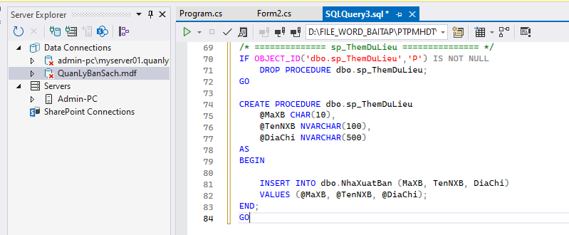

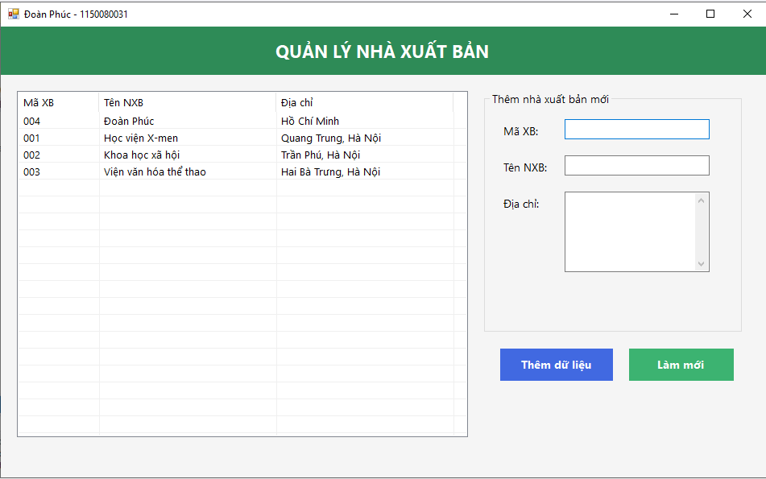

Code Form2:

using System;

using System.Data;

using System.Data.SqlClient;

using System.Drawing;

using System.Windows.Forms;

namespace LAB6

{

public class Form2 : Form

{

private readonly string _connStr =

@"Data Source=(LocalDB)\MSSQLLocalDB;AttachDbFilename=D:\File_word_baitap\PTPMHDT\Lab_thuc_hanh\LAB6\LAB6\QuanLyBanSach.mdf;Integrated Security=True;Connect Timeout=30";

private ListView lsvDanhSach;

private TextBox txtMaXB, txtTenXB, txtDiaChi;

private Button btnRefresh, btnThem;

private Label lblHeader;

public Form2()

{

InitializeUI();

}

private void InitializeUI()

{

// ===== Form =====

this.Text = "Đoàn Phúc - 1150080031";

this.StartPosition = FormStartPosition.CenterScreen;

this.ClientSize = new Size(950, 560);

this.BackColor = Color.WhiteSmoke;

this.Font = new Font("Segoe UI", 10F);

// ===== Header =====

Panel pnlHeader = new Panel

{

Dock = DockStyle.Top,

Height = 60,

BackColor = Color.SeaGreen

};

this.Controls.Add(pnlHeader);

lblHeader = new Label

{

Text = "QUẢN LÝ NHÀ XUẤT BẢN",

ForeColor = Color.White,

Font = new Font("Segoe UI", 16, FontStyle.Bold),

AutoSize = false,

Dock = DockStyle.Fill,

TextAlign = ContentAlignment.MiddleCenter

};

pnlHeader.Controls.Add(lblHeader);

// ===== Danh sách =====

lsvDanhSach = new ListView

{

Location = new Point(20, 80),

Size = new Size(560, 430),

View = View.Details,

FullRowSelect = true,

GridLines = true,

HideSelection = false,

BackColor = Color.White

};

lsvDanhSach.Columns.Add("Mã XB", 100, HorizontalAlignment.Left);

lsvDanhSach.Columns.Add("Tên NXB", 220, HorizontalAlignment.Left);

lsvDanhSach.Columns.Add("Địa chỉ", 220, HorizontalAlignment.Left);

this.Controls.Add(lsvDanhSach);

// ===== GroupBox nhập thông tin =====

GroupBox grpChiTiet = new GroupBox

{

Text = "Thêm nhà xuất bản mới",

Location = new Point(600, 80),

Size = new Size(320, 300)

};

this.Controls.Add(grpChiTiet);

Label lblMa = new Label { Text = "Mã XB:", Location = new Point(20, 40), AutoSize = true };

txtMaXB = new TextBox { Location = new Point(100, 35), Width = 180 };

Label lblTen = new Label { Text = "Tên NXB:", Location = new Point(20, 85), AutoSize = true };

txtTenXB = new TextBox { Location = new Point(100, 80), Width = 180 };

Label lblDiaChi = new Label { Text = "Địa chỉ:", Location = new Point(20, 130), AutoSize = true };

txtDiaChi = new TextBox

{

Location = new Point(100, 125),

Width = 180,

Height = 100,

Multiline = true,

ScrollBars = ScrollBars.Vertical

};

grpChiTiet.Controls.Add(lblMa);

grpChiTiet.Controls.Add(txtMaXB);

grpChiTiet.Controls.Add(lblTen);

grpChiTiet.Controls.Add(txtTenXB);

grpChiTiet.Controls.Add(lblDiaChi);

grpChiTiet.Controls.Add(txtDiaChi);

// ===== Nút Thêm dữ liệu =====

btnThem = new Button

{

Text = "Thêm dữ liệu",

Location = new Point(620, 400),

Width = 140,

Height = 40,

BackColor = Color.RoyalBlue,

ForeColor = Color.White,

Font = new Font("Segoe UI", 10, FontStyle.Bold),

FlatStyle = FlatStyle.Flat

};

btnThem.FlatAppearance.BorderSize = 0;

btnThem.MouseEnter += (s, e) => btnThem.BackColor = Color.MidnightBlue;

btnThem.MouseLeave += (s, e) => btnThem.BackColor = Color.RoyalBlue;

btnThem.Click += BtnThem_Click;

this.Controls.Add(btnThem);

// ===== Nút Làm mới =====

btnRefresh = new Button

{

Text = "Làm mới",

Location = new Point(780, 400),

Width = 130,

Height = 40,

FlatStyle = FlatStyle.Flat,

BackColor = Color.MediumSeaGreen,

ForeColor = Color.White,

Font = new Font("Segoe UI", 10, FontStyle.Bold)

};

btnRefresh.FlatAppearance.BorderSize = 0;

btnRefresh.MouseEnter += (s, e) => btnRefresh.BackColor = Color.ForestGreen;

btnRefresh.MouseLeave += (s, e) => btnRefresh.BackColor = Color.MediumSeaGreen;

btnRefresh.Click += (s, e) => HienThiDanhSachNXB();

this.Controls.Add(btnRefresh);

this.Load += (s, e) => HienThiDanhSachNXB();

}

// ======================= CHỨC NĂNG =======================

private void HienThiDanhSachNXB()

{

try

{

using (var con = new SqlConnection(_connStr))

using (var cmd = new SqlCommand("sp_HienThiNXB", con))

{

cmd.CommandType = CommandType.StoredProcedure;

con.Open();

using (var reader = cmd.ExecuteReader())

{

lsvDanhSach.Items.Clear();

while (reader.Read())

{

var item = new ListViewItem(reader.GetString(0).Trim());

item.SubItems.Add(reader.GetString(1));

item.SubItems.Add(reader.IsDBNull(2) ? "" : reader.GetString(2));

lsvDanhSach.Items.Add(item);

}

}

}

txtMaXB.Clear();

txtTenXB.Clear();

txtDiaChi.Clear();

txtMaXB.Focus();

}

catch (Exception ex)

{

MessageBox.Show("Lỗi hiển thị danh sách:\n" + ex.Message, "Lỗi", MessageBoxButtons.OK, MessageBoxIcon.Error);

}

}

private void BtnThem_Click(object sender, EventArgs e)

{

if (string.IsNullOrWhiteSpace(txtMaXB.Text) ||

string.IsNullOrWhiteSpace(txtTenXB.Text) ||

string.IsNullOrWhiteSpace(txtDiaChi.Text))

{

MessageBox.Show("Vui lòng nhập đầy đủ thông tin!", "Cảnh báo", MessageBoxButtons.OK, MessageBoxIcon.Warning);

return;

}

try

{

using (var con = new SqlConnection(_connStr))

using (var cmd = new SqlCommand("sp_ThemDuLieu", con))

{

cmd.CommandType = CommandType.StoredProcedure;

cmd.Parameters.Add("@MaXB", SqlDbType.Char, 10).Value = txtMaXB.Text.Trim();

cmd.Parameters.Add("@TenNXB", SqlDbType.NVarChar, 100).Value = txtTenXB.Text.Trim();

cmd.Parameters.Add("@DiaChi", SqlDbType.NVarChar, 500).Value = txtDiaChi.Text.Trim();

con.Open();

int kq = cmd.ExecuteNonQuery();

if (kq > 0)

{

MessageBox.Show(" Thêm dữ liệu thành công!", "Thông báo", MessageBoxButtons.OK, MessageBoxIcon.Information);

HienThiDanhSachNXB();

}

}

}

catch (Exception ex)

{

MessageBox.Show("Lỗi khi thêm dữ liệu:\n" + ex.Message, "Lỗi", MessageBoxButtons.OK, MessageBoxIcon.Error);

}

}

}

}

**Thực hành 3: Sửa dữ liệu cho bảng Nhà Xuất bản.**

Code T-SQL:

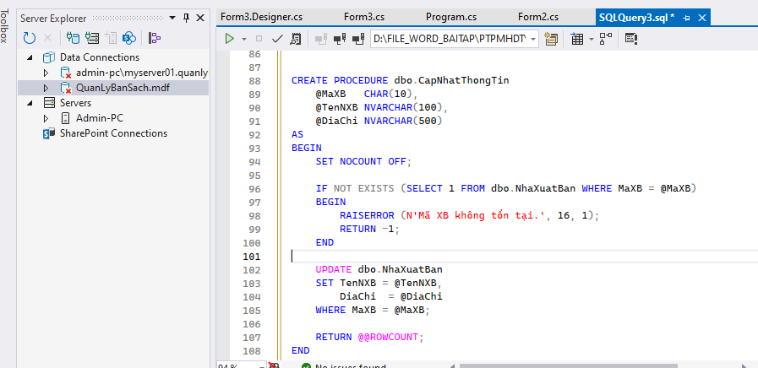

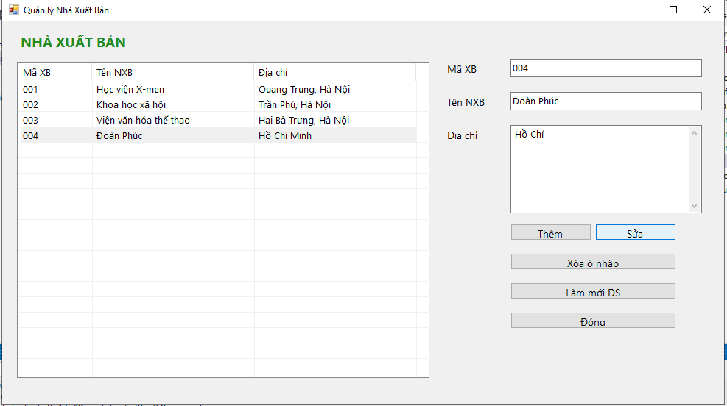

CODE FORM3:

using System;

using System.Data;

using System.Data.SqlClient;

using System.Drawing;

using System.Windows.Forms;

namespace LAB6

{

public class Form3 : Form

{

private string _connStr =

@"Data Source=(LocalDB)\MSSQLLocalDB;AttachDbFilename=D:\File_word_baitap\PTPMHDT\Lab_thuc_hanh\LAB6\LAB6\QuanLyBanSach.mdf;Integrated Security=True;Connect Timeout=30";

private ListView lsvNXB;

private Label lblTitle, lblMa, lblTen, lblDiaChi;

private TextBox txtMa, txtTen, txtDiaChi;

private Button btnThem, btnSua, btnClear, btnRefresh, btnDong;

public Form3()

{

InitializeComponent();

}

public Form3(string connStr) : this()

{

_connStr = connStr;

}

private void InitializeComponent()

{

this.Text = "Quản lý Nhà Xuất Bản";

this.StartPosition = FormStartPosition.CenterScreen;

this.Font = new Font("Segoe UI", 10F);

this.ClientSize = new Size(980, 520);

lblTitle = new Label

{

Text = "NHÀ XUẤT BẢN",

Font = new Font("Segoe UI", 14F, FontStyle.Bold),

ForeColor = Color.ForestGreen,

AutoSize = true,

Location = new Point(20, 15)

};

this.Controls.Add(lblTitle);

// ========== ListView ==========

lsvNXB = new ListView

{

Location = new Point(20, 55),

Size = new Size(560, 430),

View = View.Details,

FullRowSelect = true,

GridLines = true,

HideSelection = false

};

lsvNXB.Columns.Add("Mã XB", 100, HorizontalAlignment.Left);

lsvNXB.Columns.Add("Tên NXB", 220, HorizontalAlignment.Left);

lsvNXB.Columns.Add("Địa chỉ", 220, HorizontalAlignment.Left);

lsvNXB.SelectedIndexChanged += LsvNXB_SelectedIndexChanged;

this.Controls.Add(lsvNXB);

// ========== Khối nhập ==========

int baseX = 600;

int baseY = 55;

lblMa = new Label { Text = "Mã XB", AutoSize = true, Location = new Point(baseX, baseY) };

txtMa = new TextBox { Location = new Point(baseX + 90, baseY - 4), Width = 260, MaxLength = 10 };

lblTen = new Label { Text = "Tên NXB", AutoSize = true, Location = new Point(baseX, baseY + 45) };

txtTen = new TextBox { Location = new Point(baseX + 90, baseY + 41), Width = 260, MaxLength = 100 };

lblDiaChi = new Label { Text = "Địa chỉ", AutoSize = true, Location = new Point(baseX, baseY + 90) };

txtDiaChi = new TextBox

{

Location = new Point(baseX + 90, baseY + 86),

Width = 260,

Height = 120,

Multiline = true,

ScrollBars = ScrollBars.Vertical,

MaxLength = 500

};

// 🔹 Nút chức năng

btnThem = new Button { Text = "Thêm", Location = new Point(baseX + 90, baseY + 220), Width = 110 };

btnSua = new Button { Text = "Sửa", Location = new Point(baseX + 205, baseY + 220), Width = 110 };

btnClear = new Button { Text = "Xóa ô nhập", Location = new Point(baseX + 90, baseY + 260), Width = 225 };

btnRefresh = new Button { Text = "Làm mới DS", Location = new Point(baseX + 90, baseY + 300), Width = 225 };

btnDong = new Button { Text = "Đóng", Location = new Point(baseX + 90, baseY + 340), Width = 225 };

btnThem.Click += BtnThem_Click;

btnSua.Click += BtnSua_Click;

btnClear.Click += delegate { ClearInputs(); };

btnRefresh.Click += delegate { LoadList(); };

btnDong.Click += delegate { this.Close(); };

this.Controls.AddRange(new Control[]

{

lblMa, txtMa, lblTen, txtTen, lblDiaChi, txtDiaChi,

btnThem, btnSua, btnClear, btnRefresh, btnDong

});

this.Load += delegate { LoadList(); txtMa.Focus(); };

}

// ====== Khi chọn dòng trong ListView ======

private void LsvNXB_SelectedIndexChanged(object sender, EventArgs e)

{

if (lsvNXB.SelectedItems.Count == 0) return;

var it = lsvNXB.SelectedItems[0];

txtMa.Text = it.SubItems[0].Text;

txtTen.Text = it.SubItems[1].Text;

txtDiaChi.Text = it.SubItems[2].Text;

}

// ====== Nút Thêm ======

private void BtnThem_Click(object sender, EventArgs e)

{

string ma = txtMa.Text.Trim();

string ten = txtTen.Text.Trim();

string diaChi = txtDiaChi.Text.Trim();

if (ma.Length == 0) { MessageBox.Show("Nhập Mã XB."); txtMa.Focus(); return; }

if (ten.Length == 0) { MessageBox.Show("Nhập Tên NXB."); txtTen.Focus(); return; }

try

{

using (var con = new SqlConnection(_connStr))

using (var cmd = new SqlCommand("dbo.ThemDuLieu", con))

{

cmd.CommandType = CommandType.StoredProcedure;

cmd.Parameters.Add("@MaXB", SqlDbType.Char, 10).Value = ma;

cmd.Parameters.Add("@TenNXB", SqlDbType.NVarChar, 100).Value = ten;

cmd.Parameters.Add("@DiaChi", SqlDbType.NVarChar, 500).Value = diaChi;

con.Open();

int rows = cmd.ExecuteNonQuery();

if (rows > 0)

{

MessageBox.Show("Thêm dữ liệu thành công!", "Thông báo");

LoadList();

ClearInputs();

txtMa.Focus();

}

}

}

catch (Exception ex)

{

MessageBox.Show("Lỗi thêm: " + ex.Message);

}

}

// ====== Nút Sửa (gọi SP CapNhatThongTin) ======

private void BtnSua_Click(object sender, EventArgs e)

{

string ma = txtMa.Text.Trim();

string ten = txtTen.Text.Trim();

string diaChi = txtDiaChi.Text.Trim();

if (ma == "") { MessageBox.Show("Chọn dòng cần sửa!"); return; }

try

{

using (var con = new SqlConnection(_connStr))

using (var cmd = new SqlCommand("dbo.CapNhatThongTin", con))

{

cmd.CommandType = CommandType.StoredProcedure;

cmd.Parameters.Add("@MaXB", SqlDbType.Char, 10).Value = ma;

cmd.Parameters.Add("@TenNXB", SqlDbType.NVarChar, 100).Value = ten;

cmd.Parameters.Add("@DiaChi", SqlDbType.NVarChar, 500).Value = diaChi;

con.Open();

int rows = cmd.ExecuteNonQuery();

if (rows > 0)

{

MessageBox.Show("Cập nhật thành công!", "Thông báo");

LoadList();

ClearInputs();

}

else

{

MessageBox.Show("Không có bản ghi nào được cập nhật!");

}

}

}

catch (Exception ex)

{

MessageBox.Show("Lỗi cập nhật: " + ex.Message);

}

}

// ====== Load danh sách ======

private void LoadList()

{

try

{

using (var con = new SqlConnection(_connStr))

using (var cmd = new SqlCommand(

"SELECT MaXB, TenNXB, ISNULL(DiaChi,N'') FROM dbo.NhaXuatBan ORDER BY MaXB ASC", con))

{

con.Open();

using (var rd = cmd.ExecuteReader())

{

FillList(rd);

}

}

}

catch (Exception ex)

{

MessageBox.Show("Lỗi tải danh sách: " + ex.Message);

}

}

private void FillList(SqlDataReader rd)

{

lsvNXB.BeginUpdate();

lsvNXB.Items.Clear();

while (rd.Read())

{

string ma = rd.GetValue(0).ToString().Trim();

string ten = rd.GetValue(1).ToString();

string dc = rd.IsDBNull(2) ? "" : rd.GetValue(2).ToString();

var item = new ListViewItem(ma);

item.SubItems.Add(ten);

item.SubItems.Add(dc);

lsvNXB.Items.Add(item);

}

lsvNXB.EndUpdate();

}

private void ClearInputs()

{

txtMa.Text = "";

txtTen.Text = "";

txtDiaChi.Text = "";

}

}

}

**Thực hành 4: Xóa dữ liệu cho bảng Nhà xuất bản.**

**Code T-SQL:**

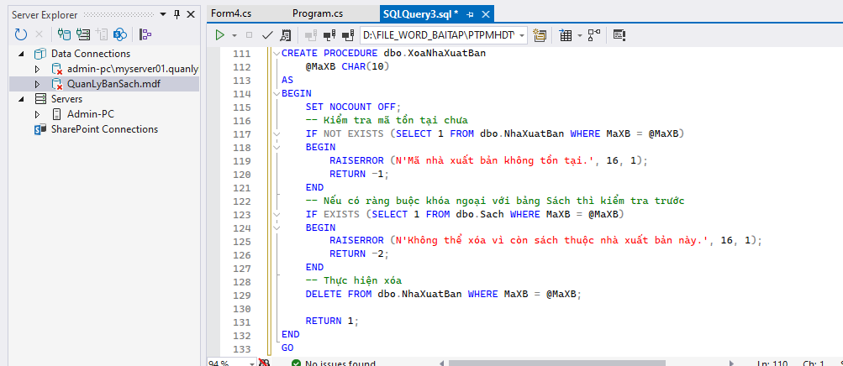

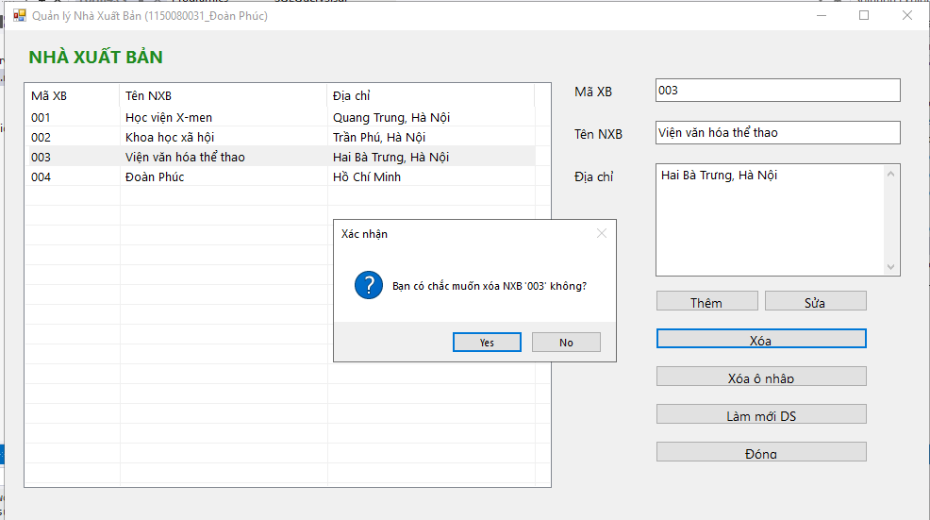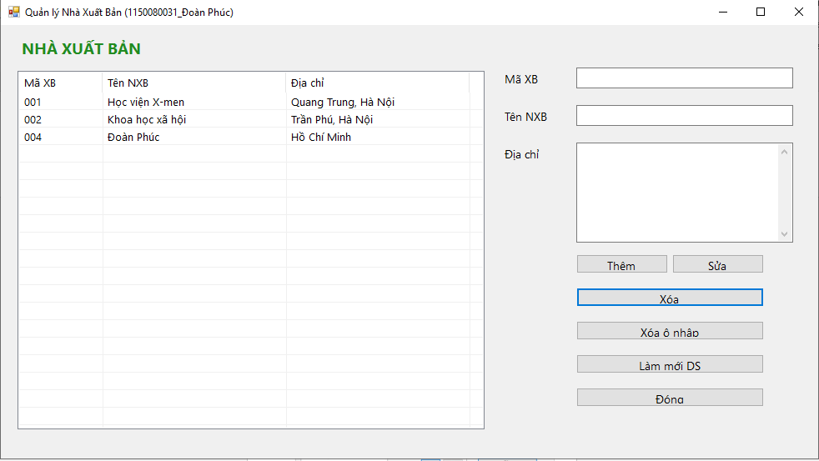

Code Form4**:**

**using System;**

**using System.Data;**

**using System.Data.SqlClient;**

**using System.Drawing;**

**using System.Windows.Forms;**

**namespace LAB6**

**{**

**public class Form4 : Form**

**{**

**private string _connStr =**

**@"Data Source=(LocalDB)\MSSQLLocalDB;AttachDbFilename=D:\File_word_baitap\PTPMHDT\Lab_thuc_hanh\LAB6\LAB6\QuanLyBanSach.mdf;Integrated Security=True;Connect Timeout=30";**

**private ListView lsvNXB;**

**private Label lblTitle, lblMa, lblTen, lblDiaChi;**

**private TextBox txtMa, txtTen, txtDiaChi;**

**private Button btnThem, btnSua, btnXoa, btnClear, btnRefresh, btnDong;**

**public Form4()**

**{**

**InitializeComponent();**

**}**

**private void InitializeComponent()**

**{**

**this.Text = "Quản lý Nhà Xuất Bản (1150080031_Đoàn Phúc)";**

**this.StartPosition = FormStartPosition.CenterScreen;**

**this.Font = new Font("Segoe UI", 10F);**

**this.ClientSize = new Size(980, 520);**

**lblTitle = new Label**

**{**

**Text = "NHÀ XUẤT BẢN",**

**Font = new Font("Segoe UI", 14F, FontStyle.Bold),**

**ForeColor = Color.ForestGreen,**

**AutoSize = true,**

**Location = new Point(20, 15)**

**};**

**this.Controls.Add(lblTitle);**

**// ========== ListView ==========**

**lsvNXB = new ListView**

**{**

**Location = new Point(20, 55),**

**Size = new Size(560, 430),**

**View = View.Details,**

**FullRowSelect = true,**

**GridLines = true,**

**HideSelection = false**

**};**

**lsvNXB.Columns.Add("Mã XB", 100, HorizontalAlignment.Left);**

**lsvNXB.Columns.Add("Tên NXB", 220, HorizontalAlignment.Left);**

**lsvNXB.Columns.Add("Địa chỉ", 220, HorizontalAlignment.Left);**

**lsvNXB.SelectedIndexChanged += LsvNXB_SelectedIndexChanged;**

**this.Controls.Add(lsvNXB);**

**// ========== Khối nhập ==========**

**int baseX = 600;**

**int baseY = 55;**

**lblMa = new Label { Text = "Mã XB", AutoSize = true, Location = new Point(baseX, baseY) };**

**txtMa = new TextBox { Location = new Point(baseX + 90, baseY - 4), Width = 260, MaxLength = 10 };**

**lblTen = new Label { Text = "Tên NXB", AutoSize = true, Location = new Point(baseX, baseY + 45) };**

**txtTen = new TextBox { Location = new Point(baseX + 90, baseY + 41), Width = 260, MaxLength = 100 };**

**lblDiaChi = new Label { Text = "Địa chỉ", AutoSize = true, Location = new Point(baseX, baseY + 90) };**

**txtDiaChi = new TextBox**

**{**

**Location = new Point(baseX + 90, baseY + 86),**

**Width = 260,**

**Height = 120,**

**Multiline = true,**

**ScrollBars = ScrollBars.Vertical,**

**MaxLength = 500**

**};**

**// 🔹 Nút chức năng**

**btnThem = new Button { Text = "Thêm", Location = new Point(baseX + 90, baseY + 220), Width = 110 };**

**btnSua = new Button { Text = "Sửa", Location = new Point(baseX + 205, baseY + 220), Width = 110 };**

**btnXoa = new Button { Text = "Xóa", Location = new Point(baseX + 90, baseY + 260), Width = 225 };**

**btnClear = new Button { Text = "Xóa ô nhập", Location = new Point(baseX + 90, baseY + 300), Width = 225 };**

**btnRefresh = new Button { Text = "Làm mới DS", Location = new Point(baseX + 90, baseY + 340), Width = 225 };**

**btnDong = new Button { Text = "Đóng", Location = new Point(baseX + 90, baseY + 380), Width = 225 };**

**btnThem.Click += BtnThem_Click;**

**btnSua.Click += BtnSua_Click;**

**btnXoa.Click += BtnXoa_Click;**

**btnClear.Click += delegate { ClearInputs(); };**

**btnRefresh.Click += delegate { LoadList(); };**

**btnDong.Click += delegate { this.Close(); };**

**this.Controls.AddRange(new Control[]**

**{**

**lblMa, txtMa, lblTen, txtTen, lblDiaChi, txtDiaChi,**

**btnThem, btnSua, btnXoa, btnClear, btnRefresh, btnDong**

**});**

**this.Load += delegate { LoadList(); txtMa.Focus(); };**

**}**

**// ====== Khi chọn dòng trong ListView ======**

**private void LsvNXB_SelectedIndexChanged(object sender, EventArgs e)**

**{**

**if (lsvNXB.SelectedItems.Count == 0) return;**

**var it = lsvNXB.SelectedItems[0];**

**txtMa.Text = it.SubItems[0].Text;**

**txtTen.Text = it.SubItems[1].Text;**

**txtDiaChi.Text = it.SubItems[2].Text;**

**}**

**// ====== Nút Thêm ======**

**private void BtnThem_Click(object sender, EventArgs e)**

**{**

**string ma = txtMa.Text.Trim();**

**string ten = txtTen.Text.Trim();**

**string diaChi = txtDiaChi.Text.Trim();**

**if (ma.Length == 0) { MessageBox.Show("Nhập Mã XB."); txtMa.Focus(); return; }**

**if (ten.Length == 0) { MessageBox.Show("Nhập Tên NXB."); txtTen.Focus(); return; }**

**try**

**{**

**using (var con = new SqlConnection(_connStr))**

**using (var cmd = new SqlCommand("dbo.ThemDuLieu", con))**

**{**

**cmd.CommandType = CommandType.StoredProcedure;**

**cmd.Parameters.Add("@MaXB", SqlDbType.Char, 10).Value = ma;**

**cmd.Parameters.Add("@TenNXB", SqlDbType.NVarChar, 100).Value = ten;**

**cmd.Parameters.Add("@DiaChi", SqlDbType.NVarChar, 500).Value = diaChi;**

**con.Open();**

**int rows = cmd.ExecuteNonQuery();**

**if (rows > 0)**

**{**

**MessageBox.Show("Thêm dữ liệu thành công!", "Thông báo");**

**LoadList();**

**ClearInputs();**

**txtMa.Focus();**

**}**

**}**

**}**

**catch (Exception ex)**

**{**

**MessageBox.Show("Lỗi thêm: " + ex.Message);**

**}**

**}**

**// ====== Nút Sửa ======**

**private void BtnSua_Click(object sender, EventArgs e)**

**{**

**string ma = txtMa.Text.Trim();**

**string ten = txtTen.Text.Trim();**

**string diaChi = txtDiaChi.Text.Trim();**

**if (ma == "") { MessageBox.Show("Chọn dòng cần sửa!"); return; }**

**try**

**{**

**using (var con = new SqlConnection(_connStr))**

**using (var cmd = new SqlCommand("dbo.CapNhatThongTin", con))**

**{**

**cmd.CommandType = CommandType.StoredProcedure;**

**cmd.Parameters.Add("@MaXB", SqlDbType.Char, 10).Value = ma;**

**cmd.Parameters.Add("@TenNXB", SqlDbType.NVarChar, 100).Value = ten;**

**cmd.Parameters.Add("@DiaChi", SqlDbType.NVarChar, 500).Value = diaChi;**

**con.Open();**

**int rows = cmd.ExecuteNonQuery();**

**if (rows > 0)**

**{**

**MessageBox.Show("Cập nhật thành công!", "Thông báo");**

**LoadList();**

**ClearInputs();**

**}**

**else**

**{**

**MessageBox.Show("Không có bản ghi nào được cập nhật!");**

**}**

**}**

**}**

**catch (Exception ex)**

**{**

**MessageBox.Show("Lỗi cập nhật: " + ex.Message);**

**}**

**}**

**// ====== Nút Xóa ======**

**private void BtnXoa_Click(object sender, EventArgs e)**

**{**

**string ma = txtMa.Text.Trim();**

**if (ma == "")**

**{**

**MessageBox.Show("Chọn dòng cần xóa!");**

**return;**

**}**

**if (MessageBox.Show("Bạn có chắc muốn xóa NXB '" + ma + "' không?",**

**"Xác nhận", MessageBoxButtons.YesNo, MessageBoxIcon.Question) == DialogResult.No)**

**return;**

**try**

**{**

**using (var con = new SqlConnection(_connStr))**

**using (var cmd = new SqlCommand("dbo.XoaNhaXuatBan", con))**

**{**

**cmd.CommandType = CommandType.StoredProcedure;**

**cmd.Parameters.Add("@MaXB", SqlDbType.Char, 10).Value = ma;**

**con.Open();**

**int rows = cmd.ExecuteNonQuery();**

**if (rows > 0)**

**{**

**MessageBox.Show("Xóa thành công!", "Thông báo");**

**LoadList();**

**ClearInputs();**

**}**

**}**

**}**

**catch (SqlException ex)**

**{**

**MessageBox.Show("Lỗi SQL: " + ex.Message);**

**}**

**catch (Exception ex)**

**{**

**MessageBox.Show("Lỗi xóa: " + ex.Message);**

**}**

**}**

**// ====== Load danh sách ======**

**private void LoadList()**

**{**

**try**

**{**

**using (var con = new SqlConnection(_connStr))**

**using (var cmd = new SqlCommand(**

**"SELECT MaXB, TenNXB, ISNULL(DiaChi,N'') FROM dbo.NhaXuatBan ORDER BY MaXB ASC", con))**

**{**

**con.Open();**

**using (var rd = cmd.ExecuteReader())**

**{**

**FillList(rd);**

**}**

**}**

**}**

**catch (Exception ex)**

**{**

**MessageBox.Show("Lỗi tải danh sách: " + ex.Message);**

**}**

**}**

**private void FillList(SqlDataReader rd)**

**{**

**lsvNXB.BeginUpdate();**

**lsvNXB.Items.Clear();**

**while (rd.Read())**

**{**

**string ma = rd.GetValue(0).ToString().Trim();**

**string ten = rd.GetValue(1).ToString();**

**string dc = rd.IsDBNull(2) ? "" : rd.GetValue(2).ToString();**

**var item = new ListViewItem(ma);**

**item.SubItems.Add(ten);**

**item.SubItems.Add(dc);**

**lsvNXB.Items.Add(item);**

**}**

**lsvNXB.EndUpdate();**

**}**

**private void ClearInputs()**

**{**

**txtMa.Text = "";**

**txtTen.Text = "";**

**txtDiaChi.Text = "";**

**}**

**}**

**}**