Tên: Đoàn Phúc

Lớp: 11CNPM1

MSSV: 1150080031

**LAB 3: WINDOWS FORMS APPLICATION NÂNG CAO**

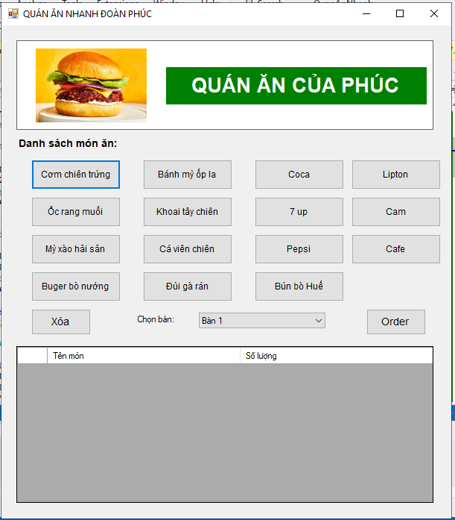

Form1.cs:

using System;

using System.Data;

using System.Drawing;

using System.IO;

using System.Windows.Forms;

namespace QuanAnNhanh

{

public partial class Form1 : Form

{

private DataTable dtOrder;

private ComboBox cmbBan;

private DataGridView dgvOrder;

private Button btnOrder, btnXoa;

public Form1()

{

KhoiTaoGiaoDien();

KhoiTaoDataTable();

}

private void KhoiTaoGiaoDien()

{

this.Text = "QUÁN ĂN NHANH ĐOÀN PHÚC";

this.Size = new Size(620, 700);

this.StartPosition = FormStartPosition.CenterScreen;

Panel pnlHeader = new Panel

{

Location = new Point(20, 20),

Size = new Size(560, 120),

BorderStyle = BorderStyle.FixedSingle,

BackColor = Color.White

};

PictureBox picLogo = new PictureBox

{

Location = new Point(10, 10),

Size = new Size(180, 100),

SizeMode = PictureBoxSizeMode.Zoom,

BackColor = Color.White

};

picLogo.Load("https://www.foodandwine.com/thmb/pwFie7NRkq4SXMDJU6QKnUKlaoI=/1500x0/filters:no_upscale():max_bytes(150000):strip_icc()/Ultimate-Veggie-Burgers-FT-Recipe-0821-5d7532c53a924a7298d2175cf1d4219f.jpg");

this.Controls.Add(picLogo);

Label lblTenQuan = new Label

{

Text = "QUÁN ĂN CỦA PHÚC",

Location = new Point(200, 35),

Size = new Size(350, 50),

Font = new Font("Arial", 20, FontStyle.Bold),

ForeColor = Color.White,

BackColor = Color.Green,

TextAlign = ContentAlignment.MiddleCenter

};

pnlHeader.Controls.Add(picLogo);

pnlHeader.Controls.Add(lblTenQuan);

// Label danh sách món ăn

Label lblDanhSach = new Label

{

Text = "Danh sách món ăn:",

Location = new Point(20, 150),

Size = new Size(200, 20),

Font = new Font("Arial", 10, FontStyle.Bold)

};

// Tạo các button món ăn - hàng 1

Button btnComChien = TaoButtonMonAn("Cơm chiên trứng", 40, 180);

Button btnBanhMy = TaoButtonMonAn("Bánh mỳ ốp la", 190, 180);

Button btnCoca = TaoButtonMonAn("Coca", 340, 180);

Button btnLipton = TaoButtonMonAn("Lipton", 470, 180);

// Hàng 2

Button btnOcRang = TaoButtonMonAn("Ốc rang muối", 40, 230);

Button btnKhoaiTay = TaoButtonMonAn("Khoai tây chiên", 190, 230);

Button btn7Up = TaoButtonMonAn("7 up", 340, 230);

Button btnCam = TaoButtonMonAn("Cam", 470, 230);

// Hàng 3

Button btnMyXao = TaoButtonMonAn("Mỳ xào hải sản", 40, 280);

Button btnCaVien = TaoButtonMonAn("Cá viên chiên", 190, 280);

Button btnPepsi = TaoButtonMonAn("Pepsi", 340, 280);

Button btnCafe = TaoButtonMonAn("Cafe", 470, 280);

// Hàng 4

Button btnBuger = TaoButtonMonAn("Buger bò nướng", 40, 330);

Button btnDuiGa = TaoButtonMonAn("Đùi gà rán", 190, 330);

Button btnBunBo = TaoButtonMonAn("Bún bò Huế", 340, 330);

// Panel chức năng

btnXoa = new Button

{

Text = "Xóa",

Location = new Point(40, 380),

Size = new Size(80, 35),

Font = new Font("Arial", 10)

};

btnXoa.Click += BtnXoa_Click;

Label lblChonBan = new Label

{

Text = "Chọn bàn:",

Location = new Point(180, 387),

Size = new Size(80, 20)

};

cmbBan = new ComboBox

{

Location = new Point(265, 385),

Size = new Size(170, 25),

DropDownStyle = ComboBoxStyle.DropDownList

};

for (int i = 1; i <= 10; i++)

{

cmbBan.Items.Add($"Bàn {i}");

}

cmbBan.SelectedIndex = 0;

btnOrder = new Button

{

Text = "Order",

Location = new Point(490, 380),

Size = new Size(80, 35),

Font = new Font("Arial", 10)

};

btnOrder.Click += BtnOrder_Click;

// DataGridView hiển thị order

dgvOrder = new DataGridView

{

Location = new Point(20, 430),

Size = new Size(560, 210),

AutoSizeColumnsMode = DataGridViewAutoSizeColumnsMode.Fill,

AllowUserToAddRows = false,

ReadOnly = true,

SelectionMode = DataGridViewSelectionMode.FullRowSelect

};

// Thêm controls vào form

this.Controls.Add(pnlHeader);

this.Controls.Add(lblDanhSach);

this.Controls.Add(btnComChien);

this.Controls.Add(btnBanhMy);

this.Controls.Add(btnCoca);

this.Controls.Add(btnLipton);

this.Controls.Add(btnOcRang);

this.Controls.Add(btnKhoaiTay);

this.Controls.Add(btn7Up);

this.Controls.Add(btnCam);

this.Controls.Add(btnMyXao);

this.Controls.Add(btnCaVien);

this.Controls.Add(btnPepsi);

this.Controls.Add(btnCafe);

this.Controls.Add(btnBuger);

this.Controls.Add(btnDuiGa);

this.Controls.Add(btnBunBo);

this.Controls.Add(btnXoa);

this.Controls.Add(lblChonBan);

this.Controls.Add(cmbBan);

this.Controls.Add(btnOrder);

this.Controls.Add(dgvOrder);

}

private Button TaoButtonMonAn(string tenMon, int x, int y)

{

Button btn = new Button

{

Text = tenMon,

Location = new Point(x, y),

Size = new Size(120, 40),

Font = new Font("Arial", 9)

};

btn.Click += BtnMonAn_Click;

return btn;

}

private void KhoiTaoDataTable()

{

dtOrder = new DataTable();

dtOrder.Columns.Add("Tên món", typeof(string));

dtOrder.Columns.Add("Số lượng", typeof(int));

dgvOrder.DataSource = dtOrder;

}

private void BtnMonAn_Click(object sender, EventArgs e)

{

Button btn = (Button)sender;

string tenMon = btn.Text;

// Kiểm tra món đã có trong danh sách chưa

DataRow[] rows = dtOrder.Select($"[Tên món] = '{tenMon}'");

if (rows.Length > 0)

{

// Tăng số lượng

rows[0]["Số lượng"] = (int)rows[0]["Số lượng"] + 1;

}

else

{

// Thêm món mới

dtOrder.Rows.Add(tenMon, 1);

}

}

private void BtnXoa_Click(object sender, EventArgs e)

{

if (dgvOrder.SelectedRows.Count > 0)

{

int index = dgvOrder.SelectedRows[0].Index;

dtOrder.Rows[index].Delete();

}

else

{

MessageBox.Show("Vui lòng chọn món cần xóa!", "Thông báo",

MessageBoxButtons.OK, MessageBoxIcon.Warning);

}

}

private void Form1_Load(object sender, EventArgs e)

{

}

private void BtnOrder_Click(object sender, EventArgs e)

{

if (dtOrder.Rows.Count == 0)

{

MessageBox.Show("Chưa có món nào được chọn!", "Thông báo",

MessageBoxButtons.OK, MessageBoxIcon.Warning);

return;

}

string tenBan = cmbBan.SelectedItem.ToString();

string fileName = $"Order_{tenBan}_{DateTime.Now:yyyyMMdd_HHmmss}.txt";

try

{

using (StreamWriter sw = new StreamWriter(fileName))

{

sw.WriteLine("=====================================");

sw.WriteLine(" QUÁN ĂN NHANH PHÚC");

sw.WriteLine("=====================================");

sw.WriteLine($"Bàn: {tenBan}");

sw.WriteLine($"Thời gian: {DateTime.Now:dd/MM/yyyy HH:mm:ss}");

sw.WriteLine("-------------------------------------");

sw.WriteLine("TÊN MÓN\t\t\tSỐ LƯỢNG");

sw.WriteLine("-------------------------------------");

foreach (DataRow row in dtOrder.Rows)

{

sw.WriteLine($"{row["Tên món"]}\t\t{row["Số lượng"]}");

}

sw.WriteLine("=====================================");

}

MessageBox.Show($"Order thành công!\nĐã lưu vào file: {fileName}",

"Thông báo", MessageBoxButtons.OK, MessageBoxIcon.Information);

// Xóa danh sách sau khi order

dtOrder.Clear();

}

catch (Exception ex)

{

MessageBox.Show($"Lỗi khi ghi file: {ex.Message}", "Lỗi",

MessageBoxButtons.OK, MessageBoxIcon.Error);

}

}

}

}

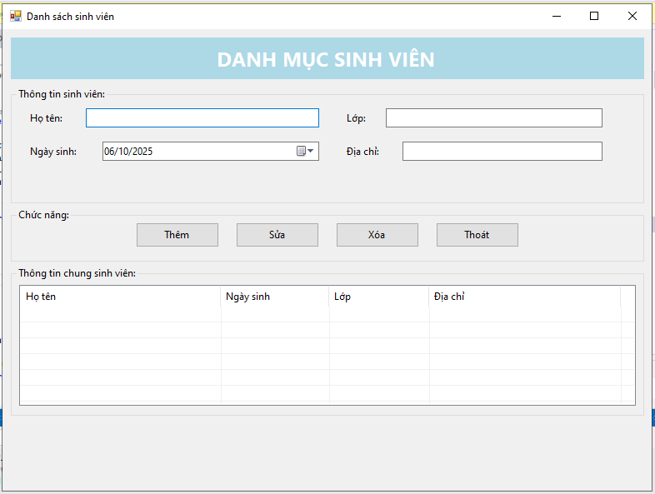

Form2.cs:

using System;

using System.Drawing;

using System.Windows.Forms;

namespace QuanAnNhanh

{

public partial class Form2 : Form

{

TextBox txtHoTen, txtLop, txtDiaChi;

DateTimePicker dtpNgaySinh;

Button btnThem, btnSua, btnXoa, btnThoat;

ListView lvSV;

public Form2()

{

InitializeComponent();

TaoGiaoDien();

}

private void TaoGiaoDien()

{

Text = "Danh sách sinh viên";

StartPosition = FormStartPosition.CenterScreen;

ClientSize = new Size(780, 480);

Font = new Font("Segoe UI", 9F);

// Title

var lblTitle = new Label

{

Text = "DANH MỤC SINH VIÊN",

Font = new Font("Segoe UI", 18, FontStyle.Bold),

ForeColor = Color.White,

BackColor = Color.LightBlue,

TextAlign = ContentAlignment.MiddleCenter,

Location = new Point(10, 10),

Size = new Size(760, 50)

};

Controls.Add(lblTitle);

// Group thông tin

var grpInfo = new GroupBox

{

Text = "Thông tin sinh viên:",

Location = new Point(10, 70),

Size = new Size(760, 140)

};

Controls.Add(grpInfo);

int left1 = 20, left2 = 400, top = 25, h = 26, w1 = 280, w2 = 320;

grpInfo.Controls.Add(new Label { Text = "Họ tên:", Location = new Point(left1, top + 4), AutoSize = true });

txtHoTen = new TextBox { Location = new Point(left1 + 70, top), Size = new Size(w1, h) };

grpInfo.Controls.Add(txtHoTen);

grpInfo.Controls.Add(new Label { Text = "Lớp:", Location = new Point(left2, top + 4), AutoSize = true });

txtLop = new TextBox { Location = new Point(left2 + 50, top), Size = new Size(w2 - 60, h) };

grpInfo.Controls.Add(txtLop);

grpInfo.Controls.Add(new Label { Text = "Ngày sinh:", Location = new Point(left1, top + 44), AutoSize = true });

dtpNgaySinh = new DateTimePicker

{

Location = new Point(left1 + 90, top + 40),

Size = new Size(w1 - 20, h),

Format = DateTimePickerFormat.Custom,

CustomFormat = "dd/MM/yyyy"

};

grpInfo.Controls.Add(dtpNgaySinh);

grpInfo.Controls.Add(new Label { Text = "Địa chỉ:", Location = new Point(left2, top + 44), AutoSize = true });

txtDiaChi = new TextBox { Location = new Point(left2 + 70, top + 40), Size = new Size(w2 - 80, h) };

grpInfo.Controls.Add(txtDiaChi);

// Chức năng

// Chức năng

var grpActions = new GroupBox

{

Text = "Chức năng:",

Location = new Point(10, 215),

Size = new Size(760, 65)

};

Controls.Add(grpActions);

// Danh sách các nút

string[] tenNut = { "Thêm", "Sửa", "Xóa", "Thoát" };

Button[] dsNut = new Button[tenNut.Length];

int soNut = tenNut.Length;

int khoangTrong = 20; // khoảng cách giữa các nút

int chieuRongNut = 100;

int chieuCaoNut = 30;

// Tính toán khoảng cách đều nhau trong groupbox

int tongRongNut = soNut * chieuRongNut + (soNut - 1) * khoangTrong;

int startX = (grpActions.Width - tongRongNut) / 2; // canh giữa

int y = (grpActions.Height - chieuCaoNut) / 2;

for (int i = 0; i < soNut; i++)

{

dsNut[i] = new Button

{

Text = tenNut[i],

Size = new Size(chieuRongNut, chieuCaoNut),

Location = new Point(startX + i * (chieuRongNut + khoangTrong), y)

};

grpActions.Controls.Add(dsNut[i]);

}

// Gán biến và sự kiện

btnThem = dsNut[0];

btnSua = dsNut[1];

btnXoa = dsNut[2];

btnThoat = dsNut[3];

btnThem.Click += BtnThem_Click;

btnSua.Click += BtnSua_Click;

btnXoa.Click += BtnXoa_Click;

btnThoat.Click += (s, e) => Close();

grpActions.Controls.AddRange(new Control[] { btnThem, btnSua, btnXoa, btnThoat });

// Listview

var grpList = new GroupBox

{

Text = "Thông tin chung sinh viên:",

Location = new Point(10, 285),

Size = new Size(760, 180)

};

Controls.Add(grpList);

lvSV = new ListView

{

Location = new Point(10, 22),

Size = new Size(740, 145),

View = View.Details,

FullRowSelect = true,

GridLines = true

};

lvSV.Columns.Add("Họ tên", 240);

lvSV.Columns.Add("Ngày sinh", 130);

lvSV.Columns.Add("Lớp", 120);

lvSV.Columns.Add("Địa chỉ", 230);

lvSV.SelectedIndexChanged += LvSV_SelectedIndexChanged;

grpList.Controls.Add(lvSV);

}

// ====== HANDLERS ======

private void BtnThem_Click(object sender, EventArgs e)

{

if (string.IsNullOrWhiteSpace(txtHoTen.Text))

{

MessageBox.Show("Họ tên không được rỗng!", "Thông báo",

MessageBoxButtons.OK, MessageBoxIcon.Warning);

txtHoTen.Focus();

return;

}

var item = new ListViewItem(txtHoTen.Text.Trim());

item.SubItems.Add(dtpNgaySinh.Value.ToString("dd/MM/yyyy"));

item.SubItems.Add(txtLop.Text.Trim());

item.SubItems.Add(txtDiaChi.Text.Trim());

lvSV.Items.Add(item);

ClearInputs();

}

private void BtnXoa_Click(object sender, EventArgs e)

{

if (lvSV.SelectedItems.Count == 0)

{

MessageBox.Show("Vui lòng chọn 1 dòng để xóa!", "Thông báo",

MessageBoxButtons.OK, MessageBoxIcon.Warning);

return;

}

lvSV.Items.Remove(lvSV.SelectedItems[0]);

ClearInputs();

}

private void BtnSua_Click(object sender, EventArgs e)

{

if (lvSV.SelectedItems.Count == 0)

{

MessageBox.Show("Vui lòng chọn 1 dòng để sửa!", "Thông báo",

MessageBoxButtons.OK, MessageBoxIcon.Warning);

return;

}

if (string.IsNullOrWhiteSpace(txtHoTen.Text))

{

MessageBox.Show("Họ tên không được rỗng!", "Thông báo",

MessageBoxButtons.OK, MessageBoxIcon.Warning);

txtHoTen.Focus();

return;

}

var it = lvSV.SelectedItems[0];

it.Text = txtHoTen.Text.Trim();

it.SubItems[1].Text = dtpNgaySinh.Value.ToString("dd/MM/yyyy");

it.SubItems[2].Text = txtLop.Text.Trim();

it.SubItems[3].Text = txtDiaChi.Text.Trim();

}

private void LvSV_SelectedIndexChanged(object sender, EventArgs e)

{

if (lvSV.SelectedItems.Count == 0) return;

var it = lvSV.SelectedItems[0];

txtHoTen.Text = it.Text;

DateTime d;

if (DateTime.TryParseExact(it.SubItems[1].Text, "dd/MM/yyyy",

System.Globalization.CultureInfo.InvariantCulture,

System.Globalization.DateTimeStyles.None, out d))

{

dtpNgaySinh.Value = d;

}

txtLop.Text = it.SubItems[2].Text;

txtDiaChi.Text = it.SubItems[3].Text;

}

// ====== UTIL ======

private void ClearInputs()

{

txtHoTen.Clear();

txtLop.Clear();

txtDiaChi.Clear();

dtpNgaySinh.Value = DateTime.Today;

txtHoTen.Focus();

}

// Designer stub

}

}

**LAB 4: WINFORM KẾT NỐI CƠ SỞ DỮ LIỆU CƠ BẢN**

* Mởkết nối

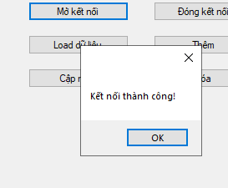

* Đóng kết nối

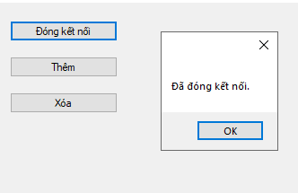

* Load dữ liệu

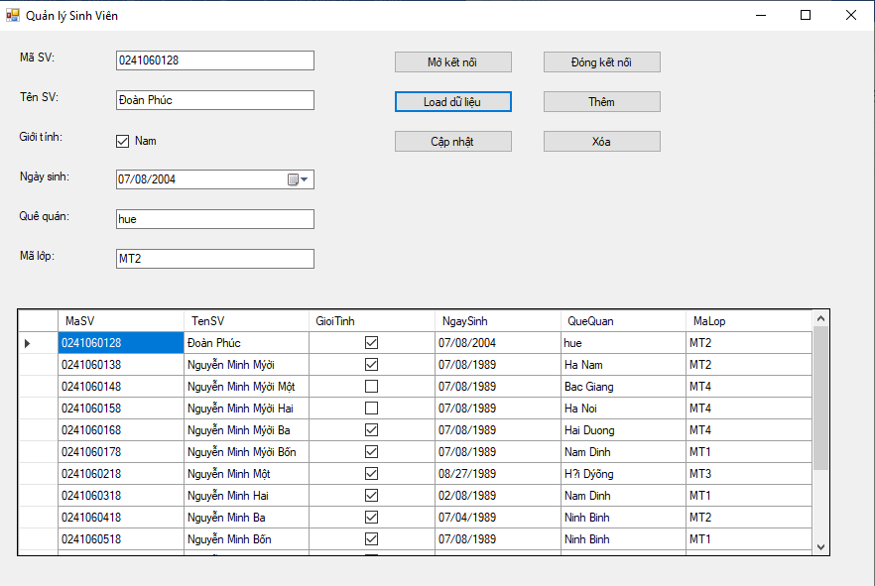

* Thêm

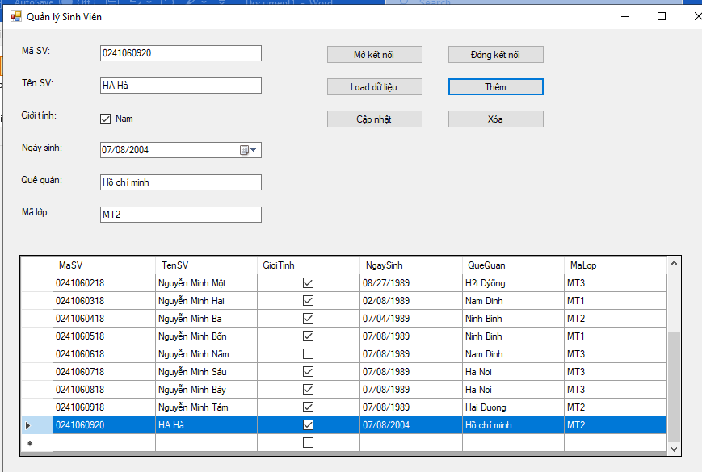

* Xoá

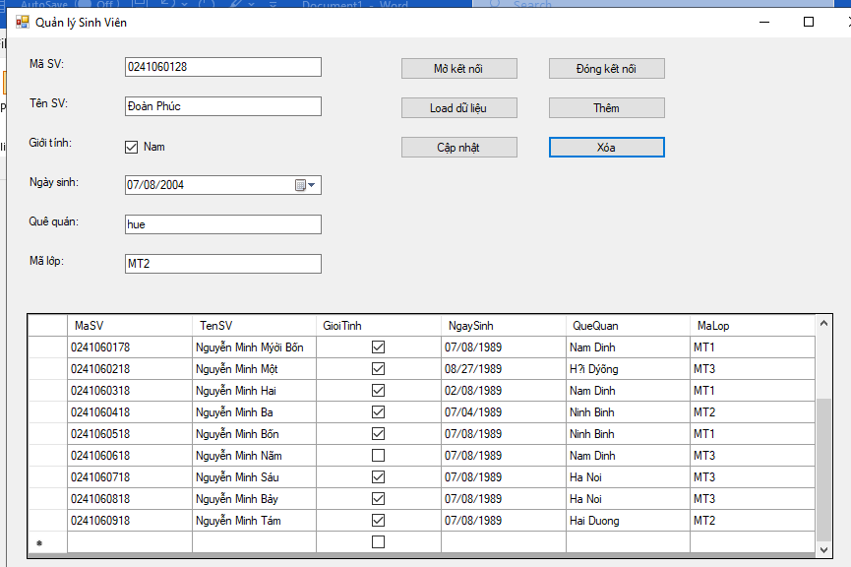

* Cập nhật

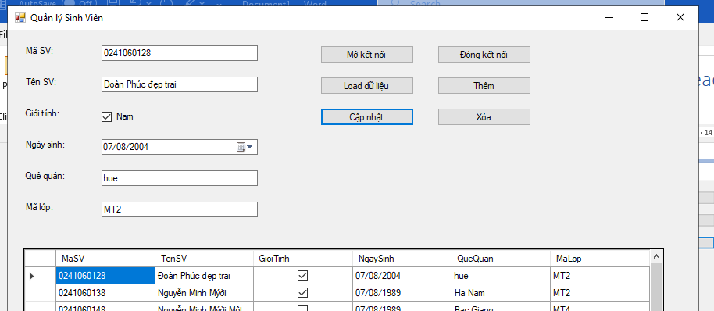

**using System;**

**using System.Data;**

**using System.Data.SqlClient;**

**using System.Drawing;**

**using System.Windows.Forms;**

**namespace Lab4**

**{**

**public partial class Form1 : Form**

**{**

**string strCon = @"Data Source=ADMIN-PC\MYSERVER01;Initial Catalog=quanlylop;Integrated Security=True";**

**SqlConnection sqlCon = null;**

**SqlDataAdapter adapter = null;**

**DataTable dt = null;**

**// Controls**

**DataGridView dataGridView1;**

**TextBox txtMaSV, txtTenSV, txtQueQuan, txtMaLop;**

**CheckBox chkGioiTinh;**

**DateTimePicker dtNgaySinh;**

**Button btnMoKetNoi, btnDongKetNoi, btnLoadData, btnAdd, btnUpdate, btnDelete;**

**public Form1()**

**{**

**InitializeComponent();**

**BuildUI();**

**}**

**private void BuildUI()**

**{**

**this.Text = "Quản lý Sinh Viên";**

**this.Size = new Size(900, 600);**

**Label lblMaSV = new Label() { Text = "Mã SV:", Location = new Point(20, 20) };**

**txtMaSV = new TextBox() { Location = new Point(120, 20), Width = 200 };**

**Label lblTenSV = new Label() { Text = "Tên SV:", Location = new Point(20, 60) };**

**txtTenSV = new TextBox() { Location = new Point(120, 60), Width = 200 };**

**Label lblGioiTinh = new Label() { Text = "Giới tính:", Location = new Point(20, 100) };**

**chkGioiTinh = new CheckBox() { Text = "Nam", Location = new Point(120, 100) };**

**Label lblNgaySinh = new Label() { Text = "Ngày sinh:", Location = new Point(20, 140) };**

**dtNgaySinh = new DateTimePicker() { Location = new Point(120, 140), Format = DateTimePickerFormat.Short };**

**Label lblQueQuan = new Label() { Text = "Quê quán:", Location = new Point(20, 180) };**

**txtQueQuan = new TextBox() { Location = new Point(120, 180), Width = 200 };**

**Label lblMaLop = new Label() { Text = "Mã lớp:", Location = new Point(20, 220) };**

**txtMaLop = new TextBox() { Location = new Point(120, 220), Width = 200 };**

**// Buttons**

**btnMoKetNoi = new Button() { Text = "Mở kết nối", Location = new Point(400, 20), Width = 120 };**

**btnDongKetNoi = new Button() { Text = "Đóng kết nối", Location = new Point(550, 20), Width = 120 };**

**btnLoadData = new Button() { Text = "Load dữ liệu", Location = new Point(400, 60), Width = 120 };**

**btnAdd = new Button() { Text = "Thêm", Location = new Point(550, 60), Width = 120 };**

**btnUpdate = new Button() { Text = "Cập nhật", Location = new Point(400, 100), Width = 120 };**

**btnDelete = new Button() { Text = "Xóa", Location = new Point(550, 100), Width = 120 };**

**// DataGridView**

**dataGridView1 = new DataGridView()**

**{**

**Location = new Point(20, 280),**

**Size = new Size(820, 250),**

**AutoSizeColumnsMode = DataGridViewAutoSizeColumnsMode.Fill**

**};**

**// Add controls**

**this.Controls.Add(lblMaSV);**

**this.Controls.Add(txtMaSV);**

**this.Controls.Add(lblTenSV);**

**this.Controls.Add(txtTenSV);**

**this.Controls.Add(lblGioiTinh);**

**this.Controls.Add(chkGioiTinh);**

**this.Controls.Add(lblNgaySinh);**

**this.Controls.Add(dtNgaySinh);**

**this.Controls.Add(lblQueQuan);**

**this.Controls.Add(txtQueQuan);**

**this.Controls.Add(lblMaLop);**

**this.Controls.Add(txtMaLop);**

**this.Controls.Add(btnMoKetNoi);**

**this.Controls.Add(btnDongKetNoi);**

**this.Controls.Add(btnLoadData);**

**this.Controls.Add(btnAdd);**

**this.Controls.Add(btnUpdate);**

**this.Controls.Add(btnDelete);**

**this.Controls.Add(dataGridView1);**

**// Gán sự kiện**

**btnMoKetNoi.Click += btnMoKetNoi_Click;**

**btnDongKetNoi.Click += btnDongKetNoi_Click;**

**btnLoadData.Click += btnLoadData_Click;**

**btnAdd.Click += btnAdd_Click;**

**btnUpdate.Click += btnUpdate_Click;**

**btnDelete.Click += btnDelete_Click;**

**dataGridView1.SelectionChanged += dataGridView1_SelectionChanged;**

**this.FormClosing += Form1_FormClosing;**

**}**

**// ================== CODE XỬ LÝ ===================**

**private void btnMoKetNoi_Click(object sender, EventArgs e)**

**{**

**try**

**{**

**if (sqlCon == null)**

**sqlCon = new SqlConnection(strCon);**

**if (sqlCon.State == ConnectionState.Closed)**

**{**

**sqlCon.Open();**

**MessageBox.Show("Kết nối thành công!");**

**}**

**}**

**catch (Exception ex)**

**{**

**MessageBox.Show("Lỗi: " + ex.Message);**

**}**

**}**

**private void btnDongKetNoi_Click(object sender, EventArgs e)**

**{**

**if (sqlCon != null && sqlCon.State == ConnectionState.Open)**

**{**

**sqlCon.Close();**

**MessageBox.Show("Đã đóng kết nối.");**

**}**

**}**

**private void btnLoadData_Click(object sender, EventArgs e)**

**{**

**try**

**{**

**if (sqlCon == null) sqlCon = new SqlConnection(strCon);**

**if (sqlCon.State == ConnectionState.Closed) sqlCon.Open();**

**string sql = "SELECT MaSV, TenSV, GioiTinh, NgaySinh, QueQuan, MaLop FROM SinhVien";**

**adapter = new SqlDataAdapter(sql, sqlCon);**

**dt = new DataTable();**

**adapter.Fill(dt);**

**dataGridView1.DataSource = dt;**

**}**

**catch (Exception ex)**

**{**

**MessageBox.Show("Lỗi load dữ liệu: " + ex.Message);**

**}**

**}**

**private void dataGridView1_SelectionChanged(object sender, EventArgs e)**

**{**

**if (dataGridView1.CurrentRow == null) return;**

**if (dataGridView1.CurrentRow.DataBoundItem is DataRowView drv)**

**{**

**txtMaSV.Text = drv["MaSV"].ToString();**

**txtTenSV.Text = drv["TenSV"].ToString();**

**chkGioiTinh.Checked = drv["GioiTinh"].ToString() == "True";**

**dtNgaySinh.Value = drv["NgaySinh"] == DBNull.Value ? DateTime.Now : Convert.ToDateTime(drv["NgaySinh"]);**

**txtQueQuan.Text = drv["QueQuan"].ToString();**

**txtMaLop.Text = drv["MaLop"].ToString();**

**}**

**}**

**private void btnAdd_Click(object sender, EventArgs e)**

**{**

**try**

**{**

**string sql = "INSERT INTO SinhVien (MaSV, TenSV, GioiTinh, NgaySinh, QueQuan, MaLop) VALUES (@MaSV, @TenSV, @GioiTinh, @NgaySinh, @QueQuan, @MaLop)";**

**using (SqlCommand cmd = new SqlCommand(sql, sqlCon))**

**{**

**cmd.Parameters.AddWithValue("@MaSV", txtMaSV.Text.Trim());**

**cmd.Parameters.AddWithValue("@TenSV", txtTenSV.Text.Trim());**

**cmd.Parameters.AddWithValue("@GioiTinh", chkGioiTinh.Checked ? 1 : 0);**

**cmd.Parameters.AddWithValue("@NgaySinh", dtNgaySinh.Value);**

**cmd.Parameters.AddWithValue("@QueQuan", txtQueQuan.Text.Trim());**

**cmd.Parameters.AddWithValue("@MaLop", txtMaLop.Text.Trim());**

**cmd.ExecuteNonQuery();**

**}**

**btnLoadData_Click(null, null);**

**}**

**catch (Exception ex)**

**{**

**MessageBox.Show("Lỗi thêm: " + ex.Message);**

**}**

**}**

**private void btnUpdate_Click(object sender, EventArgs e)**

**{**

**try**

**{**

**string sql = "UPDATE SinhVien SET TenSV=@TenSV, GioiTinh=@GioiTinh, NgaySinh=@NgaySinh, QueQuan=@QueQuan, MaLop=@MaLop WHERE MaSV=@MaSV";**

**using (SqlCommand cmd = new SqlCommand(sql, sqlCon))**

**{**

**cmd.Parameters.AddWithValue("@MaSV", txtMaSV.Text.Trim());**

**cmd.Parameters.AddWithValue("@TenSV", txtTenSV.Text.Trim());**

**cmd.Parameters.AddWithValue("@GioiTinh", chkGioiTinh.Checked ? 1 : 0);**

**cmd.Parameters.AddWithValue("@NgaySinh", dtNgaySinh.Value);**

**cmd.Parameters.AddWithValue("@QueQuan", txtQueQuan.Text.Trim());**

**cmd.Parameters.AddWithValue("@MaLop", txtMaLop.Text.Trim());**

**cmd.ExecuteNonQuery();**

**}**

**btnLoadData_Click(null, null);**

**}**

**catch (Exception ex)**

**{**

**MessageBox.Show("Lỗi cập nhật: " + ex.Message);**

**}**

**}**

**private void btnDelete_Click(object sender, EventArgs e)**

**{**

**try**

**{**

**string sql = "DELETE FROM SinhVien WHERE MaSV=@MaSV";**

**using (SqlCommand cmd = new SqlCommand(sql, sqlCon))**

**{**

**cmd.Parameters.AddWithValue("@MaSV", txtMaSV.Text.Trim());**

**cmd.ExecuteNonQuery();**

**}**

**btnLoadData_Click(null, null);**

**}**

**catch (Exception ex)**

**{**

**MessageBox.Show("Lỗi xóa: " + ex.Message);**

**}**

**}**

**private void Form1_FormClosing(object sender, FormClosingEventArgs e)**

**{**

**if (sqlCon != null && sqlCon.State == ConnectionState.Open)**

**sqlCon.Close();**

**}**

**}**

**}**