Tên: Đoàn Thanh Nam

Mssv: 20146506

Bài Tập chương 4

Câu 1:

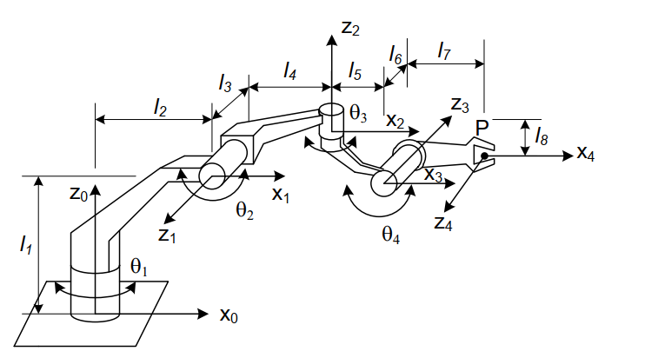

|  |  |  |  |  |  |
| --- | --- | --- | --- | --- | --- |
| # | θ | L | α | d | var |
| 1 | θ1 | L2 |  | L1 | θ1 |
| 2 | θ2 | L4 |  | -L3 | θ2 |
| 3 | θ3 | L5 |  | -L8 | θ3 |
| 4 | θ4 | L7 |  | L6 | θ4 |

Câu 2:

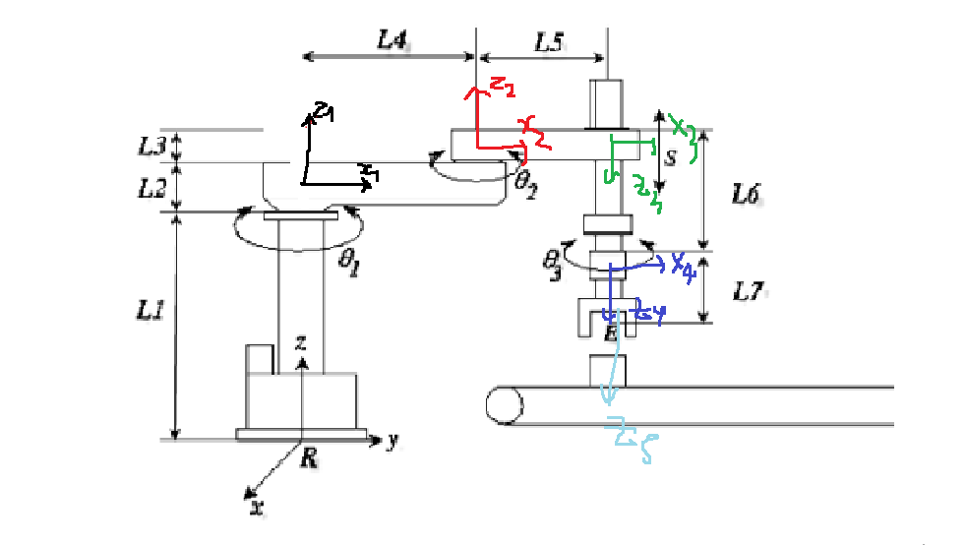

|  |  |  |  |  |  |
| --- | --- | --- | --- | --- | --- |
| # | θ | L | α | d | var |
| 1 | θ1 | 0 |  | L1+L2 | θ1 |
| 2 | θ2 | L4 |  | L3 | θ2 |
| 3 | 0 | L5 |  | 0 | θ3 |
| 4 | θ3 | 0 |  | L6 | θ4 |
| 5 | 0 | 0 | 0 | L7 |  |

Câu 3:

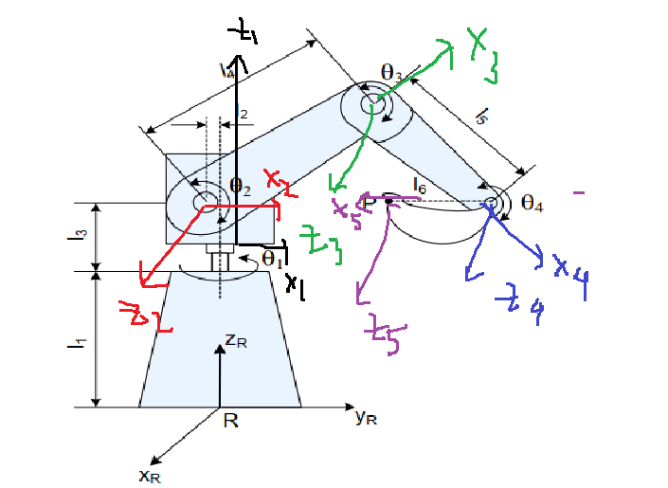

|  |  |  |  |  |  |
| --- | --- | --- | --- | --- | --- |
| # | θ | L | α | d | var |
| 1 | θ1 | 0 |  | L1 | θ1 |
| 2 | θ2 | L2 |  | L3 | θ2 |
| 3 | θ3 | L4 |  | 0 | θ3 |
| 4 | θ 4 | L5 |  | 0 | θ4 |
| 5 | 0 | 0 | 0 | L6 | 0 |

Câu 4:

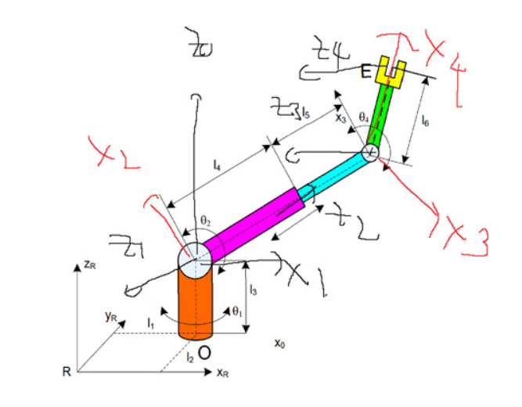

|  |  |  |  |  |  |
| --- | --- | --- | --- | --- | --- |
| # | θ | L | α | d | var |
| 1 | θ1 | 0 |  | L1 | θ1 |
| 2 | θ2 + | 0 |  | 0 | θ2 |
| 3 |  | 0 |  | L5 | L5 |
| 4 | θ3 + | L6 | 0 | 0 | θ3 |

Câu 5:

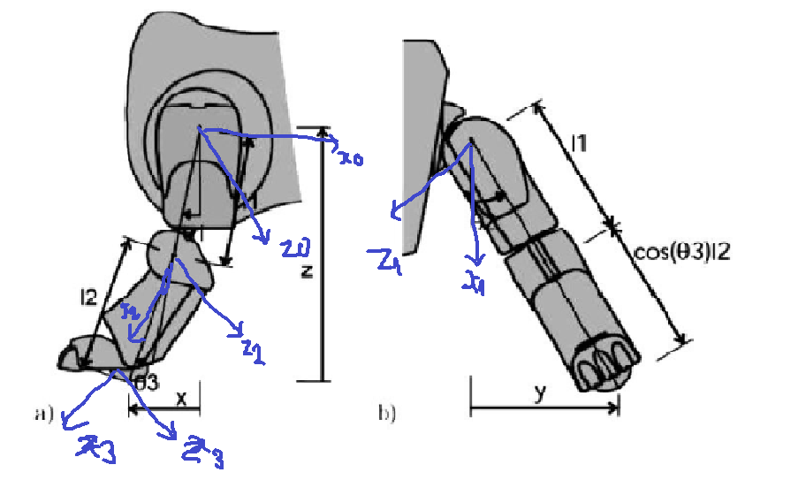

|  |  |  |  |  |  |
| --- | --- | --- | --- | --- | --- |
| # | θ | L | α | d | var |
| 1 | θ1+ | 0 |  | 0 | θ1 |
| 2 | θ2 | L1 | - | 0 | θ2 |
| 3 | θ3 | L2 |  | 0 | θ3 |

Câu 6:

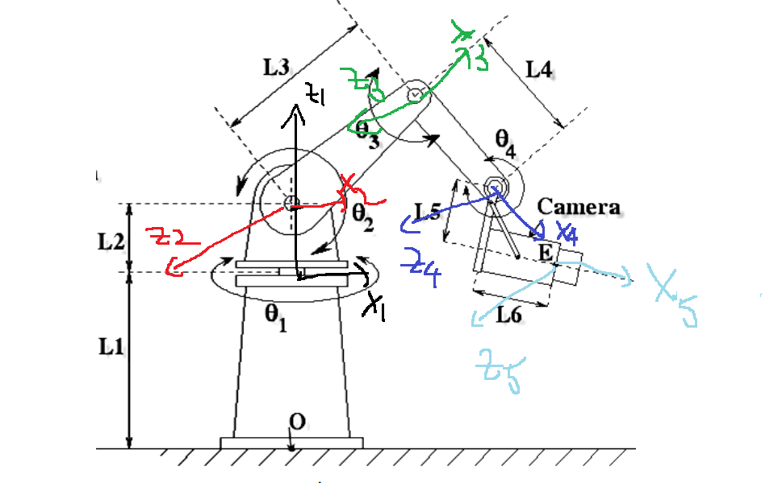

|  |  |  |  |  |  |
| --- | --- | --- | --- | --- | --- |
| # | θ | L | α | d | var |
| 1 | θ1 | 0 |  | L1 | θ1 |
| 2 | θ2 | L2 |  | 0 | θ2 |
| 3 | θ3 | L3 |  | 0 | θ3 |
| 4 | θ 4 | L4 |  | 0 | θ4 |
| 5 | θ 4 | L6 | 0 | L5 | 0 |

Câu 7:

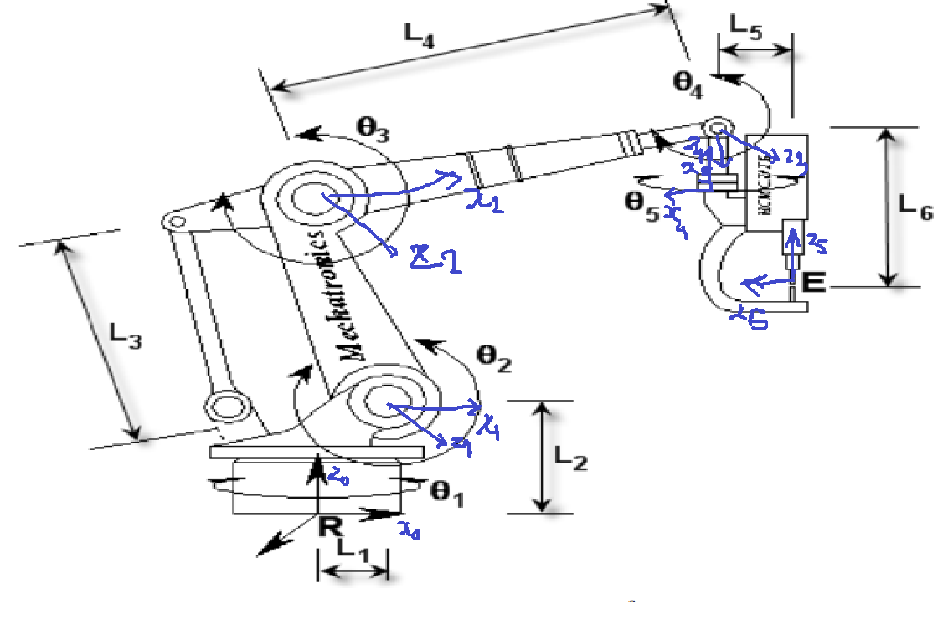

|  |  |  |  |  |  |
| --- | --- | --- | --- | --- | --- |
| # | θ | L | α | d | var |
| 1 | θ1 | L1 |  | L2 | θ1 |
| 2 | θ2 | L3 |  | 0 | θ2 |
| 3 | θ3 - | L4 |  | 0 | θ3 |
| 5 | θ 4 - | L5 |  | L6 | θ4 |