**Please, upload your answers in Canvas: assignment PC LAB – April 7**

Name: Vu The Doan

Student nr: 12918687

PC2a – Looping

**1.** Write a script *beautyofmathstr* that produces the following output:

> source(' beautyofmathstr.R')

1 x 8 + 1 = 9

12 x 8 + 2 = 98

123 x 8 + 3 = 987

1234 x 8 + 4 = 9876

12345 x 8 + 5 = 98765

123456 x 8 + 6 = 987654

1234567 x 8 + 7 = 9876543

12345678 x 8 + 8 = 98765432

123456789 x 8 + 9 = 987654321

- Use strings only!

- Note: "123" is equal to paste("12", "3", sep="")

- You can use

cat(sprintf("%s x 8 + %d = %s\n", xstr, i, ystr))

to display your results (see also video *Additional Topics*). Here %s will be replaced by the string xstr, %d will be replaced by the integer i and the second %s represents ystr.

getwd()

setwd("D:/UvA/Year 1/Block 5/Programming and Numerical Analysis/Week 2")

rm(list = ls())

"1 x 8 + 1 = 9

12 x 8 + 2 = 98

123 x 8 + 3 = 987

1234 x 8 + 4 = 9876

12345 x 8 + 5 = 98765

123456 x 8 + 6 = 987654

1234567 x 8 + 7 = 9876543

12345678 x 8 + 8 = 98765432

123456789 x 8 + 9 = 987654321"

xstr <- ""

i <- 1

ystr <- ""

for(i in c(1:9)) {

xstr <- paste0(xstr, i)

ystr <- paste0(ystr, 10-i)

cat(sprintf("%s x 8 + %d = %s\n", xstr, i, ystr))

}

**2.** The reciprocal of the mathematical constant *e* can be approximated as follows:



Write a R-script that iterates the right-hand side of the formula for values of *n* until the difference between the exact value (using the build-in function exp(-1)) and its approximation for the first time is smaller than 0.0001. The script should display the exact value of , its approximation in 4 decimals and the value found for *n*.

Hint: use a while loop

Example output:

The build-in value of e^(-1) is 0.3679

The approximation is 0.3678

The value for n is ...

The value for n such that the difference is for the first time smaller than 0.0001 equals?

**Answer**:

3. A Pythagorean triplet is a set of three positive integers $(a, b, c)$, for which, $a^{2} + b^{2} = c^{2}$. For example, $3^{2} + 4^{2} = 5^{2}$ (9 + 16 = 25). There ***exists exactly one*** Pythagorean triplet for which $a + b + c = 1000$. Find the product $abc$.

In this question, you will investigate 3 algorithms in increasing order of efficiency.

a. First, we use a naïve algorithm, called *Algorithm I*, with three while loops for finding $(a,b,c)$ as follows:

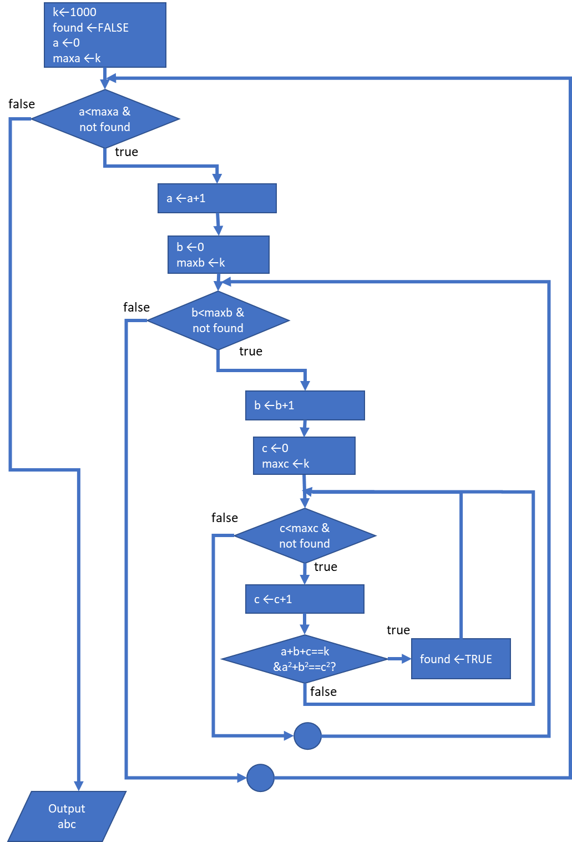

**b**. Let’s analyze the program somewhat more. First, since squares are always positive and $c^{2}=a^{2}+b^{2}$, we conclude that $c>a$ and $c>b$. Next, since we can switch the roles of $a$ and $b$ $(3^{2}+4^{2}=4^{2}+3^{2})$, we can without loss of generality assume $0<a<b<c.$ Finally, since $a+b+c=1000$, we can derive the following bounds due to the ordering of $a$, $b$ and $c$:

(i) $1≤a<k/3$

(ii) $b>a$

(iii) $c=1000-a-b$

Copy the source code of sub question (**a**) and modify the algorithm to incorporate restriction (i)-(iii). We call this *Algorithm II*. Note that the while loop for $c$ can be removed.

**c**. We can improve the algorithm as follows. Replacing $c$ by $1000-(a+b)$ in the Pythagorean condition, we get

$a^{2}+b^{2}={\left(1,000-\left(a+b\right)\right)}^{2}=1,000,000+a^{2}+b^{2}+2\left(ab-1,000\left(a+b\right)\right).$

After simplifying, we get

$500,000+ab=1,000\left(a+b\right).$

Solving this equation for $a$ gives

$a=\frac{1,000\left(500-b\right)}{1,000-b}$.

Setting the denominator to $m=1000-b$, we can rewrite the term $500-b$ as

$500-b=1,000-b-500=m-500$,

so that we obtain

$a=\frac{1,000\left(m-500\right)}{m}=\frac{1,000m-500,000}{m}=1000-\frac{500000}{m}.$

Since $a$ is a positive integer, we know that

(i) $b<500$ [since $500-b>0]$

(ii) m>500 [since $500,000/m$, $m$ should be smaller than $1,000$]

(iii) 500,000 should be a multiple of $m$, ie. the remainder of 500,000 divided by $m$ should be zero.

*Pseudo code for Algorithm III*:

for m in 501 to 1000

if (500000 mod m = 0) then

a ←1000 – (500000 div m)

b ← 1000 – m

c ← 1000 – a – b

exit [for]

Code this algorithm in R.

d. To determine the efficiency, we compare the execution length. For, this you can use (you may need to install the library tictoc first):

library(tictoc)

tic()

# … code

#toc()

Fill in the following table:

|  |  |  |
| --- | --- | --- |
| Algorithm | Time | Relative efficiency to A |
| I |  | 1.0 |
| II |  |  |
| III |  |  |

Note that the execution time will be different for all due to differences in computer power! How much faster are algorithms II and III with respect to the naïve I?