MAIN
import pandas as pd
pd.read_csv('name.csv', delimiter = ',' , names=columnNames, skiprows=[0], header=None, sep=';', index_col=0)
- sep: Delimiter in file
- index_col=0: setting the index to be column zero
pd.read_csv(r'csv_link')
.head()
pd.DataFrame([…], columns=['…']): Create Data frame
to_csv('name.csv', index=False/ [‘…’], header=colNames, sep=';', na_rep='Unknown'): Save data to csv file
- sep: Delimiter in file
- na_rep: Handling Missing Values
.loc['index']: Locate index

[analyticsvidhya]

INTRODUCTION
CSV is a typical file format that is often used in domains like Monetary Services, etc. Most applications can enable you to import and export knowledge in CSV format.
Thus, it is necessary to induce a good understanding of the CSV format to higher handle the data you are used with every day.
So, throughout this article, we’ll see various instances of operating with CSV files and provide examples to tie everything along.

WHAT IS A CSV?
CSV (Comma Separated Values) may be a simple file format accustomed to store tabular data, like a spreadsheet or database. CSV file stores tabular data (numbers and text) in plain text. Each line of the file could be a data record. Each record consists of 1 or more fields, separated by commas, the utilization of the comma as a field separator is that the source of the name for this file format.
In Basic operations, we are going to understand the subsequent three things:
- How to work with CSV files
- How to open a CSV file
- How to Save a CSV file
Working with CSV Files
Working with CSV files isn’t that tedious task but it’s pretty straightforward. However, counting on your workflow, there can become caveats that you simply might want to observe out for.
Opening a CSV File
If you’ve got a CSV file, you’ll open it in Excel without much trouble. Just open Excel, open and find the CSV file to figure with (or right-click on the CSV file and choose Open in Excel). After you open the file, you’ll notice that the info is simply plain text put into different cells.
Saving a CSV File
If you wish to save lots of your current workbook into a CSV file, you have got to use the subsequent commands:
File -> Save As… and choose CSV file.
More often than not, you’ll get this warning:
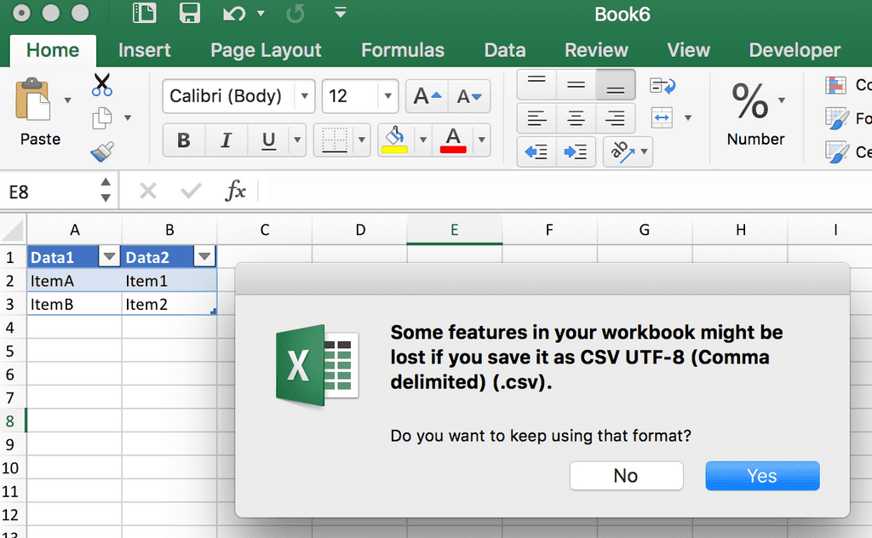
Let’s understand what’s this error saying to us?
Here Excel is trying to mention is that your CSV Files don’t save any reasonable formatting in the least.
For Example, Column widths, font styles, colors, etc. won’t be saved.
Just your plain old data are saved in an exceedingly comma-separated file.
Note that even after you put it aside, Excel will still show the formats that you just had, so don’t be fooled by this and think that after you open the workbook again that your formats will still be there. They won’t be.
Even after you open up a CSV get in Excel, if you apply any quite formatting in the least, like adjust the column widths to work out the info, Excel will still warn you that you just can’t save the formats that you just added, you’ll get a warning like this one:
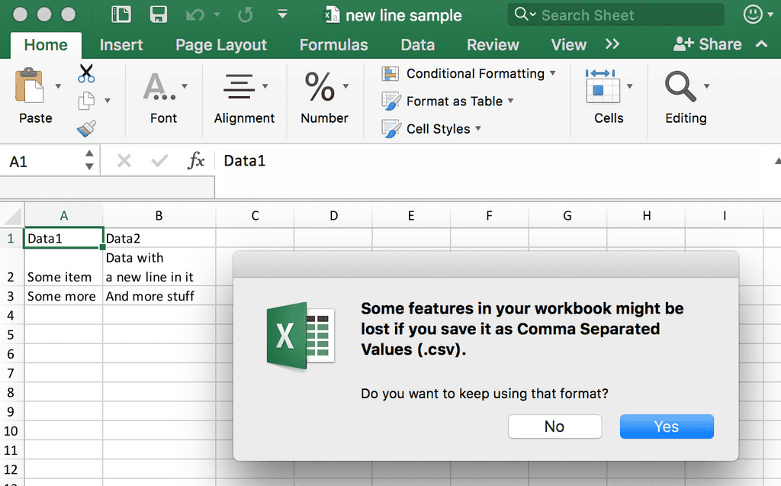
So, the aim to note that is your formats can never be saved in CSV Files.

WHY CSV FILES?
CSV files are used as the simplest way to speak data between different applications. Say you had a database application and you wanted to export the info to a file. If you wish to export it to an Excel file, the database application would support exporting to XLS* files.
However, since the CSV file format is extremely straightforward and lightweight (much a lot of therefore than XLS* files), it’s easier for varied applications to support it. In its basic usage, you have a line of text, with every column of data go alternative ways by a comma. That’s it. And since of this simplicity, it’s simple for developers to make Export / Import practicality with CSV files to transfer knowledge between applications instead of a lot of sophisticated file formats.
For Example,
Let’s have a tabular data in the given form below:
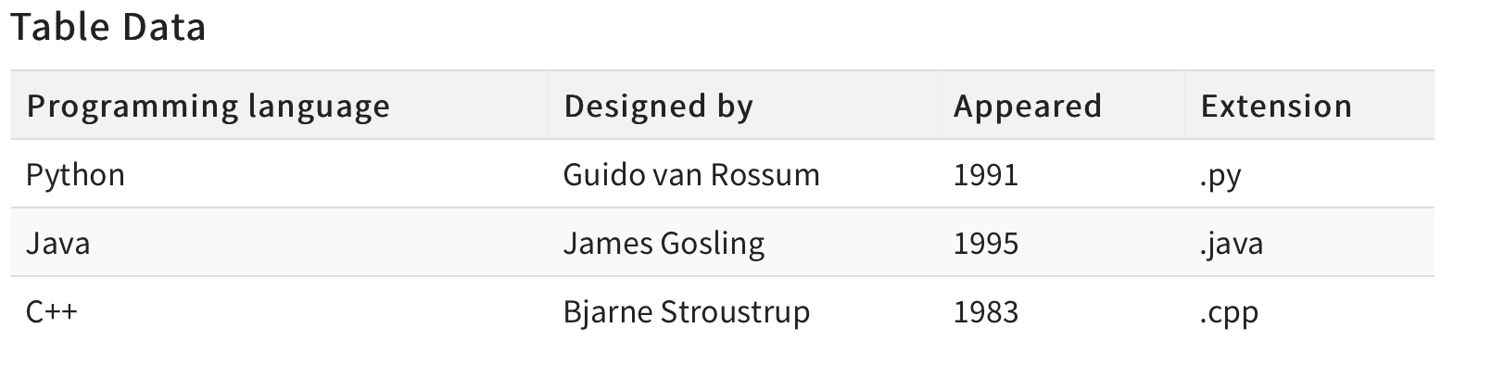
If we convert this data into a CSV Format, then its look like this:
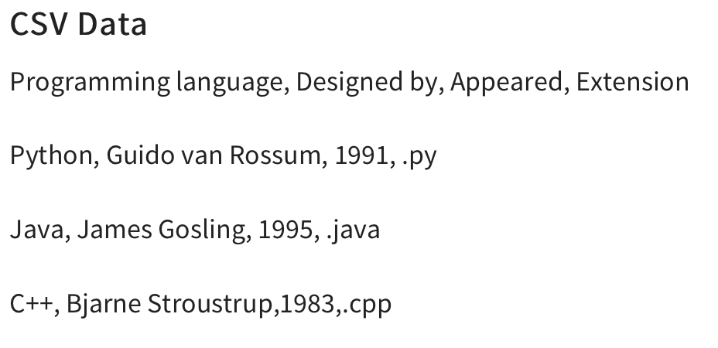
Now, we are completed with all the basics of CSV files. So, In the later part of the article, we will be discussing working with CSV files in a detailed manner.

[STACKABUSE]

WHAT IS A CSV FILE?
Let's quickly recap what a CSV file is - nothing more than a simple text file, following a few formatting conventions. However, it is the most common, simple, and easiest method to store tabular data. This format arranges tables by following a specific structure divided into rows and columns. It is these rows and columns that contain your data.
A new line terminates each row to start the next row. Similarly, a delimiter, usually a comma, separates columns within each row.
For example, we might have a table that looks like this:
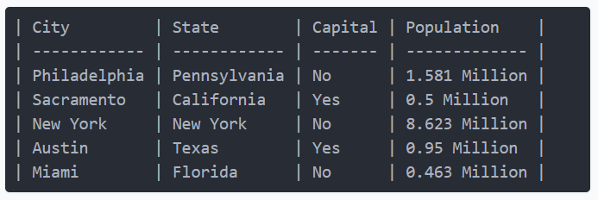
If we were to convert it into the CSV format, it'd look like this:
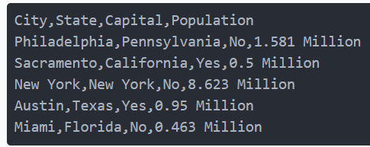
Although the name (Comma-Separated Values) inherently uses a comma as the delimiter, you can use other delimiters (separators) as well, such as the semicolon (;). Each row of the table is a new line of the CSV file and it's a very compact and concise way to represent tabular data.
Now, let's take a look at the read_csv() function.
READING AND WRITING CSV FILES
Pandas is a very powerful and popular framework for data analysis and manipulation. One of the most striking features of Pandas is its ability to read and write various types of files including CSV and Excel. You can effectively and easily manipulate CSV files in Pandas using functions like read_csv() and to_csv().

INSTALLING PANDAS
We have to install Pandas before using it. Let's use pip:
$ pip install pandas

READING CSV FILES
Let's import the Titanic Dataset, which can be obtained on GitHub:
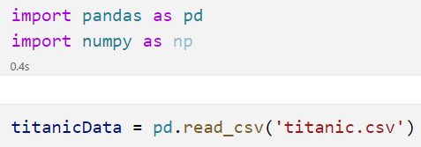
Pandas will search for this file in the directory of the script, naturally, and we just supply the filepath to the file we'd like to parse as the one and only required argument of this method.
Let's take a look at the head() of this dataset to make sure it's imported correctly:
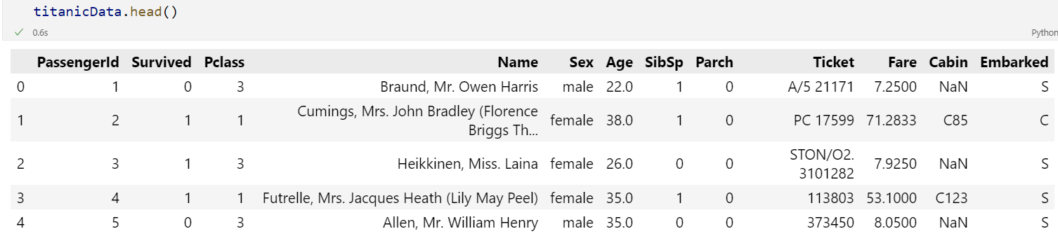
Alternatively, you can also read CSV files from online resources, such as GitHub, simply by passing in the URL of the resource to the read_csv() function. Let's read this same CSV file from the GitHub repository, without downloading it to our local machine first:
import pandas as pd

titanic_data = pd.read_csv(r'https://raw.githubusercontent.com/datasciencedojo/datasets/master/titanic.csv')
print(titanic_data.head())

CUSTOMIZING HEADERS
By default, the read_csv() method uses the first row of the CSV file as the column headers. Sometimes, these headers might have odd names, and you might want to use your own headers. You can set headers either after reading the file, simply by assigning the columns field of the DataFrame instance another list, or you can set the headers while reading the CSV in the first place.
Let's define a list of column names, and use those names instead of the ones from the CSV file:
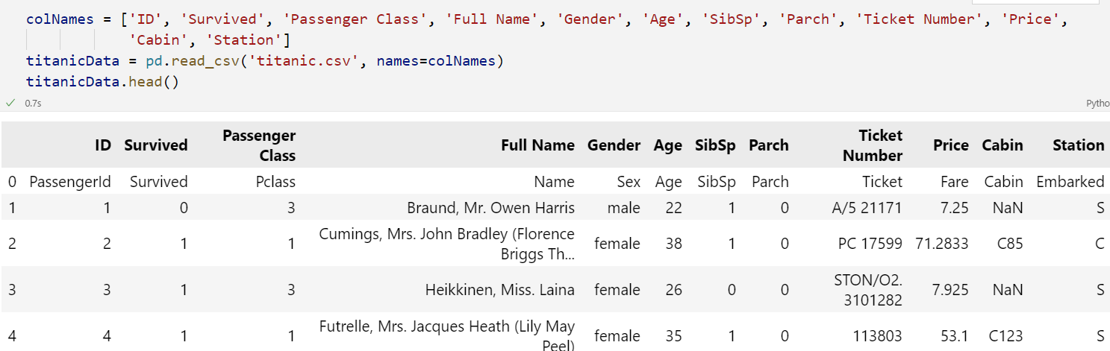
Hmm, now we've got our custom headers, but the first row of the CSV file, which was originally used to set the column names is also included in the DataFrame. We'll want to skip this line, since it no longer holds any value for us.

SKIPPING ROWS WHILE READING CSV
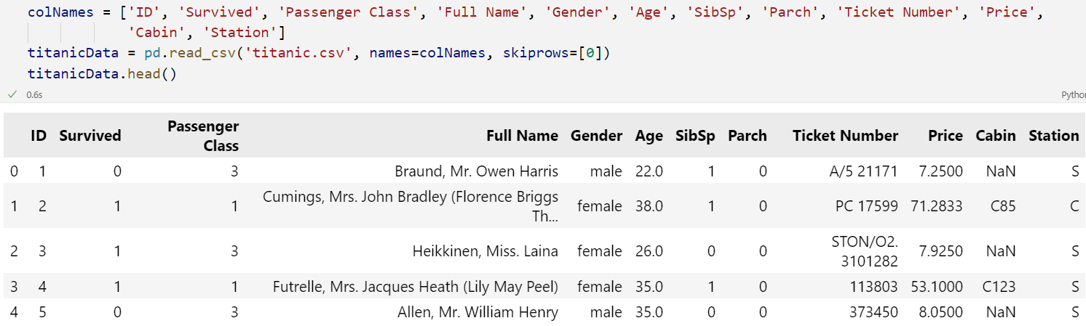
Works like a charm! The skiprows argument accepts a list of rows you'd like to skip. You can skip, for example, 0, 4, 7 if you'd like as well

REMOVING HEADERS
You can also decide to remove the header completely, which would result in a DataFrame that simply has 0...n header columns, by setting the header argument to None:
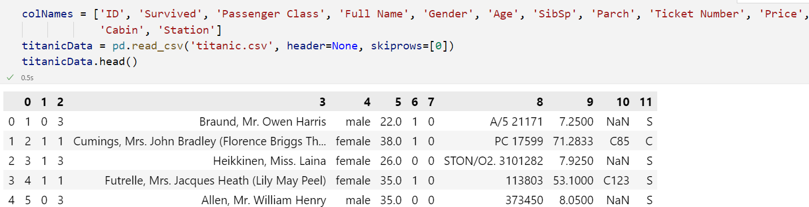
You'll also want to skip the first row here, since if you don't, the values from the first row will be actually be included in the first row

SPECIFYING DELIMITERS
As stated earlier, you'll eventually probably encounter a CSV file that doesn't actually use commas to separate data. In such cases, you can use the sep argument to specify other delimiters:
titanic_data = pd.read_csv(r'E:\Datasets\titanic.csv', sep=';')

WRITING CSV FILES WITH TO_CSV()
Again, DataFrames are tabular. Turning a DataFrame into a CSV file is as simple as turning a CSV file into a DataFrame - we call the write_csv() function on the DataFrame instance.
When writing a DataFrame to a CSV file, you can also change the column names, using the columns argument, or specify a delimiter via the sep argument. If you don't specify either of these, you'll end up with a standard Comma-Separated Value file.
Let's play around with this:
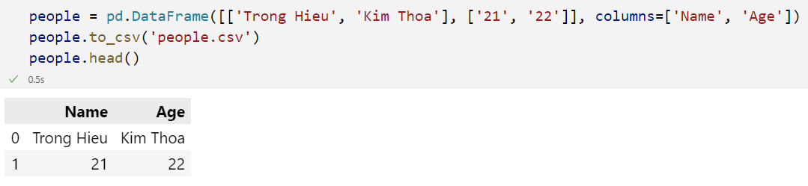
Here, we've made a simple DataFrame. Then, we've gone ahead and saved that data into a CSV file using to_csv() and providing the filename.
Though, this isn't really well-formatted. We've still got the indices from the DataFrame, which also puts a weird missing spot before the column names. If we re-imported this CSV back into a DataFrame, it'd be a mess:
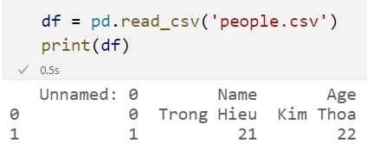
The indices from the DataFrame ended up becoming a new column, which is now Unnamed.
When saving the file, let's make sure to drop the index of the DataFrame:
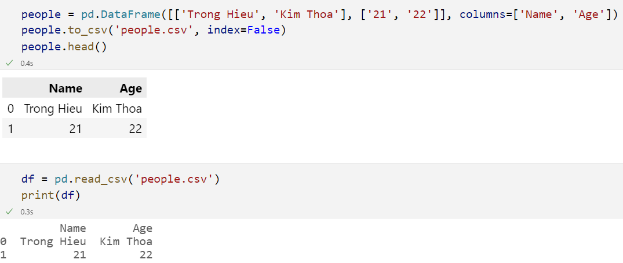

CUSTOMIZING HEADERS
Let's change the column headers from the default ones:
We've made a new_header list, that contains different values for our columns. Then, using the header argument, we've set these instead of the original column names. This generates a .csv with these contents:
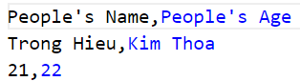

CUSTOMIZING DELIMITER
Let's change the delimiter from the default (,) value to a new one:
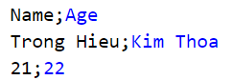

HANDLING MISSING VALUES
Sometimes, DataFrames have missing values that we've left as NaN or NA. In such cases, you might want to format these when you write them out into a CSV file. You can use the na_rep argument and set the value to be put instead of a missing value

[learndatasci]
The pandas package is the most important tool at the disposal of Data Scientists and Analysts working in Python today. The powerful machine learning and glamorous visualization tools may get all the attention, but pandas is the backbone of most data projects.
[pandas] is derived from the term "panel data", an econometrics term for data sets that include observations over multiple time periods for the same individuals. — Wikipedia
If you're thinking about data science as a career, then it is imperative that one of the first things you do is learn pandas. In this post, we will go over the essential bits of information about pandas, including how to install it, its uses, and how it works with other common Python data analysis packages such as matplotlib and scikit-learn.
Article Resources

WHAT'S PANDAS FOR?
Pandas has so many uses that it might make sense to list the things it can't do instead of what it can do.
This tool is essentially your data’s home. Through pandas, you get acquainted with your data by cleaning, transforming, and analyzing it.
For example, say you want to explore a dataset stored in a CSV on your computer. Pandas will extract the data from that CSV into a DataFrame — a table, basically — then let you do things like:
- Calculate statistics and answer questions about the data, like
  - What's the average, median, max, or min of each column?
  - Does column A correlate with column B?
  - What does the distribution of data in column C look like?
- Clean the data by doing things like removing missing values and filtering rows or columns by some criteria
- Visualize the data with help from Matplotlib. Plot bars, lines, histograms, bubbles, and more.
- Store the cleaned, transformed data back into a CSV, other file or database
Before you jump into the modeling or the complex visualizations you need to have a good understanding of the nature of your dataset and pandas is the best avenue through which to do that.
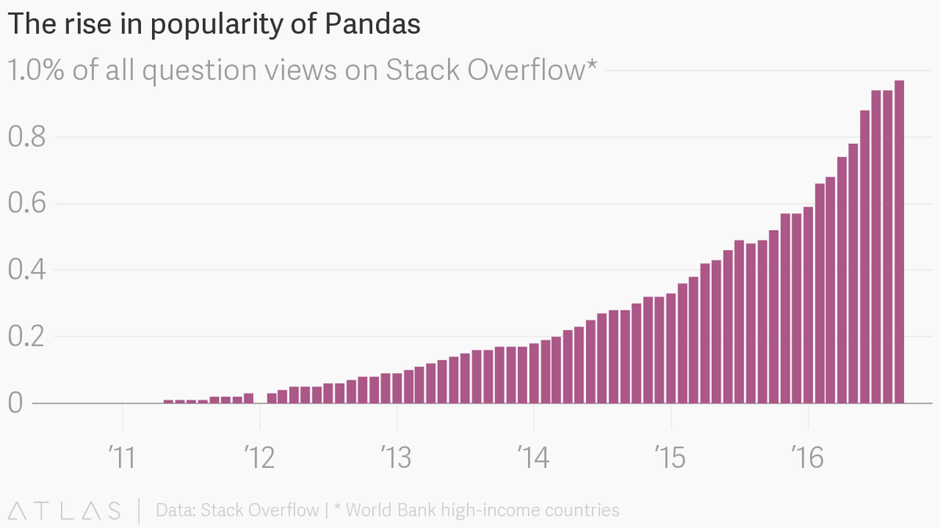

HOW DOES PANDAS FIT INTO THE DATA SCIENCE TOOLKIT?
Not only is the pandas library a central component of the data science toolkit but it is used in conjunction with other libraries in that collection.
Pandas is built on top of the NumPy package, meaning a lot of the structure of NumPy is used or replicated in Pandas. Data in pandas is often used to feed statistical analysis in SciPy, plotting functions from Matplotlib, and machine learning algorithms in Scikit-learn.
Jupyter Notebooks offer a good environment for using pandas to do data exploration and modeling, but pandas can also be used in text editors just as easily.
Jupyter Notebooks give us the ability to execute code in a particular cell as opposed to running the entire file. This saves a lot of time when working with large datasets and complex transformations. Notebooks also provide an easy way to visualize pandas’ DataFrames and plots.
WHEN SHOULD YOU START USING PANDAS?
If you do not have any experience coding in Python, then you should stay away from learning pandas until you do. You don’t have to be at the level of the software engineer, but you should be adept at the basics, such as lists, tuples, dictionaries, functions, and iterations.

INSTALL AND IMPORT
Pandas is an easy package to install. Open up your terminal program (for Mac users) or command line (for PC users) and install it using either of the following commands:
conda install pandas
OR
pip install pandas
Alternatively, if you're currently viewing this article in a Jupyter notebook you can run this cell:
!pip install pandas
The ! at the beginning runs cells as if they were in a terminal.
To import pandas we usually import it with a shorter name since it's used so much:
import pandas as pd
Now to the basic components of pandas.

CORE COMPONENTS OF PANDAS: SERIES AND DATAFRAMES
The primary two components of pandas are the Series and DataFrame.
A Series is essentially a column, and a DataFrame is a multi-dimensional table made up of a collection of Series.
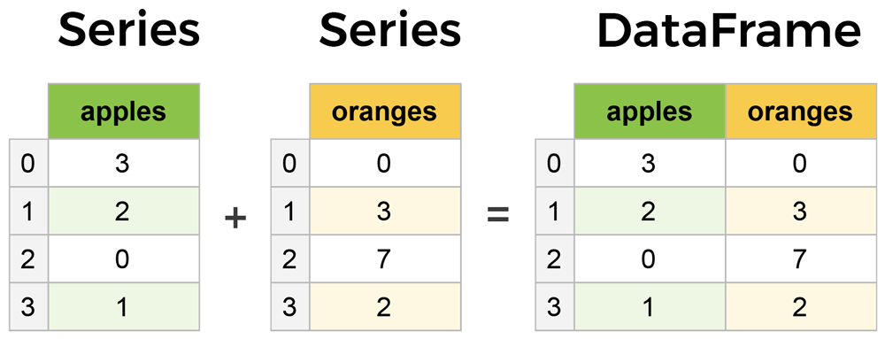
DataFrames and Series are quite similar in that many operations that you can do with one you can do with the other, such as filling in null values and calculating the mean.
You'll see how these components work when we start working with data below.

CREATING DATAFRAMES FROM SCRATCH
Creating DataFrames right in Python is good to know and quite useful when testing new methods and functions you find in the pandas docs.
There are many ways to create a DataFrame from scratch, but a great option is to just use a simple dict.
Let's say we have a fruit stand that sells apples and oranges. We want to have a column for each fruit and a row for each customer purchase. To organize this as a dictionary for pandas we could do something like:
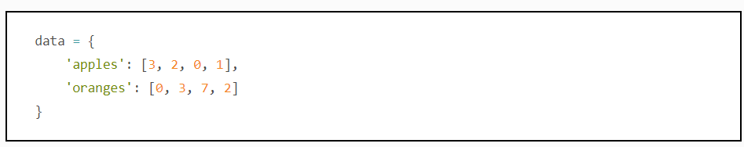
And then pass it to the pandas DataFrame constructor:
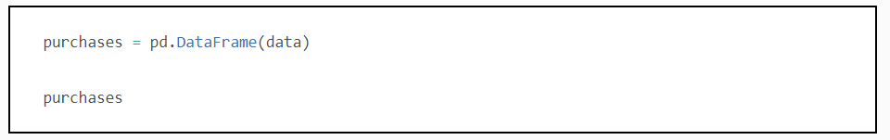
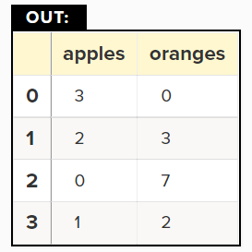
How did that work?
Each (key, value) item in data corresponds to a column in the resulting DataFrame.
The Index of this DataFrame was given to us on creation as the numbers 0-3, but we could also create our own when we initialize the DataFrame.
Let's have customer names as our index:
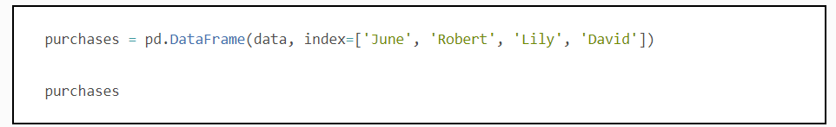
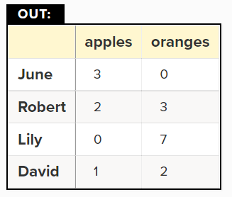
So now we could locate a customer's order by using their name:
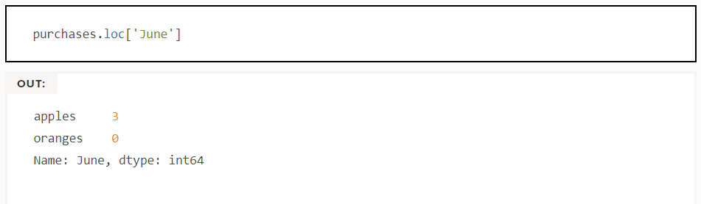
There's more on locating and extracting data from the DataFrame later, but now you should be able to create a DataFrame with any random data to learn on.
Let's move on to some quick methods for creating DataFrames from various other sources.

HOW TO READ IN DATA
It’s quite simple to load data from various file formats into a DataFrame. In the following examples we'll keep using our apples and oranges data, but this time it's coming from various files.

READING DATA FROM CSVS
With CSV files all you need is a single line to load in the data:
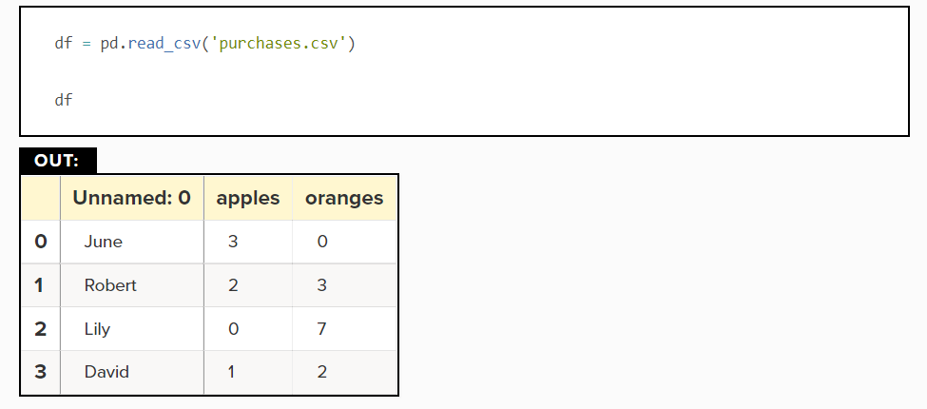
CSVs don't have indexes like our DataFrames, so all we need to do is just designate the index_col when reading:
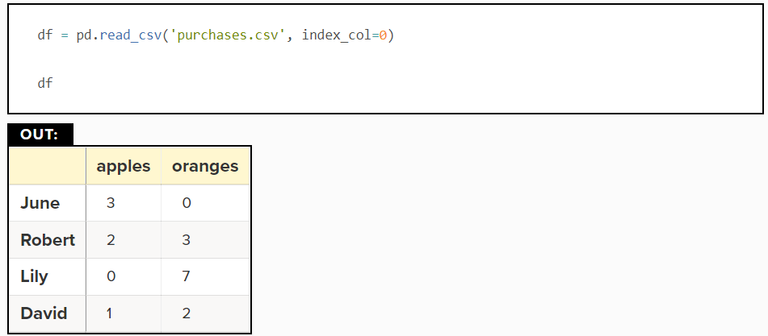
Here we're setting the index to be column zero.
You'll find that most CSVs won't ever have an index column and so usually you don't have to worry about this step.

