Implementation Report
Author: Nguyễn Đình Mạnh
ID: 23127088

Executive Summary
This report details the implementation of a arXiv paper scraping system designed to harvest metadata, LaTeX source files, and reference information from arXiv papers. The system successfully processed papers from December 2023 to January 2024 (arXiv IDs 2312.15844 onwards and 2401.00000 to 2401.03095).

Demo Video:
https://youtu.be/ZAvPgUU_F_A
1. System Architecture
1.1 Overview
The scraping system is built using a modular architecture with five core components:
- Source Identifier (source_identifier.py) - Harvests paper metadata from arXiv
- Source Downloader (source_downloader.py) - Downloads and extracts LaTeX sources
- Reference Extractor (reference_extractor.py) - Retrieves reference information
- Paper Organizer (paper_organizer.py) - Manages file organization
- Statistics Tracker (statistics_tracker.py) - Monitors performance metrics
1.2 System Flow
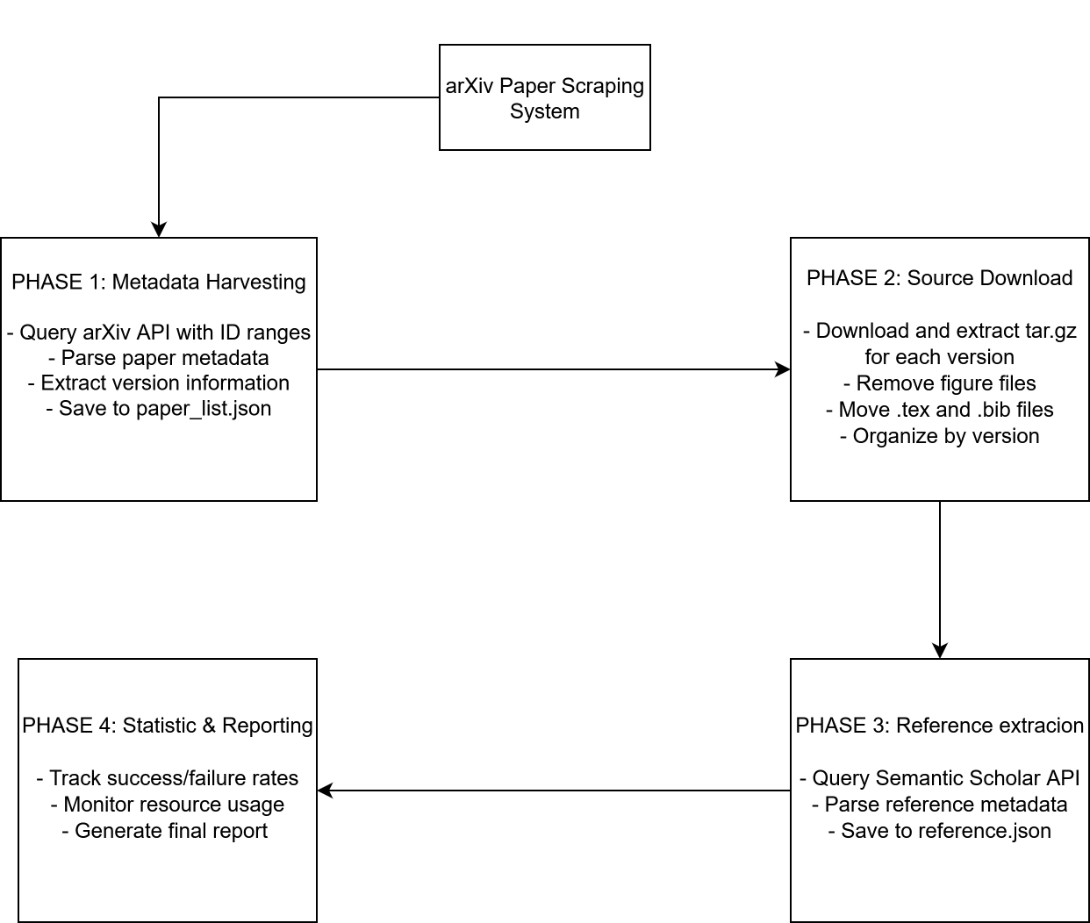

2. Implementation Details
2.1 Tools and Libraries
Core Dependencies
Library | Version | Purpose
arxiv | 2.0.0+ | Official arXiv API client for metadata retrieval
requests | 2.28.0+ | HTTP library for API calls and downloads
psutil | 5.9.0+ | System resource monitoring (RAM, disk usage)
Python | 3.8+ | Programming language runtime
Standard Library Components
- pathlib - File system path operations
- json - Data serialization and storage
- tarfile - Extraction of LaTeX source archives
- logging - Comprehensive logging system
- threading - Background memory monitoring
- time - Rate limiting and timing measurements
- concurrent.futures - Parallel paper processing
2.2 API Integration
2.2.1 arXiv API
Endpoint: http://export.arxiv.org/api/query
Implementation Strategy:
client = arxiv.Client(
page_size=100, # Maximum papers per request
delay_seconds=3.0, # Rate limiting compliance
num_retries=5 # Automatic retry on failure
)
Features Utilized:
- Batch querying (up to 100 papers per request)
- Version information extraction from entry_id
- Metadata fields: title, authors, abstract, categories, dates
- Built-in rate limiting and retry logic

Rate Limits:
- 3-second delay between requests (arXiv requirement)
- Maximum 100 results per query
- Automatic exponential backoff on errors

2.2.2 Semantic Scholar API
Endpoint: https://api.semanticscholar.org/graph/v1
Implementation:
url = f"{API_BASE}/paper/arXiv:{arxiv_id}"
headers = {'x-api-key': SEMANTIC_KEY_API}
params = {
'fields': 'references,references.title,references.authors,
references.year,references.paperId,references.externalIds'
}
Features:
- Authenticated API access with increased rate limits
- Comprehensive reference metadata

Rate Limits:
- 1-second delay between requests (with API key)
2.3 Output Organization
Directory Structure
data/
├── papers/
│ ├── 2312-15844/ # One folder per paper
│ │ ├── metadata.json # Paper metadata
│ │ ├── references.json # Reference information
│ │ ├──*.bib # BibTeX format (if available)
│ │ └── tex/ # LaTeX source files
│ │ ├── v1/ # Version 1
│ │ │ ├──*.tex
│ │ │ └── ...
│ │ └── v2/ # Version 2
│ │ ├──*.tex
│ │ └── ...
│ └── 2312-15845/
│ └── ...
├── temp/ # Temporary downloads (cleaned up)
├── statistics/
│ └── checkpoint_latest.json # Incremental statistics
└── paper_list.json # Complete paper list

3. Performance Analysis
 | 500 Papers | 5000 Papers
Time Processing | Start Time: 2025-11-15 11:11:01.858558 | Start Time: 2025-11-14 16:11:48.672444
Time Processing | End Time: 2025-11-15 11:37:36.989413 | End Time: 2025-11-14 19:17:14.890663
Time Processing | Total Duration: 0:26:35 | Total Duration: 3:05:26
Time Processing | Average Time per Paper: 4.03s | Average Time per Paper: 5.03s
Time Processing | Fastest Paper: 1.83s | Fastest Paper: 1.53s
Time Processing | Slowest Paper: 5.23 s | Slowest Paper: 82.23 s
File sizes | Total raw size: 3.04GB | Total raw size: 30.95GB
File sizes | Total extracted size (after remove figures): 427.10MB | Total extracted size (after remove figures): 2.14GB
File sizes | Average Size Before Figure Removal: 4.13 MB | Average Size Before Figure Removal: 3.90 MB
File sizes | Average Size After Figure Removal: 518.19 KB | Average Size After Figure Removal: 459.41 KB
File sizes | Figures Removed: 16478 | Figures Removed: 125606
Memory Usage | Initial RAM: 35.85MB | Initial RAM: 35.78 MB
Memory Usage | Peak RAM: 317.88 MB | Peak RAM: 669.39 MB
Memory Usage | Average RAM: 292.41 MB | Average RAM: 500.36 MB
Memory Usage | Initial Disk Usage: 0.00 GB | Initial Disk Usage: 0.00 GB
Memory Usage | Final Disk Usage: 0.37 GB | Final Disk Usage: 3.37 GB
Memory Usage | Disk Space Used: 0.37 GB | Disk Space Used: 3.37 GB
Reference Statistics | Papers with References: 466 | Papers with References: 4653
Reference Statistics | Papers without References: 30 | Papers without References: 347
Reference Statistics | Total References: 20253 | Total References: 204039
Reference Statistics | Average References per Paper: 43.46 | Average References per Paper: 43.85
Reference Statistics | Reference Success Rate: 93.95% | Reference Success Rate: 93.06%

