**Principle of Database Management:**

**Project’s Final Report**

**Topic: Bookstore**

**ACADEMIC YEAR: 2018-2019, 2nd SEMESTER**

**Group members:**

Lê Vương Duy ITITIU17096

Hồ Viết Trung ITITIU17098

Vương Minh Tùng ITITIU17105

**Table of Content**

1. **Introduction**
2. **Background of the project/research**
3. **Description of work**
4. **Program’s manual**

This document presents a project about a Bookstore database application.

In this project we have built the bookstore as a java application.

This document describes the whole project by first giving the background of the project, then the design of the Database by an ER diagram and after that we give a description of our work.

Our work is dived into two separated issues: first the designs of the graphical user interfaces (GUI) and second the java coding. After that we will show the results of our project.

There is also a manual available in this document, describing how to work with the application. In the end we will give our conclusions and a reflection on the whole project, especially working in a team.

1. **Introduction**Throughout the semester, we have worked on a project following the subject’s lab courses content. The goal of this project is to gain additional knowledge about databases. We did that by learning to design and implement a real life database application, the bookstore. Because the GUI on top of the database and the connection to the database had to be programmed in Java, it was also important to improve our programming skills in Java. Besides all the technical work we have also learned to work in a team and learned to divide tasks among or team members.
2. **Background of the Project/Research**Generally, a bookstore application is a database system which has the capabilities of storing and retrieving information about books, customers, and orders. In this project, we are considering to develop a sample centralized relational Bookstore application database for the clerks and managers at a book store.
3. **Description of Work**

Our work method followed the proposed project steps quite closely. The division of the time over the five main project steps, however, didn’t come close to our expectation. More than three quarters of the total time spent on the project went into completing to some extent Step 5, which consists of the design of our final user interface client.

* 1. ER Diagram

Our final product did not come out as planned in the midterm report. However, the idea is still the same.

In this diagram, we decided to have five objects, each with their own attributes. Their relationships are very straightforward. Customers has a one-to-many relationship with Orders, for the reason that one and the same order can’t be placed by different customers, but one customer is allowed to place multiple orders. Since all orders are made by customer, Orders has a total participation relationship with Account, instead of Customers as intended in the midterm report. Orders has a one-to-one relationship with Books since each order can only contain one book, for the sake of simplicity. Furthermore, *Books* has a many-to-one relationship with *Authors*, for the simple reason that one author can write multiple books, but to simplify the problem, multiple authors can’t write the same book. And for that reason, Books should have total participation relationship with *Author*. To be able to make orders, Customers needs to create their own account. That means, each customer should have their own account, thus Customers and Account should have a one-to-one relationship. But not all Customers will make an order, so the minimum participation of Account should be 0, and Account will have a total participation relationship with Customers.

Figure 1 show our final ERD.

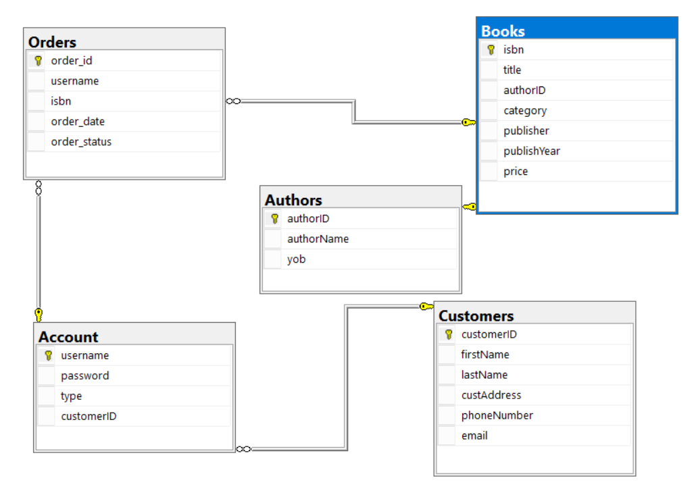

**Figure 1.** Relational Model.

* 1. **Indepth look on classes**

This project consists of a total 12 java classes files.

* **Login.java:**

This is the first thing user sees when opening the program.

User must input the correct username and password to gain access to Main Menu.

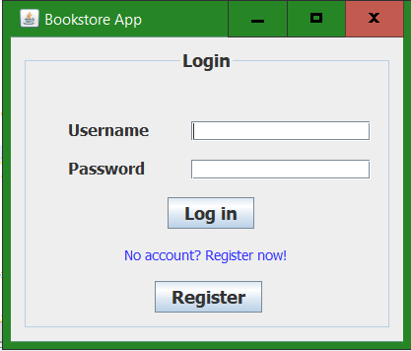

**Figure 2.** Login screen

If users have not have an account yet, they can register one for themselves.

* **CreateAccounts.java:**

The user will input their information as shown in Figure 3 to gain the access to Main Menu

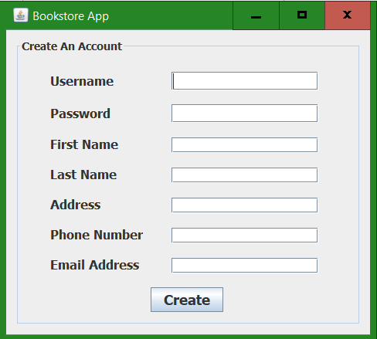

**Figure 3.** Register Menu

* **GUI.java:**

After logging into an existing account, user will come to the Main Menu. In here, user can choose to do the searching on the occurring books in the bookstore; or looking at existing Authors; or making Orders for books; or export a report on today’s sale; or making a sale off for books. The yellow-marked areas in figure 4, 5, 6 are the areas for the Admins only, Regular users cannot gain access. However, that feature has not been complete due to malfunction in JFrame. For example, In figure 6, Regular user can only see their own committed orders, not everyone’s orders.

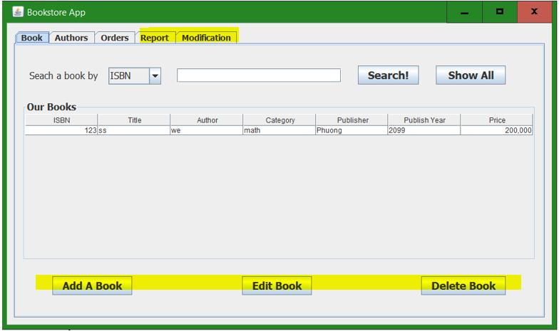

**Figure 4.** Main Menu’s Book

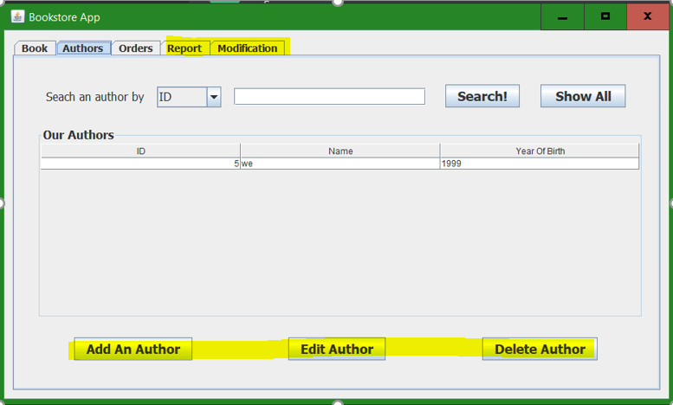

**Figure 5.** Main Menu’s Authors

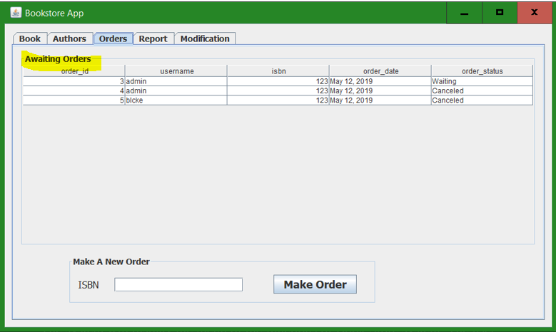

**Figure 6.** Main menu’s Orders

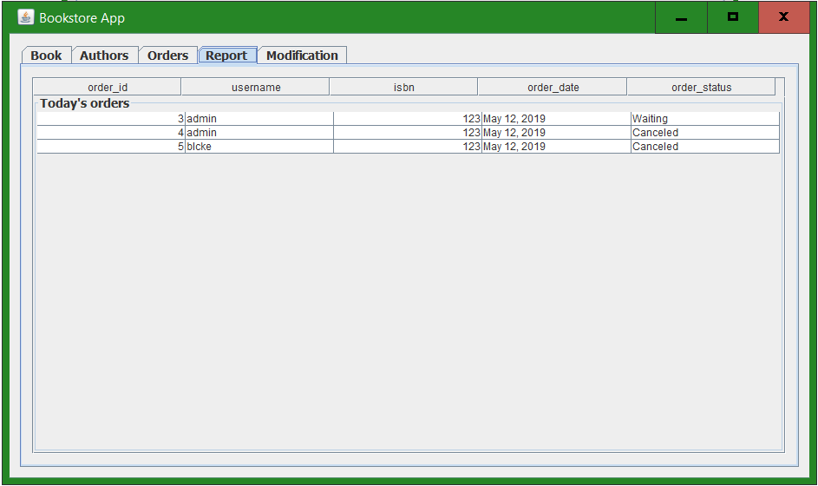

**Figure 7.** Main menu’s Report

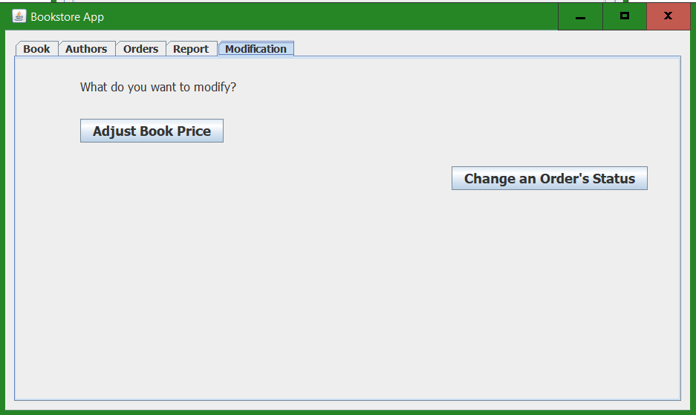

**Figure 8.** Main menu’s sale off and change order’s status

The remaning 10 java classes are made to serve the buttons in the figures from 4 to 8.

1. **Program’s Manual**

* Step 1: Open project named ‘Query’ by a java IDE.
* Step 2: Open ‘*Source Packages’ > ‘query’* located on the ‘Project’ toolbar on the left side of the screen.
* Step 3: Run the file named ‘GUI.java’.
* Step 4: Your screen should pop up a window like in Figure 2. Create an account or log in to your existing account.
* Step 5: Make your desired move!
* Step 6: After finish, click the X button to close the program. Your account will automatically be logged out.

**CONGRATS! You’ve reached the end of this manual. Thanks for reading.**

**Here are some picture of making changes to an order status.**

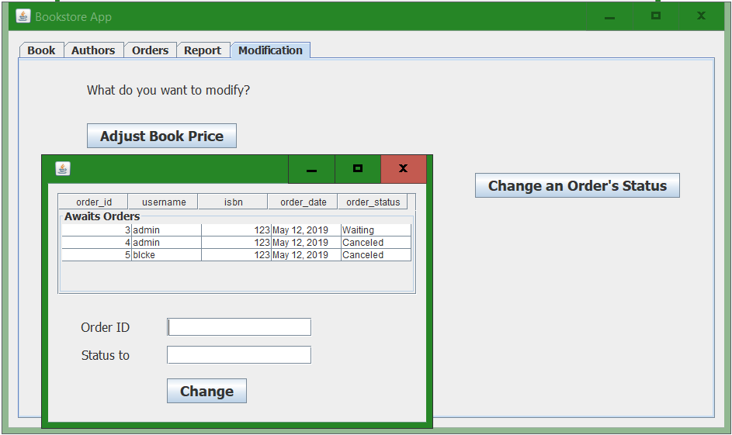

**Figure 9.** Modify order’s status

After making your desired changes, press ‘Change’, a dialog will pop up like in Figure 10, that is when information is changed. We know, it should have been ‘Changes made’, not a message like in figure.

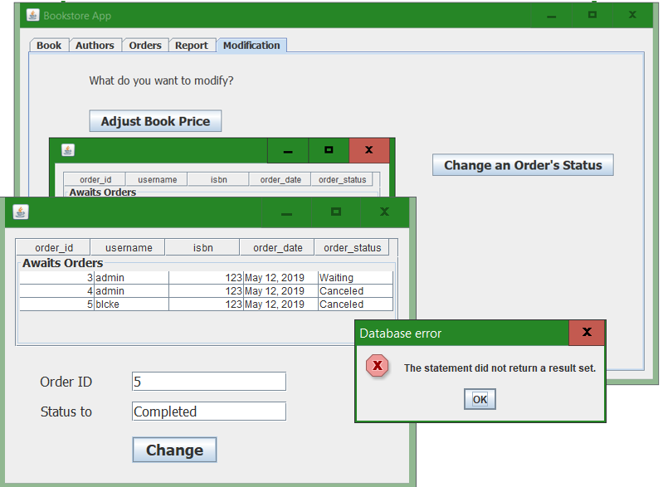

**Figure 10.** Changes were made to order number 5’s status.

**Work distribution:**

* **GUI, Main menu’s Book, Author, Order and Register’s algorithm:** Lê Vương Duy
* **Report, Modification’s algorithm:** Hồ Viết Trung
* **Login, write report:** Vương Minh Tùng
* **Github:** <https://github.com/doanxiemaine/Bookstore>