**Sinhgad Technical Education Society’s**



**SINHGAD COLLEGE OF ENGINEERING, PUNE-41**

**Electronics & Telecommunication Engineering Department**

**Second Year Electronics and Telecommunication**

PROJECT BASED LEARNING (PBL) WORK BOOK

**ACADEMIC YEAR: 2023 / 2024 Semester: IV**

**Division: B Batch: B1 Group: 2**

**Project title – Ultrasonic Distance Measurer Area of study – Digital Electronics**



**SINHGAD COLLEGE of ENGINEERING, PUNE-41**

Sr.No. 44/1, Vadgaon (Bk), Off Sinhgad Road, Pune – 411 041.

Department of E&TC Engineering

Certificate

This is to certify that, following students, ALFIYA BEG - 204B006

SONAL CHAUDHARI - 204B007 PRATIK CHAVAN - 204B008 PRANAV DAITKAR - 204B009 OM DANGRE - 204B010

has completed all the Term Work & Practical Work in the subject **Project BasedLearning (PBL)** satisfactorily in the department of E&TC Engineering asprescribed by Savitribai PhulePune University, in the academic year 2023- 2024

|  |  |  |
| --- | --- | --- |
| Prof.G.A.Thakur | Prof.S.S.Salve | Dr.M.B.Mali |
| Faculty-in-charge  Date:18/04/2024 | Co-Ordinator | HoD |

**Rules & Regulations:**



1. Handle the workbook very carefully.
2. All students must enter the correct information in the work book.
3. All entries in the PBL work book must be verified by the concerned Supervisor/Mentor.
4. Activities planned should be completed as per the instructions and schedule givenby Supervisor/Mentor.
5. Assessment of TW for Project Based Learning (PBL) is out of

25 Marks which are based on attendance, regularity of completion of activities on given time and student’s involvement.

1. Assessment of PR for PBL is out of 50 Marks which are based on idea inception, outcomes of PBL, problem solving skills, solution provided, final product, documentation, demonstration, contest participation, and awareness.
2. Students need to submit final report of 5 to 10 pages in the prescribed format givenat the end of this workbook.

**Course Objectives:**



* To emphasize project-based learning activities that are long-term, interdisciplinary andstudent-centric.
* To inculcate independent and group learning by solving real world problem with thehelp of available resources.
* To be able to develop application based on the fundamentals of electronics and communication engineering by possibly the integration of previously acquired knowledge.
* To get practical experience in all steps in the life cycle of the development of electronic systems: specification, design, implementation, and testing.
* To be able to select and utilize appropriate hardware and software tools to design andanalyze the proposed system.
* To provide every student the opportunity to get involved either individually or as a groupso as to develop team skills and learn professionalism.

**Course Outcomes:**



CO1: Identify the real-world problem (possibly of interdisciplinary nature) through arigorous literature survey and formulate / set relevant aim and objectives.

CO2: Contribute to society through proposed solution by strictly following professionalethics and safety measures.

CO3: Propose a suitable solution based on the fundamentals of electronics andcommunication engineering by possibly the integration of previously acquired knowledge. CO4: Analyze the results and arrive at valid conclusion.

CO5: Use of technology in proposed work and demonstrate learning in oral and writtenform.

CO6: Develop ability to work as an individual and as a team member.

**Group Information:**



**Division: B Batch: B2 Group: 6**

|  |  |  |  |
| --- | --- | --- | --- |
| Roll No. | PRN No. | Name of Student | Mobile No. |
| 204B006 | 72230790L | Alfiya beg | 8623994606 |
| 204B007 | 72230860E | Sonal Chaudhari | 9322279397 |
| 204B008 | 72230865F | Pratik Chavan | 9021034605 |
| 204B009 | 72230890G | Pranav Daitkar | 9022995039 |
| 204B010 | 72230895H | Om Dangre | 7972019587 |

Name of Faculty/Mentor : Prof.G.A.Thakur E-mail: [gathakur.scoe@sinhgad.edu](mailto:gathakur.scoe@sinhgad.edu) Mobile No.: 9404058073

**Literature survey :**



The ultrasonic distance measurement project using Raspberry Pi involves interfacing an ultrasonic sensor sensor with the Raspberry Pi to measure the distance of an abject.The system employs a popular ultrasonic sensor[HC-SR04] and utilizes python programming for data processing.The ultrasonic sensor emits sound waves and measure the time it takes for the waves to reflect back,enabling the calculation of the distance of the object.

The hardware set up involves connecting the ultrasonic sensor to the Raspberry to the Raspberry Pi's GPIO pins and the software set up includesenabling the GPIO interface and installing necessary python libraries.A python script continuously monitors the sensor reading,calculates the distance based on the timr of strike of the ultrasonic waves and displays the result in centimeters.

The project provides practical and cost-effective solution for non-contact distance measurement, with potencial applications in robotics and in various diy projects,etc.

**Weekly Planning Sheet**



|  |  |  |  |  |
| --- | --- | --- | --- | --- |
| Week No. | Activity Planned | Activities Completed | Signature of Students | Signature of  Faculty/Mentor |
| 1 | Look for options on which projects could be made and how effective it could be | After doing lot of research, we choose our topic i.e.Ultrasonic Distance measurement tool. |  |  |
| 2 | Research on selected topic | Read lots of research papers on our topic and finally selected two journal for our projects. |  |  |
| 3 | Categorized our topic into sub parts and assigned tasks to group member | Tasks were properly completed by our group. |  |  |
| 4 | How to approach our project? Whether it should be software based or hardware based | Finally, we decided to do it on software.  Software to be used is Proteus |  |  |

**Weekly Planning Sheet**



|  |  |  |  |  |
| --- | --- | --- | --- | --- |
| Week No. | Activity Planned | Activities Completed | Signature of Students | Signature of  Faculty/Mentor |
| 5 | Research on selected topics and required electronic components for design the system | Read lots of datasheets, research articles for different electronic components and finally selected electronic components for our project |  |  |
| 6 | Learn about raspberry pi pico and esp-32 software | Initialization, program development, hexcode generation and program execution all the terminologies studied |  |  |
| 7 | Prepare the schematic diagram, schematic circuitry on proteus software | By using the proteus software analysis of schematic diagram, schematic circuitry completed |  |  |
| 8 | Interfacing of all components to perform on electronic system (hardware based) | With the help of connecting wires, jumper wires connected all peripherals to microprocessor as per schematic diagram |  |  |

**Weekly Planning Sheet**



|  |  |  |  |  |
| --- | --- | --- | --- | --- |
| Week No. | Activity Planned | Activities Completed | Signature of Students | Signature of  Faculty/Mentor |
| 9 | Programming our board | All group member collectively took part in programming and it was completed properly |  |  |
| 10 | Preparation of report | We should design the report which consist of bill of material, datasheets, information of components which may be arranged in the proper PBL report format, by that method we prepared our report |  |  |
|  |  |  |  |  |
|  |  |  |  |  |

## SMOKE DETECTOR USING ARDUINO

*A Report submitted in partial fulfilment of the requirements to complete Term Work& Practical work of Project Based Learning (PBL) in the department of*

## E&TC ENGINEERING

*As prescribed by*

## SAVITRIBAI PHULE PUNE UNIVERSITY

*By*

**BEG AlFIYA MAULANA 72230790L**

**CHAUDHARI SONAL CHANDRAKANT 72230860E**

**CHAVHAN PRATIK BALASAHEB 72230865F**

**DAITKAR PRANAV ANANT 72230890G**

**DANGE OM ANIL 72230895H**

*Under the Guidance of*

**Prof. G.A.THAKUR**



**Second Year Engineering Department**

## Sinhgad College of Engineering

*44/1, Vadgaon (BK), Off Sinhgad Road,Pune-411041*

**CONTENTS**

**CERTIFICATE AKNOWLEDGEMENT ABSTRACT**

**LIST OF FIGURES**

**LIST OF PHOTOGRAPHS**

CHAPTER TITLE PAGE NO.

1. **INTRODUCTION** 2
   1. BACKGROUND 3
   2. HARDWARE REQUIRED 4
   3. SOFTWARE REQUIRED 9
   4. SPECIFICATIONS AND FEATURES 10
2. **LITERATURE SURVEY** 12
3. **DESIGN AND DEVELOPMENT** 13
   1. BLOCK DIAGRAM AND BRIEF

EXPLANATION 14

* 1. ALGORITHM 15
  2. FLOWCHART 17

1. **RESULTS** 18
2. **CONCLUSION** 20
   1. ADVANTAGES 21
   2. APPLICATIONS 22
   3. CONCLUSION 23
   4. FUTURE SCOPE 24

**APPENDIX** 25

**APPENDIX A** 26

**APPENDIX B- DATASHEET** 27

**REFERENCE**

**AKNOWLEDGEMENT**

We are feeling very humble in expressing my gratitude. It will be unfair to bind the precious help and support which we got from many people in few words. But words are the only media of expressing one’s feelings and my feeling of gratitude is absolutely beyond thesewords. It would be my pride to take this opportunity to say the thanks.

Firstly, we would thank our beloved guide **Prof. G. A. Thakur** for his valuable guidance, patience and support; He was always there to force us a bit forward to get the work done properly and on time. He has always given us freedom to do mini project work and the chance to work under his supervision.

We would like to express our sincere thanks to **Dr. S. S. Salve**, Project based learning (PBL), Department of E&TC, for her constant encouragement in the fulfillment of the PBL work. Wewould also like to express our sincere thanks to **Dr. M. B. Mali, Head,** Department of E&TCfor his co-operation and useful suggestions. We would also like to thank **Dr. S. D. Lokhande,Principal, Sinhgad College of Engineering.** He always remains a source of inspiration for usto work hard and dedicatedly.

It is the love and blessings of our families and friends which drove us to complete thisproject work.

Thank you all!

**ABSTRACT**

This project aims to design and implement an ultrasonic distance measurement tool utilizing an ESP32 microcontroller, an LCD display, and an ultrasonic sensor. The tool provides a portable, efficient, and user-friendly solution for measuring distances accurately in real-time, catering to diverse applications in robotics, automation, and IoT.The core components of the system include the ESP32 microcontroller, an ultrasonic sensor (such as the widely used HC- SR04), and an LCD display. The ESP32 orchestrates the operations, coordinating the ultrasonic sensor to emit ultrasonic pulses and receiving their reflections from nearby objects. Through precise time measurements, the ESP32 calculates the distance between the sensor and the object.The integration of the LCD display enhances user interaction by presenting real- time distance measurements in a clear and intuitive manner. Users can conveniently monitor distance changes displayed on the LCD screen, facilitating informed decision-making and operational adjustments.

**LIST OF FIGURES**

|  |  |
| --- | --- |
| FIGURES | PAGE NUMBER |
| 3.1 Block diagram of smoke detector | 14 |
| 3.2 Flowchart | 17 |
| 4.1 Result | 19 |

**LIST OF PHOTOGRAPHS**

|  |  |
| --- | --- |
| NAME OF PHOTOGRAPH | PAGE NUMBER |
| 1.1 | 4 |
| 1.2 MQ2 sensor | 5 |
| 1.3 Buzzer | 7 |
| 1.4 Jumper wires | 8 |
| 1.5 Arduino ide | 9 |

# CHAPTER 1 INTRODUTION

1

**INTRODUCTION**

The Aim of this project is to achieve a Ultrasonic Distance measurement tool based on ESP32 Board/Raspberry pi pico that measures a distance between ultrasonic sensor and any object which is is infront of it.

During the transmission microcontroller encodes the signal and transmits through the Ultrasonic transmitter. The Ultrasonic transmitter converts the electrical signal to pulse. During this time the time set is zero. Ultrasonic transducer emits a burst of 12 pulses at a frequency, which is roughly identical with resonance frequency of the two transducers. After the burst has been emitted the unit is switched to reception. The sensitivity of the receiver is a function of time. When these pulses hits any object they are reflected back and are received by ultrasonic receiver. The number of clock pulses counted between onsets of the emission the burst and the sensing of echo is equal to distance between two objects. The microcontroller calculates distance by using time. The time taken to detect the target is helpful for finding the distance of the objects. The measured distance or height is displayed on LCD. The senility of the receiver is a function of time. When these pulses hits any object they are reflected back and are received by ultrasonic receiver. The number of clock pulses counted between onsets of the emission the burst and the sensing of echo is equal to distance between two objects.

**BACKGROUND**

Ultrasonic Distance Meter working principle is based on ultrasonic waves. As the human ear's audible perception range is 20 Hz to 20 kHz, it is Insensitive to ultrasonic waves, and hence the ultrasound waves can be used for applications in industries/vehicles without hindering human activity. The distance can be measured using pulse echo and phase measurement method. The signal is transmitted by an ultrasonic transducer, reflected by an obstacle and received by another transducer where the signal is detected. The time delay of the transmitted and the received signal corresponds to the distance between the system and the obstacle.

A common use of ultrasound is for range finding. Sonar works similarly to radar. An ultrasonic pulse is generated in a particular direction. If there is an object in the way of this pulse, the pulse is reflected back to the sender as an echo and is detected. Measuring the difference in time between the pulse transmitted and the echo received, it is possible to determine how far away the object is. Bats use a variety of ultrasonic ranging (echolocation) to detect their prey.

The application area of the Ultrasonic Distance Meter is very wide in rescue operations, spy robot, versatile use in autonomous technology, use in mining; it has found essential use in light industry (e.g. Toy industry) agriculture, used in car parking systems and all other engineering practices

**HARDWARE REQUIRED**

Types of components required-

1. Raspberry pi pico/esp-32
2. Utrasonic sensor
3. Lcd display
4. Jumper wires
5. Esp-32

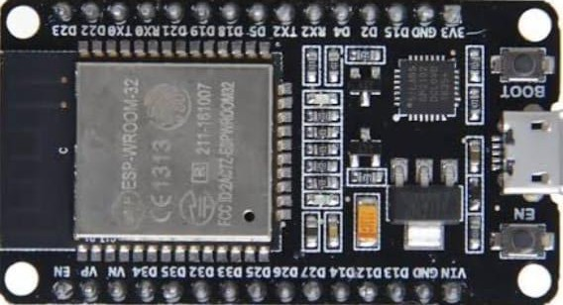

* 1. **Esp32 Board**

The ESP32 is a powerful microcontroller and Wi-Fi/Bluetooth module capable of handling various IoT applications. It features dual-core processors, low power consumption, and a rich set of peripherals for connectivity and communication.

ESP32 is the SoC (System on Chip) microcontroller which has gained massive popularity recently. Whether the popularity of ESP32 grew because of the growth of IoT or whether IoT grew because of the introduction of ESP32 is debatable.

1. Ultrasonic sensor-

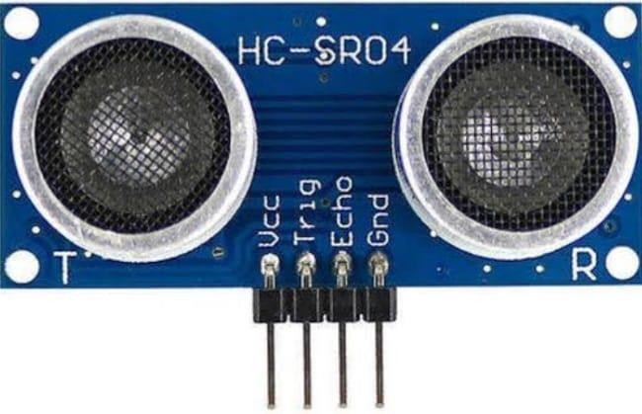

* 1. **Ultrasonic Sensor**

An ultrasonic sensor is a promiximity sensor that is used to measure the distance of a target or object. It detects the object by transmitting ultrasonic waves and converts the reflected waves into an electrical signal.These sound waves travel faster than the speed of the sound that humans can hear.

HC-SR04 stands for High-Conductance Ultrasonic Sensor consists of a transmitter and receiver.It can work well when things are between two to four centimeters away.

An HC-SR04 ultrasonic distance sensor actually consists of two ultrasonic transducers.One acts as a transmitter that converts the electrical signal into 40 KHz ultrasonic sound pulses. The other acts as a receiver and listens for the transmitted pulses.When the receiver receives these pulses, it produces an output pulse whose width is proportional to the distance of the object in front.

This sensor provides excellent non-contact range detection between 2 cm to 400 cm (~13 feet) with an accuracy of 3 mm.

Since it operates on 5 volts, it can be connected directly to an Arduino or any other 5V logic microcontroller

C) LCD display

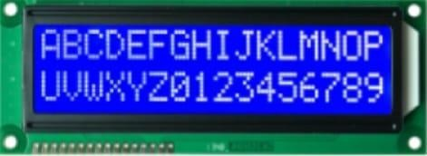

* 1. **LCD Display**

The full form of LCD is **Liquid Crystal Display**. 16×2 LCD is a basic 16 character by 2 line display Yellow/Green Backlight. Utilizes the extremely most common HD44780 parallel interface chipset.

The LCD works as per the liquid crystal colour emission principle. LCD was identified in 1888. LCD is an electronically modulated optical device which includes segments filled with liquid crystals. To display the images, LCDs used liquid crystals and polarized illumination. There is a broad bright light when current is applied to LCD TVs that reflects toward the audience.

Benefits of LCD:

The LCD’s most significant benefit is that it has low cost, energy efficiency & less low energy consumption.The LCD is smaller and thinner and is very flexible.The LCD offers excellent contrast, brightness & resolution, so the accuracy of the image is as evident as crystalLCD screen radiation is slightly lesser than the CRT monitors.With CMOS circuit boards, LCDs can be tailored so that LCD creation is quite easy.

1. Jumper wires-

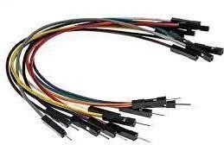

* 1. **Jumper wires**

Jumper wires are simply wires that have connector pins at each end, allowing them to be used to connect two pointsto each other without soldering. Jumper wires are typically used with breadboards and other prototyping tools in order to make it easy to change a circuit as needed. Fairly simple. In fact, it doesn’t get much more basic than jumper wires.

Though jumper wires come in a variety of colors, the colors don’t actually mean anything. This means that a red jumper wire is technically the same as a black one. But the colors can be used to your advantage in order to differentiate between types of connections, such as ground or power.

**SOFTWARE REQUIRED**

a) Arduino ide-

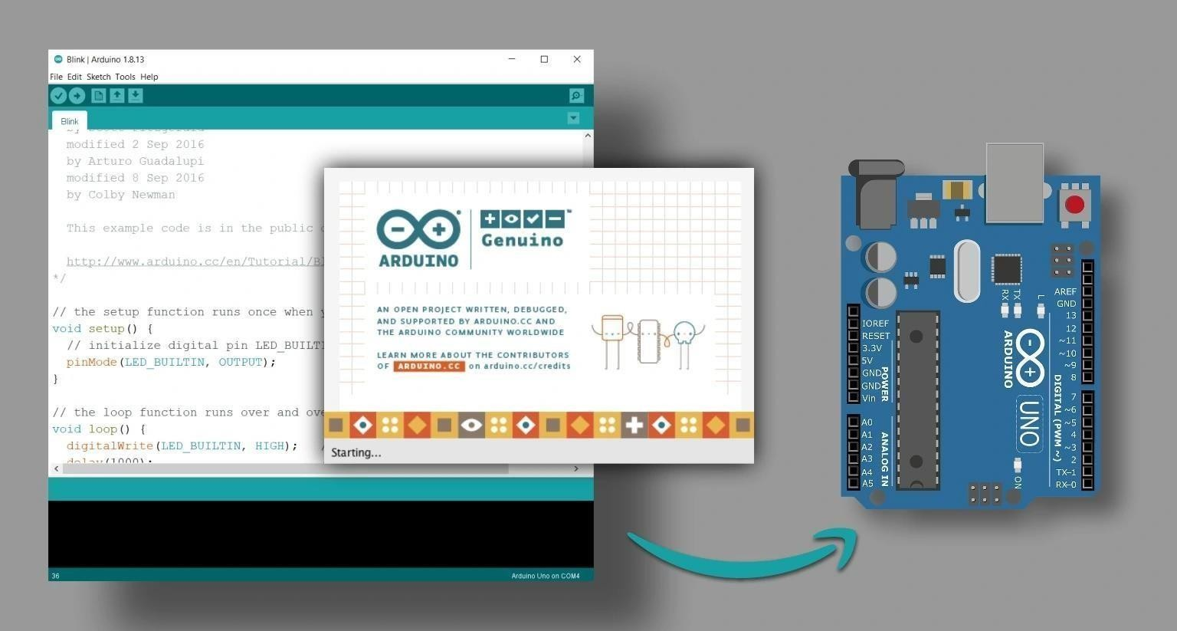

**1.1 Arduino ide**

The Arduino IDE is an open-source software, which is used to write and upload code to the Arduino boards. TheIDE application is suitable for different operating systems such as Windows, Mac OS X, and Linux. It supports the programming languages C and C++. Here, IDE stands for Integrated Development Environment.

The program or code written in the Arduino IDE is often called as sketching. We need to connect the Genuinoand Arduino board with the IDE to upload the sketch written in the Arduino IDE software. The sketch is savedwith the extension '.ino.'

**SPECIFICATIONS AND FEATURES**

Specification-

Smoke detectors are designed to sense the products of combustion. They are designed for commercial, industrialor residential applications. There are four basic types of smoke detectors:

Stand-alone devices

Detection systems or components Integrated circuits (ICs) Addressable fire protection devices

Features-

Smoke detectors have [audible alarms,](https://www.globalspec.com/learnmore/video_imaging_equipment/meters_readouts_indicators/alarms/audio_alarms) visible alarms such as [light-emitting diodes](https://www.globalspec.com/learnmore/optics_optical_components/light_sources/light_emitting_diodes) (LEDs), or both. They may alsohave an alarm output to a control unit. Smoke detectors without a built-in alarm come with alarm contacts for outputto an external annunciator in the detector base, or to a control unit. Smoke sensing ICs may have piezoelectric horn drivers or alarm output circuitry. The [National Fire Protection Association](https://www.nfpa.org/) (NFPA) establishes minimum requirements for both fire alarm systems and initiating devices such as smoke detectors. Smoke detectors and fire alarm systems that support NFPA 72 must produce an audible alarm signal that is different from all other audible signals. NFPA 72 defines performance requirements and basic features for smoke detectors and their proper spacingin commercial, residential, and industrial buildings.

# CHAPTER 2 LITERATURE SURVEY

**LITERATURE SURVEY**

The ultrasonic distance measurement project using Raspberry Pi involves interfacing an ultrasonic sensor sensor with the Raspberry Pi to measure the distance of an abject.The system employs a popular ultrasonic sensor[HC-SR04] and utilizes python programming for data processing.The ultrasonic sensor emits sound waves and measure the time it takes for the waves to reflect back,enabling the calculation of the distance of the object.

The hardware set up involves connecting the ultrasonic sensor to the Raspberry to the Raspberry Pi's GPIO pins and the software set up includesenabling the GPIO interface and installing necessary python libraries.A python script continuously monitors the sensor reading,calculates the distance based on the timr of strike of the ultrasonic waves and displays the result in centimeters.

The project provides practical and cost-effective solution for non-contact distance measurement, with potencial applications in robotics and in various DIY projects,etc

# CHAPTER 3

## DESIGN AND DEVELOPMENT

**Block diagram and brief explanation**

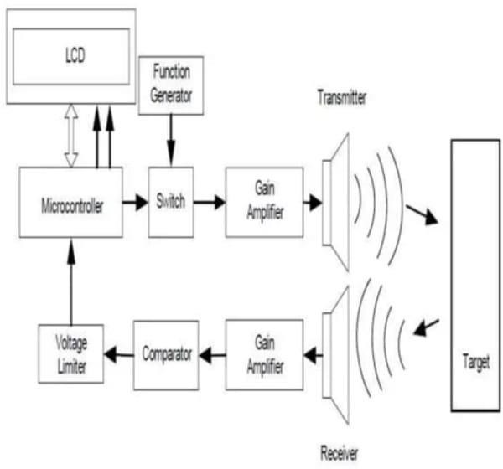

**3.1Block Diagram of Ultrasonic Distance Mesurement Tool**

During the transmission microcontroller encodes the signal and transmits through the Ultrasonic transmitter. The Ultrasonic transmitter converts the electrical signal to pulse. During this time the time set is zero. Ultrasonic transducer emits a burst of 12 pulses at a frequency, which is roughly identical with resonance frequency of the two transducers. After the burst has been emitted the unit is switched to reception. The sensitivity of the receiver is a function of time. When these pulses hits any object they are reflected back and are received by ultrasonic receiver. The number of clock pulses counted between onsets of the emission the burst and the sensing of echo is equal to distance between two objects. The microcontroller calculates distance by using time. The time taken to detect the target is helpful for finding the distance of the objects. The measured distance or height is displayed on LCD. The senility of the receiver is a function of time. When these pulses hits any object they are reflected back and are received by ultrasonic receiver. The number of clock pulses counted between onsets of the echo is equal to distance between two objects.

**ALGORITHM**

#include <LiquidCrystal_I2C.h>

LiquidCrystal_I2C lcd(0x27, 16, 2); // I2C address 0x3F, 16 column and 2 rows #define TRIG_PIN 23 // ESP32 pin GPIO23 connected to Ultrasonic Sensor's TRIG pin

#define ECHO_PIN 19 // ESP32 pin GPIO22 connected to Ultrasonic Sensor's ECHO pin float duration_us, distance_cm;

void setup() {

lcd.init(); // initialize the lcd lcd.backlight(); // open the backlight

pinMode(TRIG_PIN, OUTPUT); // config trigger pin to output mode pinMode(ECHO_PIN, INPUT); // config echo pin to input mode

}

void loop() {

// generate 10-microsecond pulse to TRIG pin digitalWrite(TRIG_PIN, HIGH); delayMicroseconds(10); digitalWrite(TRIG_PIN, LOW);

// measure duration of pulse from ECHO pin duration_us = pulseIn(ECHO_PIN, HIGH);

// calculate the distance distance_cm = 0.017 * duration_us; lcd.clear();

lcd.setCursor(0, 0); // start to print at the first row lcd.print("Distance: ");

lcd.print(distance_cm); delay(500);

}

**FLOWCHART**

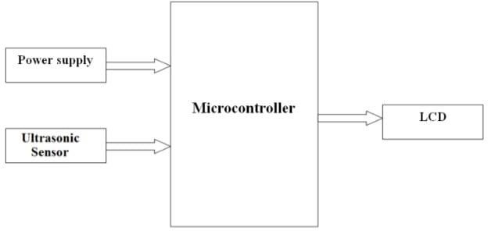

**3.1 Flowchart**

# CHAPTER 4 RESULT

**RESULTS**

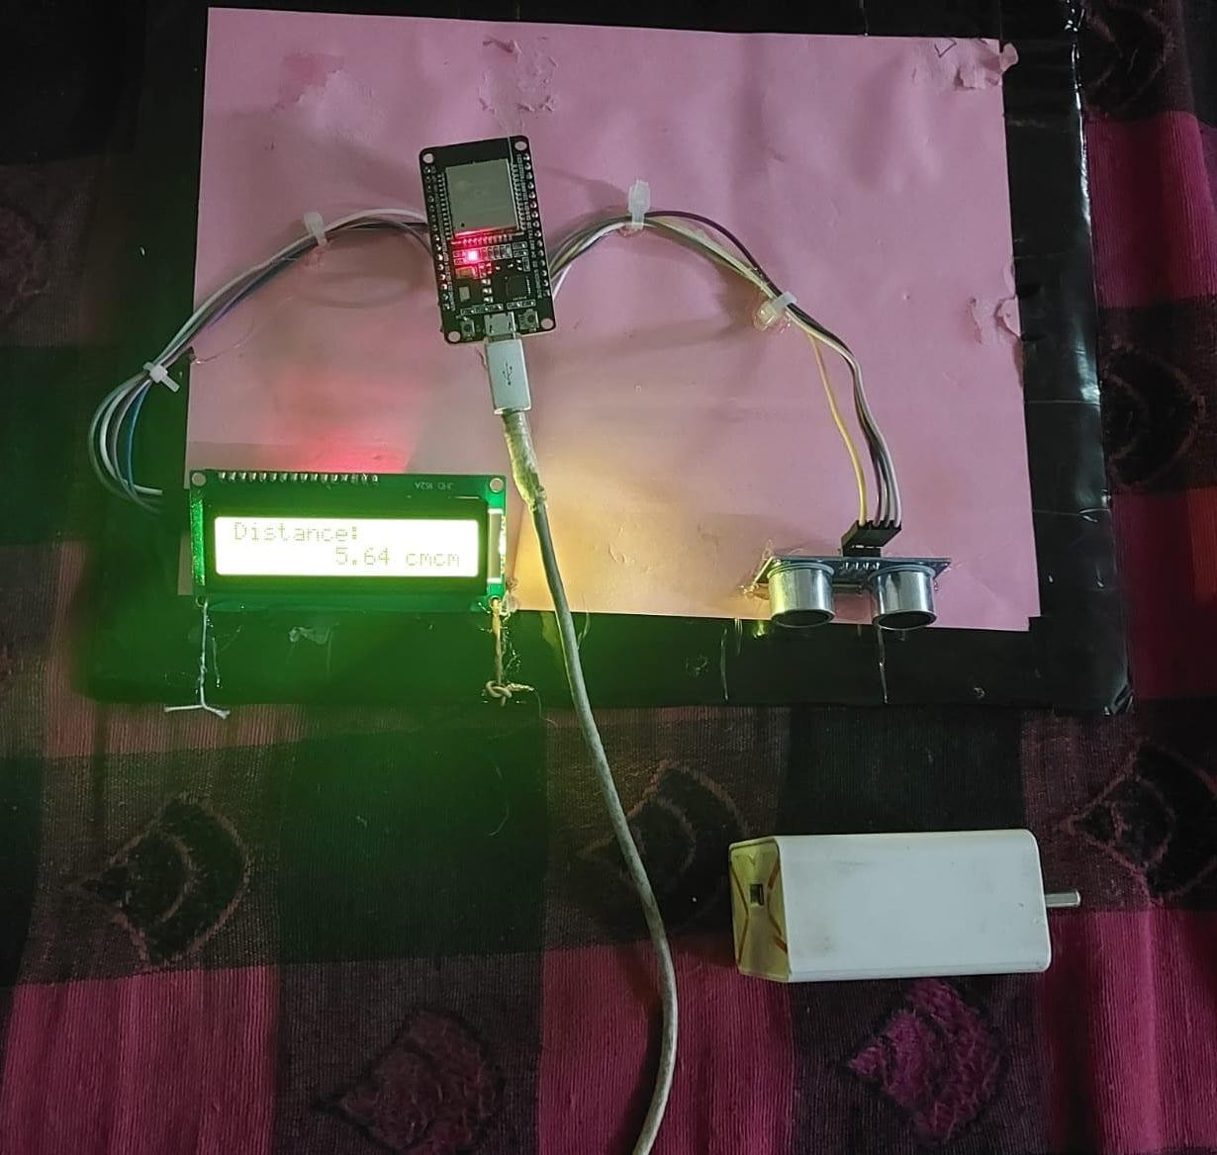

**4.1 Result**

# CHAPTER 5 CONCLUSION

**ADVANTAGES**

1. Sensing Capability for All Material Types: Ultrasonic sensors can detect a wide range of materials, making them versatile for various applications.
2. Resilience to Environmental Factors: Ultrasonic sensors remain unaffected by atmospheric conditions such as dust, rain, and snow.
3. Extended Sensing Distance: Ultrasonic sensors offer a higher sensing range compared to inductive or capacitive proximity sensors. Their detection distance can span from centimeters to several meters, and custom designs can even operate up to 20 meters
4. Precise Distance Measurements: These sensors provide impressive precision, often achieving millimeter-level accuracy in distance measurements. Their ability to detect objects without physical contact enhances precision in various applications.

**APPLICATIONS**

* 1. Parking Assistance Systems: Helping drivers park their vehicles safely by indicating the distance between the car and obstacles.
  2. Robotics: Enabling robots to navigate and avoid obstacles in their path.
  3. Industrial Automation: Monitoring the distance between machinery parts to prevent collisions and ensure safe operation.
  4. Security Systems: Detecting intruders by measuring the distance between them and a secured area.
  5. Home Automation: Implementing smart home systems to control lights, doors, and appliances based on the proximity of individuals.
  6. Healthcare: Assisting visually impaired individuals with navigation and obstacle avoidance.
  7. Water level Measurement: Monitoring water levels in tanks, reservoirs, and rivers for environmental and industrial purposes.
  8. Traffic Monitoring: Measuring vehicle speeds and monitoring traffic flow on roads and highways.

Versatility of ultrasonic distance measurement makes it applicable in various scenarios, contributing to efficiency, safety, and convenience.

**CONCLUSION**

After exploring the ultrasonic distance measurement tool using ESP32, it's clear that this technology offers a precise and efficient solution for distance measurement. With the ability to overcome the challenges of current methods, the tool is poised to significantly impact various industries, proving to be a valuable asset in the field of technology

**FUTURE SCOPE**

The future scope of ultrasonic distance measurement projects is promising, with advancements in technology driving innovation in various fields. Some potential future applications include:

1. Autonomous Vehicles: Integration of ultrasonic sensors for precise distance measurement, aiding in navigation and obstacle avoidance for self-driving cars and drones.
2. Smart Cities: Implementing ultrasonic distance measurement in urban infrastructure for efficient parking management, traffic monitoring, and pedestrian safety.
3. Healthcare: Advancing medical devices with ultrasonic sensors for non-invasive distance measurements, such as monitoring vital signs and diagnosing conditions.
4. Internet of Things (IoT): Incorporating ultrasonic sensors into IoT devices for smart home automation, asset tracking, and environmental monitoring.
5. Augmented Reality (AR) and Virtual Reality (VR): Enhancing AR/VR experiences with real-time distance measurements for more immersive applications in gaming, education, and training simulations.
6. Environmental Monitoring: Deploying ultrasonic sensors for wildlife tracking, assessing air quality, and monitoring natural disasters like landslides and avalanches.
7. Precision Agriculture: Utilizing ultrasonic distance measurement for crop monitoring, irrigation management, and drone-based farming applications.
8. Energy Efficiency: Implementing ultrasonic sensors in buildings for occupancy detection, optimizing lighting, heating, and cooling systems to reduce energy consumption.

As technology continues to evolve, ultrasonic distance measurement will play a crucial role in advancing automation, safety, and efficiency across various industries and applications

# APPENDIX

**APPENDIX A**

|  |  |
| --- | --- |
| COMPONENTS | PRICE |
| 1. ESP-32 | 750/- |
| 2. ULTRASONIC SENSOR | 200/- |
| 3. LCD DISPLAY | 50/- |
| 4. JUMPER WIRES | 50/- |

**APPENDIX B**

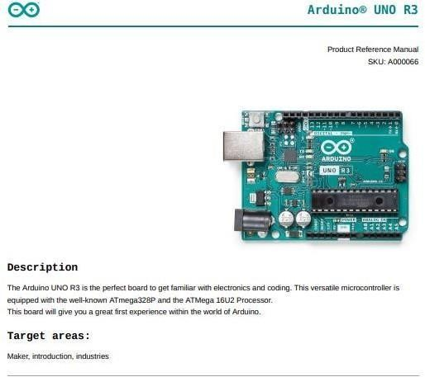

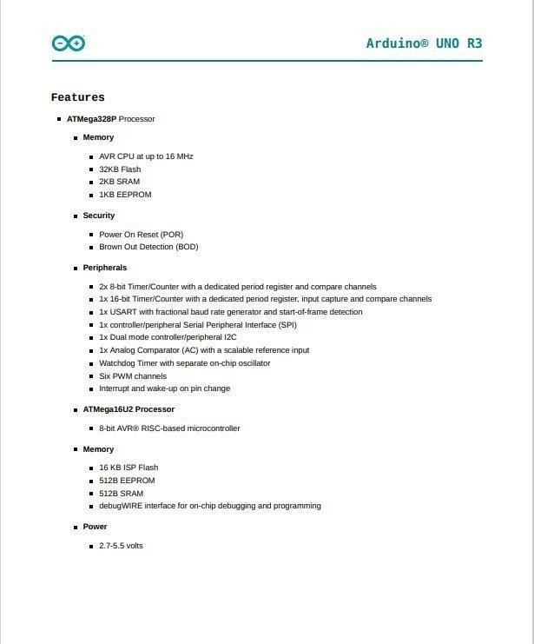

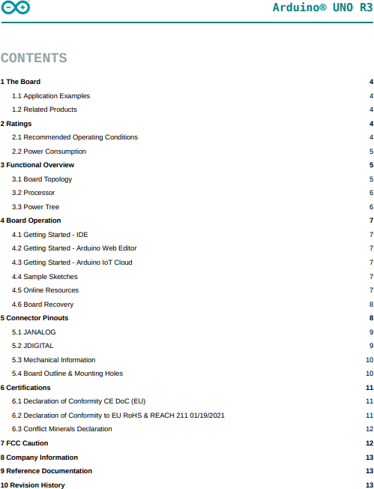

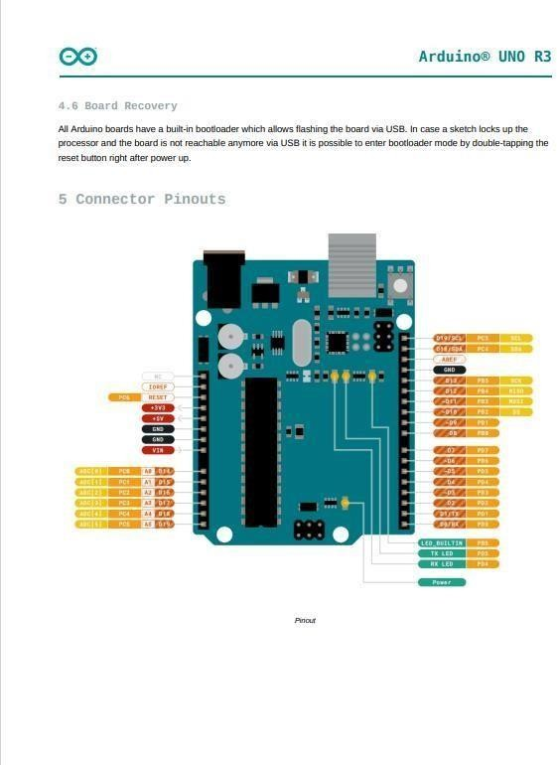

**REFERENCE**

1. The 8051 Microcontroller And Embedded Systems, Muhammad Ali Mazidi, Janice Gillis pie Mazidi
2. 8051-Basic Microcontrollers" by Jan Axelson 1994
3. RS232 Tutorial on Data Interface and cables". ARC Electronics. 2010.
4. <http://www.arcelect.com/rs232.html>
5. <http://parts.digikey.com/1/parts/678453-lcd-module-16x4-supertwist-w-led-mdls-16465->
6. ss-hv-g-led-04-g.html
7. <http://www.computer-engineering.org/ps2keyboard>
8. <http://www.engineersgarage.com/electronic-components>
9. Rusty, George (July 2, 2002). "Remembering the PROM knights of Intel. EE Times.
10. <http://www.eetimes.com/issue/fp/showArticle.jhtml?articleID=18307418>