1.Draw a simple diagram showing the main components of a food delivery app like Zomato or Swiggy (such as user, restaurant, order, delivery partner, payment) and label how they interact in the software architecture.

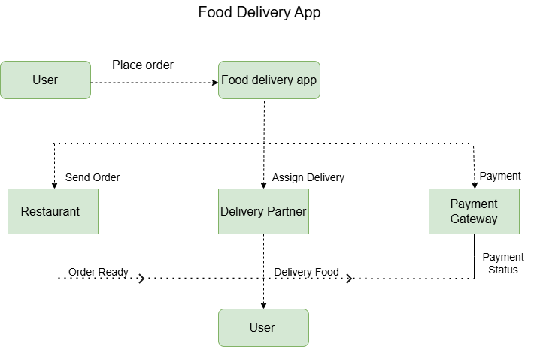

2.Pick any app you use daily (Instagram, Paytm, Flipkart, etc.) and list 5 different testing activities that must be performed before the app is released to users.<br><br><em><strong>Hint:</strong> Think about things like login, payment, notifications, speed, and security.</em>

Testing Activities Performed Before Releasing Instagram Application

Introduction :
Before releasing Instagram to users, the testing team checks different features.

No. | Testing Activity | Description | Expected Result
1. | Login Activity | Enter valid and invalid login credentials. | Successful login or error message.
2. | Notification Testing | Check like and message notifications. | Notification received correctly.
3. | Performance Testing | Scroll through the app for several minutes. | App works smoothly without lag.
4. | Security Testing | Try multiple incorrect password attempts. | Unauthorized access is prevented.
5. | Functional Testing | Upload a photo with a caption. | Photo uploads successfully.

- After all testing all the activity is check by tester and their expected result show.

- Total test case =5
- Passed=5
- Failed=0

Result: Application pass successfully and ready for release.

3.Explain in your own words why testing is important at each stage of the Software Development Life Cycle (SDLC), using an example from an app like BookMyShow or IRCTC.

- Importance of Testing at Each Stage of the Software Development Life Cycle (SDLC)

- Introduction:-

Software testing is not done by development is complete.it is use in every phase of SDLC(life cycle).it ensure that the application is reliable,easy and secure.The following example explain the importance of testing by using the BookMyShow application.

1. Requirement Analysis:-

In this stage, testers check whether all the requirements are clear and complete. If something is missing or confusing, it is discussed before development starts. For BookMyShow, the tester checks that users should be able to search for movies, choose seats, make payments, and receive booking confirmation.

2. Design Phase:-

During the design stage, testers review the application's structure and user interface. They identify possible issues before development begins. In BookMyShow, the tester checks whether the booking process is simple and whether users can easily move from movie selection to payment.

3. Development Phase:-
When developers write the code, they also test each feature one by one. This helps find coding mistakes early. For example, the login page, movie search, and seat selection are tested before combining them into the full application.

4. Testing Phase:-
This is the main testing stage where the complete application is checked. Testers verify that all features work together as expected. In BookMyShow, they test ticket booking, payment, cancellation, and e-ticket generation to make sure the entire booking process is smooth.

5. Deployment Phase:-
After the application is released, testers verify that it works properly in the live environment. For example, they confirm that users can successfully book movie tickets without errors and receive confirmation messages.

6. Maintenance Phase:-
When updates or new features are introduced, testing ensures that the changes do not affect existing functionality. For instance, if BookMyShow adds a new payment option, testers verify that ticket booking, payment, and confirmation continue to work correctly.

- Conclusion:-
Testing is important in every stage of the SDLC because it helps find and fix problems early. It improves the quality of the application and gives users a better experience. In BookMyShow, testing makes sure that users can search for movies, book tickets, make payments, and receive their booking confirmation without any issues.

4.Write down the main objectives and purpose of testing by imagining you are part of a team launching a new music streaming feature in Spotify. List at least 3 objectives and explain each in one line.

- Objectives and Purpose of Testing for a New Spotify Music Streaming Feature:-

- Introduction:-

Our team is developing a new feature in Spotify called Offline Playlist Download.Before releasing this feature to users, it is important to test it properly. Testing helps us make sure the feature works correctly, is secure, and provides a smooth experience for users.

- Main Objectives of Testing:-
- Verify Feature Functionality:-

Check that users can download playlists successfully and play songs without an internet connection.
- Ensure Good Performance:-

Verify that songs download quickly and play smoothly without buffering or app crashes.
- Check Security:-
Ensure that only premium users can access the offline download feature and that user data remains protected.

Conclusion:-
Testing is an important step before launching any new feature. By testing the offline playlist download feature, we can find and fix problems early. This helps provide a better, safer, and more reliable experience for Spotify users.

